- General Information on Dataset:

- Dataset Name: Healthcare Insurance Expenses

- Continuous so no classes

- Total number of samples is 1338

- Each sample has 6 inputs attributes and 1 target value

- Training: 80% = 1070 samples

- Validation: none

- Testing: 20% = 268 samples
- Implementation Details:

- Feature Extraction Phase:
      - 11 features extracted
      - age, bmi, children, sex_female, sex_male, smoker_no, smoker_yes, region_northeast, region_northwest, region_southeast, region_southwest

- Model-Specific:

Logistic:

Hyperparameters:
max_iter=2000, C=10, solver=”saga”, multi_class=”multinomial”

K-Means:

Hyperparameters:
n_clusters=6, n_init=10, random_state=42
Cross-Validation:
No Cross-Validation is used because dataset is split into fixed train, validation and testing sets

- Results details:
Logistic:
Loss:
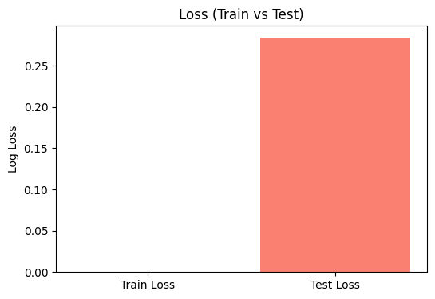

Confusion Matrix:
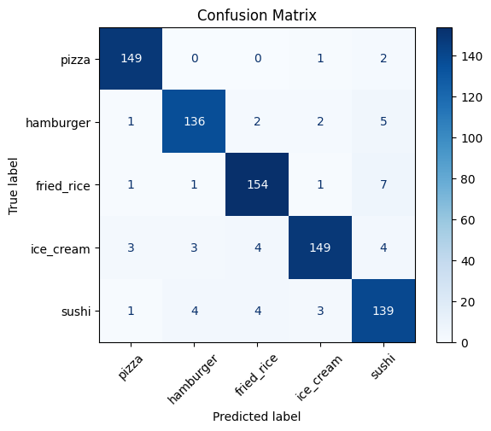

ROC Curve:
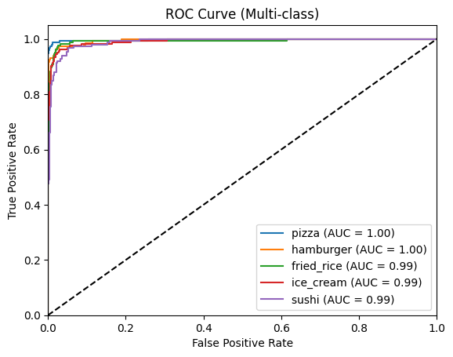

Accuracy:
Classification Report
 | Precision | Recall | F1-score | Support
Pizza | 0.96 | 0.98 | 0.97 | 152
Hamburger | 0.94 | 0.93 | 0.94 | 146
Fried Rice | 0.94 | 0.94 | 0.94 | 164
Ice Cream | 0.96 | 0.91 | 0.93 | 163
Sushi | 0.89 | 0.92 | 0.90 | 151
Accuracy |  |  | 0.94 | 776
Macro Avg | 0.94 | 0.94 | 0.94 | 776
Weighted Avg | 0.94 | 0.94 | 0.94 | 776
Train Accuracy | 100.00%
Test Accuracy | 93.69%

K-Means:
Loss:
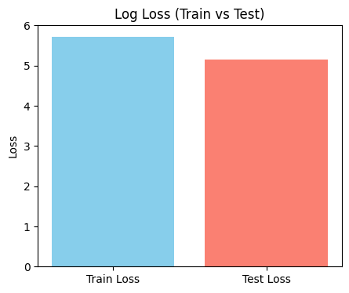

Confusion Matrix:
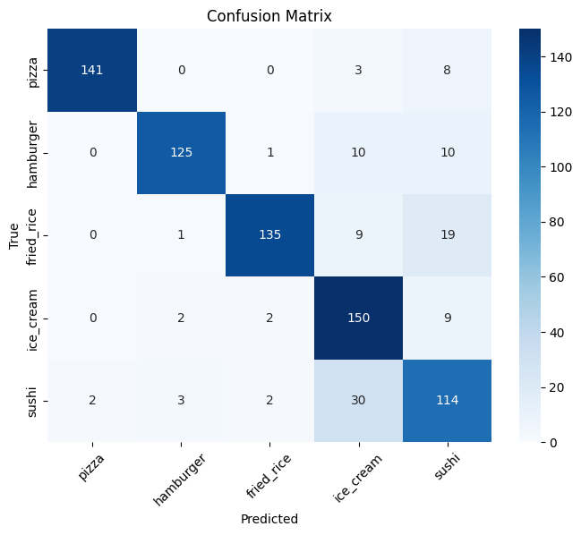

ROC Curve:
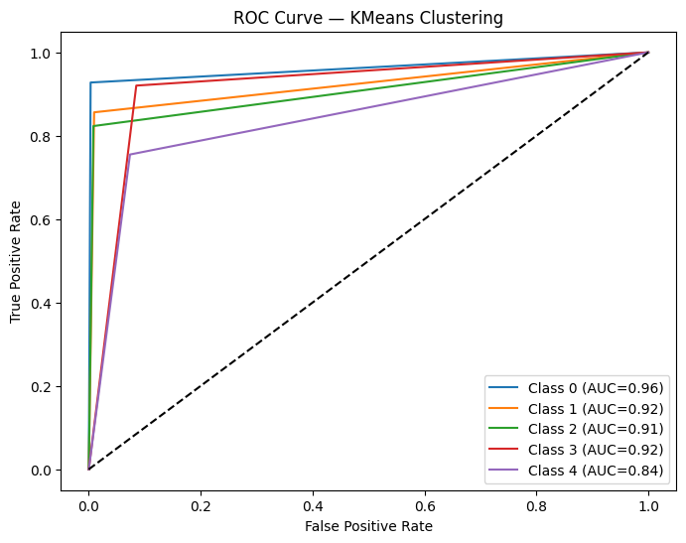

K-Means Clusters:
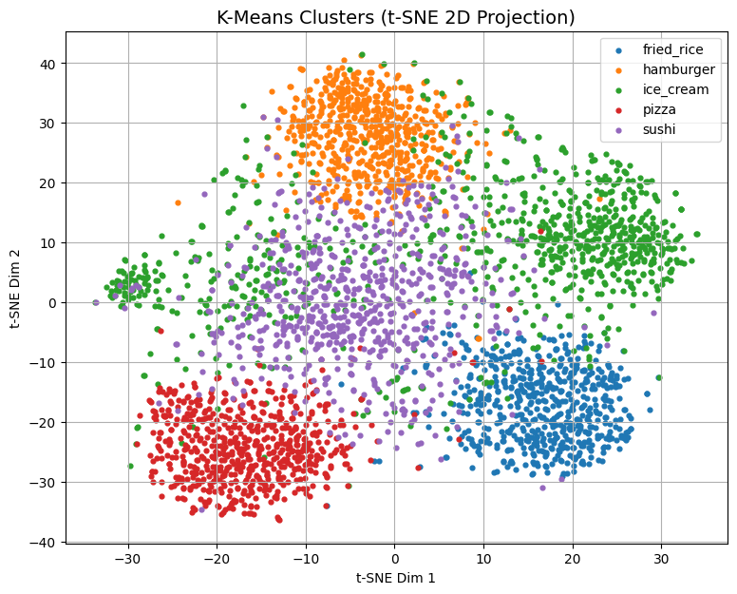

Accuracy:
Classification Report
 | Precision | Recall | F1-score | Support
Pizza | 0.99 | 0.93 | 0.96 | 152
Hamburger | 0.95 | 0.86 | 0.90 | 146
Fried Rice | 0.96 | 0.82 | 0.89 | 164
Ice Cream | 0.74 | 0.92 | 0.82 | 163
Sushi | 0.71 | 0.75 | 0.73 | 151
Accuracy |  |  | 0.86 | 776
Macro Avg | 0.87 | 0.86 | 0.86 | 776
Weighted Avg | 0.87 | 0.86 | 0.86 | 776
Train Accuracy | 84.15%
Test Accuracy | 85.70%

