Project Idea: N-Queens Problem Solver
The idea of this project is to build a program that can solve the N-Queens puzzle for any board size chosen by the user.
In the N-Queens puzzle, you must place N queens on an N×N chessboard so that none of them can attack each other. This means:
- No queens in the same row
- No queens in the same column
- No queens on the same diagonal
The project will not use just one method—it will solve the puzzle using four different AI algorithms:
- Backtracking Search – tries placing queens one by one and goes back when a conflict happens.
- Best-First Search – uses a heuristic to explore the most promising board positions first.
- Hill-Climbing Search – starts with a guess and keeps improving it to reduce conflicts.
- Cultural Algorithm – an evolutionary technique that uses a population of solutions plus shared knowledge to reach a valid arrangement.
The main idea is to compare how each algorithm performs, how fast they find a solution, and how well they work for different values of N.

Best-First Search Algorithm Documentation

Overview
- The best_first function implements a Best-First Search strategy to solve the N-Queens problem.
- It attempts to find a board configuration where no queens attack each other by repeatedly exploring the most promising states first, using a heuristic score as the priority.
The algorithm uses:
- A priority queue (heapq) to always expand the state with the lowest heuristic value.
- A heuristic function Heuristics.current to evaluate states.
- A visited set to avoid revisiting previously seen configurations.

Function Signature
def best_first (board):

Parameters
- board: An object representing the N-Queens board.
  - board.N: number of queens (and board size)
  - board.start: initial state — a list where state[col] = row of a queen
  - board.place_queen(row, col): places a queen on the final board

How the Algorithm Works :

1. Initialization
n = board.N
start = board.start.copy()
heuristic = Heuristics.current
pq = [(heuristic(start, n), start)]
visited = set()
- start is the initial configuration.
- The priority queue contains (heuristic_value, state).
- The lower the heuristic, the more promising the state.
- visited stores states already expanded.

2. Main Loop: Priority-Driven State Expansion
while pq:
h, state = heapq.heappop(pq)
- The queue always pops the state with the lowest heuristic.
- h is the number of conflicts
- state is a list of queen positions

3. Goal Test
if h == 0:
for col in range(n):
board.place_queen(state[col], col)
return True
- If heuristic = 0 → no queens attack each other → solution found.
- The queens are placed onto the board.

4. Mark State → Visited
visited.add(tuple(state))
- States are converted to tuples because lists are not hashable.
- Prevents infinite loops or redundant computation.

5. Generate Neighbor States
for i in range(n):
for j in range(n):
if j != state[i]:
new_state = state.copy()
new_state[i] = j
...
For each column i:
- Try placing the queen in every other row j
- Each new configuration is a neighbor state differing by one queen move.

6. Push Valid New States to the Priority Queue
if tuple(new_state) not in visited:
heapq.heappush(pq, (heuristic(new_state, n), new_state))
- Only unvisited states are added.
- Priority is determined again by the heuristic value.

7. Failure Case
return False
If all states are exhausted and no solution has heuristic 0, the algorithm reports failure.

Algorithm Characteristics

Search Strategy
- Greedy Best-First Search: always expands the state with minimum heuristic.
- Not guaranteed optimal, but often fast.

Heuristic
- Depends on Heuristics.current.
- Usually→ number of attacking queen pairs.

State Space
- Each state is an array of size n

Complexity
- Worst-case: exponential (as with most N-Queens search algorithms)

Flowchart
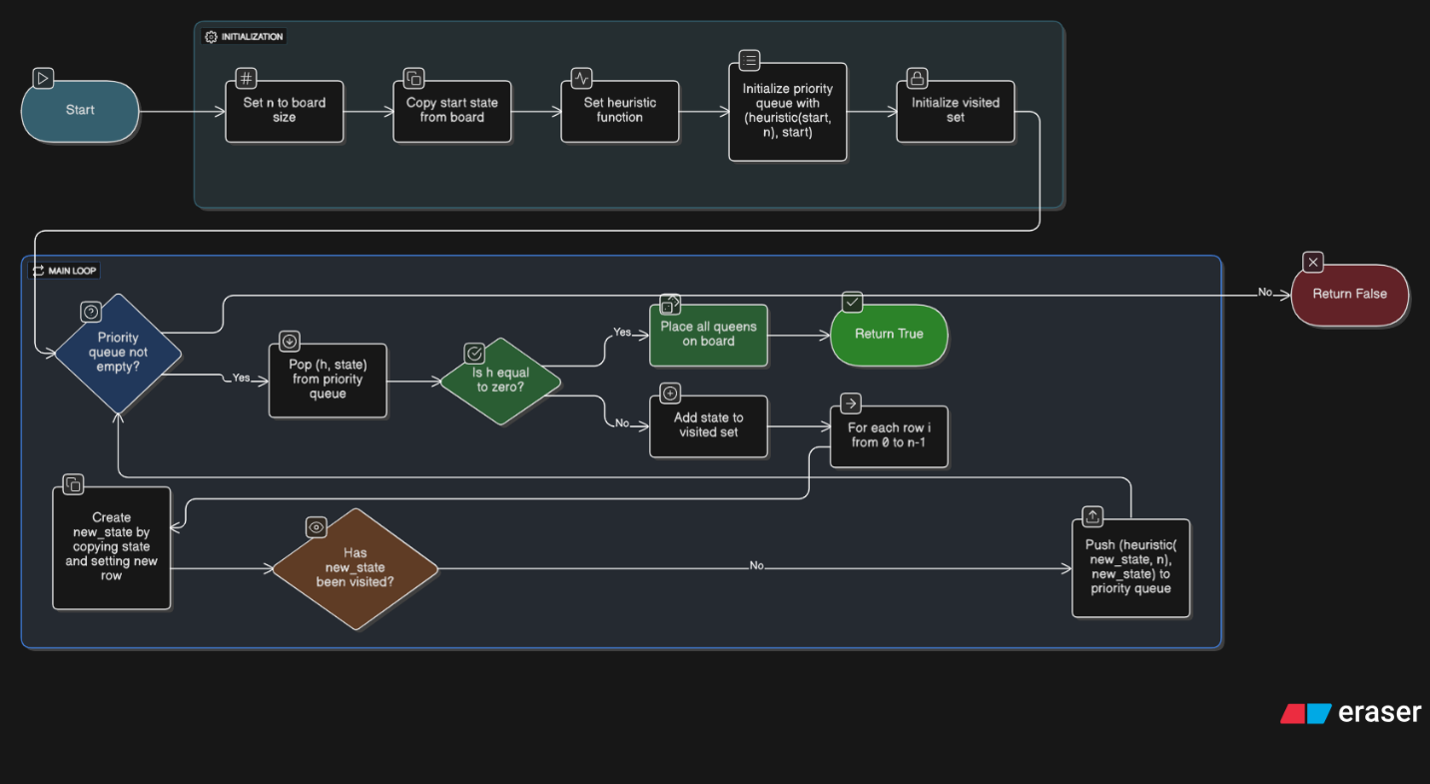

Block diagram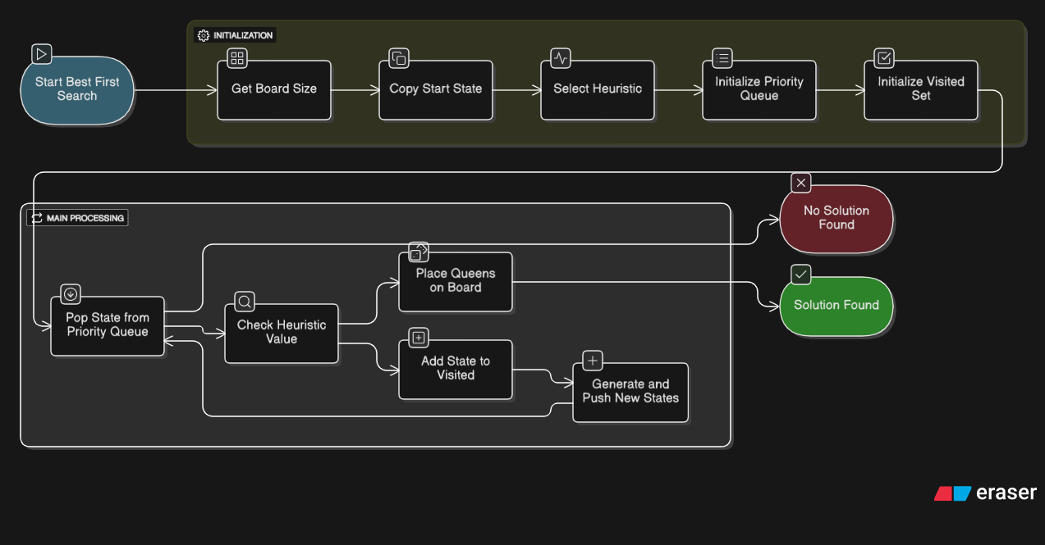

Paper Summary
This paper generalizes the theory of best-first search by studying evaluation functions that depend on the entire path rather than only the standard A* components g(n)g(n)g(n) and h(n)h(n)h(n). The authors analyze how well-known properties of A*—such as admissibility, termination, node-expansion conditions, and optimality—extend to this broader class of generalized best-first (GBF) strategies.

Key Contributions

1. A general framework for path-dependent evaluation functions
The paper introduces a generalized formulation where the evaluation function
f(n)=f(s,n1,n2,…,n)f(n) = f(s, n_1, n_2,\dots ,n)f(n)=f(s,n1​,n2​,…,n)
may depend on the entire path, not just g(n)+h(n)g(n)+h(n)g(n)+h(n). This includes nonlinear, nonadditive, and path-dependent heuristics.
They show that many properties of A* extend naturally when fff is order-preserving (i.e., expanding a path cannot reverse earlier merit comparisons).

2. Termination, completeness, and solution-quality results
The authors define a critical value called M (a “minimax saddle value”), based on the maximum fff-value along solution paths.
They prove:
- The algorithm always terminates if fff is unbounded on infinite paths.
- The returned solution has cost ≤ φ⁻¹(M) for monotonic fff.
This produces bounds for suboptimal but non-admissible heuristics—including weighted A* variants and dynamically weighted schemes.

3. Generalized node-expansion conditions
They generalize the classic A* expansion condition:
f(n)≤C∗f(n) \le C^*f(n)≤C∗
to arbitrary GBF strategies. They provide:
- Necessary and sufficient conditions for when a node must be expanded.
- Specialized, exact conditions for tree search, independent of knowing the final solution path.
These conditions support performance analysis of GBF under broader classes of heuristics.

4. Computational optimality of A*
The central contribution is a rigorous examination of A*’s optimality among equally informed algorithms—those given the same heuristic hhh.
They define a hierarchy of optimality notions (Type 0–3) and evaluate how A* compares to other admissible algorithms under several domains:
- admissible heuristics (h ≤ h*)
- consistent heuristics
- pathological vs. non-pathological cases
- best-first vs. more general strategies

Major findings
- A is not the most efficient admissible algorithm in general.*
There exist admissible algorithms that expand fewer nodes than A* for some admissible heuristics.
- No admissible algorithm is globally optimal under arbitrary admissible (possibly inconsistent) heuristics.
- A is optimal when heuristics are consistent.*
Under consistency, every admissible algorithm must expand all nodes A* must expand—establishing computational optimality.
- A* is also optimal within the class of best-first algorithms guided by path-dependent evaluation functions, assuming consistency.
Thus, A*’s optimality is conditional, not universal.

References Mentioned in the Paper
- Bagchi, A., and Mahanti, A. Search Algorithms Under Different Kinds of Heuristics.
- Dechter, R., and Pearl, J. Generalized Best-First Search Strategies and the Optimality of A* (the present paper).
- Bellman, R. Dynamic Programming.
- Gelperin, D. On the Optimality of A*.
- Pohl, I. Heuristic Search Viewed as Path Finding in a Graph.
- Hart, P. E., Nilsson, N. J., and Raphael, B. A Formal Basis for the Heuristic Determination of Minimum Cost Paths.
- Hart, P. E., Nilsson, N. J., and Raphael, B. Correction to "A Formal Basis..."
- Gaschnig, J. Heuristic Search Algorithms.
- Karp, R. Probabilistic Analysis of Search Algorithms (relates to Appendix).
- Lawler, E. L., and Wood, D. E. Branch-and-Bound Methods.
- Pearl, J. Heuristics: Intelligent Search Strategies for Computer Problem Solving.
- Miro, R. On the Optimality of A*.
- Nilsson, N. J. Principles of Artificial Intelligence.
- Nilsson, N. J. Problem-Solving Methods in Artificial Intelligence.

