**Backpropagation Report** (Task2)

**Team Number: 79**

|  |  |
| --- | --- |
| **Team Members** | **ID** |
| محمد فوزي ابراهيم رفاعي | 20201701223 |
| ربا وصفي الشماط | 20201701077 |
| ساندي يوثام نزهي نصيف | 20201701234 |
| يوسف وليد محمد اسماعيل | 20201701269 |
| رفيق نصر توفيق حنا | 20201701078 |
| يوسف إسحق وصفي واصف | 20201701002 |

**Sigmoid:**

**Resulted accuracy:**

Training accuracy: 100%

Testing accuracy: 100%

**Used parameters:**

Learning rate = 0.1

Number of hidden layers = 2

Neurons/each layer = 5, 4

Number of Epochs = 1000

With bias

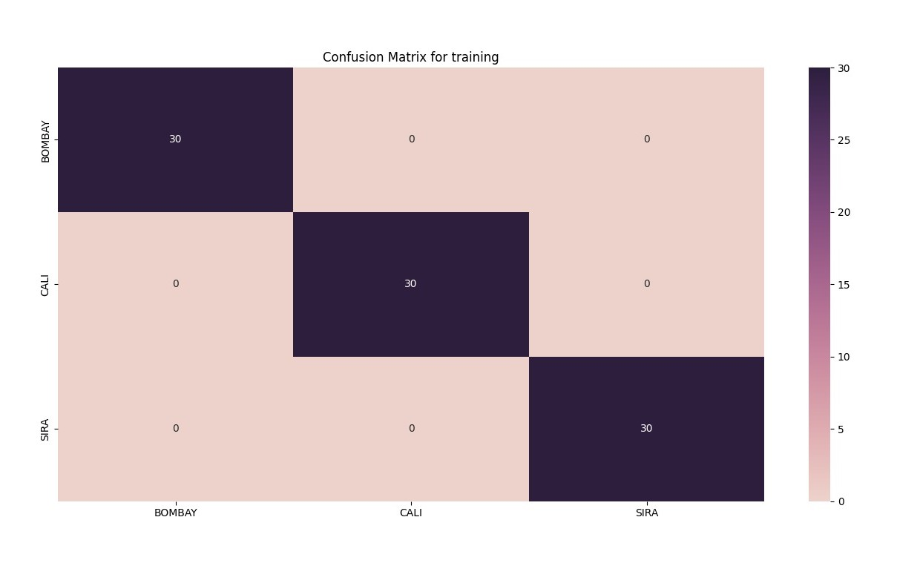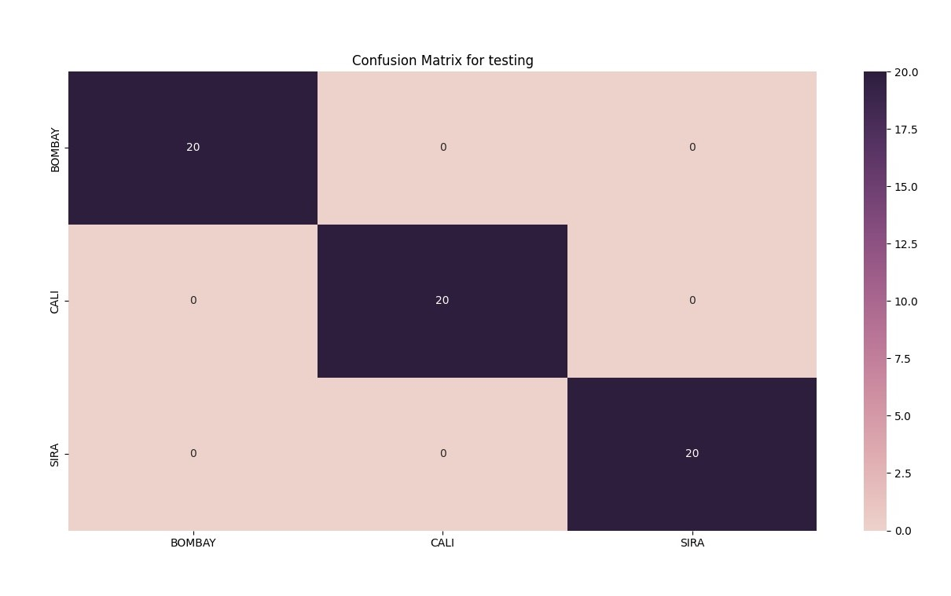

**Hyperbolic Tangent Sigmoid:**

**Resulted accuracy:**

Train Accuracy: 100%

Test Accuracy: 100%

**Used parameters:**

Learning rate = 0.01

Number of hidden layers = 3

Neurons/each layer = 4, 3, 2

Number of Epochs = 5000

With bias



Conclusion:

|  |  |  |  |  |  |  |
| --- | --- | --- | --- | --- | --- | --- |
| Activation  Function | Train  Accuracy | Test  Accuracy | LR | Epochs | #Layers | #hidden  Nodes |
| Sigmoid | 100% | 100% | 0.1 | 1000 | 2 | 5, 4 |
| Tanh | 100% | 100% | 0.01 | 5000 | 3 | 4, 3, 2 |