Monthly sales Visualization.

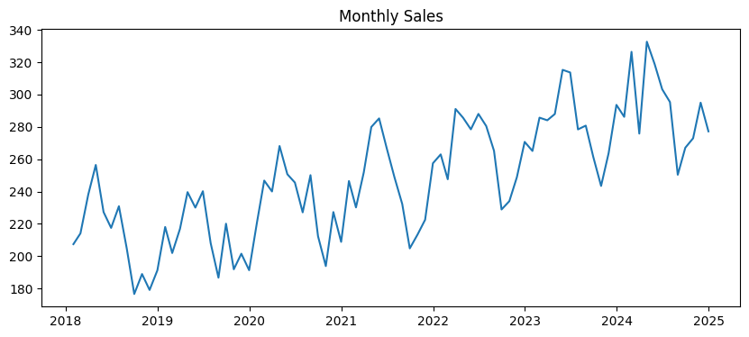

Feature Engineering (for XGBoost)

|  | **date** | **sales** | **month** | **year** | **lag_1** | **lag_12** | **rolling_mean_3** | **rolling_mean_6** | |
| --- | --- | --- | --- | --- | --- | --- | --- | --- | --- |
| **12** | 2019-01-31 | 218.09 | 1 | 2019 | 191.27 | 207.45 | 186.456667 | 195.310000 |  |
| **13** | 2019-02-28 | 201.96 | 2 | 2019 | 218.09 | 214.13 | 196.160000 | 193.171667 |  |
| **14** | 2019-03-31 | 216.97 | 3 | 2019 | 201.96 | 238.11 | 203.773333 | 192.673333 |  |
| **15** | 2019-04-30 | 239.64 | 4 | 2019 | 216.97 | 256.46 | 212.340000 | 199.398333 |  |
| **16** | 2019-05-31 | 230.07 | 5 | 2019 | 239.64 | 227.29 | 219.523333 | 207.841667 |  |

Model 1 - XGBoost

XGBoost - MAE=15.51 and RMSE=19.08

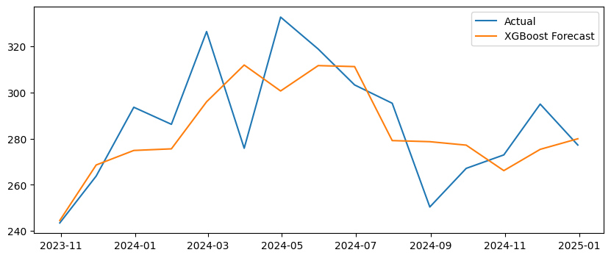

Model 2 - Prophet

Prophet - MAE=14.30 and RMSE=18.91

