**GRAPHS**

AVG SENTIMENT SCORE OF 5 CATEGORIES  
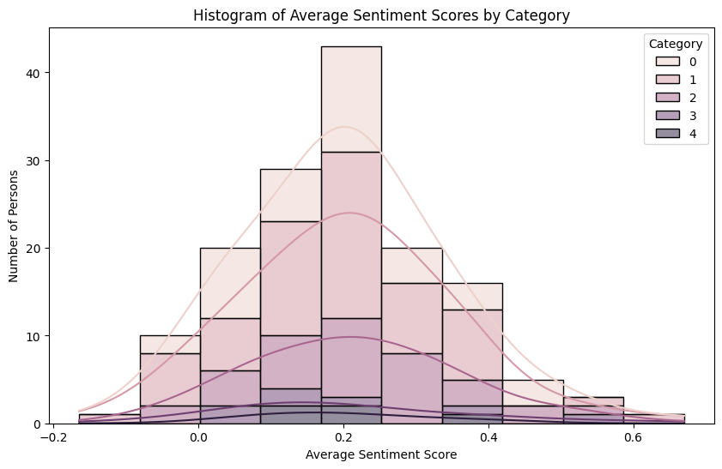

KDE FOR AVERAGED DEPREESED AND NON DEPPRESSED

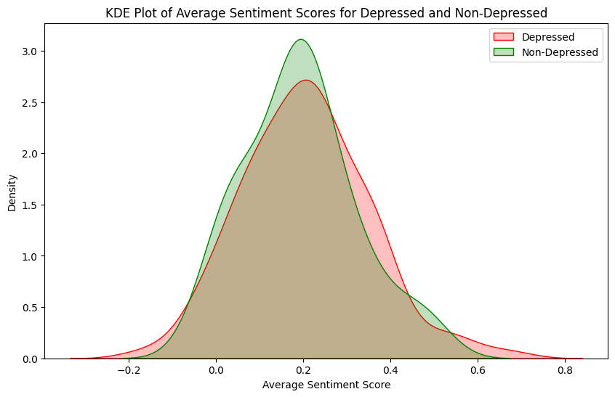

KDE FOR DEPRESSED AND NON-DEPRESSED GROUP EVERY SENTENCE

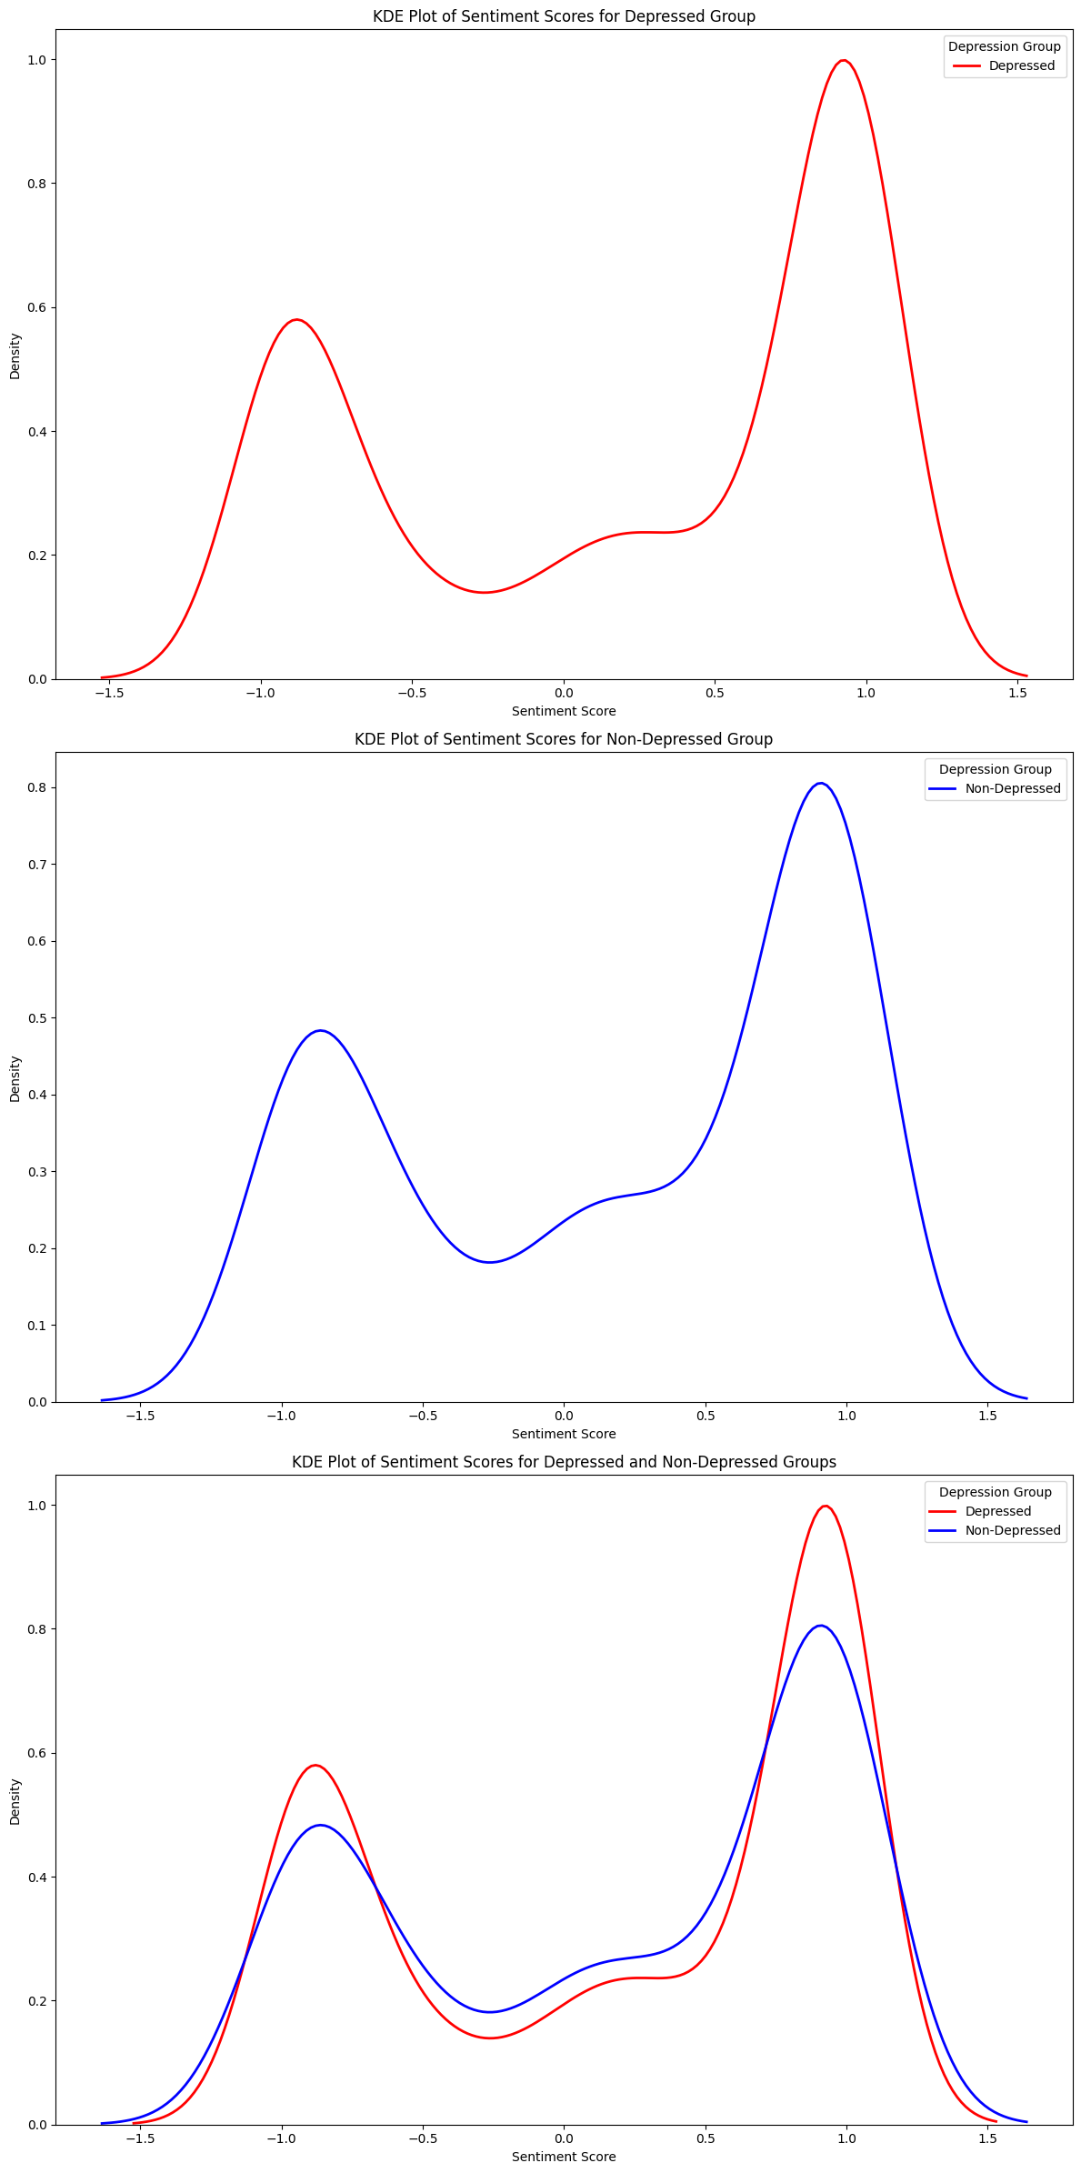

POSITVIE SENTIMENT SCORE

AVG POSITIVE SENTIMENT SCORE

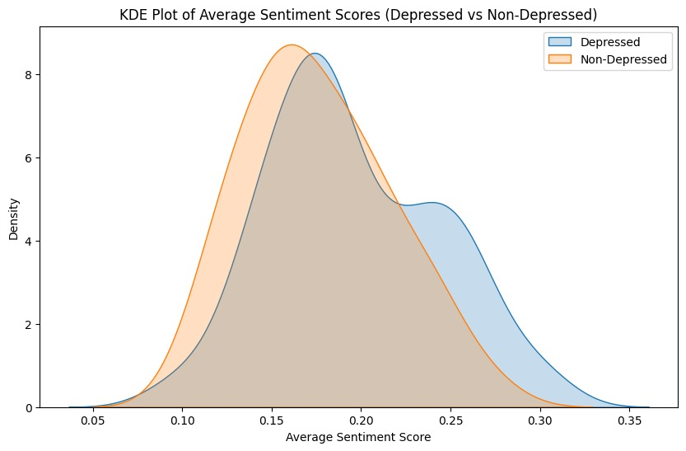

THRESHOLD.1 FOR POSTIVE SCORE

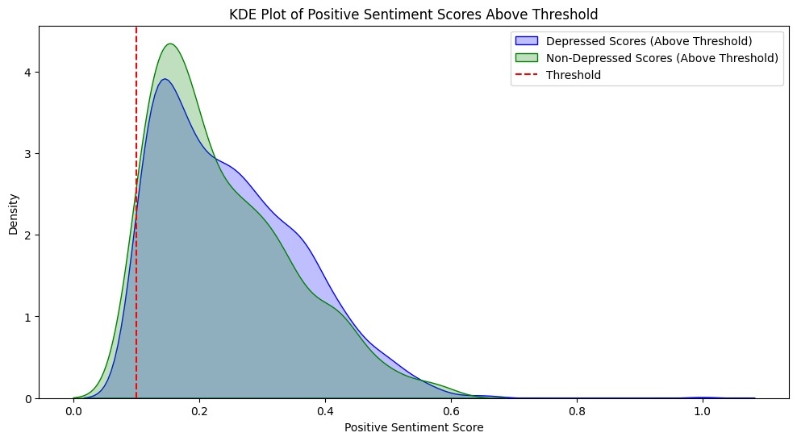

POSITIVE AND NEGATIVE WORD COUNT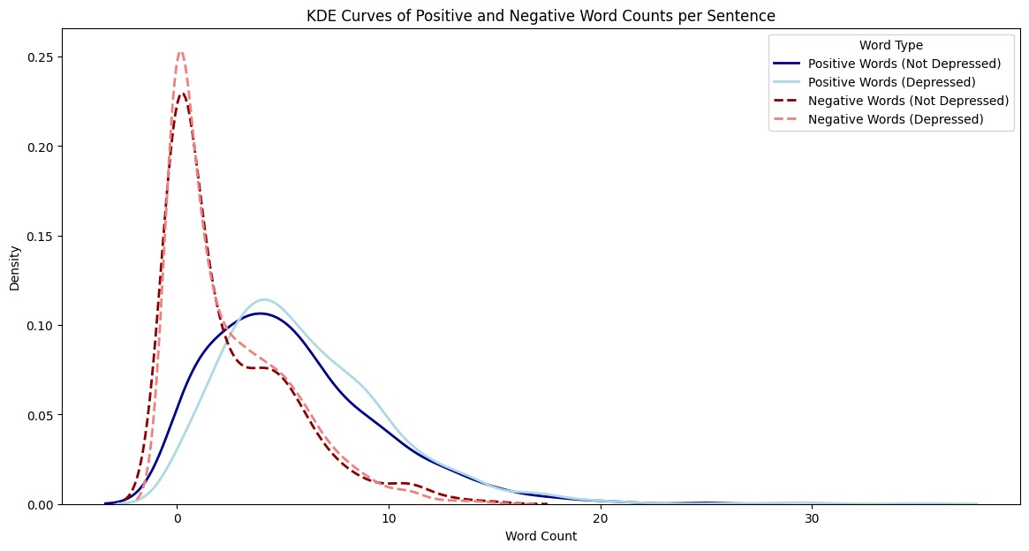

SENTENCE -LEVEL POSTIVE VS NEGATIVE

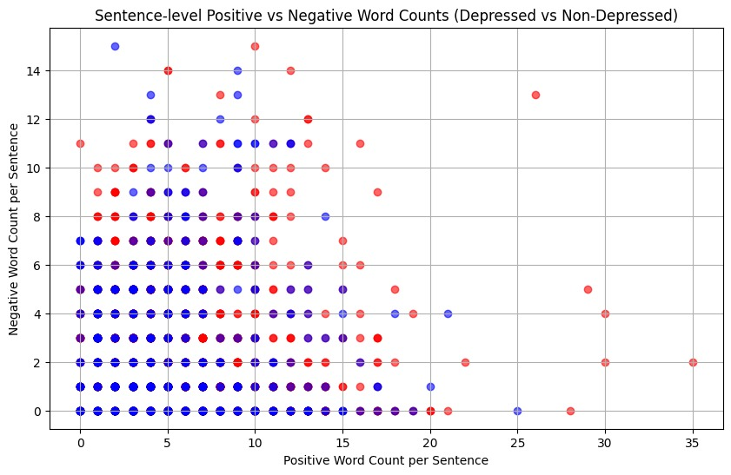

POSITVE AND NEGATIVE SCORES

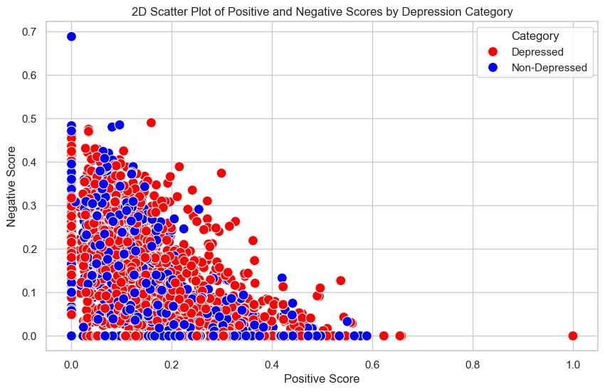

NORMALIZED POSITIVE VS NEGATIVE COUNT

TEXT BLOB

POSITVE COUNT

OVERALL SCORE AND POSITVE VS NEGATIVE COUNT

NORMALIZED POSITIVE AND NEGATIVE COUNT

SENTIWORDNET

POSITIVE AND NEGATIVE WORD COUNT

OVERALL SENTIMENT SCORE

POSITVE VS NEGATIVE SENTIMENT SCORE

NORMALIZE POSITIVE VS NEGATIVE COUNT

AFINN

TOTAL POSITIVE AND NEGATIVE WORD COUNT

OVERALL SENTIMENT SCORE

POSITIVE VS NEGATIVE SCORE

NORMALIZED POSITIVE VS NEGATIVE WORD COUNT

