CalBMP User Manual

(Version 1.0)

Contact Information:

Jingyuan Xue [jiyxue@ucdavis.edu](mailto:jiyxue@ucdavis.edu)

Department of Land Air and Water Resources, University of California, Davis, 95616

***Overview***

CalBMP is a web-based interface for site-specific best management practices evaluations in California. It is designed as an advisory and regulatory modeling tool to mitigate pesticide loading leaving upland crop field for different stakeholders including growers, pesticide advisors, extension agents, modelers and policy makers, etc. The current version of the CalBMP interface enable users to do pesticide modeling and BMP evaluations based on site-specific field conditions in terms of location, topography, soil, weather, crop management, pesticide application, and BMP selections. The CalBMP interface has many great features including:

1. No need to install offline softwares
2. Skip the long-time preparation of input files
3. No need to learn and understand the model output structures.
4. Complete database: SSURGO soil database, GridMET weather database, pesticide usage (Pesticide Use Risk Evaluation (PURE) decision support system (DSS)) and pesticide properties database (PPDB).
5. BMP scenarios: enabling simulation of the mitigation effectiveness for different BMP options including pesticide application reduction, pesticide application timing, cover crop, crop rotation and residue management, contour farming, parallel terracing, strip cropping.
6. Visualization: enabling users to review different outputs including water depths, sediment, pesticide loading/concentration in runoff, erosion and volatilization in graphs and texts. Both time-series and event-based values could be checked in the front-end.
7. Historical projects accessible: Projects could be saved after simulation, inputs and outputs files could be downloaded and saved for future use.

Below are webpages demonstrating the steps for operating CalBMP

***Welcome page***

The first-time users will need to register and login to the interface.(Fig.1)

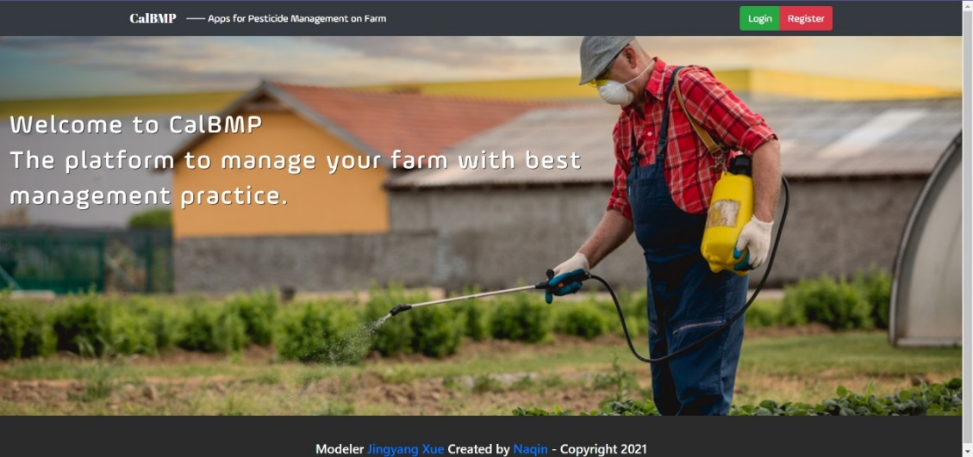

(a)

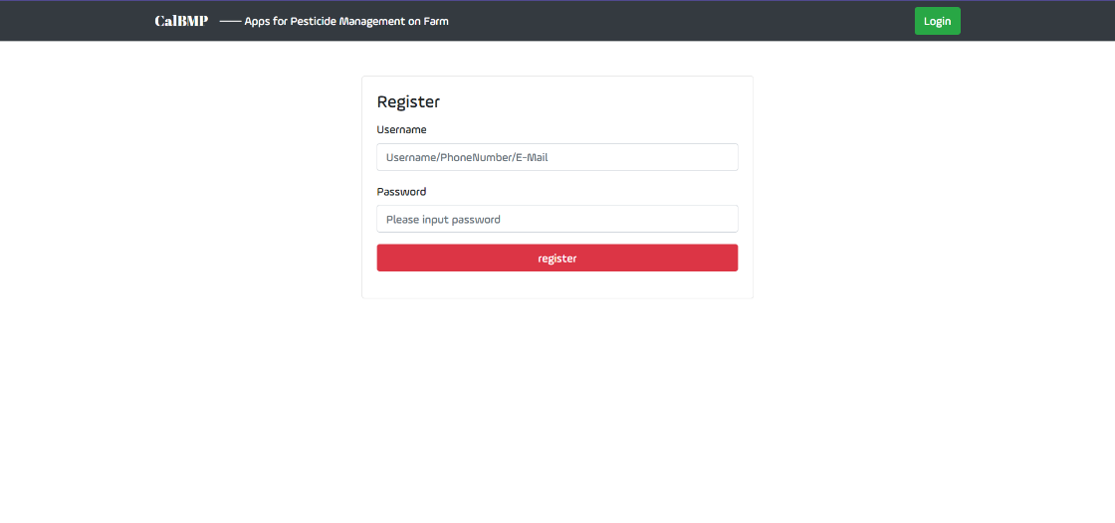

(b)

**Fig.1** CalBMP page: welcome page, registration and login

***Make a run in Baseline scenario (Example with filled input info.)***

1. Configure the user field (Fig.2):
2. Find your field location by selecting the county and zip code.
3. Specifying the soil series and input the field area.
4. Specify the crop management and pesticide application (Fig.3):
5. Select crop, emergence date, maturity date, harvest date, irrigation type. (Put mouse on the date selection window, there will be pop-ups beside showing recommended time period guiding user’s selection.)
6. Select application Numbers, pesticide name, application rate, date, method and location (Multiple applications could be applied in each run. Up to three chemicals could be evaluated in each run.)
7. Visualization (Fig.4):
8. Select water depths, sediment, pesticide loading in runoff, erosion and volatilization in the left side bar.
9. Switch between “Water”, “Pesticide”, “Loading”, and “Concentration” taps on the top to review the outputs varying with time. (Drag the time slide bar below the graph to change the time period from year to week. Put the mouse on the curve to see the value and date of the index. Other legends could be grayed out to leave only one index in each graph for review.)
10. Click on “summary” button on the right to review the summarized basic field and management information for this project. Values of event-based outputs could be reviewed in the table as well.

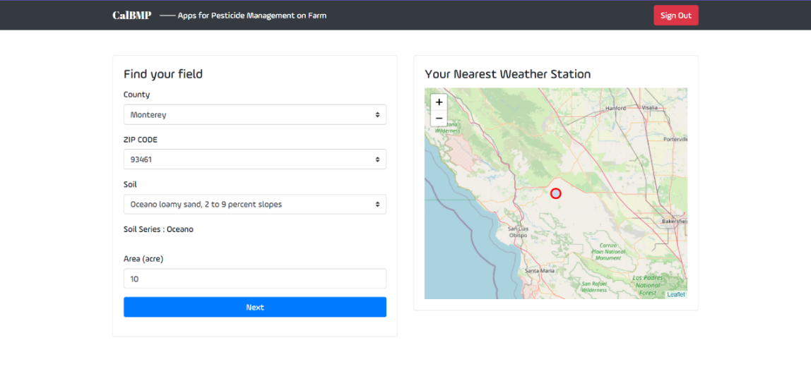

**Fig.2** CalBMP page: finding the field. (Location, soil, area need to be specified by user to configure one field. The nearest weather station is automatically visualized in the map for user’s review.)

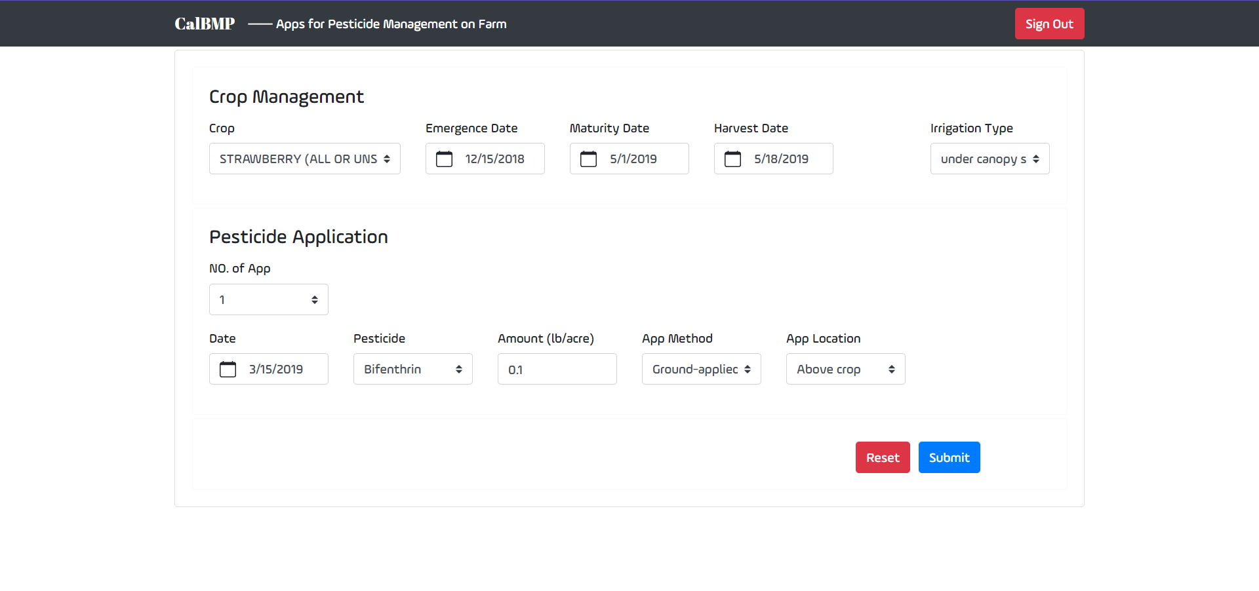

**Fig.3** CalBMP page: specifying the crop management and pesticide application.

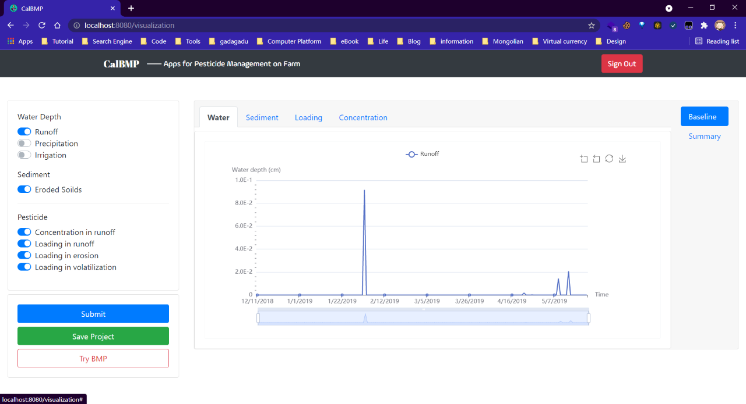

(a)

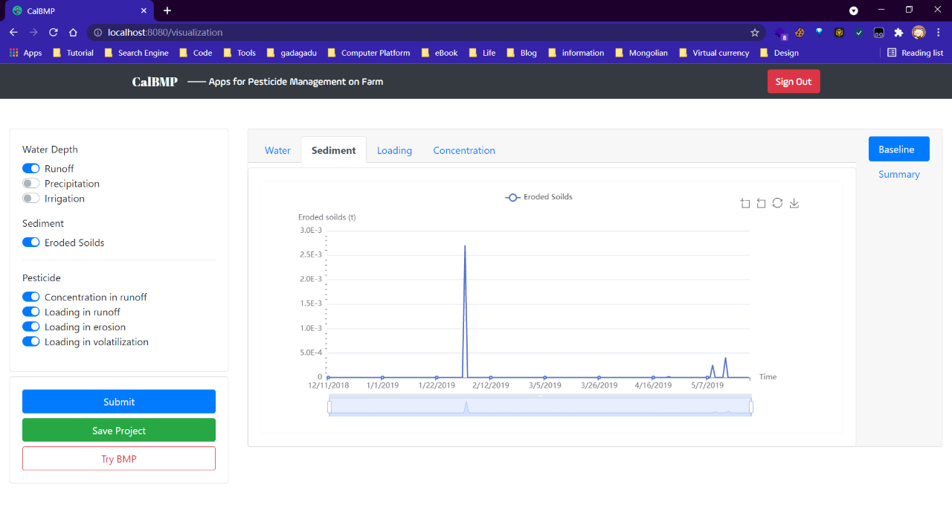

(b)

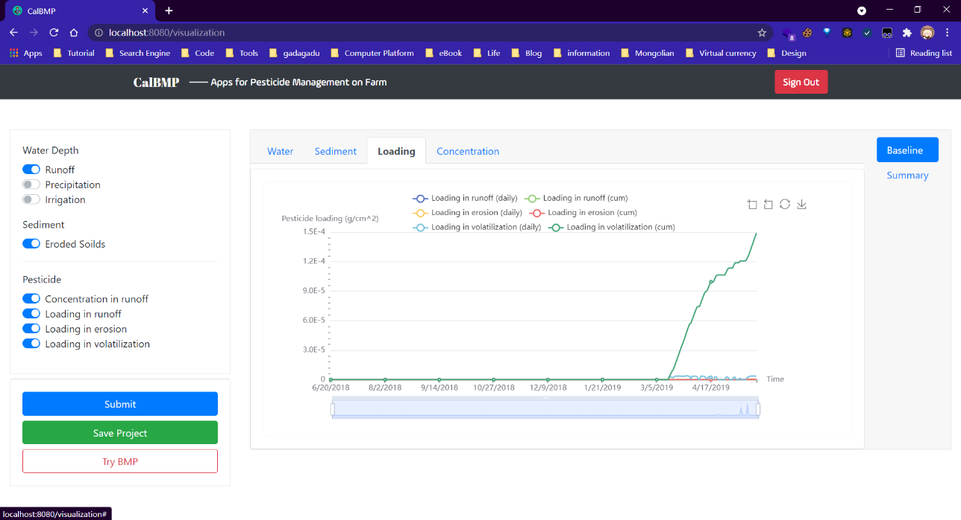

(c)

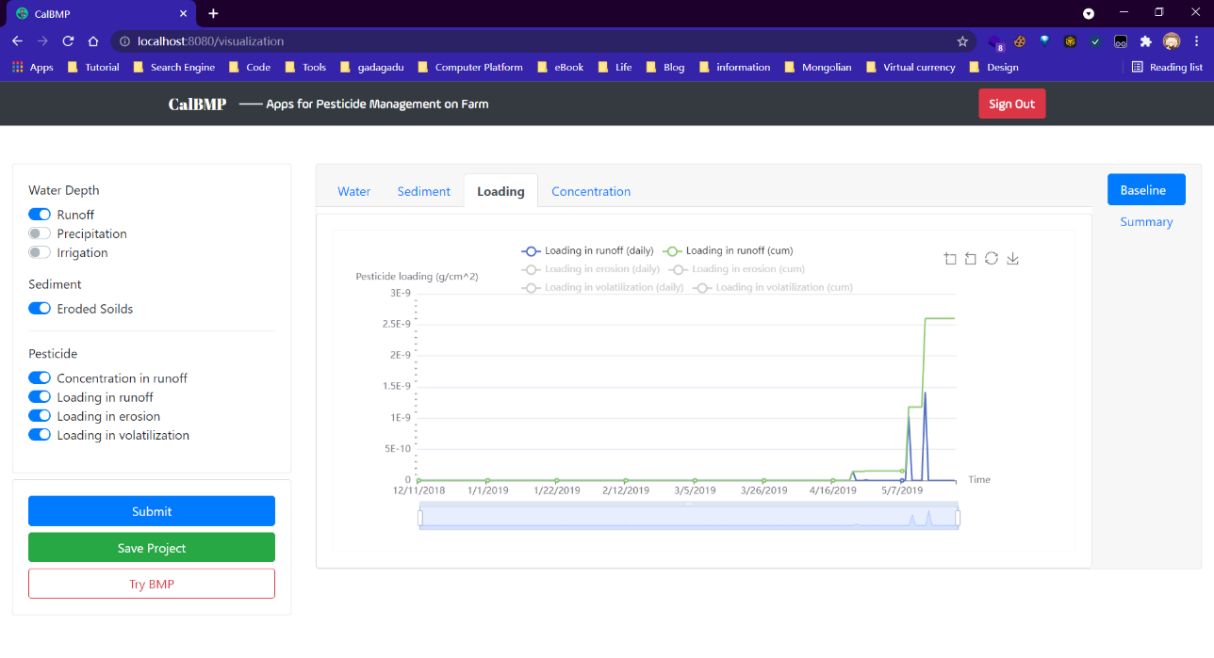

(d)

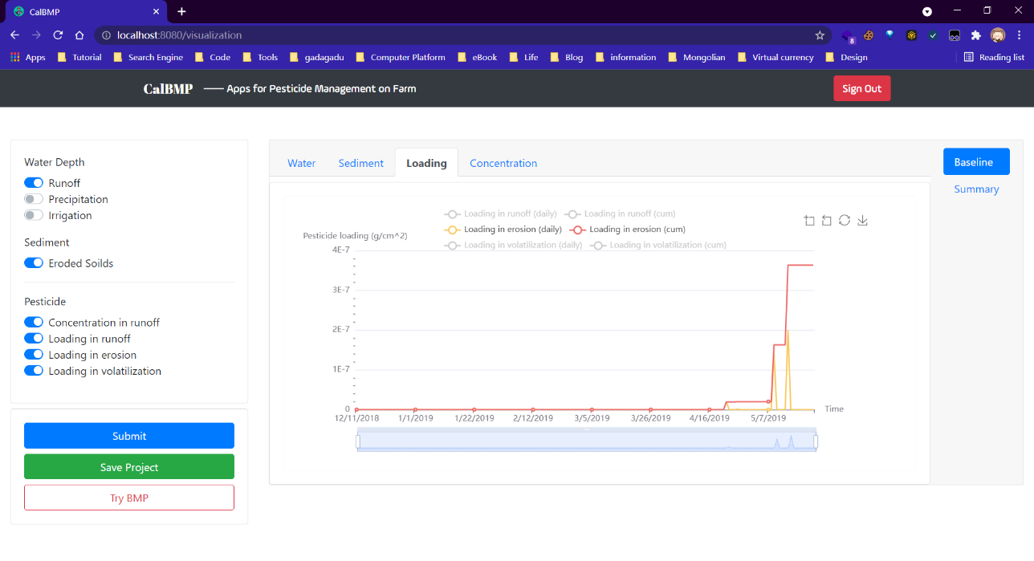

(e)

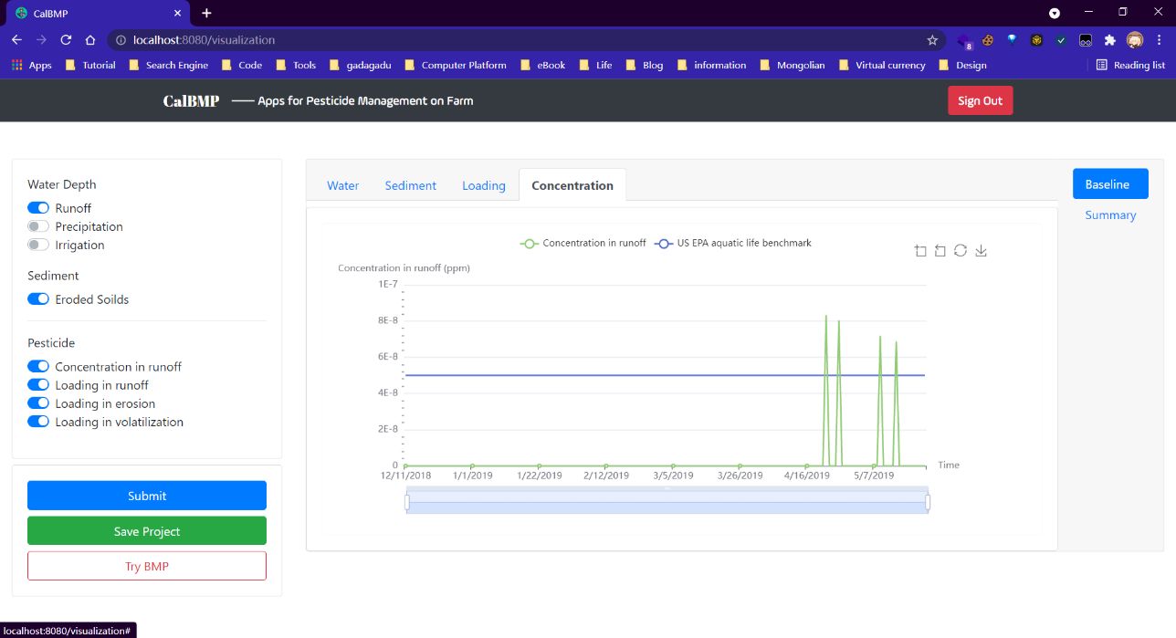

(f)

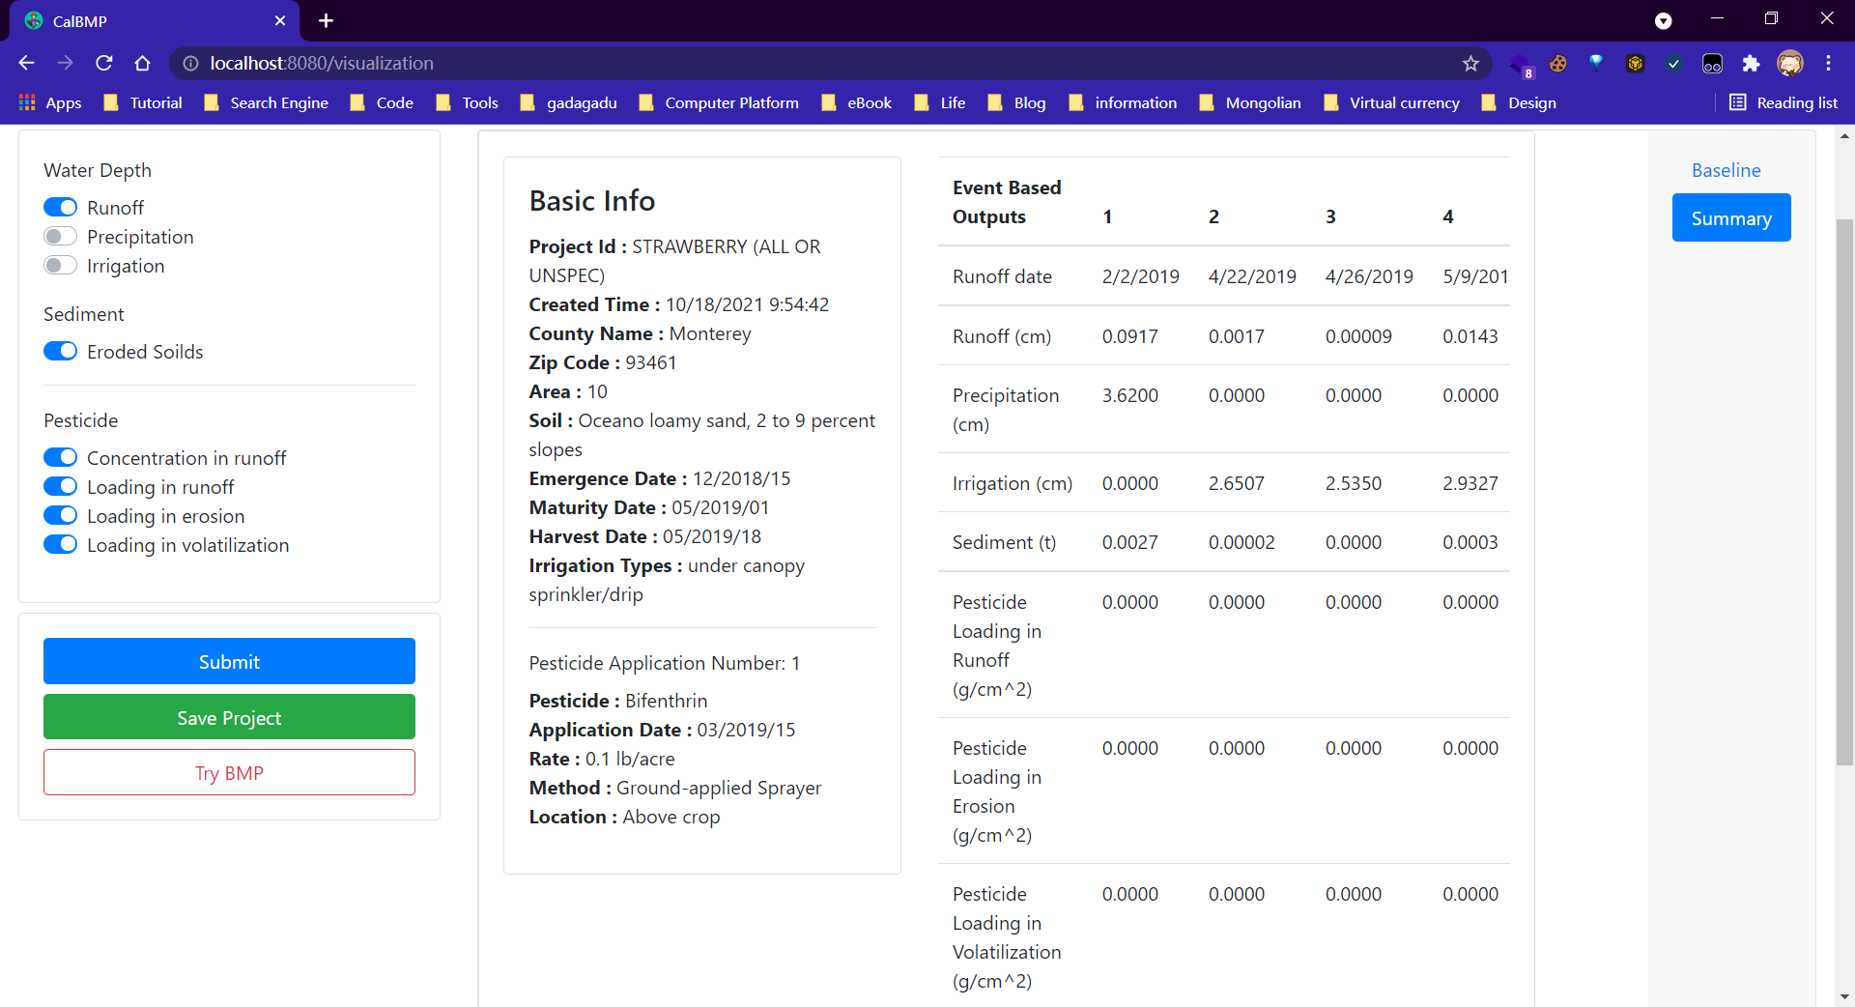

(g)

**Fig.4** CalBMP page: outputs visualization in the baseline scenario.

***Make a run in BMP scenario (Example with filled input info.)***

1. Select BMP options (Fig.5a). (Single or multiple BMP options could be selected in each BMP scenario.)
2. Input required parameters in pop-ups for selected BMP and click the “submit” button to run BMP scenario. Examples with filled information were provided for each BMP option (Fig.5b-h).
3. Visualization
4. Select “water depth”, “sediment”, “pesticide concentration in runoff”, “pesticide loading in runoff”, “pesticide loading in erosion” and “pesticide loading in volatilization” in the left side bar. Switch between “Water”, “Pesticide”, “Loading”, and “Concentration” in the top taps to review the outputs varying with time. (Same as visualization in baseline scenario)
5. Click on “Try other BMP” button on the right to run another BMP scenario. (Optional)
6. Click on “BMP comparison” button on the right to review the BMP effectiveness for single BMP or effectiveness comparison between BMP scenarios. (Fig. 6a-b)
7. Click on “BMP summary” button on the right to review the table including summarized BMP scenario information and pesticide reduction percentage in main pathways. (Fig.6c)

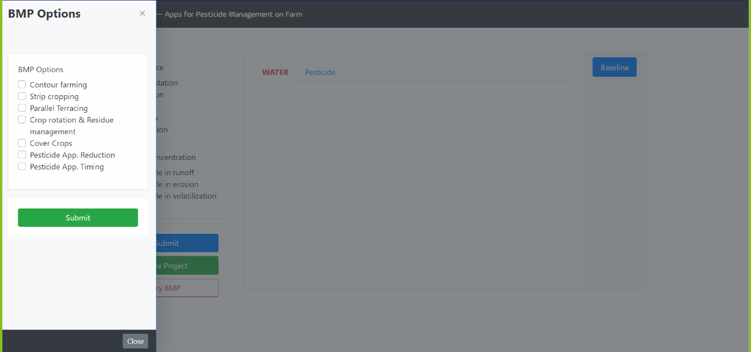

(a)

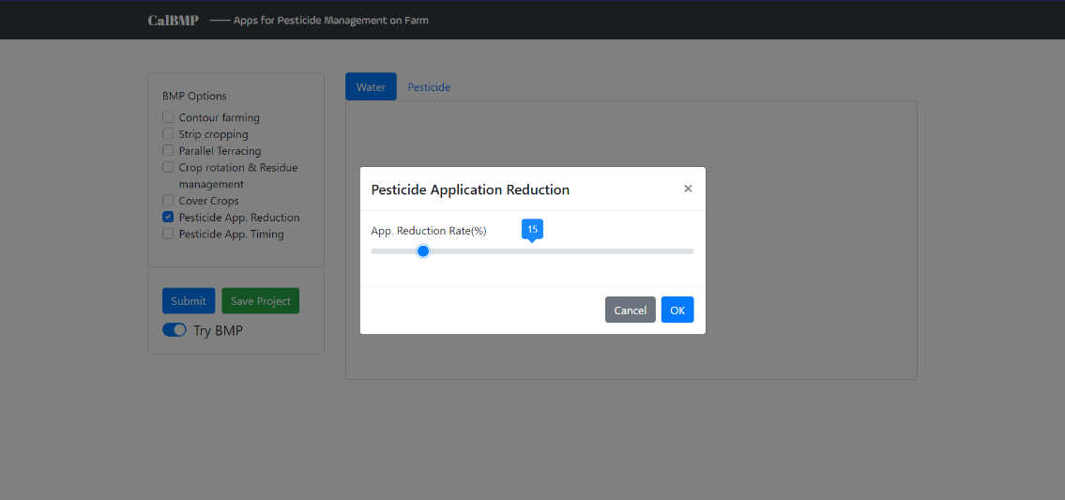

(b)

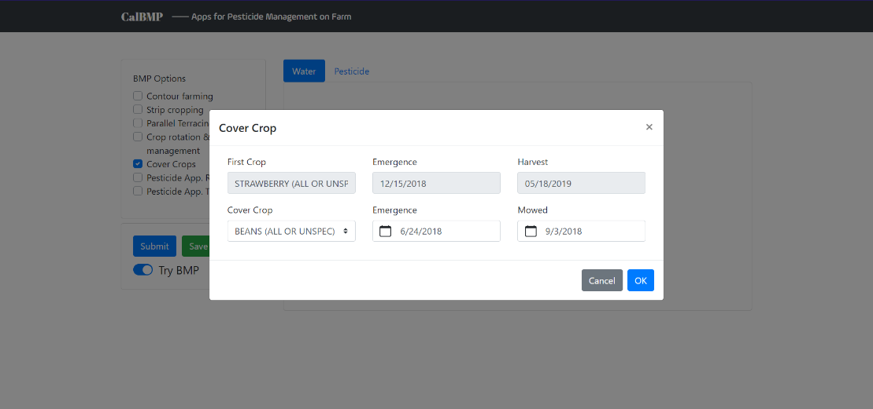

(c)

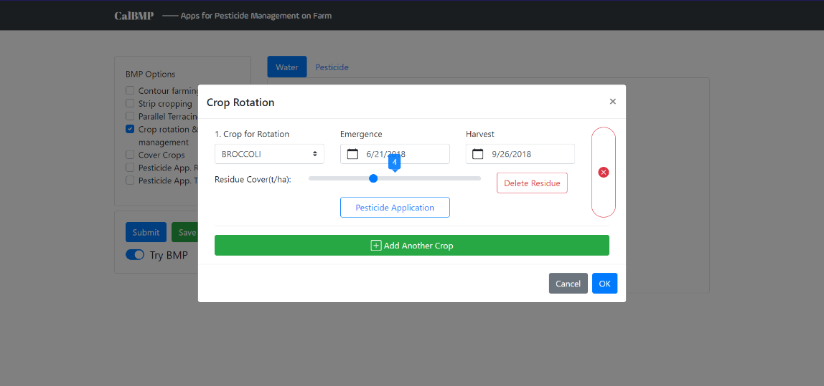

(d)

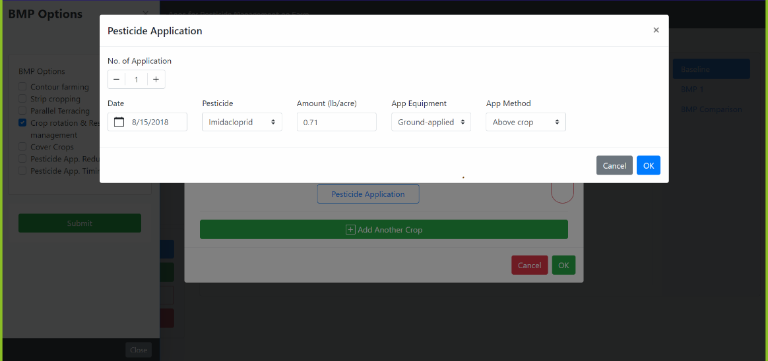

(e)

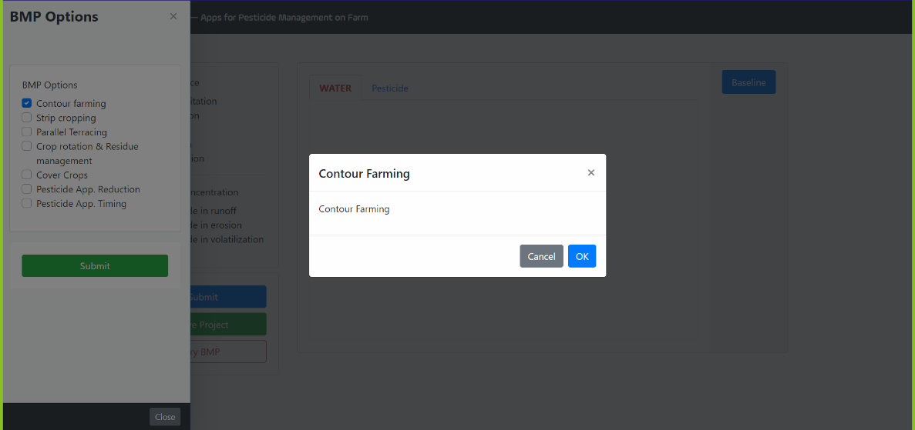

(f)

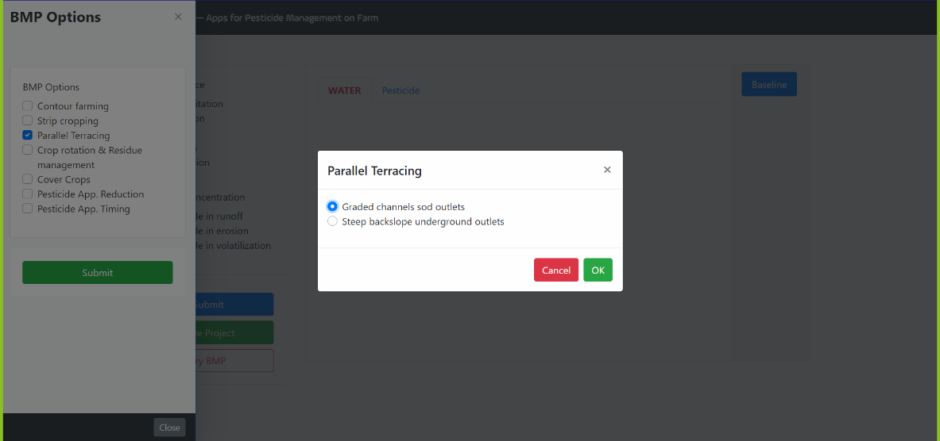

(g)

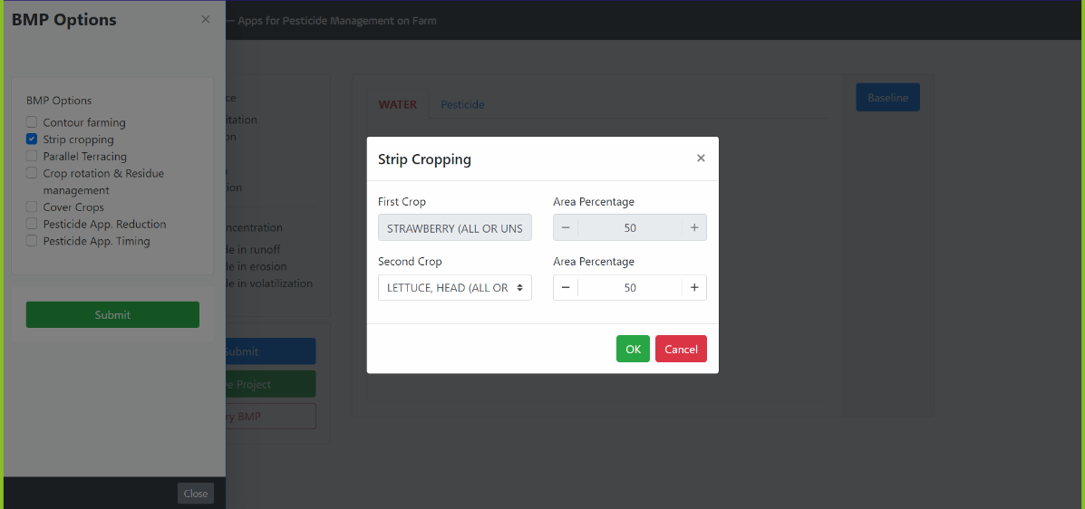

(h)

**Fig.5** CalBMP page: selecting BMP/BMPs in the BMP scenario.

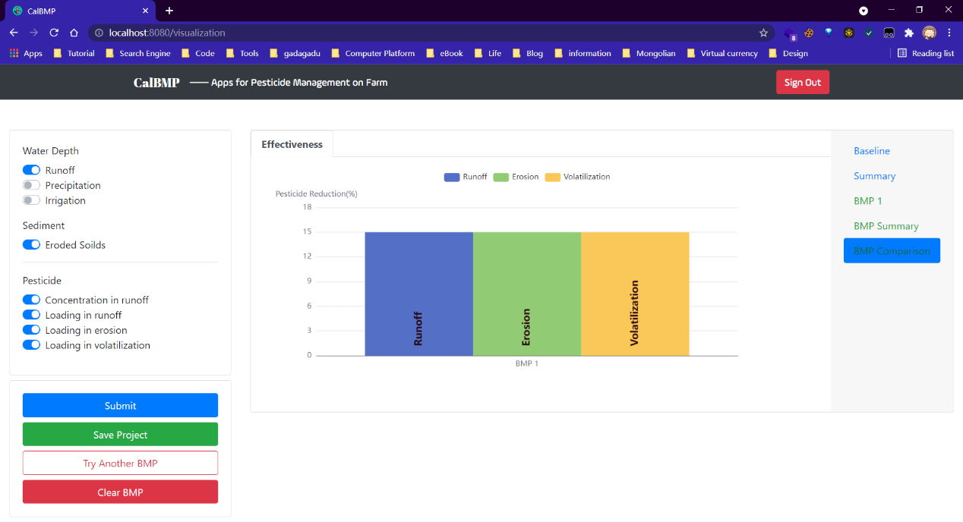

(a)

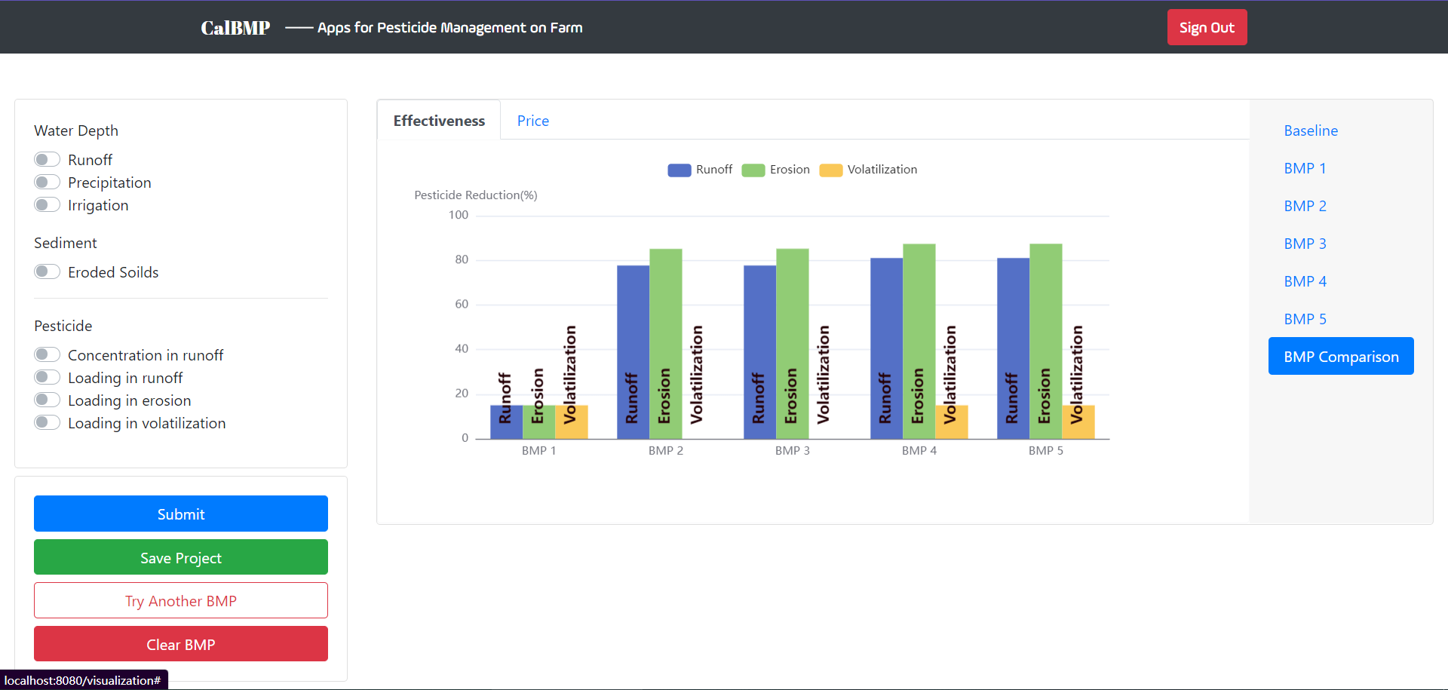

(b)

(c)

**Fig.6** CalBMP page: outputs visualization in the BMP scenario.

***Help***

Help contains this user manual and the developer’s contact information.