Co-diffusion
CYP
2020/5/3

US one way

Cases 2020/03/07 - 2020-04-24
Param. | Estimate | Std. | Error | t value | Pr(>|t|)
M | 1.3159331 | 0.0640758 | 20.537 | < 2e-16 | ***
P | 0.0016618 | 0.0002744 | 6.057 | 2.38e-07 | ***
Q | 0.1095144 | 0.0072015 | 15.207 | < 2e-16 | ***

News 2020/01/11 - 2020-04-24
Param. | Estimate | Std. | Error | t value | Pr(>|t|)
P | 0.003478 | 0.000480 | 7.247 | 8.40e-11 | ***
Q | 0.033066 | 0.002797 | 11.824 | < 2e-16 | ***
c1 | 0.045329 | 0.008164 | 5.552 | 2.25e-07 | ***
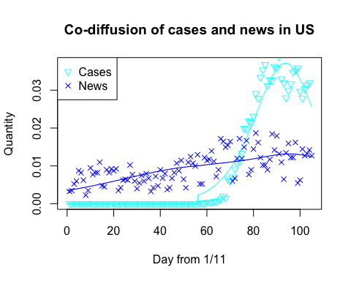

UK one way

Cases 2020/03/12 - 2020/04/24
Param. | Estimate | Std. | Error | t value | Pr(>|t|)
M | 1.3123825 | 0.0830045 | 15.81 | < 2e-16 | ***
P | 0.0024500 | 0.0004571 | 5.36 | 3.74e-06 | ***
Q | 0.1149791 | 0.0100024 | 11.49 | 2.99e-14 | ***

News 2020/01/11 - 2020-04-24
Param. | Estimate | Std. | Error | t value | Pr(>|t|)
P | 0.002368 | 0.000303 | 7.814 | 5.15e-12 | ***
Q | 0.040532 | 0.002311 | 17.539 | < 2e-16 | ***
c1 | 0.058339 | 0.008946 | 6.521 | 2.72e-09 | ***
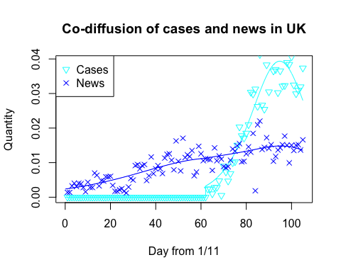

AU one way

Cases 2020/03/13 - 2020/04/24
Param. | Estimate | Std. | Error | t value | Pr(>|t|)
P | 0.006141 | 0.001029 | 5.97 | 4.78e-07 | ***
Q | 0.227823 | 0.013657 | 16.68 | < 2e-16 | ***

News 2020/01/11 - 2020-04-24
Param. | Estimate | Std. | Error | t value | Pr(>|t|)
P | 0.0029292 | 0.0003775 | 7.759 | 6.77e-12 | ***
Q | 0.0373053 | 0.0025151 | 14.832 | < 2e-16 | ***
c1 | 0.0185380 | 0.0032489 | 5.706 | 1.14e-07 | ***
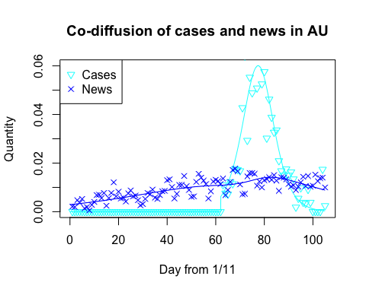

CA one way

Cases 2020/03/15 - 2020/04/24
Param. | Estimate | Std. | Error | t value | Pr(>|t|)
M | 1.5098915 | 0.2351892 | 6.420 | 1.51e-07 | ***
P | 0.0034999 | 0.0008755 | 3.998 | 0.000284 | ***
Q | 0.0945436 | 0.0180356 | 5.242 | 6.22e-06 | ***

News 2020/01/11 - 2020-04-24
Param. | Estimate | Std. | Error | t value | Pr(>|t|)
P | 0.0018914 | 0.0002888 | 6.550 | 2.38e-09 | ***
Q | 0.0428883 | 0.0025510 | 16.812 | < 2e-16 | ***
c1 | 0.0604855 | 0.0103192 | 5.861 | 5.68e-08 | ***
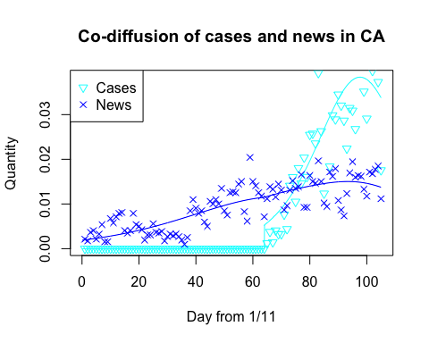

TW one way

Cases 2020/03/10 - 2020/04/24
Param. | Estimate | Std. | Error | t value | Pr(>|t|)
P | 0.008277 | 0.002052 | 4.034 | 0.000215 | ***
Q | 0.199345 | 0.020898 | 9.539 | 2.81e-12 | ***

News 2020/01/11 - 2020-04-24
Param. | Estimate | Std. | Error | t value | Pr(>|t|)
P | 0.0075716 | 0.0008421 | 8.991 | 8.27e-14 | ***
Q | 0.0485094 | 0.0041096 | 11.804 | < 2e-16 | ***
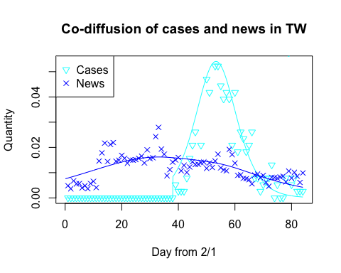

CN one way

Cases 2020/01/23 - 2020-03-09
Param. | Estimate | Std. | Error | t value | Pr(>|t|)
P | 0.004270 | 0.002451 | 1.742 | 0.0884 | . (因那一天的極端值)
Q | 0.203826 | 0.038377 | 5.311 | 3.24e-06 | ***

News 2020/01/05 - 2020-03-09
Param. | Estimate | Std. | Error | t value | Pr(>|t|)
P | 0.0012169 | 0.0001898 | 6.412 | 2.21e-08 | ***
Q | 0.1005110 | 0.0058224 | 17.263 | < 2e-16 | ***
c1 | -0.0347552 | 0.0038236 | -9.090 | 5.22e-13 | ***

Cases 拔掉極值(15136)則
Param. | Estimate | Std. | Error | t value | Pr(>|t|)
P | 0.007666 | 0.002089 | 3.669 | 0.000654 | ***
Q | 0.198893 | 0.022243 | 8.942 | 1.87e-11 | ***

News
Param. | Estimate | Std. | Error | t value | Pr(>|t|)
P | 0.0012978 | 0.0002043 | 6.351 | 2.81e-08 | ***
Q | 0.1007428 | 0.0060422 | 16.673 | < 2e-16 | ***
c1 | -0.0329952 | 0.0037591 | -8.778 | 1.79e-12 | ***
