**PROJECT REPORT**

# Employee Management System

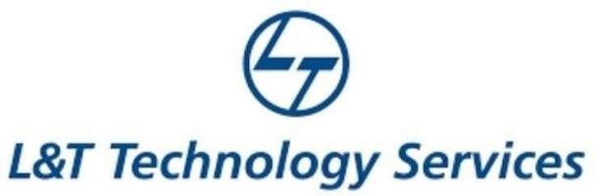

# NAME: - DivyaMadhuri.Tammineni

**TABLE OF CONTENTS**

|  |  |  |
| --- | --- | --- |
| **SERIAL No.** | **CONTENT** | **PAGE No.** |
| 1 | Introduction | 3 |
| 2 | Objective | 3 |
| 3 | Features | 3 |
| 4 | 4 W’s 1H | 4 |
| 5 | SWOT Analysis | 4 |
| 6 | Requirements | 6 |
| 7 | Architecture | 7 |
| 8 | Use case diagram | 8 |
| 9 | Expected results/Outcomes | 9 |

# Introduction

Employee Management system is an application that enables users to create and store Employee Records. The application also provides facilities of a payroll system which enables user to generate Pay slips too. This application is helpful to department of the organization which maintains data of employees related to an organization .

Java is a platform independent language. Its created applications can be used on a standalone machine as well as on distributed network. More over applications developed in java can be extended to Internet based applications.

Thus java was chosen as background to design this application.

# Objective:

In this world of growing technologies everything has been computerized. With large number of work opportunities the Human workforce has increased. Thus there is a need of a system which can handle the data of such a large number of Employees in an organization. This project simplifies the task of maintain records because of its user friendly nature.

# Benefits:

Foster Open Communication.

Constructive Feedback Is Easy.

Create A Smooth Onboarding Process.

Help Employees Develop Skills.

Improve Employee Engagement.

Less Paperwork.

Track Time And Attendance.

Better Employee-Manager Relationship.

# Features

## Saves Productive Time

Smooth Decision Making

Prompt and Accurate Payroll

Happy Workforce

Online Employee Management

Employee Self-Service Portal

# Who:

EMS helps to eliminate the manual process and saves a lot of time and money. This system maintains the professional and personal details of the employees and the company in a safe manner. The employee management system lowers the burden and the pressure on HRs and the business manager.

# What:

 provides with insights into their workforce, and helps them to better plan

and manage work hours to easily control labor costs

and increase productivity

# Where:

Employee management systems are useful for running a smooth organization, especially organizations of scale. It assists HR personnel to keep track of employee information such as salary details, medical information, attendance/leave records, overall performance and more.

# How:

An employee management system is a software, that helps your employees to give their best efforts every day to achieve the goals of your organization. It guides and manages employees efforts in the right direction. It also securely stores and manages personal and other work-related details for your employees.

# SWOT Analysis

**Strengths**

• Low salary/Benefits Overheads

• Quick to respond to changes

• Quick decision making

**Weakness**

• High existing work loads

• Non existent project planning

• Lack of expertise in some areas

**Opportunities**

• High demand for services offered - can increase market share

• There are new markets which require same services - can offer services to new markets

**Threats**

• Low levels of loyalty of contractor

• Larger competitors traditionally get larger market share

• High cost of technology investment



**Architecture:**

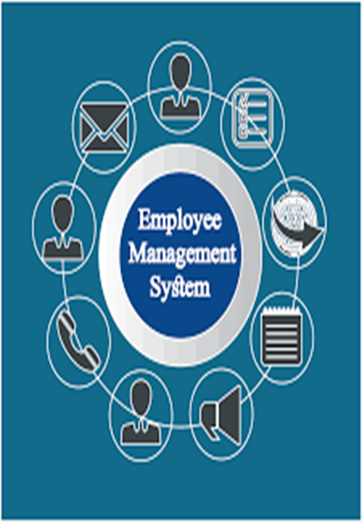

# Use Case Diagram

