*Mesh

1. profile/role/peripheral.c

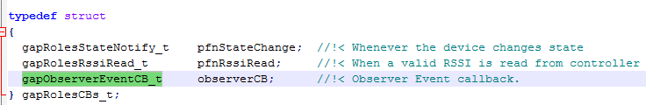

加入下列case 呼叫observer做事

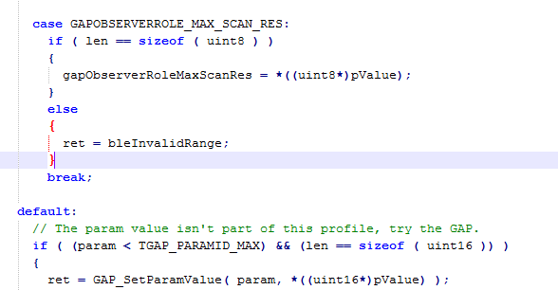

2. ble\SimpleBLEPeripheral_Jingho\CC2540DB\ buildConfig.cfg

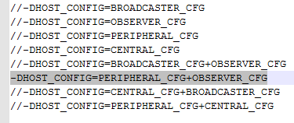

3.IAR

LIB加入ble\library\CC2540\bin\peri_observ

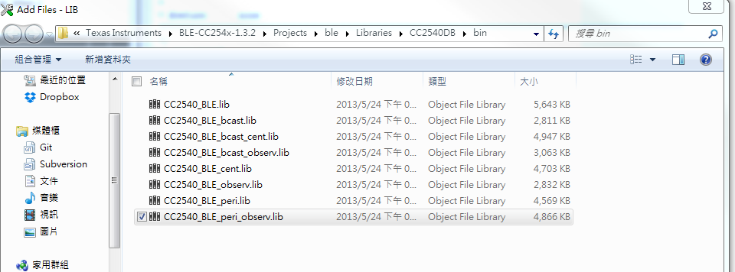

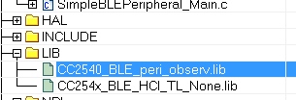

4.simple………..c



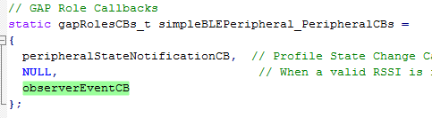

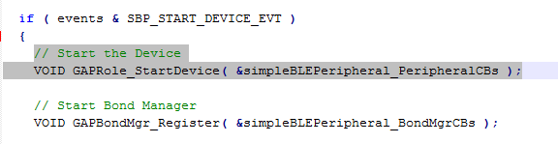

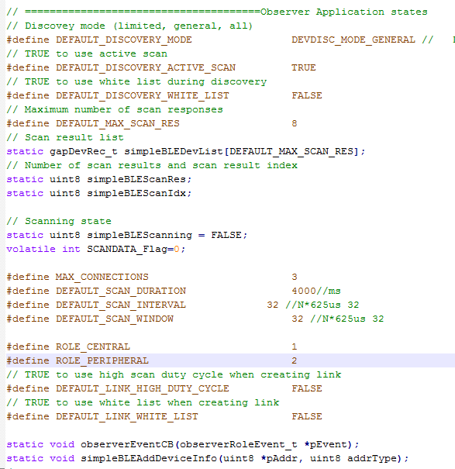

按左鍵開始廣播，會顯示搜尋到的裝置名稱

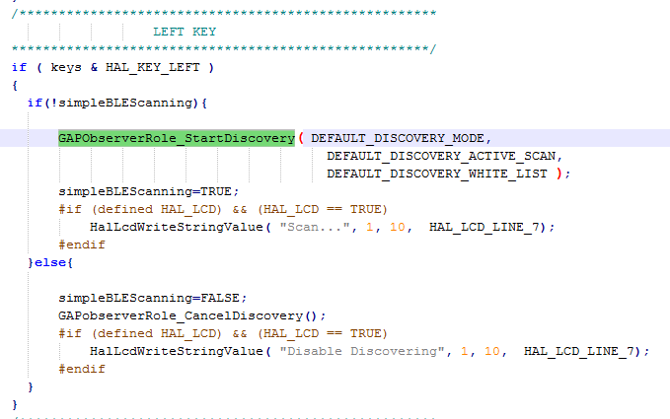

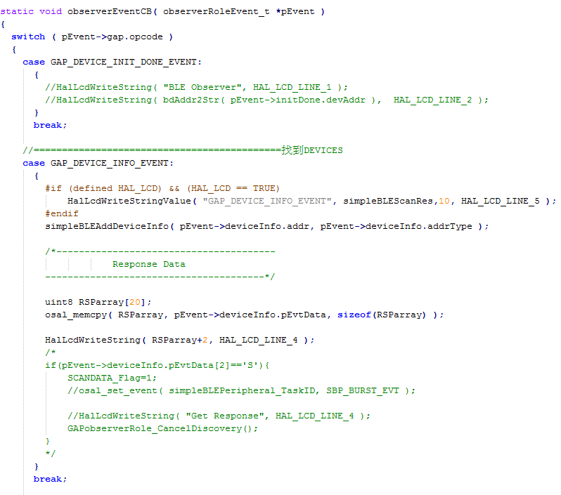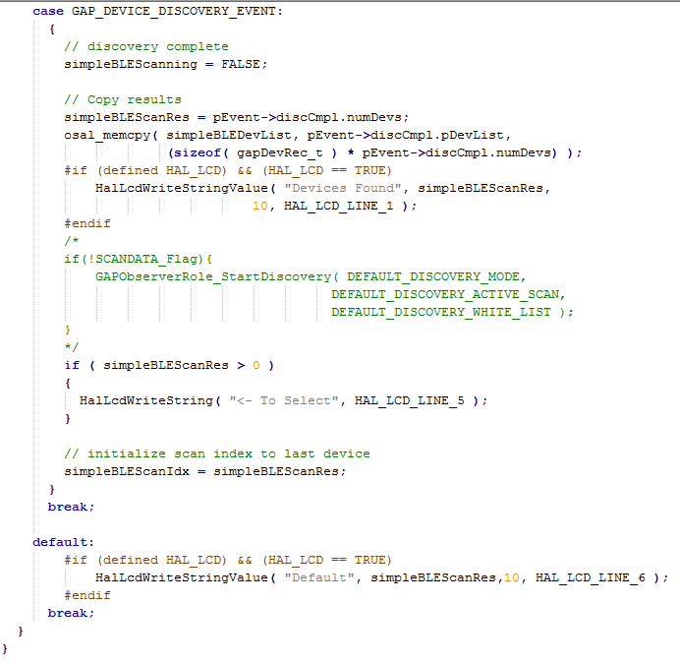

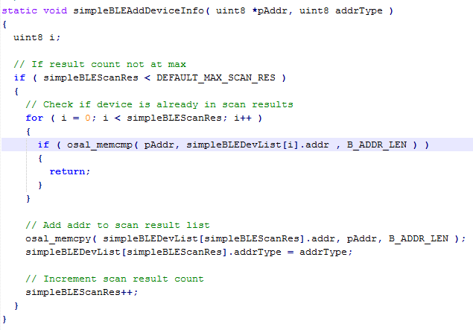

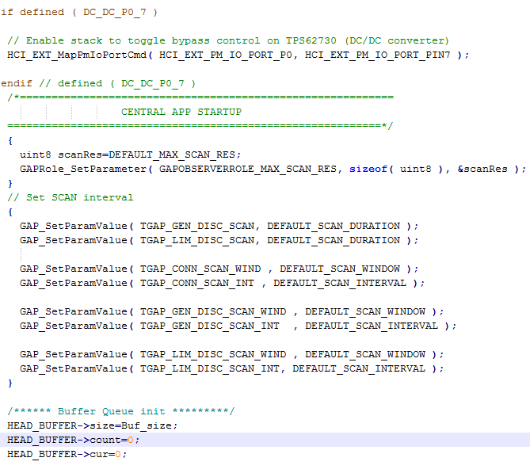

static uint8 scanRspData[] = 當被搜尋到，master會request slave，slave收到後會發送scanRspdata

static uint8 advertData[] = slave廣播會發送MAC