# Project

|  |  |
| --- | --- |
| **Goal** | Development of a battery-management-system, including the modelling of the environment to enable a hardware-in-the loop testing. |
| **Project manager** | Manuel du Bois |
| **Team** | Frederico Jose Dias Möller, Ingmar Molt, Manuel du Bois |

# Summary

## Rating of status

|  |  |  |  |  |  |  |  |
| --- | --- | --- | --- | --- | --- | --- | --- |
| **Subproject Name** | **Project – Leader** | **status** | | | | **progress** | **comments** |
| **time** | **budget** | **function** | **technology** |
| Communication-matrix |  | + | + | + | + | completed |  |
| Modelling the battery |  | + | + | + | + | Completed | Polynomial interpolation of OCV-Values implemented |
| Limit monitoring |  | + | + | + | + | completed |  |
| HIL_testbench |  | + | + | + | + | completed |  |

|  |  |  |
| --- | --- | --- |
| *Status* |  | *progress* |
| *+* | *Project status is like planned or better.* | *not started* |
| *0* | *Project status is a little bit worse than planned.* | *started* |
| *-* | *A significant deviation has been realized. Escalation is necessary* | *in work* |
|  |  | *in test or under review* |
|  |  | *completed* |

## Milestone Trend Analysis

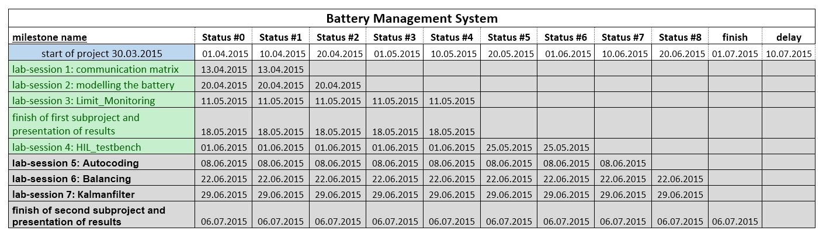

According to the project milestones, we could generate approximately one week of time-buffer. That has been taken into account for the recalculation of project milestones.

## Budget

*Not relevant*

# Progress

## Progress in the last term

In the last term, the program to run on the realtime pc has been prepared.

Thus the battery-model and CAN communication matrix have been integrated.

By the use of a graphical Interface the battery model can be handled to provide test-data for the future BMS.

Furthermore local variables and information received from the BMS are visualized.

When trying to generate executable code from the battery-model algebraic loop where detected, which inhibited the building process to proceed. We solved this problem by inserting “unit-delays” at the concerning positions.

The following steps were made, for evaluation:

* To check if CAN-communication is configured well and all Telegram IDs are connected and processed correctly, a Busmaster-USB-Dongle was used to Receive and Send data.
* The Transmission could be observed in the LabcarEE CAN Bus Monitor
* To check if the balancing of simulated cells is done correctly the corresponding Telegramm with

ID 0x221 is send, while battery-parameter are observed on the GUI

## Following steps

In the Following we are going to prepare the program, which will be executed on the BMS

(Signal-Processor-Board). Firstly we are going to implement the limit monitoring.

Then evaluation of the cooperation of both devices will be tested

## Current risks

Eventually it will be necessary to do some little changes in the RTPC program due to error-code handling.

This might consume a little extra time.

## Decisions

| Description | Responsible pers. | Due Date |
| --- | --- | --- |
|  |  |  |
|  |  |  |
|  |  |  |

# Other comments

Kiel, 01.06.15

The project leader