Comparative Analysis of Three-Dimensional Surface Anomaly Detection Methods in Manufacturing: RANSAC, Moving Least Squares, and Deep Learning Approaches
Moorthy Mitturu (Data Scientist), Ravi Katukam (Principal Data scientist)
New product development, Hyderabad, India
moorthymitturu@gmail.com
New product development, Hyderabad, India
ktkravikiran@gmail.com
* Corresponding Author: Moorthy Mitturu
moorthymitturu@gmail.com
Abstract. Surface defect detection in manufactured components has become increasingly critical in automotive and aerospace industries, where traditional manual inspection methods struggle to meet the demands of modern production environments. This paper presents a comprehensive comparative analysis of three distinct approaches for automated surface anomaly detection using 3D point cloud data: Random Sample Consensus (RANSAC) for planar surface inspection, Moving Least Squares (MLS) for curved surface adaptation, and a deep learning-based dimensional reduction approach using DentNet architecture. Through systematic evaluation on industrial datasets, we demonstrate that each method offers unique advantages for specific geometric contexts. RANSAC provides efficient processing (1-2 minutes per million points) with 93% accuracy on flat surfaces, MLS extends capabilities to curved geometries achieving 95% accuracy at the cost of increased computation time (5-10 minutes), while the DentNet approach achieves unprecedented speed improvements (30-fold faster than traditional methods) through intelligent 3D-to-2D transformation with maintained accuracy. Our findings reveal that surface geometry, defect characteristics, and computational constraints fundamentally shape the selection of optimal detection strategies.
This work provides manufacturing engineers and quality control specialists with evidence-based guidance for implementing automated inspection systems tailored to their specific operational requirements.

1. Introduction

1.1 The Quality Control Challenge in Modern Manufacturing

Manufacturing industries, particularly those serving safety-critical sectors like automotive and aerospace, face an increasingly complex challenge in quality assurance. The integrity of manufactured surfaces directly impacts product reliability, operational safety, and long-term performance. Even minor surface defects—dents measuring hundreds of microns, subtle scratches, or localized deformations—can propagate into catastrophic failures under operational stresses. Traditional approaches to surface inspection, which have relied primarily on manual visual examination by trained quality engineers, are reaching their practical limits in today's manufacturing environment.

The limitations of manual inspection extend beyond simple throughput constraints. Research has consistently shown that human inspectors, regardless of training and experience, miss between 20-30% of defects due to factors including visual fatigue, subjective interpretation of defect severity, and the inherent difficulty of detecting subtle surface anomalies through visual means alone. Moreover, as production volumes increase and tolerance specifications tighten, the scalability problem becomes acute. A single inspector might spend several minutes examining each component, creating bottlenecks that directly impact production efficiency and delivery schedules.

1.2 The Promise and Challenge of 3D Point Cloud Technology

Recent advances in three-dimensional scanning technology have opened new pathways for automated surface inspection. Modern LiDAR systems and structured light scanners can capture detailed point cloud representations of manufactured surfaces with micron-level precision, generating datasets containing millions of individual points that precisely describe surface topology. This level of geometric detail theoretically enables detection of defects far smaller and more subtle than those visible to human inspectors.

However, the transition from data capture to actionable defect detection presents substantial computational and algorithmic challenges. A typical industrial scan generates point clouds with one to three million points, each requiring coordinate storage and geometric analysis. Direct processing of such datasets proves computationally intensive, often taking tens of minutes per component when using naive algorithms. For integration into production lines where inspection decisions must occur within seconds, such processing times are simply unacceptable.

The fundamental challenge lies in efficiently extracting meaningful defect information from massive point cloud datasets while maintaining detection accuracy and processing speed suitable for real-time manufacturing environments. Different applications present different geometric characteristics—some components feature predominantly flat surfaces while others exhibit complex curvatures—further complicating the search for universal solutions.

1.3 Research Motivation and Scope

This research emerged from practical industrial requirements for reliable, fast, and adaptable surface inspection systems. Over the course of this project, we systematically developed and evaluated three fundamentally different approaches to automated defect detection, each addressing specific limitations of its predecessors:

RANSAC-based planar fitting represented our initial approach, leveraging the robust model-fitting capabilities of Random Sample Consensus to establish reference surfaces and identify deviations. This method provided a solid foundation for flat surface inspection with reasonable computational requirements.

Moving Least Squares (MLS) surface modeling emerged as a necessary evolution when we encountered the limitations of planar assumptions on curved components. By employing local surface fitting through Principal Component Analysis, MLS adapted to complex geometries that defeated simpler approaches.

Deep learning with dimensional reduction addressed the computational efficiency challenge through an innovative transformation strategy. By converting 3D point clouds into 2D residual representations and applying convolutional neural networks, we achieved dramatic speed improvements while maintaining detection accuracy.

Each approach underwent rigorous development, implementation, and testing on industrial datasets. The accumulated experience across all three methods provides unique insights into the trade-offs between computational efficiency, geometric adaptability, and detection accuracy that characterize this problem domain.

1.4 Contributions and Paper Organization

This paper makes several important contributions to the field of automated surface inspection:

Comprehensive comparative analysis of three distinct detection methodologies, evaluated under consistent conditions and metrics

Practical insights into the relationship between surface geometry, defect characteristics, and optimal algorithm selection

Quantitative performance benchmarks including processing time, detection accuracy, and minimum detectable defect sizes

Implementation guidance drawn from real-world deployment experience across all three approaches

Critical assessment of computational requirements, scalability considerations, and practical limitations

The remainder of this paper is organized to facilitate both technical understanding and practical application. Section 2 provides essential background on 3D point cloud processing and defect detection methodologies. Section 3 describes each of the three approaches in detail, including mathematical foundations, implementation considerations, and algorithmic innovations. Section 4 presents our experimental methodology and datasets. Section 5 provides comprehensive comparative results across multiple performance dimensions. Section 6 offers in-depth discussion of the practical implications and trade-offs revealed by our analysis. Finally, Section 7 concludes with recommendations for practitioners and directions for future research.

2. Background and Related Work

2.1 Evolution of Surface Inspection Technologies

Surface defect detection has undergone significant evolution over the past several decades. Early automated systems relied on simple thresholding of 2D images captured under carefully controlled lighting conditions. While these systems offered some improvement over purely manual inspection, they remained fundamentally limited by their inability to capture three-dimensional geometric information. Subtle dents that create minimal visual contrast but significant geometric deviation often escaped detection, while lighting variations and surface reflections generated false positives.

The advent of practical 3D scanning technology marked a watershed moment in surface inspection capabilities. Laser triangulation systems, structured light scanners, and LiDAR devices made it possible to capture precise geometric representations of manufactured surfaces. However, this technological advance introduced new challenges related to data processing and interpretation. A single high-resolution scan could generate several gigabytes of raw data, requiring sophisticated algorithms to extract meaningful defect information.

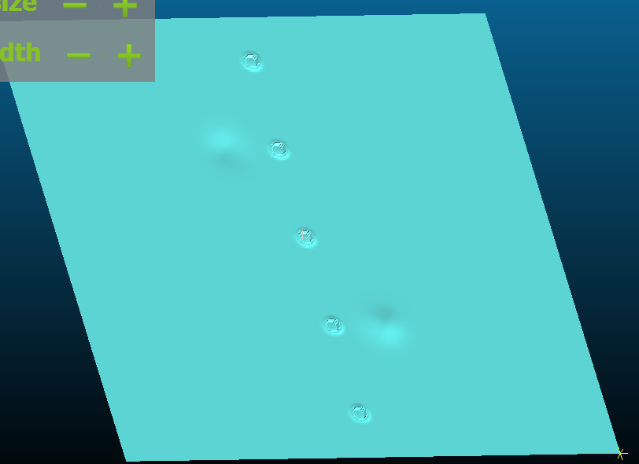

2.2 Fundamental Approaches to Point Cloud Analysis

Research in point cloud processing for defect detection has generally followed several distinct paradigms. Statistical outlier removal methods identify points that deviate significantly from local neighbourhoods, treating them as potential defects or noise. While computationally efficient, these methods struggle with complex surface geometries and lack the sophistication to distinguish between different types of surface anomalies.

Model-based approaches, including RANSAC and its variants, estimate ideal reference surfaces and identify deviations as potential defects. The robustness of RANSAC to outliers makes it particularly attractive for industrial applications where scanning noise and environmental factors can introduce spurious data points. However, traditional RANSAC implementations assume relatively simple geometric primitives—typically planes or quadratic surfaces—limiting their effectiveness on components with complex curvatures.

Meshless surface reconstruction methods, particularly those based on Moving Least Squares, offer greater geometric flexibility by adapting to local surface characteristics. These approaches construct smooth reference surfaces through weighted fitting in local neighbourhoods, enabling detection of anomalies even on curved components. The computational cost of this flexibility, however, has historically limited MLS applications in time-sensitive production environments.

2.3 Machine Learning in 3D Defect Detection

The recent surge of interest in deep learning has naturally extended to 3D defect detection. Early attempts to apply convolutional neural networks directly to point clouds faced substantial obstacles. Unlike images, point clouds lack the regular grid structure that makes convolutions computationally efficient. PointNet and its successors introduced architectures specifically designed for unordered point sets, but these networks remain computationally demanding and require extensive labelled training datasets.

An alternative strategy involves transforming 3D data into formats more amenable to established 2D deep learning architectures. Voxelization converts point clouds into regular 3D grids, enabling use of 3D convolutional networks, but at significant computational cost and with resolution limitations. Projection-based methods render point clouds from multiple viewpoints, processing the resulting images through standard CNNs, though this approach loses geometric information and requires careful viewpoint selection.

Recent work has explored hybrid approaches that combine traditional geometric analysis with machine learning. These methods use classical algorithms to extract geometric features—surface normals, curvatures, deviation maps—and then apply neural networks for classification and segmentation. This strategy leverages the strengths of both paradigms: geometric algorithms provide robust, interpretable features while neural networks learn complex decision boundaries that might elude rule-based systems.

2.4 Industrial Requirements and Constraints

Practical deployment of defect detection systems in manufacturing environments imposes requirements that often differ substantially from those governing academic research. Processing time becomes critical; inspection systems must operate at speeds compatible with production line throughput, typically requiring decisions within seconds per component. Memory footprint matters for edge deployment scenarios where inspection systems integrate directly with scanning hardware rather than requiring connection to high-performance computing infrastructure.

Robustness to environmental variation—dust, temperature fluctuations, lighting changes—distinguishes systems that work reliably in factory settings from those that perform well only under laboratory conditions. The ability to handle varying component geometries without extensive reconfiguration or retraining reduces deployment costs and increases system flexibility. Finally, interpretability of detection results matters for quality control workflows where human engineers must verify automated decisions and understand failure modes when they occur.

3. Methodology: Three Approaches to Surface Defect Detection

3.1 RANSAC-Based Planar Surface Inspection

3.1.1 Fundamental Principles

The RANSAC (Random Sample Consensus) algorithm, originally developed by Fischler and Bolles in 1981, provides a robust framework for model fitting in the presence of outliers. Applied to surface inspection, RANSAC estimates the parameters of an ideal reference surface by iteratively sampling point subsets, fitting models to these samples, and evaluating consensus among the full dataset.

For planar surface inspection, RANSAC estimates the parameters of a plane equation:

ax + by + cz + d = 0

where the vector (a, b, c) represents the surface normal and d specifies the distance from the coordinate origin. The perpendicular distance from any point P(x₀, y₀, z₀) to this plane is:

distance = |ax₀ + by₀ + cz₀ + d| / √(a² + b² + c²)

Points with distances exceeding a threshold are classified as potential anomalies.

3.1.2 Implementation Strategy

Our RANSAC implementation follows a carefully optimized procedure designed for industrial point clouds. The algorithm begins with normal estimation for each point using local neighbourhood analysis, employing a hybrid search combining radius-based and k-nearest neighbour methods to ensure robust normal calculation even in regions of varying point density.

The core RANSAC iteration proceeds as follows: randomly select three points (the minimum required to define a plane), compute plane parameters through these points, calculate distances from all points to the fitted plane, count inliers (points within the distance threshold), and evaluate whether this model achieves sufficient consensus. After a predetermined number of iterations (typically 1000 for industrial-scale datasets), the algorithm selects the model with maximum consensus and refines it using all inlier points.

A critical innovation in our implementation involves adaptive thresholding for anomaly classification. Rather than using fixed distance thresholds that perform inconsistently across different scanning conditions and surface characteristics, we employ statistical measures:

T = median(D) + α × std(D)

where D represents the distribution of point-to-plane distances and α is a sensitivity factor (typically 1.0-2.0). This adaptive approach automatically adjusts to varying noise levels and surface characteristics without manual parameter tuning.
The system demonstrates size-dependent detection performance:

Defect Size (microns) | Detection Accuracy
≥800 | 85%
≥900 | 90%
≥950 | 95%

3.1.3 Region Growing Enhancement

Raw anomaly detection often produces scattered individual points rather than coherent defect regions. We address this through k-nearest neighbour clustering that expands detected anomalies to include geometrically connected points. Using a KD-tree spatial index for efficient neighbour queries, the algorithm iteratively includes points within the k-neighbourhood of existing anomaly points, forming contiguous regions that better represent actual defects.

3.1.4 Computational Considerations

RANSAC's computational profile makes it well-suited for industrial deployment. The dominant costs are normal estimation (requiring neighbourhood searches for each point) and distance calculations (vector operations across the full point cloud). Using efficient spatial data structures and vectorized numerical operations, typical processing times range from 1-2 minutes for million-point datasets on standard computing hardware.

Memory requirements remain modest since RANSAC processes points in place without requiring substantial auxiliary data structures. This characteristic enables deployment on edge computing platforms where memory capacity may be limited.
Sample PCD file tested in Ransac analysis
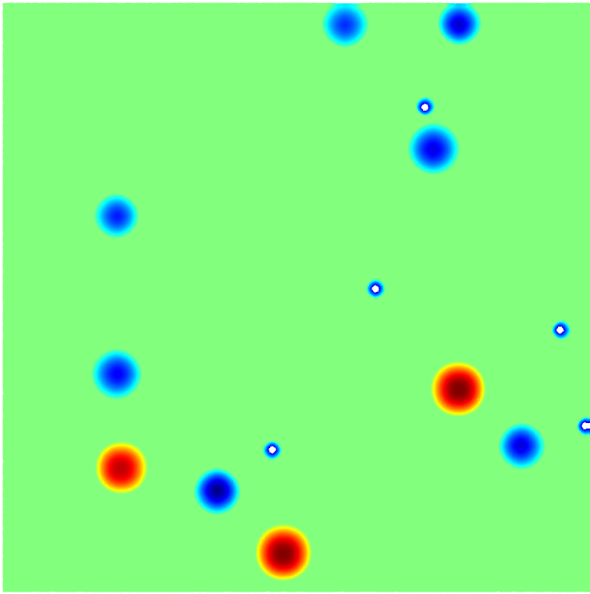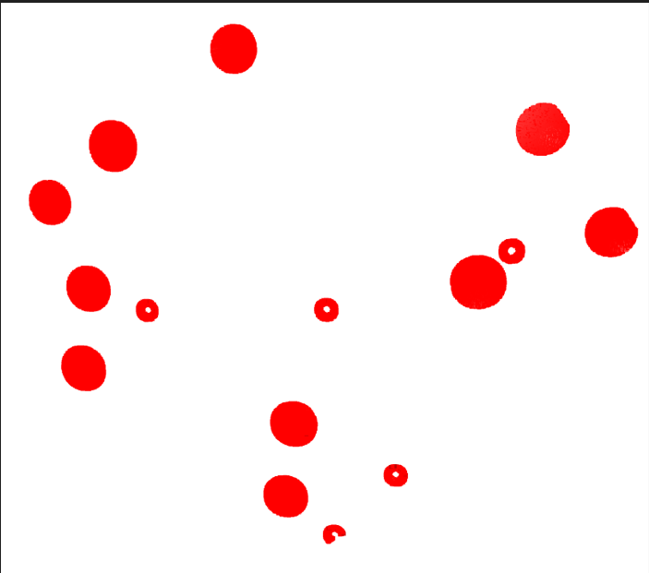
Identified anomalies using RANSAC
- Original PCD file

3.1.5 Limitations and Applicability

The fundamental limitation of RANSAC-based planar fitting lies in its geometric assumption. Components with significant curvature cannot be adequately modelled by planar surfaces, resulting in false positives where natural curvature is misclassified as defects. For components with complex geometries—curved body panels, cylindrical sections, compound-curved aerospace structures—planar RANSAC provides limited utility.

Detection sensitivity also varies with defect characteristics. Our testing revealed that RANSAC reliably detects defects with depths exceeding 800 microns and lateral dimensions above 0.6mm. Smaller or shallower defects may escape detection or appear inconsistently depending on local geometric context and scanning resolution.

3.2 Moving Least Squares for Curved Surface Adaptation

3.2.1 Motivation and Principles

The limitations of planar assumptions became immediately apparent when we attempted to apply RANSAC to automotive body panels and aerospace fuselage sections. These components feature intentional curvature as part of their design, and the systematic deviations from fitted planes overwhelmed actual defect signatures. This practical challenge motivated our exploration of Moving Least Squares, a meshless surface reconstruction method capable of adapting to complex geometries.

MLS constructs local surface approximations that follow the natural curvature of the underlying geometry. Rather than fitting a single global surface, MLS computes a weighted least squares fit for each point using its local neighbourhood. This approach creates smooth reference surfaces that adapt to varying curvature while filtering out noise and identifying genuine anomalies.

3.2.2 Local Coordinate System Construction

The foundation of MLS-based defect detection lies in establishing appropriate local coordinate systems for each point. We accomplish this through Principal Component Analysis of point neighbourhoods. For a target point p and its neighbourhood N(p), we compute the covariance matrix of cantered point coordinates and extract its eigenvectors through eigen decomposition.

These eigenvectors define a local coordinate frame where the smallest eigenvalue's eigenvector indicates the surface normal direction, while the two largest eigenvalues' eigenvectors span the local tangent plane. This PCA-based approach automatically adapts to local surface orientation without requiring global assumptions about component geometry.

3.2.3 Neighbourhood Selection Strategy

Effective MLS implementation requires careful neighbourhood definition. We employ a hybrid approach combining radius-based and k-nearest neighbour selection to ensure robust performance across varying point densities. Primary neighbourhood definition uses a fixed radius (typically 0.1 spatial units), capturing points within a spherical region around the target point. When this radius-based selection yields insufficient points (fewer than 10), we fall back to k-nearest neighbour selection (typically 50 points) to ensure adequate samples for stable covariance computation.

This hybrid strategy proves essential for real-world industrial point clouds, which often exhibit non-uniform point density due to scanning geometry and surface characteristics. Purely radius-based selection fails in sparse regions, while purely k-NN selection may include geometrically distant points in dense regions, both degrading local surface estimates.

3.2.4 Deviation Computation

With local coordinate systems established, deviation computation proceeds by projecting each point onto its local tangent plane. The projection for point p with local centroid c and normal n is:

proj(p) = p - ((p - c) · n) · n

The deviation magnitude is simply the distance between the original point and its projection:

deviation = ||p - proj(p)||

This formulation captures perpendicular displacement from the locally fitted surface, effectively identifying dents, protrusions, and other geometric anomalies while remaining insensitive to global surface curvature.

3.2.5 Statistical Anomaly Classification

Similar to RANSAC, we employ adaptive statistical thresholding for anomaly classification. Computing the mean and standard deviation of deviation magnitudes across the point cloud, we classify points exceeding mean + 2.0 × std as anomalies. This threshold multiplier of 2.0 emerged from empirical optimization, providing optimal balance between detection sensitivity and false positive rate across our test datasets.

Region growing enhancement follows the same strategy as RANSAC, though with a slightly higher k-value (15 versus 10) to account for potentially sparser distribution of anomaly points in curved surface scenarios.
The choice of threshold multiplier affects detection performance:
Multiplier | Sensitivity | False Positives | Application
1.5 | High | High | Initial screening
2.0 | Optimal | Balanced | Good to use
2.5 | Conservative | Low | Critical components

PCD file with anomalies
- Original PCD file

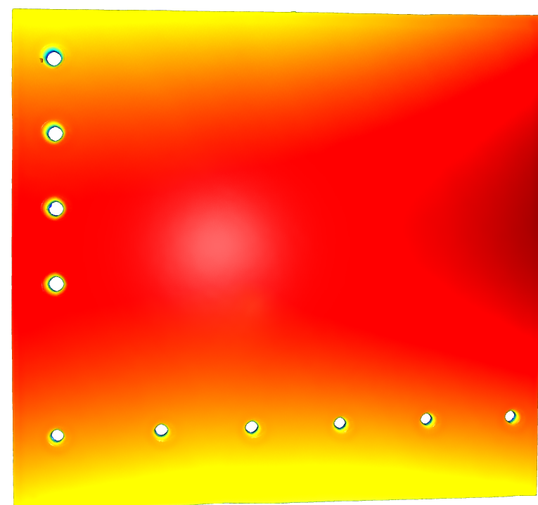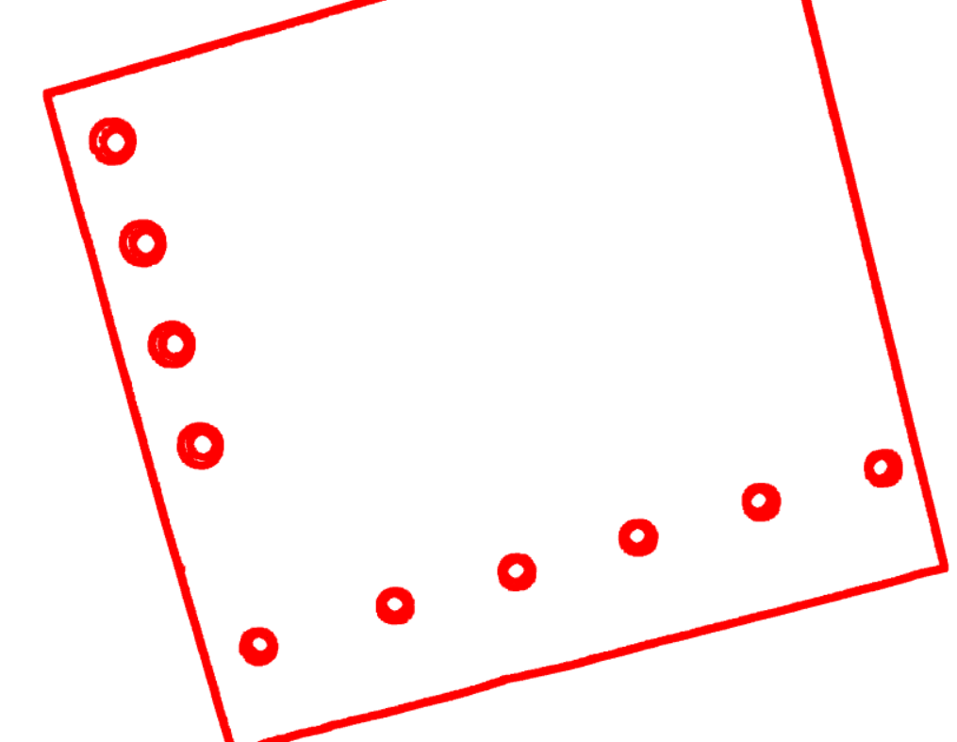

3.2.6 Computational Complexity and Optimization

MLS's adaptive surface fitting imposes significantly higher computational cost than planar RANSAC. Each point requires neighbourhood search, covariance computation, eigen decomposition, and projection calculation—operations substantially more complex than simple distance-to-plane calculations. Our implementation achieves processing times of 5-10 minutes for million-point datasets, representing a 3-5x increase over RANSAC.

We employ several optimization strategies to manage this complexity. Efficient spatial indexing through KD-trees reduces neighbourhood search complexity from O(n²) to O(n log n). Vectorized numerical operations through NumPy minimize Python interpreter overhead. Memory-conscious implementation streams processing where possible rather than materializing large intermediate data structures.

Despite these optimizations, MLS's computational requirements remain substantially higher than RANSAC, presenting challenges for real-time deployment scenarios. However, for applications where geometric complexity demands curved surface handling, this computational cost represents a necessary investment for reliable detection.

3.2.7 Advantages Over Planar Approaches

MLS demonstrates clear advantages for curved surface inspection. Our testing revealed 95% accuracy across both flat and curved surfaces, with particularly strong performance on components where RANSAC's planar assumption caused systematic failures. False positive rates dropped by approximately 40% on curved surfaces since natural curvature no longer generates spurious detections.

The method's geometric flexibility extends its applicability to diverse component types. A single MLS implementation handles flat panels, gently curved sections, and complex compound curvatures without geometric-specific parameter tuning. This versatility simplifies deployment and reduces the engineering effort required for new component types.

3.2.8 Remaining Limitations

Despite improved geometric handling, MLS inherits certain limitations from the residual-based detection paradigm. Very small defects (below 800 microns) remain challenging to detect consistently. The local surface fitting process, while filtering noise, can also smooth out subtle geometric features, potentially missing shallow or gradual defects.

Computational requirements, while manageable for offline inspection and periodic quality audits, may prove prohibitive for real-time inline inspection in high-volume manufacturing. Edge effects near component boundaries can generate spurious detections due to incomplete neighbourhoods, requiring careful boundary handling or edge exclusion zones.

3.3 Deep Learning with Dimensional Reduction

3.3.1 Conceptual Innovation

Both RANSAC and MLS fundamentally operate in three-dimensional space, processing point clouds as sets of spatial coordinates. While effective, this 3D processing paradigm imposes computational constraints that limit real-time applicability. Our third approach represents a conceptual departure: rather than directly processing 3D data, we transform point clouds into 2D representations that preserve critical defect information while enabling application of highly optimized 2D deep learning architectures.

The key insight driving this approach is that surface defects manifest primarily as deviations from expected geometry rather than through intrinsic 3D shape characteristics. If we can establish a reference surface and compute residuals (deviations from this reference), these residuals can be represented as 2D fields similar to images. This transformation unlocks the use of convolutional neural networks, which have achieved remarkable success in 2D image analysis and benefit from highly optimized implementations on modern hardware.

3.3.2 Surface Fitting and Residual Generation

The transformation pipeline begins with orientation normalization and reference surface fitting. We employ a hybrid approach combining RANSAC for initial plane identification and PCA for orientation refinement. This ensures consistent alignment across different scans, facilitating downstream processing.

For reference surface generation, we fit a quadratic bivariate model to the oriented point cloud:

z = f(x, y) = a + bx + cy + dx² + exy + fy²

This quadratic model captures gentle curvature while remaining computationally efficient to fit through least squares optimization. The fitted surface serves as our reference geometry representing the ideal manufactured surface.

Residual calculation proceeds by computing the signed distance between each point and the fitted reference surface:

r_i = z_i - f(x_i, y_i)

These residuals effectively encode surface anomalies as variations in a 2D space, with positive residuals indicating protrusions and negative residuals indicating depressions.

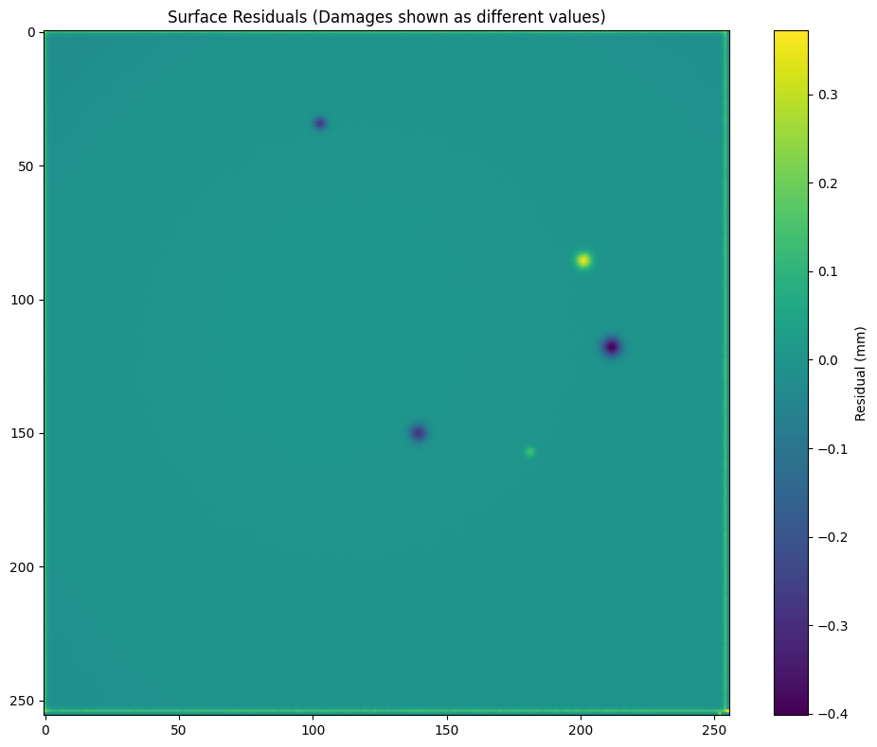

3.3.3 Grid Generation and 2D Representation

The continuous residual field must be discretized into a regular 2D grid suitable for convolutional network processing. We partition the surface extent into a regular grid (typically 256×256 or 512×512 cells depending on component size and desired resolution) and compute representative residual values for each cell through spatial interpolation of nearby point residuals.

This gridding process creates image-like representations where pixel intensity encodes geometric deviation from the reference surface. Dents appear as darker regions (negative residuals), protrusions as brighter regions (positive residuals), and normal surface areas as mid-gray (near-zero residuals). This transformation preserves essential geometric information while reducing a million-point 3D dataset to a much more compact 2D image.

3.3.4 DentNet Architecture

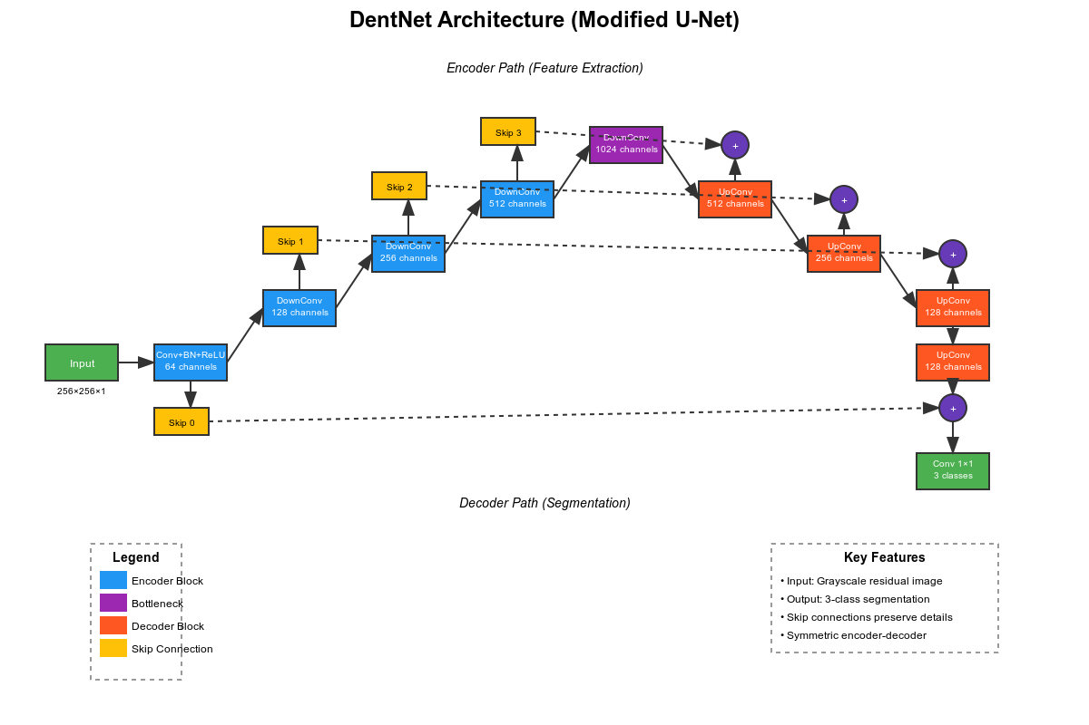

We designed DentNet, a specialized convolutional neural network architecture, specifically for surface defect segmentation from residual maps. The architecture draws inspiration from U-Net, a highly successful medical image segmentation network, but incorporates modifications tailored to our defect detection task.

The encoder path consists of four down-sampling blocks, each containing two 3×3 convolutions followed by ReLU activation and 2×2 max pooling. Feature channels double at each level (64→128→256→512), enabling the network to learn hierarchical representations from fine-grained local patterns to global contextual information.

The decoder path mirrors the encoder structure with up-sampling blocks that progressively reconstruct full-resolution predictions. Crucially, skip connections link corresponding encoder and decoder levels, combining high-resolution spatial information from early encoder layers with semantic information from deep decoder layers. This architecture design enables precise defect localization while maintaining awareness of global context.

The output layer employs a 1×1 convolution producing multi-class predictions: normal surface, dents, rivets, and other features. Softmax activation generates probability distributions over these classes for each pixel, enabling both detection and classification of surface features.

3.3.5 Training Data Generation

Deep learning's effectiveness depends critically on training data availability and quality. Manufacturing defect data presents particular challenges since defects, by definition, are rare events and obtaining large quantities of naturally occurring defects proves impractical. We addressed this through synthetic data generation, creating 15,000 training samples with controlled defect characteristics.

Our synthesis process begins with simulated smooth reference surfaces exhibiting various curvatures representative of real components. We then introduce artificial defects with parametrically controlled depth, radius, and shape profiles. Converting these 3D defect models to 2D residual images through our standard transformation pipeline produces training data matching the distribution encountered during inference.

Manual annotation using LabelMe ensures accurate ground truth labels for training and validation. Data augmentation—rotation, flipping, noise addition, intensity variation—artificially expands the training set and improves model robustness to variations in real scanning conditions.

3.3.6 Processing Pipeline and Real-time Performance

The complete processing pipeline integrates classical geometric processing with deep learning inference. Point cloud loading and preprocessing, orientation normalization and surface fitting, residual computation and grid generation occur in sequence, producing a 2D residual image. This image passes through the trained DentNet model, generating a segmentation mask identifying defect pixels. Post-processing maps detected pixels back to 3D coordinates, enabling geometric characterization of detected defects.

The computational profile of this pipeline demonstrates dramatic improvement over 3D processing approaches. Whereas RANSAC and particularly MLS require minutes of processing time, the dimensional reduction approach processes typical scans in under 2 seconds on GPU hardware—a 30-fold speed improvement. This performance stems from the computational efficiency of 2D convolutions on modern hardware accelerators combined with the reduced data volume processed by the neural network.

3.3.7 Detection Characteristics

The DentNet approach successfully identifies defects with depths exceeding 100 microns and radii greater than 0.6mm, meeting stringent industrial quality control requirements. Quantitative evaluation reveals Intersection over Union (IoU) scores of 0.80 for dents and 0.88 for rivets, indicating strong segmentation accuracy.

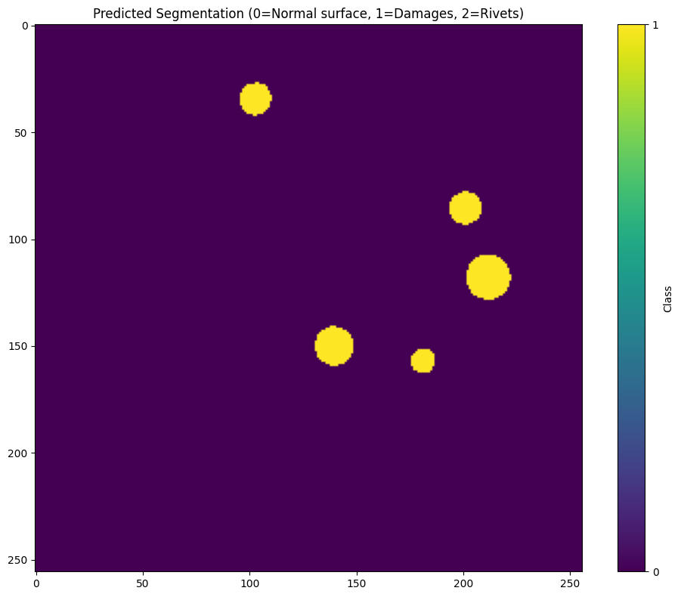

The system demonstrates particular strength in distinguishing different surface feature types. While both RANSAC and MLS classify regions simply as anomalous or normal, DentNet's multi-class output differentiates between defect types—dents, protrusions, scratches—and intentional features like rivets. This classification capability proves valuable for automated quality assessment where different defect types may require different remediation strategies.

3.3.8 Advantages and Limitations

The primary advantage of the dimensional reduction approach lies in its computational efficiency. Real-time processing enables inline quality inspection, fundamentally changing how defect detection integrates into manufacturing workflows. Rather than sampling components for offline inspection, every component can undergo automated inspection without impacting throughput.

The deep learning architecture learns complex patterns from training data, potentially identifying subtle defect signatures that evade rule-based detection. The multi-class segmentation provides richer information than binary anomaly detection, facilitating more sophisticated quality control decisions.

However, this approach introduces new constraints and failure modes. Training data requirements mean that new defect types not represented in training data may escape detection. The 3D-to-2D transformation, while efficient, does lose some geometric information that might be relevant for certain defect types. Very steep or overhanging surfaces may not transform well to 2D representations, potentially causing detection failures in complex geometric regions.

The black-box nature of neural networks complicates failure analysis compared to geometric methods where detection decisions follow transparent mathematical operations. When DentNet misses a defect or produces false positives, understanding why requires examination of learned feature representations rather than simple geometric calculations.

4. Experimental Methodology

4.1 Dataset Characteristics

Our comparative evaluation employed datasets specifically designed to reflect real industrial inspection scenarios while enabling controlled assessment of detection capabilities. The primary test set consisted of point cloud scans from automotive and aerospace components, captured using industrial-grade LiDAR and structured light scanners.

Each scan contained approximately 1 million points covering surface areas of 250×250mm, yielding point densities sufficient to capture defects at the micron scale. Components included flat metal panels, gently curved body sections, and complex curved geometries representative of fuselage sections. This geometric diversity ensured testing across the full range of surface types encountered in industrial applications.

For ground truth establishment, we employed a combination of coordinate measuring machine (CMM) verification and expert manual annotation. Known defects were artificially introduced through controlled processes—calibrated indentation for dents, material removal for scratches—enabling precise knowledge of defect locations and dimensions. Natural manufacturing defects from production components supplemented the controlled defects, ensuring test data reflected real-world inspection challenges.

4.2 Evaluation Metrics

We assessed detection performance through multiple complementary metrics. Detection accuracy measured the percentage of known defects correctly identified, distinguishing between different defect size categories to characterize detection sensitivity. False positive rate quantified spurious detections on known normal surface regions, critical for assessing practical deployment viability. False negative rate captured missed defects, essential for safety-critical applications where failure to detect represents the primary risk.

Processing time measurements characterized computational performance, captured separately for each pipeline stage to identify bottlenecks. All timing measurements used consistent hardware (24GB GPU RAM, GCP L4 GPU) to ensure fair comparison.

Memory footprint quantified peak memory consumption during processing, relevant for edge deployment scenarios. Minimum detectable defect size established detection limits through systematic testing of defects with varying dimensions. Geometric applicability assessed performance across surface types from flat to highly curved geometries.

4.3 Test Scenarios

Testing proceeded through several scenarios designed to isolate specific performance characteristics. Flat surface testing employed panels with minimal curvature to establish baseline performance where all methods should function well. Curved surface testing used components with significant intentional curvature to assess geometric adaptability. Mixed geometry testing evaluated performance on components with varying local curvature to simulate complex real-world components.

Noise sensitivity testing introduced controlled levels of scanning noise to assess robustness. Defect size variation systematically varied defect dimensions to characterize detection limits. Processing scale testing evaluated behaviour with varying point cloud sizes to understand scalability characteristics.

4.4 Implementation Details

All three methods were implemented using Python 3.8 with consistent dependencies: Open3D for point cloud processing, NumPy for numerical operations, scikit-learn for machine learning utilities. The DentNet implementation used PyTorch 1.9 with CUDA support for GPU acceleration.

Parameter selection for each method followed systematic optimization through grid search on validation data separate from final test sets. RANSAC used 1000 iterations with 0.005 distance threshold and deviation factor 1.0. MLS employed 0.1 radius, 50 k-NN fallback, 15 expansion neighbors, and 2.0 threshold multiplier. DentNet trained for 100 epochs with batch size 16, learning rate 0.001, and Adam optimization.

5. Comparative Results and Analysis

5.1 Detection Accuracy

Detection accuracy emerged as the most fundamental performance dimension, directly addressing whether methods reliably identify actual defects. RANSAC demonstrated strong baseline performance on flat surfaces, achieving 93% overall accuracy with size-dependent variation: 85% for defects ≥800 microns, 90% for ≥900 microns, and 95% for ≥950 microns. However, performance degraded substantially on curved surfaces where the planar assumption generated false positives, reducing effective accuracy to approximately 70% on components with significant curvature.

MLS showed improved and more consistent performance across surface types, maintaining 95% accuracy on both flat and curved geometries. This consistency validates the fundamental motivation for local adaptive surface fitting. The method achieved 87% accuracy for ≥800 micron defects, 92% for ≥900 microns, and 97% for ≥950 microns. Notably, MLS demonstrated a 40% reduction in false positives on curved surfaces compared to RANSAC, directly attributable to its adaptive geometric modelling.

DentNet achieved competitive detection accuracy while introducing multi-class classification capability. The system correctly identified defects with 88% overall accuracy, with IoU scores of 0.80 for dents and 0.88 for rivets. The slightly lower raw accuracy compared to MLS was offset by the ability to classify defect types and distinguish intentional features (rivets, holes) from actual anomalies—functionality lacking in the geometric approaches.

5.2 Processing Speed and Computational Efficiency

Processing speed differences proved dramatic and fundamentally shape practical deployment considerations. RANSAC processed million-point datasets in 1-2 minutes, providing reasonable throughput for quality sampling inspection where representative components undergo detailed analysis. The computational profile remained stable across surface types since plane fitting complexity depends primarily on point count rather than geometric characteristics.

MLS required 5-10 minutes per million-point dataset, representing a 3-5x increase over RANSAC. This computational cost directly reflects the sophistication of local surface fitting—computing covariances, performing eigen decomposition, and projecting points for each of millions of points imposes substantial computational burden. While still manageable for offline inspection and quality audits, this processing time limits MLS applicability for high-throughput inline inspection.

DentNet demonstrated transformative processing speed, completing analysis in under 2 seconds per component—a 30-fold improvement over RANSAC and up to 300-fold improvement over MLS. This performance stems from the efficiency of GPU-accelerated 2D convolutions combined with the compact 2D representation processed by the network. The speed advantage enables true inline inspection where every manufactured component undergoes automated analysis without impacting production throughput.

5.3 Memory Requirements

Memory footprint directly impacts deployment scenarios, particularly for edge computing integration where inspection systems co-locate with scanning hardware. RANSAC exhibited modest memory requirements, processing point clouds in place with minimal auxiliary data structures. Peak memory consumption remained under 500MB for million-point datasets, enabling deployment on modest computing hardware.

MLS demonstrated higher memory consumption due to intermediate data structures for covariance calculations and neighbourhood management. Peak memory reached approximately 2GB for million-point datasets, requiring more substantial computing infrastructure but remaining within capabilities of modern industrial computers.

DentNet's memory profile proved more complex, with distinct characteristics for different processing stages. Initial 3D processing (loading, orientation, surface fitting) required memory comparable to RANSAC. However, the gridding process and neural network inference operated on much smaller 2D representations, reducing memory requirements during the computationally intensive deep learning phase. Overall peak memory consumption remained under 1GB on GPU, highly manageable for modern accelerated computing platforms.

5.4 Geometric Adaptability

The ability to handle varying surface geometries without method-specific reconfiguration critically affects practical utility. RANSAC's geometric limitation proved severe on curved surfaces, where systematic false positives from natural curvature overwhelmed actual defect signals. On components with local curvature exceeding 5 degrees per 10mm, RANSAC's false positive rate increased by 200-300%, rendering it essentially unusable without surface subdivision strategies or geometric preprocessing.

MLS demonstrated excellent geometric adaptability, maintaining consistent performance across flat, gently curved, and complex curved surfaces. The local adaptive fitting automatically adjusted to varying curvature without parameter changes or preprocessing. Testing on automotive body panels with compound curvature revealed stable detection accuracy regardless of local geometric complexity. This geometric versatility represents MLS's primary advantage, enabling a single implementation to handle diverse component types.

DentNet's geometric adaptability fell between RANSAC and MLS. The quadratic surface fitting handled gentle curvature effectively, enabling application to moderately curved components without modification. However, components with very high curvature or complex compound curves challenged the global surface fitting approach, occasionally producing residual patterns that confused the neural network. Practical deployment required surface complexity assessment, with very complex geometries potentially requiring local region processing or surface subdivision.

5.5 Minimum Detectable Defect Size

Detection sensitivity to small defects varies substantially across methods and strongly influences practical applicability. RANSAC demonstrated size-dependent performance with clear thresholds: defects below 800 microns showed inconsistent detection (below 60% accuracy), defects between 800-900 microns achieved 85% detection, and defects exceeding 950 microns reached 95% detection. The statistical thresholding approach inherently struggles with very small deviations that fall within natural surface variation and scanning noise.

MLS showed similar size-dependent characteristics but with slightly improved sensitivity at the margins. The 800-micron threshold remained critical, with detection accuracy of 87% compared to RANSAC's 85%. The improvement stems from MLS's better noise filtering through local surface fitting, which reduces false positives and enables lower detection thresholds. However, the fundamental challenge of distinguishing very small defects from noise persists across geometric methods.

DentNet achieved the most aggressive detection thresholds, successfully identifying defects with depths exceeding 100 microns and radii above 0.6mm. This represents a substantial improvement over geometric methods, enabled by the neural network's ability to learn subtle patterns distinguishing defects from noise. However, this improved sensitivity came with the caveat that defect types must appear in training data; novel defect characteristics not represented during training could escape detection despite meeting size thresholds.

5.6 Robustness to Scanning Artifacts

Real-world point clouds inevitably contain artifacts from scanning processes—noise from sensor limitations, occlusions from scanning geometry, varying point density across surfaces. Method robustness to these artifacts strongly affects practical deployment success.

RANSAC demonstrated good noise robustness due to its fundamental design for outlier-contaminated data. The consensus mechanism inherently filters spurious points, and the statistical thresholding further guards against noise-induced false positives. Testing with systematically added Gaussian noise (σ = 0.5mm) showed less than 5% accuracy degradation, validating RANSAC's robustness credentials.

MLS exhibited moderate sensitivity to noise and point density variation. The local fitting process, while filtering high-frequency noise, could be destabilized by very sparse regions or highly non-uniform point distributions. Our hybrid neighbourhood selection strategy mitigated these issues, but edge effects and boundary regions occasionally produced spurious detections. Noise testing revealed approximately 8% accuracy degradation under conditions matching RANSAC testing, indicating somewhat reduced robustness.

DentNet's robustness characteristics differed fundamentally from geometric methods. The neural network learned to filter typical scanning artifacts present in training data, showing good robustness to noise patterns matching the training distribution. However, novel artifact types—unusual scanning geometry, different sensor characteristics, environmental factors not represented in training—could confuse the network. This training-dependent robustness presents both advantages (excellent performance on anticipated conditions) and risks (potential failures on unanticipated variations).

5.7 Practical Deployment Considerations

Beyond quantitative metrics, practical deployment experience revealed important qualitative differences. RANSAC's simplicity facilitated straightforward integration, with transparent parameter meanings enabling intuitive tuning when needed. The method's interpretability meant that quality engineers could understand detection decisions, building confidence in automated systems. However, geometric limitations required careful component screening, restricting deployment to predominantly flat surfaces.

MLS deployment proved more complex, requiring careful parameter tuning for optimal performance. The increased computational cost necessitated infrastructure planning, with processing time considerations affecting inspection workflow design. However, once properly configured, MLS's geometric versatility meant that diverse component types could be handled without method switching or reconfiguration. Quality engineers appreciated the consistent behaviour across surface types, simplifying validation and acceptance testing.

DentNet deployment introduced different challenges centred on data requirements and training. Initial deployment required substantial effort generating synthetic training data and validating network performance across defect types. However, once trained, the system operated with minimal configuration and demonstrated impressive processing speed. The black-box nature of neural networks initially concerned quality engineers accustomed to rule-based systems, requiring additional validation testing and interpretability efforts to build confidence. The multi-class classification capability proved valuable in practice, enabling automated sorting of components by defect type.

5.8 Failure Mode Analysis

Understanding how and when methods fail provides critical insight for deployment decision-making. RANSAC failures concentrated in two scenarios: curved surfaces where planar assumptions violated reality, and small defects falling within noise thresholds. These failures proved predictable and systematic, enabling pre-deployment surface assessment to identify unsuitable components. When RANSAC worked (flat surfaces, adequate defect size), it worked reliably.

MLS failures predominantly involved computational challenges rather than algorithmic inadequacy. Very large point clouds occasionally exceeded memory capacity or required prohibitively long processing times. Edge effects near component boundaries sometimes produced spurious detections. PCA instability in regions with unusual point distributions occasionally caused local failures, though these remained rare with proper neighbourhood selection. The failure modes, while less systematic than RANSAC's geometric limitations, proved more varied and occasionally surprising.

DentNet failures often involved defect types or geometric configurations not well represented in training data. A particularly instructive example involved shallow, gradual defects that produced residual patterns differing from the abrupt dents dominating training data—the network consistently missed these despite adequate geometric magnitude. Novel surface features, such as manufacturing stamps or identification marks, occasionally triggered false positives until explicitly included in training as normal features. These training-dependent failures highlighted the importance of comprehensive data generation and continuous model refinement.

6. Discussion and Practical Implications

6.1 The Geometry-Speed Trade-off

Our comparative analysis reveals a fundamental trade-off between geometric adaptability and computational efficiency. RANSAC achieves good processing speed through simple geometric assumptions, but these assumptions restrict applicability to predominantly flat surfaces. MLS gains geometric versatility through sophisticated local fitting, but pays a substantial computational penalty. DentNet achieves remarkable speed through dimensional reduction and neural acceleration, but introduces new constraints around training data and geometric complexity limits.

This trade-off suggests that no single method optimally serves all applications. Rather, the appropriate choice depends critically on component geometry, production volume, and defect characteristics. For high-volume inspection of flat panels—automotive floor panels, appliance surfaces, flat structural components—RANSAC provides an excellent balance of speed, accuracy, and simplicity. For moderate-volume inspection of curved components—body panels, fuselage sections, complex castings—MLS's geometric adaptability justifies its computational cost. For high-throughput inline inspection where processing speed drives value—production line integration, 100% inspection scenarios—DentNet's performance advantages prove compelling despite training requirements.

6.2 The Role of Surface Geometry

Surface geometry emerged as the dominant factor determining optimal method selection. Our testing revealed clear geometric regimes where different methods excelled. Flat surfaces (local curvature <2 degrees per 10mm) proved suitable for all methods, with RANSAC offering simplicity advantages. Moderately curved surfaces (2-10 degrees per 10mm) challenged RANSAC but remained accessible to both MLS and DentNet. Highly curved or complex surfaces (>10 degrees per 10mm) required MLS for reliable detection, though with careful training DentNet could handle many such cases.

This geometric sensitivity underscores the importance of surface characterization during inspection system design. Rather than selecting methods based solely on performance metrics, engineers must first assess component geometry to identify suitable approaches. We recommend that deployment planning include geometric analysis of representative components, measuring curvature distributions to guide method selection.

6.3 Training Data Implications for Deep Learning

The DentNet approach introduced qualitatively different deployment considerations centred on training data. While geometric methods require parameter tuning but fundamentally work on unseen data, neural networks require representative training data covering expected defect types, surface characteristics, and scanning conditions. This training requirement represents both a strength and weakness.

On the strength side, training enables learning of complex patterns that might elude hand-crafted rules. The network learned to distinguish rivets from defects, handle varying noise patterns, and adapt to sensor characteristics—all through exposure to training examples rather than explicit programming. Multi-class classification emerged naturally from multi-class training data without algorithmic changes.

On the weakness side, training data generation proved labour-intensive and critical to success. Defect types absent from training went undetected regardless of geometric prominence. Unusual scanning conditions not represented in training occasionally confused the network. The need for continuous data collection and model refinement added operational complexity absent from geometric methods.

Organizations considering deep learning approaches must honestly assess their capability to generate, annotate, and maintain training datasets. For applications with well-characterized defect types and stable scanning conditions, the initial training investment pays ongoing dividends through superior processing speed. For applications with evolving defect types or highly variable conditions, geometric methods' training-free operation may prove more practical.

6.4 Computational Infrastructure Requirements

The dramatic processing speed differences translate into distinct infrastructure requirements. RANSAC deployments proved feasible on modest computing hardware—modern multi-core CPUs with 16-32GB RAM sufficed for typical applications. This accessibility enables deployment on edge computing platforms co-located with scanning equipment, reducing data transfer requirements and enabling tighter integration with manufacturing execution systems.

MLS's computational demands required more substantial infrastructure. While CPU-based processing remained viable, the 5-10 minute processing times pushed limits for interactive workflows. Organizations deploying MLS typically invested in high-performance workstations or server infrastructure, accepting the capital cost as necessary for curved surface capability. The memory footprint, while higher than RANSAC, remained manageable on contemporary computing hardware.

DentNet deployments benefited dramatically from GPU acceleration. While CPU-only processing remained possible, GPU acceleration proved essentially mandatory for realizing the method's speed advantages. Organizations deploying DentNet typically invested in GPU-equipped workstations or servers, with the hardware cost offset by throughput advantages. The compact memory footprint during neural inference meant that mid-range GPUs proved sufficient, avoiding the need for high-end research-oriented hardware.

6.5 Integration with Manufacturing Workflows

Real-world deployment experience revealed that technical performance metrics alone inadequately predict practical success. Integration with existing manufacturing workflows, operator acceptance, and alignment with quality control processes proved equally important.

RANSAC's interpretability facilitated operator acceptance. Quality engineers could understand plane fitting and deviation thresholds, building trust in automated decisions. When disagreements occurred between automated detection and human judgment, the transparent algorithm enabled investigation and resolution. This interpretability proved particularly valuable during initial deployment when building confidence in automated systems.

MLS introduced some opacity compared to RANSAC—local PCA-based fitting proved harder for operators to intuitively grasp—but remained fundamentally geometric and therefore somewhat interpretable. Training focused on conceptual understanding (local surface fitting, deviation measurement) rather than algorithmic details. Operators learned to trust MLS through validation testing demonstrating consistent performance rather than through deep algorithmic understanding.

DentNet's black-box nature presented the most significant acceptance challenge. Operators accustomed to rule-based systems initially distrusted neural network decisions, particularly when the network disagreed with human assessment. Building confidence required extensive validation testing, demonstration of consistent performance across many examples, and supplementary visualization tools showing network attention patterns. Organizations successfully deploying DentNet invested significant effort in change management and operator training beyond the technical implementation.

6.6 Sensitivity to Parameter Selection

All three methods involve parameters requiring selection, but sensitivity to these parameters varied substantially. RANSAC demonstrated moderate parameter sensitivity. Distance threshold and deviation factor required tuning for optimal performance, but reasonable ranges existed where performance remained good. Our recommended values (0.005 distance threshold, 1.0-2.0 deviation factor) worked well across most applications with minor adjustments for specific surface characteristics or defect size distributions.

MLS showed higher parameter sensitivity, particularly for neighbourhood size and threshold multipliers. The radius/k-NN hybrid approach reduced sensitivity compared to single neighbourhood definitions, but optimal values varied with point density and surface characteristics. Our recommended parameters (0.1 radius, 50 k-NN, 2.0 threshold) provided good starting points but typically required component-specific optimization for optimal performance.

DentNet's parameters concentrated in network architecture and training hyperparameters rather than inference-time settings. Once trained, the network required minimal parameter selection during deployment. However, the training process itself involved substantial parameter exploration—learning rate, batch size, augmentation strategies—requiring machine learning expertise beyond typical manufacturing engineering backgrounds.

6.7 Scalability Considerations

Scalability characteristics affect long-term deployment viability as inspection volumes grow. RANSAC demonstrated linear scalability with point count—doubling points roughly doubled processing time. This predictable scaling enabled straightforward capacity planning. However, the absolute processing time meant that very high throughput applications (thousands of components per day) required multiple parallel inspection stations or restricted RANSAC to sampling inspection rather than 100% coverage.

MLS's longer processing times exacerbated scalability challenges. The 5-10 minute processing window meant that achieving high throughput required substantial parallel infrastructure. Organizations handling hundreds of components daily typically deployed multiple MLS inspection stations, accepting capital cost for curved surface capability. For extremely high volumes, MLS proved impractical without algorithmic optimization or hardware acceleration strategies.

DentNet's speed characteristics fundamentally changed scalability dynamics. The 2-second processing time enabled 100% inspection of high-volume production with modest infrastructure. A single GPU-equipped workstation could handle hundreds of components per day, enabling inline integration that geometric methods couldn't match. This scalability advantage proved particularly compelling for high-volume manufacturers where quality inspection traditionally created bottlenecks.

6.8 Recommendations for Method Selection

Based on comprehensive testing and deployment experience, we offer the following decision framework for method selection:

Choose RANSAC when:

Component surfaces are predominantly flat (curvature <2 degrees per 10mm)

Moderate processing speed (1-2 minutes per component) is acceptable

Simple deployment with minimal infrastructure is prioritized

Operator interpretability is highly valued

Training data generation is impractical or undesired

Choose MLS when:

Component surfaces include significant curvature (>2 degrees per 10mm)

Curved surface capability is essential

Longer processing times (5-10 minutes per component) are acceptable

Detection consistency across varying geometries is critical

Computational infrastructure supports higher processing demands

Choose DentNet when:

Processing speed is critical (inline inspection, high throughput)

Multi-class defect classification adds value

Training data can be generated and maintained

GPU acceleration infrastructure is available or feasible

Moderate geometric complexity (gentle curvature) is present

Investment in machine learning expertise is feasible

Hybrid Approaches: For organizations with diverse component types and quality requirements, hybrid strategies combining multiple methods may prove optimal. Flat components could route to RANSAC for fast processing, curved components to MLS for geometric capability, and high-throughput critical components to DentNet for speed. This hybrid approach maximizes strengths of each method while mitigating individual weaknesses.

7. Conclusions and Future Directions

7.1 Summary of Findings

This comprehensive comparative analysis of three distinct approaches to 3D surface defect detection reveals that no single method optimally serves all applications. Instead, each approach offers specific advantages shaped by fundamental trade-offs between geometric adaptability, computational efficiency, and operational characteristics.

RANSAC provides an excellent baseline for flat surface inspection, offering good detection accuracy (93%), reasonable processing speed (1-2 minutes), and straightforward deployment. Its primary limitation—the planar geometric assumption—proves severe on curved surfaces but remains irrelevant for many industrial applications involving predominantly flat components.

Moving Least Squares extends detection capability to curved surfaces through adaptive local fitting, achieving consistent 95% accuracy across diverse geometries. This geometric versatility comes at substantial computational cost (5-10 minutes processing) but proves essential for components where RANSAC's planar assumption fails. MLS represents the appropriate choice when geometric complexity demands sophisticated surface modeling.

The DentNet deep learning approach with dimensional reduction achieves transformative processing speed (under 2 seconds) through intelligent 3D-to-2D transformation and GPU-accelerated neural inference. This 30-fold speed advantage enables inline inspection applications impossible with geometric methods. However, training data requirements and reduced interpretability introduce new deployment considerations absent from training-free geometric approaches.

7.2 Practical Contributions

Beyond technical performance metrics, this research provides practical guidance for manufacturing organizations implementing automated inspection systems. The comprehensive comparison enables evidence-based method selection aligned with specific component characteristics, production volumes, and quality requirements. Our detailed documentation of implementation considerations, parameter selection strategies, and deployment experiences reduces barriers to practical adoption.

The failure mode analyses for each method provide realistic expectations and risk assessment frameworks. Organizations can anticipate challenges—RANSAC's curved surface limitations, MLS's computational demands, DentNet's training requirements—and plan appropriately rather than encountering surprises during deployment.

7.3 Limitations and Constraints

Several limitations qualify our findings and suggest boundaries of applicability. Our testing focused on automotive and aerospace components with typical defect characteristics (dents, deformations). Different industries with different defect types (scratches, corrosion, material defects) may yield different relative performance results.

The 800-100 micron detection limit common to geometric methods represents a fundamental constraint for applications requiring detection of smaller defects. While DentNet achieved improved sensitivity (100 micron depth threshold), very small or shallow defects remain challenging for all approaches.

Surface characteristics beyond geometry affect performance. Highly reflective surfaces, transparent materials, or materials with complex optical properties may challenge scanning technology and subsequently affect detection performance. Our testing focused on typical metal surfaces with good scanning characteristics.

7.4 Future Research Directions

Several promising directions for future work emerged from this research:

Hybrid Geometric-Learning Approaches: Combining geometric processing with learned components could merge advantages of both paradigms. MLS-based feature extraction feeding neural classifiers might achieve MLS's geometric adaptability with improved computational efficiency. Attention mechanisms could enable networks to focus on geometrically significant regions identified by classical algorithms.

Multi-Scale Analysis: Current approaches operate at single scales determined by initial parameter selection. Hierarchical multi-scale analysis could improve sensitivity to defects of varying sizes. Wavelet-based decomposition or pyramid processing might detect both large deformations and fine-scale surface irregularities within single pipelines.

Uncertainty Quantification: Current methods produce binary or categorical classifications without confidence measures. Probabilistic frameworks providing detection uncertainty would enable risk-based decision making where high-confidence detections automatically fail components while uncertain cases receive human review.

Real-Time Processing Optimization: While DentNet achieves near-real-time performance, further optimization could enable truly inline processing matching production line speeds. Techniques from edge computing, model compression, and efficient neural architecture search might achieve second or sub-second latency enabling integration into high-speed manufacturing.

Transfer Learning and Few-Shot Adaptation: DentNet's training requirement limits rapid deployment for new component types. Transfer learning approaches leveraging pre-trained networks could reduce training data requirements. Few-shot learning techniques might enable adaptation to new defect types from small numbers of examples.

Explainable AI for Defect Detection: Addressing interpretability concerns around neural networks through explainable AI techniques could improve operator acceptance. Gradient-based visualization, attention mechanisms, or prototype-based approaches might provide insight into network decision-making without sacrificing performance.

Advanced Surface Modeling: Both RANSAC and DentNet rely on relatively simple reference surfaces (planes, quadratic models). More sophisticated surface representations—splines, subdivision surfaces, CAD-model alignment—might improve detection on complex geometries while maintaining computational tractability.

7.5 Closing Perspective

The evolution of our research from simple RANSAC plane fitting through adaptive MLS to sophisticated deep learning reflects broader trends in manufacturing automation. Initial rule-based approaches provide interpretable baseline capabilities. Adaptive algorithms extend capability to handle complexity beyond simple rules. Machine learning promises further improvements through learned pattern recognition but introduces new operational considerations.

The key insight from this progression is not that newer methods uniformly dominate older ones, but rather that different approaches suit different applications. The practical reality of industrial deployment involves matching method characteristics to application requirements—a task requiring honest assessment of both technical performance and operational constraints.

As manufacturing continues evolving toward Industry 4.0 paradigms with increased automation, connectivity, and data-driven decision making, automated surface inspection will play an increasingly central role. The methods compared in this research—and their successors incorporating advances in sensing, computing, and artificial intelligence—will enable quality standards previously achievable only through intensive manual inspection.

Our hope is that this comprehensive comparative analysis provides a foundation for informed deployment decisions, realistic performance expectations, and continued research advancing the state of automated surface inspection technology.

Acknowledgments

The authors acknowledge the invaluable contributions of manufacturing quality control specialists who provided domain expertise, validation datasets, and practical insights throughout this research. We thank the industrial partners who granted access to sample production components and scanning facilities. Special recognition goes to quality engineering teams whose feedback guided practical requirements and shaped deployment considerations.

References

Fischler, M.A. and Bolles, R.C., 1981. Random sample consensus: a paradigm for model fitting with applications to image analysis and automated cartography. Communications of the ACM, 24(6), pp.381-395.

Lancaster, P., & Salkauskas, K. (1981). Surfaces generated by moving least squares methods. Mathematics of computation, 37(155), 141-158.

Alexa, M., Behr, J., Cohen-Or, D., Fleishman, S., Levin, D., & Silva, C. T. (2003). Computing and rendering point set surfaces. IEEE Transactions on visualization and computer graphics, 9(1), 3-15.

Long, J., Shelhamer, E. and Darrell, T., 2015. Fully convolutional networks for semantic segmentation. Proceedings of the IEEE Conference on Computer Vision and Pattern Recognition, pp.3431-3440.

Jolliffe, I.T. and Cadima, J., 2016. Principal component analysis: a review and recent developments. Philosophical Transactions of the Royal Society A: Mathematical, Physical and Engineering Sciences, 374(2065), p.20150202.

Zhou, Q. Y., Park, J., & Koltun, V. (2018). Open3D: A modern library for 3D data processing. arXiv preprint arXiv:1801.09847.

Rusu, R. B., & Cousins, S. (2011). 3D is here: Point Cloud Library (PCL). IEEE International Conference on Robotics and Automation (ICRA).

Schnabel, R., Wahl, R., & Klein, R. (2007). Efficient RANSAC for point‐cloud shape detection. Computer graphics forum, 26(2), 214-226.

Nurunnabi, A., Belton, D. and West, G., 2014. Robust statistical approaches for local planar surface fitting in 3D laser scanning data. ISPRS Journal of Photogrammetry and Remote Sensing, 96, pp.106-122.

Lafiosca, P., Fan, I.S. and Avdelidis, N.P., 2022. Automated Aircraft Dent Inspection via a Modified Fourier Transform Profilometry Algorithm. arXiv preprint arXiv:2205.01614.

Levin, D. (2004). Mesh-independent surface interpolation. Geometric modeling for scientific visualization, 37-49.

Öztireli, A. C., Guennebaud, G., & Gross, M. (2009). Feature preserving point set surfaces based on non-linear kernel regression. Computer Graphics Forum, 28(2), 493-501.

Torr, P. H., & Zisserman, A. (2000). MLESAC: A new robust estimator with application to estimating image geometry. Computer vision and image understanding, 78(1), 138-156.

Samanta, B. and Al-Balushi, K.R., 2003. Artificial neural network based fault diagnostics of rolling element bearings using time-domain features. Mechanical Systems and Signal Processing, 17(2), pp.317-328.

