**Focus group information**

**Date:** 27.11.2023

**Duration:** 11.00 – 12.23 (CET)  
**Place:** Microsoft Teams (virtual meeting)

**Session language:** Slovenian

**Participants**: 5 focus group participants + 1 moderator

* Participant 1: Engineering manager (medium enterprise)
* Participant 2: Head of IT project management (large enterprise)
* Participant 3: Project manager and CEO (small enterprise)
* Participant 4: Software architect (large public institution)
* Participant 5: Software architect (small enterprise)
* Moderator: Assistant Professor Damjan Fujs, PhD

**Session Objective:** To collaboratively identify and discuss potential Scrum AI Support Features (SAISFs) [we name it as a candidate SASFs in the paper] that could enhance software engineering practices within Scrum. The focus group aimed to gather expert insights on relevant SAISFs, considering only those for which suitable AI tools are currently available or expected to become available in the near future.

**Detailed Focus Group Description**

To provide deeper insight into how the focus group was conducted, we outline the structured process we followed, which was grounded in established qualitative research practices. The focus group methodology consisted of four main phases:

**(1) planning the research, including defining the research problem;**

**(2) designing the focus group, which involved selecting and segmenting participants and preparing pre-session materials;**

**(3) conducting the focus group session, with attention to session flow, data capturing, and the role of the moderator; and**

**(4) analyzing the data and reporting the results.**

This structured approach ensured that the sessions were purposeful, inclusive, and aligned with the study’s objectives. Detailed descriptions of each step are provided below to enhance transparency and reproducibility. This practice is in line with the following source:

Kontio, J., Bragge, J., & Lehtola, L. (2008). The Focus Group Method as an Empirical Tool in Software Engineering. In Guide to Advanced Empirical Software Engineering (pp. 93–116). Springer London. https://doi.org/10.1007/978-1-84800-044-5_4

**Overview of the Focus Group Process**

To identify key AI features that could support Scrum-based software development. This is referred to as SAISF – Scrum AI Support Features. We conducted a structured focus group with five experienced software engineering professionals. This qualitative phase was designed to gather expert insights prior to the broader quantitative survey. The focus group process followed a four-phase structure, aligned with established practices in empirical software engineering research (Kontio et al., 2008).

Participants were selected using purposive sampling, specifically expert sampling, to ensure that the discussion was informed by individuals with deep, practical experience in software engineering and Scrum methodology. This approach allowed us to gather high-quality, context-rich insights relevant to the research objectives. See Figure 1 for a detailed overview of the steps carried out as part of the study. Each of the key points is described in more detail later in this document.

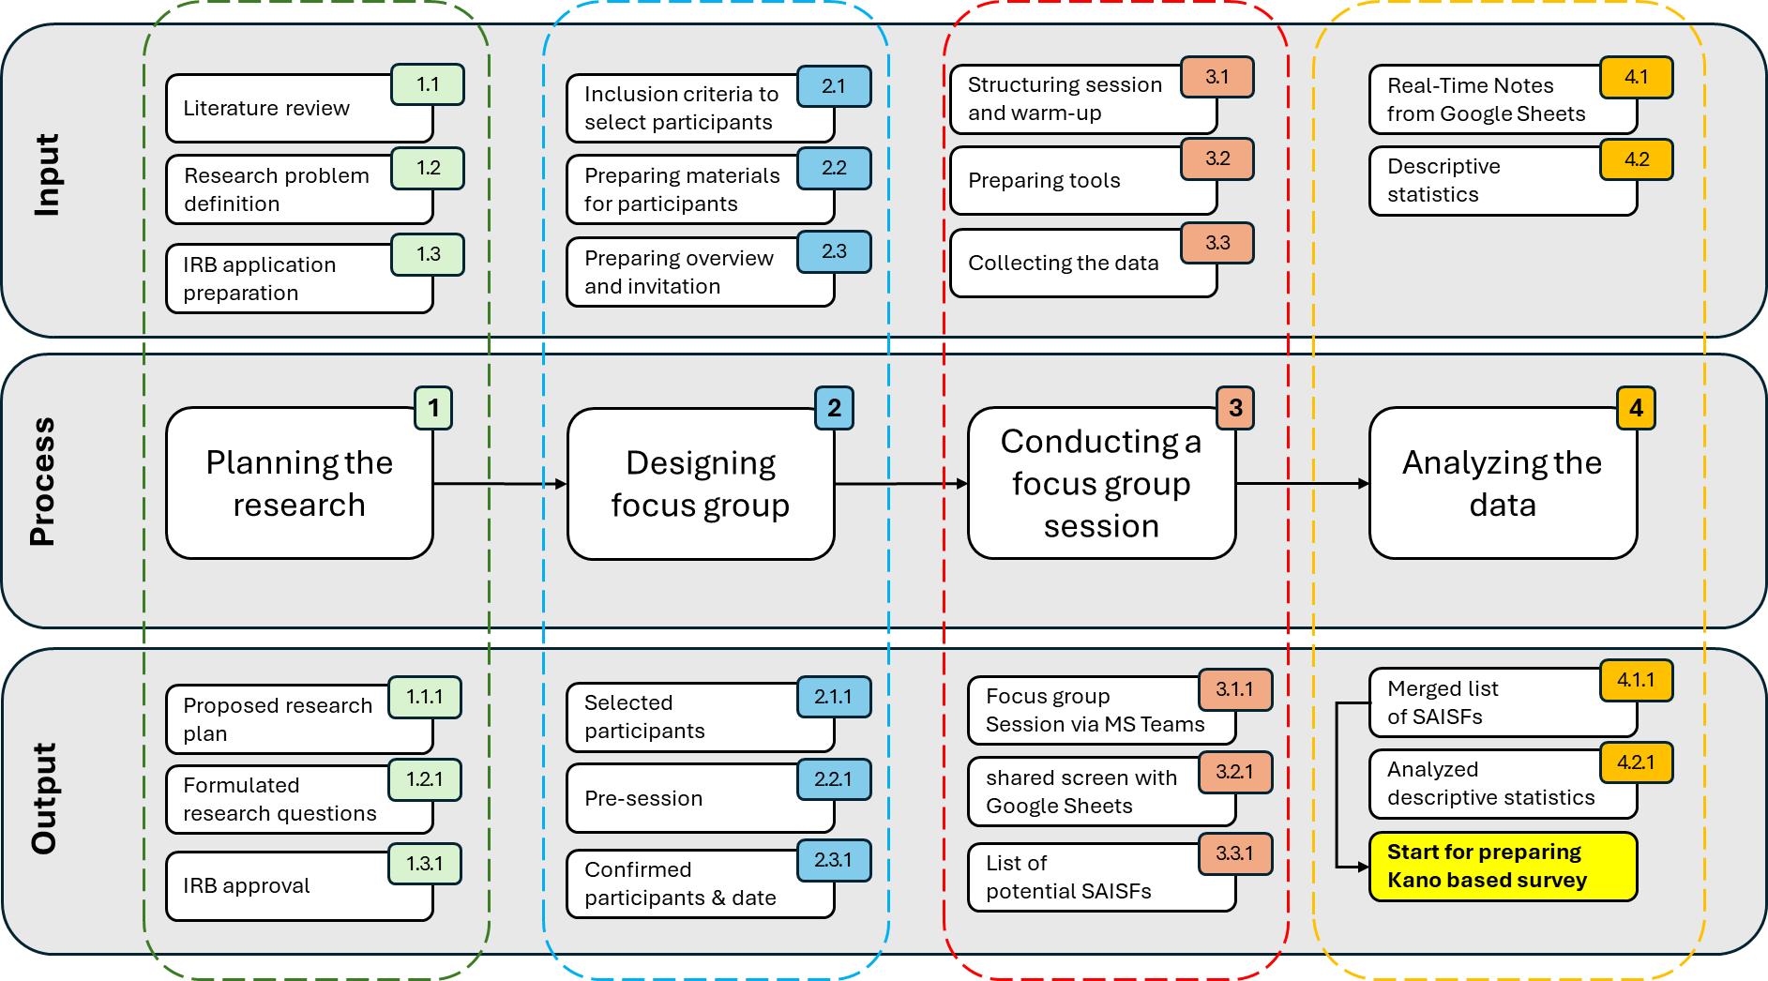

Figure 1: Overview of the focus group research process: from planning to data analysis. This diagram illustrates the four main phases of the focus group methodology: (1) Planning the Research, (2) Designing focus group, (3) Conducting the focus group session, and (4) Analyzing the data. Each phase is supported by corresponding input activities (e.g., 1.1, 2.1) and results in specific outputs (e.g., 1.1.1, 2.1.1), reflecting a nested structure. The numbering system links each output directly to its originating input and phase, ensuring traceability and clarity in the research process. Note: IRB (Institutional Review Board), SAISF (Scrum AI support features).

1. **Planning the research**
   * Research problem definition

We began by clearly defining the research problem: identifying and prioritizing AI features that could enhance Scrum practices across different team sizes and roles. Since the study involved human participants, we also obtained ethical approval from the Institutional Review Board (IRB). Approval of all ethical and research procedures was granted by the ethics review board of the Faculty of Computer and Information Science, University of Ljubljana, issued on 10 October 2023, and performed in line with the Code of ethics for researchers at the University of Ljubljana [The project approval number is: 20231010001].

To ensure a comprehensive understanding, we planned to use a mixed-methods approach, combining both qualitative and quantitative research methods. Additionally, we conducted a thorough review of the literature, covering both the research domain and relevant research methodologies, such as best practices for conducting focus groups and other qualitative techniques.

1. **Designing focus group**
   * **Selecting participants**

Participants were selected based on their expertise in software engineering and agile methodologies. The selection process aimed to ensure diversity in roles and perspectives.

To ensure the relevance and depth of the focus group discussion, the authors collaboratively proposed a list of potential participants. Each of the four authors of the paper was asked to suggest two candidates with substantial experience in Scrum-based software engineering. This initial pool was then reviewed in a joint meeting, where we defined inclusion criteria to guide the final selection. The primary inclusion criterion was fluency in Slovene, which was chosen to ensure smooth communication and interaction during the focus group session to minimize language barriers in qualitative research settings. ut of the eight proposed candidates, we selected five who met the criteria.

Thus, we employed purposive sampling, specifically expert sampling, to select participants who could provide informed, practice-oriented insights. Based on a consensus among the authors, five participants were invited to join the study. Each brought distinct expertise from different areas of software engineering, contributing valuable perspectives and enhancing the overall richness of the data collected.

To ensure a diversity of perspectives, participants were chosen based on the predefined criteria of researchers. This segmentation allowed us to capture a broad range of insights related to AI integration in Scrum practices, reflecting different responsibilities and viewpoints within software engineering teams.

The criteria we established based on extensive debate of researchers were as follows:

* + **Professional experience**: Individuals were chosen to represent a broad spectrum of roles within the software development and project management ecosystem, including engineering management, project leadership, and software architecture. This diversity ensured that the discussion would capture multiple perspectives on the integration of AI in Scrum environments.
  + **Organizational diversity**: Participants came from organizations of varying sizes (small enterprises, medium enterprises, large enterprises, and public institutions). This variation allowed for insights into how organizational scale and structure might influence the applicability and benefits of SAISFs.
  + **Domain expertise**: All participants had extensive experience in agile methodologies, particularly Scrum, and were familiar with the challenges and opportunities in software engineering. Their expertise ensured that the discussion remained grounded in practical realities.
  + **Strategic and operational insight**: The group included individuals with both strategic oversight (e.g., engineering manager, head of PMO) and hands-on technical experience (e.g., software architects), enabling a holistic exploration of SAISFs from both management and implementation perspectives.
  + **Language**: The focus group was conducted in Slovenian to ensure participants could communicate comfortably and naturally. Using the native language minimized misunderstandings, encouraged deeper engagement, and led to more authentic and detailed contributions.
  + **Pre-session**

Prior to the session, participants received pre-session materials designed to align expectations and provide a shared understanding of the study’s objectives. These materials included a overview of our research plan, a informal description of the focus group format. Moreover, we also provide them a link to the Scrum methodology (to familiarize themselves with the Scrum framework). Although they were already familiar with Scrum, we still provided universal materials to all participants to help the focus group run more smoothly (Link: <https://www.scrum.org/learning-series/what-is-scrum/> ).

Additionally, we also provided them in advance with starting points for the focus group, a PDF document listing desirable functions of AI applications in Scrum (agile project management). It was a one-pager designed to help the group synchronize and understand what we had in mind regarding potential features they might 'want' (see Figure 2). We included a table outlining what universal AI capabilities could be, such as creating, recommending, analyzing, etc. However, we were not very specific, as we did not want to suggest particular desirable functions and thus influence the results.

Slika, ki vsebuje besede besedilo, posnetek zaslona, papir, pisava

Vsebina, ustvarjena z UI, morda ni pravilna.

Figure 2: A one-pager provided to focus group participants, summarizing the Scrum phases and possible AI functions to refresh their understanding.

This preparation helped ensure that participants were well-informed and ready to contribute meaningfully to the discussion.

Based on this pre-session, potential participants also had the opportunity to decide whether they wanted to take part or not. In the email, we explained the focus group format, mentioning that it would last a maximum of 2 hours and, for logistical convenience, would be conducted via the Microsoft Teams platform. We also provided information about data protection, assuring them that the results would be presented in aggregate and that their responses could not be linked to their names. We also informed them that the focus group would be recorded in order to facilitate the creation of the final SAISF list (researcher data analysis), and that the recording would not be stored for more than 60 days.

After they confirmed their participation, we sent them a link to the Doodle platform, where they indicated the time slot that suited them best for the focus group session.

We did not provide payment for participation in the focus group. However, we did mention to them that we would mention them in the paper in the Acknowledgements section as a thank you for participating in the focus group.

1. **Conducting a focus group session**

The session followed a structured sequence, starting with an introduction and warm-up, followed by a guided discussion around AI use cases in Scrum. A moderator facilitated the conversation, ensuring balanced participation and focus. All discussions were recorded and transcribed for analysis.

* + **Basic sequence**

The session followed a structured format, beginning with introductions and a warm-up discussion, followed by guided exploration of AI use cases in Scrum. The focus group was conducted on Monday (27 November 2023 at 11:00) via the Microsoft Teams platform. The conversation via MS Teams was recorded also to track the duration, in line with our goal of keeping the focus group under two hours.

* + **Data capturing**

The data were analyzed using thematic coding to identify recurring patterns, insights, and consensus points among participants. Data collection was carried out by having the researcher share their screen with a Google Sheets table, which was also visible to the other focus group members. This approach helped participants follow the flow of ideas more easily and allowed us to simultaneously start forming the list of potential SAISF. At this stage, we also asked participants about their actual roles at work, how many years of professional experience they have, and whether they agree to be mentioned in the Acknowledgements section.

* + **Role of moderator**

The moderator played a crucial role in facilitating the focus group session. Their responsibilities included guiding the discussion according to the predefined structure, encouraging balanced participation among all experts, managing time, and ensuring that the conversation remained focused on the research objectives. The moderator also created a respectful and open environment that allowed participants to share their insights freely, while minimizing bias and groupthink. This approach helped ensure the reliability and depth of the qualitative data collected.

The role of the moderator was carried out by Damjan Fujs, who has extensive prior experience in conducting focus groups in both academic research and industry projects. His background ensured a structured and balanced discussion, allowing participants to express their views while maintaining focus on the research objectives.

The focus group was conducted in Slovenian to ensure that participants could express themselves more naturally and clearly, reducing potential misunderstandings and encouraging richer, more nuanced discussion.

1. **Analyzing the data and reporting the results**

The data captured during the focus group were analyzed to identify recurring patterns and insights. This analysis resulted in a list of 18 key Scrum AI Support Features (SAISFs), which formed the basis for the subsequent Kano-based survey. It should be noted here that the merging was performed afterwards, i.e., following the focus group session. For example, several similar SAISFs proposed during the focus group were later merged into more general key features. This included cases where different suggestions addressed the same underlying need, such as identifying repetitive backlog items or recommending process improvements. This merging was done after the session, based on researcher discussion and thematic similarity. This merging step was necessary due to the use of the Kano methodology in the subsequent survey. Since Kano analysis relies on evaluating user perceptions of distinct features, we aimed to avoid asking participants about essentially the same functionality in multiple ways. By consolidating similar SAISFs into broader, semantically unified categories, we ensured that each survey item represented a clearly distinguishable feature, reducing redundancy and improving the clarity of the questionnaire.

Moreover, we analyzed descriptive statistics of the participants, including their roles and years of experience, and reported these findings in the paper. Additionally, the insights derived from the focus group discussion were used as a starting point for constructing the questionnaire, ensuring that the survey items were grounded in expert input and relevant to real-world Scrum practices.