­­

**جمهورية العراق**

**وزارة التعليم العالي والبحث العلمي**

**جامعة واسط**

**كلية التربية للعلوم الصرفة**

**قسم علوم حاسوب**

**نظام ادارة الموارد البشرية والترفيعات والعلاوات الخاصه بجامعة واسط**

المشروع مقدم الى كلية التربية

للعلوم الصرفة / جامعة واسط / قسم الحاسوب

كجزء من متطلبات نيل شهادة البكالوريوس في علوم الحاسوب

**أشراف الدكتور :**

**م.م اسم المشرف**

**من قبل:**

**محمود شمران عذيب**

**2022-2023 السنة الجامعية**

بسم الله الرحمن الرحيم

)) هُوَ الَّذِي بَعَثَ فِي الْأُمِّيِّينَ رَسُولًا مِّنْهُمْ يَتْلُو عَلَيْهِمْ آيَاتِهِ وَيُزَكِّيهِمْ وَيُعَلِّمُهُمُ الْكِتَابَ وَالْحِكْمَةَ وَإِن كَانُوا مِن قَبْلُ لَفِي ضَلَالٍ مُّبِينٍ ((

صدق الله العظيم

# **الإهــــــــــــــــــــداء**

إلى من شجعني على المثابرة طوال عمري، إلى الرجل الأبرز في حياتي  
(والدي العزيـز)

إلى من بـــــــها أعلو، وعليها أرتكز، إلى القـــــــلب المعطاء  
(والدتي الحـبيـبة)

إلى من بذلوا جهدًا في مساعدتي وكانوا خيرَ سندٍ  
(إخــواني وأخواتي)

إلى أسرتي إلى أصدقائي وزملائي ....

إلى كل من ساهم ولو بحرف في حياتي الدراسية.....

إلى كل هؤلاء: أهدي هذا العمل، الذي أسال الله تعالى أن يتقبله خالصًا....

# شكر وتقدير

الحمد لله الذي انزل القران شفاء ورحمة للمؤمنين والصلاة والسلام على من اعطي السبع المثاني والقران العظيم وعلى اله اجمعين الذين رفعوا بهمهم العالية اعلام الدين وعلى اصحابه الذين امنوا به وازروه ونصروه واتبعوا النور الذي انزل معه الذين ابلوا البلاء الحسن بنصرته واقامة دينه.

وبعد...

نحمد الله والثناء عليه جلت قدرته على توفيقه بإتمام هذا الجهد العلمي المتواضع فيطيب لنا ويبهج انفسنا ان نتوجه بالشكر والامتنان الى الاهل الذين ساندونا وكانوا نعم العون في كل الظروف والى كافة الاساتذة الافاضل في قسم علوم الحاسبات بكلية التربية للعلوم الصرفة بجامعة واسط ونخص بالشكر (( م.م اسم المشرف)) الذي ساعدنا ووقف معنا لاكمال هذا البحث وكذلك نتوجه بالشكر والعرفان الى كل الزملاء الاعزاء.

**Abstract:**

We have implemented (Human Resources Management System, Promotions and Bonuses for Wasit University), which is a system used to manage the working relationship between the company and its employees. It includes recruitment, management, change, administrative procedures, administrative changes, bonuses, incentives, promotions, management of certificates of thanks and appreciation, with a limit of 3 additions in the same year, performance review, salary review, administrative updates, administrative notifications and other related human resources functions. The purpose of the HRMS is to streamline HR processes, improve communication and collaboration, ensure compliance with labor laws and company policies, and print reports in PDF format.

**الملخص :**

قمنا بتطبيق (**نظام إدارة الموارد البشرية والترقيات والمكافآت لجامعة واسط**) وهو نظام يستخدم لإدارة علاقة العمل بين الشركة وموظفيها. ويشمل التوظيف وألادارة والتغيير والإجراءات الإدارية والتغييرات الإدارية والمكافئات والحوافز والترفعيات وادارة شهادات الشكر والتقدير مع الحد من الاضافة 3 في نفس السنة ومراجعة الأداء ومراجعة الرواتب والتحديثات الإدارية والإخطارات الإدارية ووظائف الموارد البشرية الأخرى ذات الصلة. الغرض من نظام إدارة الموارد البشرية هو تبسيط عمليات الموارد البشرية وتحسين التواصل والتعاون وضمان الامتثال لقوانين العمل وسياسات الشركة وطباعة تقارير بصيغة .PDF

# List of Contents:

**الإهــــــــــــــــــــداء** ii

شكر وتقدير iii

List of Contents: v

List of Figures: 1

Chapter One Introduction 2

**1-2.** **Research problem:** 3

**1-3.** **Research importance-:** 3

**1-4.** **Search Objective-:** 4

**1-5.** **System idea-:** 4

**1-6.** **Similar Research:** 4

Chapter Two 7

**2-1 VB.NET:** 8

**2-2 Variables:** 8

**2-3 Loops:** 9

**2-4 Loop Type Description** 9

2-5 Arrays: 10

**2-6 Functions and Sub** 10

**2-7 SQL Server:** 10

**2-8 SQL standard and proprietary extensions** 12

**2-9 SQL commands and syntax** 13

Chapter Three Database 15

**3.2. Users:** 16

**3.3. Employee:** 17

**3.4. Reward:** 17

**3.5. Upgrades:** 18

**3.6. Acknowledgments:** 18

Chapter Four 20

Design & implementation 20

**4-1. Splash Screen:** 21

**4-2. Login Screen:** 21

**4-3. Main Menu:** 23

**4-4. Employee:** 24

**4-5. Manage Employee:** 25

**4-6. Reword:** 25

**4-7. Upgrades:** 27

**4-8. Total:** 28

**4-9. Backup:** 30

**4-10. About:** 30

Chapter Five Conclusions and Recommendations 31

References: 33

# 

# List of Figures

Figure 1 . Database Diagram 16

Figure 2 - Users 16

Figure 3 - Employee 17

Figure 4 – Reward 17

Figure 5 . Upgrades 18

Figure 6 . Acknowledgments 18

Figure 7 . Project Planning 19

Figure 8 . Splash Screen 21

Figure 9 - Login Screen 22

Figure 10- Error Message 22

Figure 11 . Messagebox Make Sure Deletion 23

Figure 12 . Messagebox Delete Information 23

Figure 13 . Messagebox Insert Information 23

Figure 14 . Main Menu 23

Figure 15 – Employee 24

Figure 16 . Report Employee Information 24

Figure 17 - Manage Employee 25

Figure 18 - Reword 25

Figure 19 . reward information 26

Figure 20 . show type infotainment 26

Figure 21 . report PDF 27

Figure 22 . Upgrades 27

Figure 23 . Total 28

Figure 24 . Information Total 29

Figure 25 – Total 29

Figure 26 . Backup 30

Figure 27 - About 30

# Chapter One Introduction

* 1. **Introduction -:**

The spread and advancement of computing in the modern world is one of the main factors that support human development and scientific progress. It is known that computerization helps in facilitating administrative and commercial operations, as well as in improving communication and rapid transfer of information, and in promoting science and technology. [1]

In this research, we will learn about the importance of the spread of computing in the modern world, and we will mention many scientific sources that support this principle.

* 1. **Research problem:**

Many government departments, private companies and universities suffer in managing employee data as a result of technological development and the emergence of computers and as a result of the lack of manual systems in dealing with data and the huge cost that users spend in terms of time and effort to access and deal with data, it was necessary to keep pace with this development by moving to computerized systems to solve the problems faced by manual systems.

* 1. **Research importance-:**

The project helps in managing all employee data, tracking their status, actions, rewards, penalties, and managing all employee data by entering new data, modifying it, and deleting data with user permissions, meaning that the program manager needs to be arrested to allow the employee to use the application and print a report in PDF format.

* 1. **Search Objective-:**

The employee rewards project report is a report that includes details of how rewards are determined for employees, including the conditions required for obtaining them, the wages paid to employees, increases for good work, penalties for poor work, other elements that are considered in determining rewards, and other necessary reports to manage rewards for employees.

This report includes many different tables that contain information about employees, such as names, roles, other rewards, the time period for obtaining them, the required conditions.

Ease of use without unnecessary obstacles the use of the program is very easy and does not require special experience or high skill, any employee can use it.

* 1. **System idea-:**

The beauty of the program and its simple and elegant form is one of the reasons for the creation of many human resource management systems that are characterized by complexity and difficulty in use and many problems and errors that appear at the employee who is used, but here the situation is different because of its high potential in management.

* 1. **Similar Research:**

1. Valverde, Camilo José Lopes, the case of a human resources consulting firm, The aim of this case study is to evaluate what is the profile and main hard and soft skills of the professionals in finance and banking (F&B) that the market values the most, and what recruitment and selection (R&S) practices are applied by a Portuguese human resources (HR) consulting firm in these two sectors, and if they are in line with the scientific literature. Therefore, a qualitative analysis was conducted through researching existing literature, participant observation in the field by the researcher and through interviews with recruiters, managers, and customers of a human resources consulting firm. 2021. [2]
2. Nishad Nawazk Universities Human Resource Management System, the paper developed and tested a human resource management system in the university. To achieve the aim, objectives, the study designed methodology and taken the opinion from the users. To reach to the results percentage methods was adopted and data collected with a structured questionnaire. The study found that the program well-executed and employees usage human resource management system in the human resource department of universities. The tools were useful for developers, researchers and Industry,2020 [3].
3. Mohamed, Abdullahi Said, Development of an improved Web-based System for the Human Resource Management Unit of Somali University, Human Resource (HR) unit is a vital department in any institution of higher learning. The unit manages the staff welfare, recruits new staff and keep track of their records until retirement. The unit is also responsible for adequate dissemination of information through official memo and online communication to the entire stake holders of the institutions and beyond. The main objective of this study was to introduce a substantial improvement to the existing website that was been used by the HR unit of Somali University. The analysis of the old system shows that it requires improvement in the areas of security, usability, design patterns etc. In an attempt to achieve this, the stake holders within the unit were interviewed and some relevant information they gave was documented. Opportunity was also given to interact with the old system and some of its weaknesses were also documented for improvement. Specifically, the security and administration, information dissemination module, design styles module and navigations were some of the areas identified for improvement, 2019 [4]
4. Chithra Biju Menon, Vaibhav Narwane, Relevance of Database and Information Retrieval System in Mechanical Engineering Program: A Case Study, A mechanical engineer often experiences the need for working on databases in his career. However, it is observed that there is difficulty in convincing the students of Mechanical Engineering Program that the course of Database and Information Retrieval System is relevant to them. This paper focuses on the methodology adopted in order to reinforce the belief in the course of database and information retrieval system, 2022 [5]
5. Tengsi Mayang Nopita Sari, “Application of the Simple Additive Weighting (SAW) Method in Recommended Skripsi Topics”, Students were confused by the selection of thesis topics from the 3 thesis topics to be discussed in research, thus slowing down the thesis submission process and some students did not submit titles during semester 7. thesis topic, one way is by utilizing information technology systems. The recommendation application for thesis topics at the Management Study Program, Faculty of Economics, University of Dehasen Bengkulu, was made using the Visual Basic .Net programming language and SQL Server 2008r2 database. In the application, one of the Decision Support System (DSS) methods has been applied, namely the Simple Additive Weighting (SAW) method which is used to help determine recommendations for final semester student thesis topics based on the value of the courses obtained by students. There are 3 thesis topics in the Management Study Program, Faculty of Economics, University of Dehasen Bengkulu, namely finance, human resources, and marketing with a course value of 17 courses. 2022, [6].

# Chapter Two

Project Material

**2-1 VB.NET:**

Visual Basic, originally called Visual Basic .NET (VB.NET), is a multi-paradigm, object-oriented programming language, implemented on .NET, Mono, and the .NET Framework. Microsoft launched VB.NET in 2002 as the successor to its original Visual Basic language, the last version of which was Visual Basic 6.0. Although the ".NET" portion of the name was dropped in 2005, this article uses "Visual Basic [.NET]" to refer to all Visual Basic languages released since 2002, in order to distinguish between them and the classic Visual Basic. Along with C# and F#, it is one of the three main languages targeting the .NET ecosystem. As of March 11, 2020, Microsoft announced that evolution of the VB.NET language has concluded.

Microsoft's integrated development environment (IDE) for developing in Visual Basic is Visual Studio. Most Visual Studio editions are commercial; the only exceptions are Visual Studio Express and Visual Studio Community, which are freeware. In addition, the .NET Framework SDK includes a freeware command-line compiler called vbc.exe. Mono also includes a command-line VB.NET compiler.

Visual Basic is often used in conjunction with the Windows Forms GUI library to make desktop apps for Windows. Programming for Windows Forms with Visual Basic involves dragging and dropping controls on a form using a GUI designer and writing corresponding code for each control.

**2-2 Variables:**

A variable is nothing but a name given to a storage area that our programs can manipulate. Each variable in VB.Net has a specific type, which determines the size and layout of the variable's memory; the range of values that can be stored within that memory; and the set of operations that can be applied to the variable.

**2-3 Loops:**

There may be a situation when you need to execute a block of code several number of times. In general, statements are executed sequentially: The first statement in a function is executed first, followed by the second, and so on. Programming languages provide various control structures that allow for more complicated execution paths. A loop statement allows us to execute a statement or group of statements multiple times and following is the general form of a loop statement in most of the programming languages –

**2-4 Loop Type Description**

Do Loop It repeat the enclosed block of statements while a Boolean condition is True or until the condition becomes True. It could be terminated at any time with the Exit Do Statement For...Next It repeats a group of statements a specified number of times and a loop index counts the number of loop iterations as the loop executes.

For Each...Next

It repeats a group of statements for each element in a

collection. This loop is used for accessing and

manipulating all elements in an array or a VB.Net collection.

* While... End While It executes a series of statements as long as a given
* condition is True.
* With... End with It is not exactly a looping construct. It executes a series
* of statements that repeatedly refer to a single object or
* structure.
* Nested loops You can use one or more loops inside any another
* While, For or Do loop.

2-5 Arrays:

An array stores a fixed-size sequential collection of elements of the same type. An array is used to store a collection of data, but it is often more useful to think of an array as a collection of variables of the same type. All arrays consist of contiguous memory locations. The lowest address corresponds to the first element and the highest address to the last element.

For example:

1. Dim intData(30) ' an array of 31 elements
2. Dim strData(20) As String ' an array of 21 strings
3. Dim twoDarray(10, 20) As Integer 'a two dimensional
4. array of integers
5. Dim ranges(10, 100) 'a two dimensional array

**2-6 Functions and Sub**

A procedure is a group of statements that together perform a task when called. After the procedure is executed, the control returns to the statement calling the procedure. VB.Net has two types of procedures −

1- Functions

2- Sub procedures or Subs

**Note: Functions return a value, whereas Subs do not return a value**

**2-7 SQL Server:**

Structured Query Language (SQL) is a standardized programming language that is used to manage [relational databases](https://searchdatamanagement.techtarget.com/definition/relational-database) and perform various operations on the data in them. Initially created in the 1970s, SQL is regularly used not only by database administrators, but also by developers writing data integration scripts and data analysts looking to set up and run analytical queries.

The term *SQL* is pronounced *less-Kew-ell*or *sequel*.

SQL is used for the following:

* modifying database table and index structures;
* adding, updating and deleting rows of data; and
* retrieving subsets of information from within relational database management systems ([RDBMSes](https://searchdatamanagement.techtarget.com/definition/RDBMS-relational-database-management-system)) -- this information can be used for transaction processing, analytics applications and other applications that require communicating with a relational database.

SQL queries and other operations take the form of commands written as statements and are aggregated into programs that enable users to add, modify or retrieve data from database tables.

A table is the most basic unit of a database and consists of rows and columns of data. A single table holds records, and each record is stored in a row of the table. Tables are the most used type of database objects, or structures that hold or reference data in a relational database. Other types of database objects include the following:

* **Views** are logical representations of data assembled from one or more database tables.
* **Indexes** are lookup tables that help speed up database lookup functions.
* **Reports** consist of data retrieved from one or more tables, usually a subset of that data that is selected based on search criteria.

Each column in a table corresponds to a category of data -- for example, customer name or address -- while each row contains a data value for the intersecting column.

Relational databases are relational because they are composed of tables that relate to each other. For example, a SQL database used for customer service can have one table for customer names and addresses and other tables that hold information about specific purchases, product codes and customer contacts. A table used to track customer contacts usually uses a unique customer identifier called a *key* or [*primary key*](https://searchsqlserver.techtarget.com/definition/primary-key) to reference the customer's record in a separate table used to store customer data, such as name and contact information.

SQL became the de facto standard programming language for relational databases after they emerged in the late 1970s and early 1980s.

**2-8 SQL standard and proprietary extensions**

An official SQL standard was adopted by the American National Standards Institute ([ANSI](https://www.techtarget.com/searchdatacenter/definition/ANSI)) in 1986, with the International Organization for Standardization ([ISO](https://www.techtarget.com/searchdatacenter/definition/ISO)) adopting the standard in 1987. New versions of the SQL standard are published every few years, the most recent in 2016.

ISO/IEC 9075 is the ISO SQL standard developed jointly by ISO and the International Electrotechnical Commission. The standard way of referring to an ISO standard version is to use the standards organizations -- ISO/IEC -- followed by the ISO standard number, a colon and the publication year. The current ISO standard for SQL is ISO/IEC 9075:2016.

Both proprietary and open source RDBMSes built around SQL are available for use by organizations. SQL-compliant database server products include the following:

* [Microsoft SQL Server](https://searchdatamanagement.techtarget.com/definition/SQL-Server)
* Oracle Database
* IBM [Db2](https://searchdatamanagement.techtarget.com/definition/Db2)
* SAP HANA
* SAP Adaptive Server
* Oracle [MySQL](https://searchoracle.techtarget.com/definition/MySQL)
* open source [PostgreSQL](https://whatis.techtarget.com/definition/PostgreSQL)

Some versions of SQL include proprietary extensions to the standard language for procedural programming and other functions. For example, Microsoft offers a set of extensions called [Transact-SQL](https://searchdatamanagement.techtarget.com/definition/T-SQL), while Oracle's extended version of the standard is [Procedural Language for SQL](https://searchoracle.techtarget.com/definition/PL/SQL). Commercial vendors offer proprietary extensions to differentiate their product offerings by giving customers additional features and functions. As a result, the different variants of extended SQL offered by vendors are not fully compatible with one another.

**2-9 SQL commands and syntax**

SQL is, fundamentally, a programming language designed for accessing, modifying and extracting information from relational databases. As a programming language, SQL has commands and a syntax for issuing those commands.

SQL commands are divided into several different types, including the following:

* **Data Definition Language (**[**DDL**](https://whatis.techtarget.com/definition/Data-Definition-Language-DDL)**)**commands are also called *data definition commands* because they are used to define data tables.
* **Data Manipulation Language (DML)**commands are used to manipulate data in existing tables by adding, changing or removing data. Unlike DDL commands that define how data is stored, DML commands operate in the tables defined with DDL commands.
* **Data Query Language** consists of just one command, SELECT, used to get specific data from tables. This command is sometimes grouped with the DML commands.
* **Data Control Language** commands are used to grant or revoke user access privileges.
* **Transaction Control Language** commands are used to change the state of some data -- for example, to COMMIT transaction changes or to ROLLBACK transaction changes.SQL syntax, the set of rules for how SQL statements are written and formatted, is similar to other programming languages. Some components of SQL syntax include the following:
* SQL statements start with a SQL command and end with a semicolon (**;**), for example:

SELECT * FROM customers;

This SELECT statement extracts all of the contents of a table called customers.

# Chapter Three Database

## **3.1. Overview:**

In this chapter, we will display all the tables in a database with the Diagram schema, which is the basis for building the project. 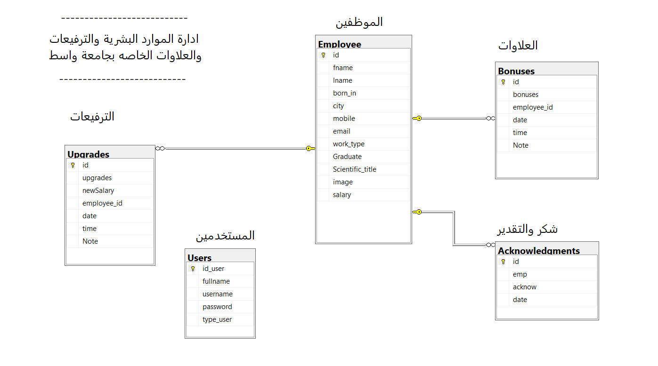

Figure 1 . Database Diagram

## We note the type of linking between the tables, which is the relationship of one table to several tables, which is the employees table, which is linked to the bonuses table, the promotions table, and the certificates of appreciation table.

## **3.2. Users:**

It is the table responsible for storing user data and the login process.

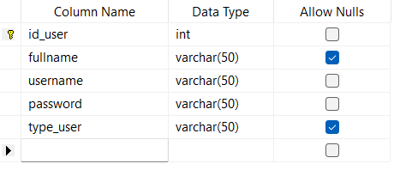

Figure 2 - Users

## **3.3. Employee:**

All employee data and personal information such as employee number, employee name, father's name, phone, housing, e-mail, university degree, births, employee photo, salary, and date of addition are stored.

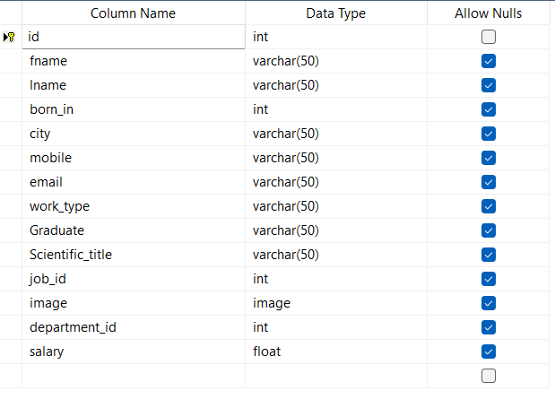

Figure 3 - Employee

## **3.4. Reward:**

All rewards that occur are stored in the program such as employee number, date and reason for reward.

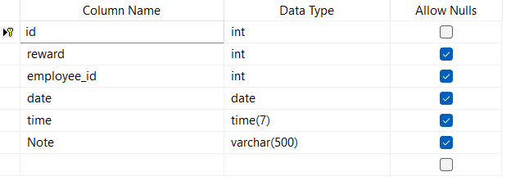

Figure 4 – Reward

## **3.5. Upgrades:**

All employee promotions, the new salary, the employee number, the date the promotions were added, and the note or reason for the promotions are stored.

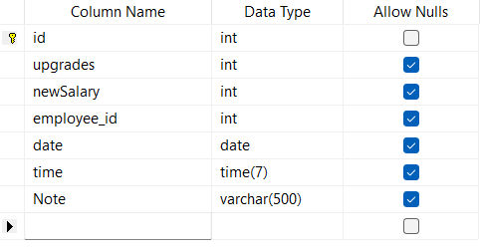

Figure 5 . Upgrades

## **3.6. Acknowledgments:**

All employee thanks and appreciation data, the title of the thanks and appreciation book, and the date of addition are stored. Only 3 books of appreciation books and certificates are stored per year for each employee.

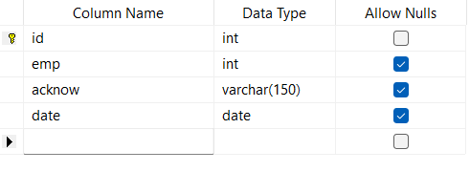

Figure 6 . Acknowledgments

**3.7. Project Planning:**

Note the project layout, table divisions, and the relationships between them.

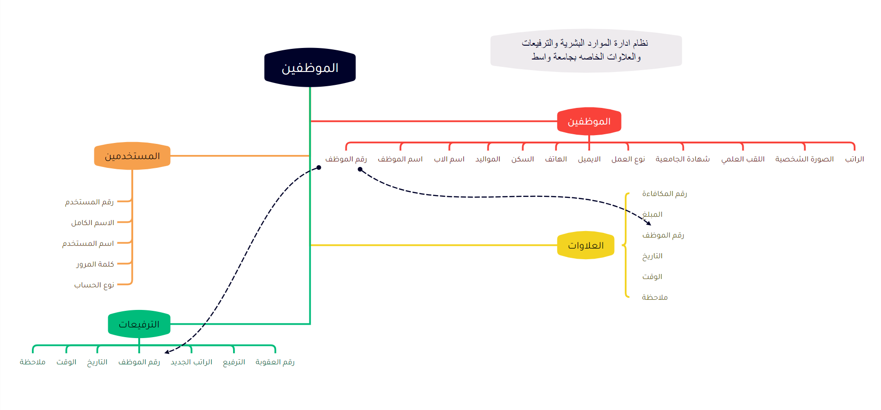

Figure 7 . Project Planning

# Chapter Four

# Design & implementation

## **4-1. Splash Screen:**

It is the first window that appears when the program is running. It contains a Progress Bar, which is a counter that increases automatically when the counter value becomes 100. The window closes and the next window opens, which is the login window.

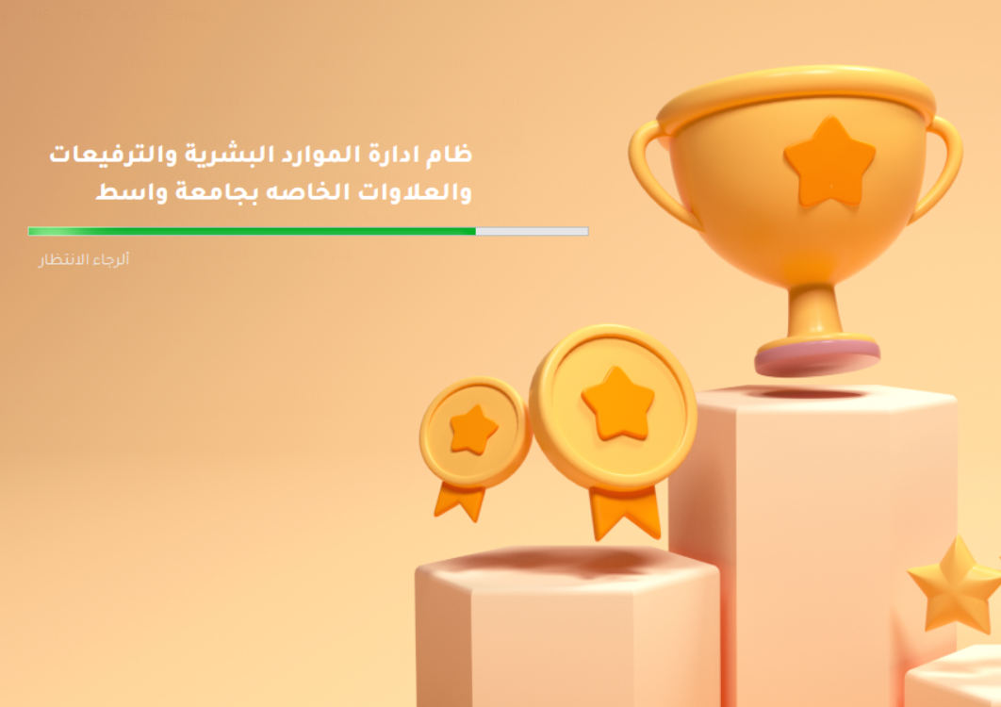

Figure 8 . Splash Screen

## **4-2. Login Screen:**

In the event that the username and password are written incorrectly, that is, it does not match what is in the database, an error message will appear telling you to verify the username or password.

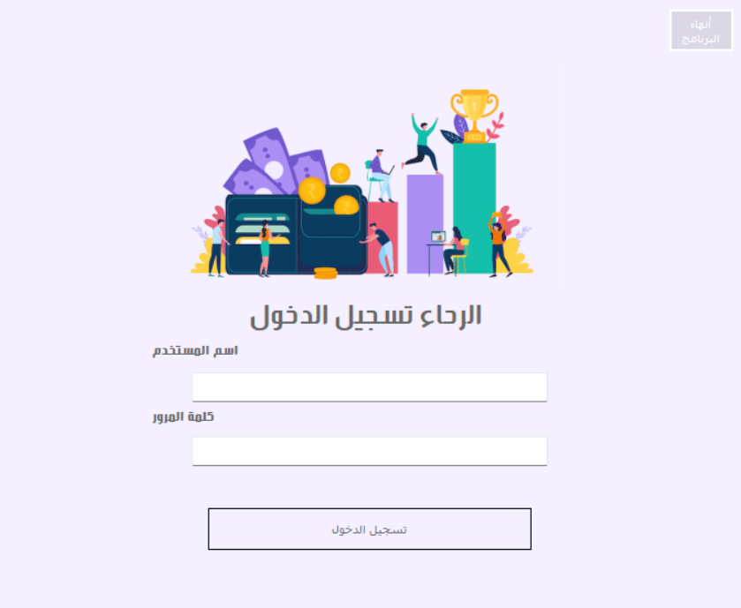

Figure 9 - Login Screen

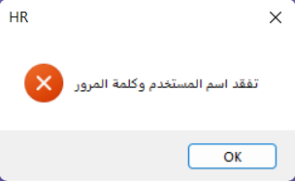In the event that the username and password are written incorrectly, that is, it does not match what is in the database, an error message will appear telling you to verify the username or password.

Figure 10- Error Message

MessageBox Used in Project:

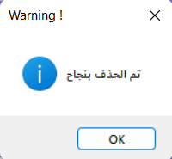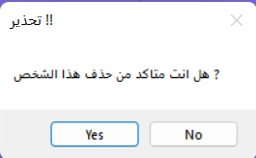

Figure 11 . Messagebox Make Sure Deletion

Figure 12 . Messagebox Delete Information

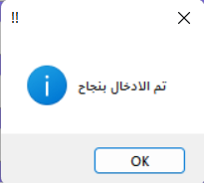

Figure 13 . Messagebox Insert Information

## **4-3. Main Menu:**

It is considered one of the most important interfaces in the program because it shows all the windows in the project and the user can choose the desired window very easily.

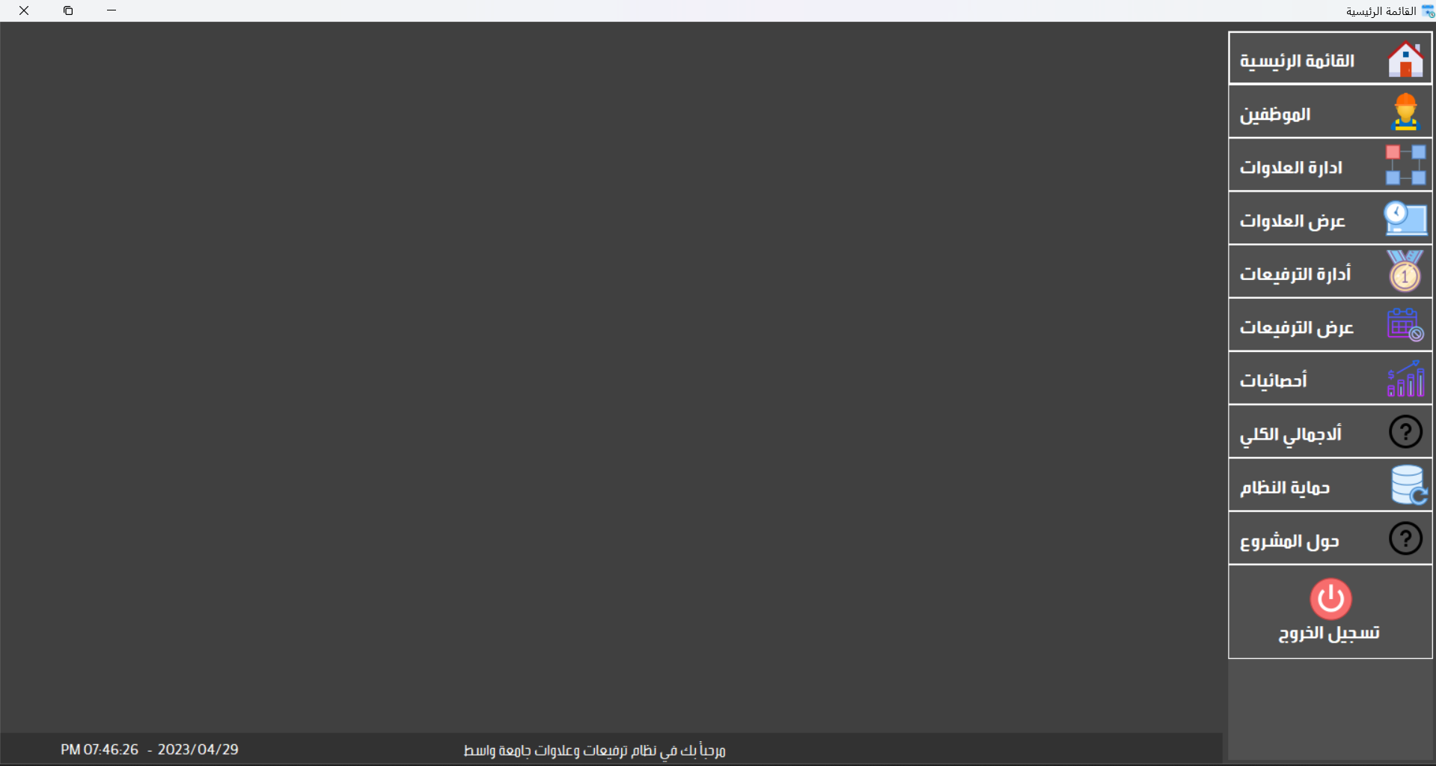

Figure 14 . Main Menu

## **4-4. Employee:**

Managing employee data that is displayed through the project windows. Data can be printed in the form of a report and saved in pdf format

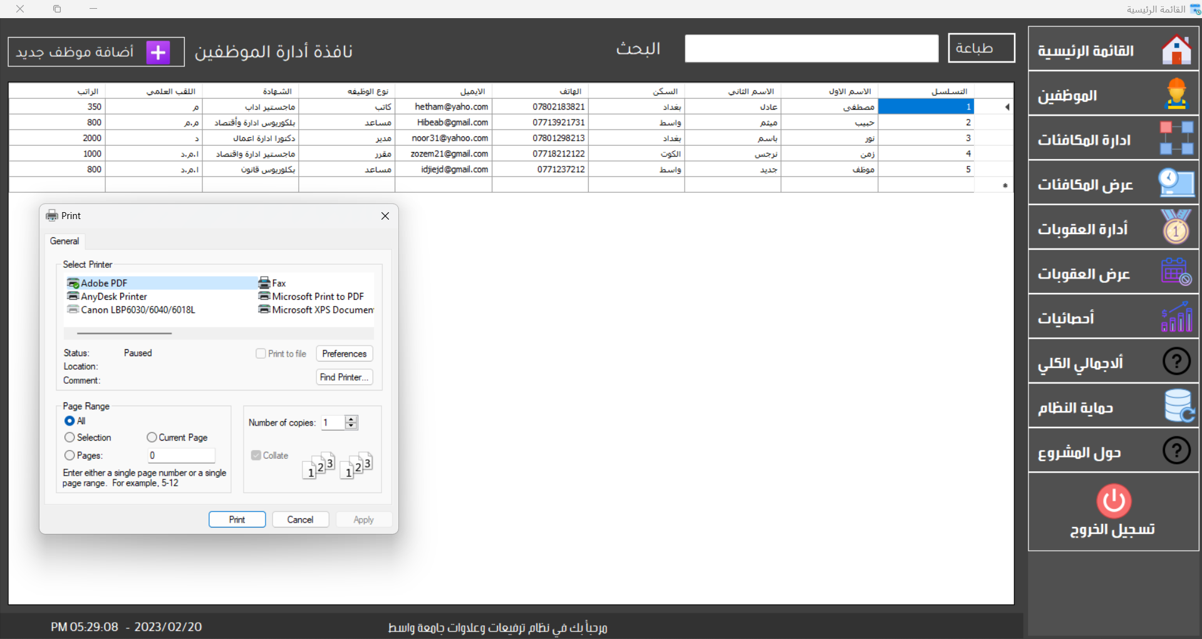

Figure 15 – Employee

Pdf report employee information:

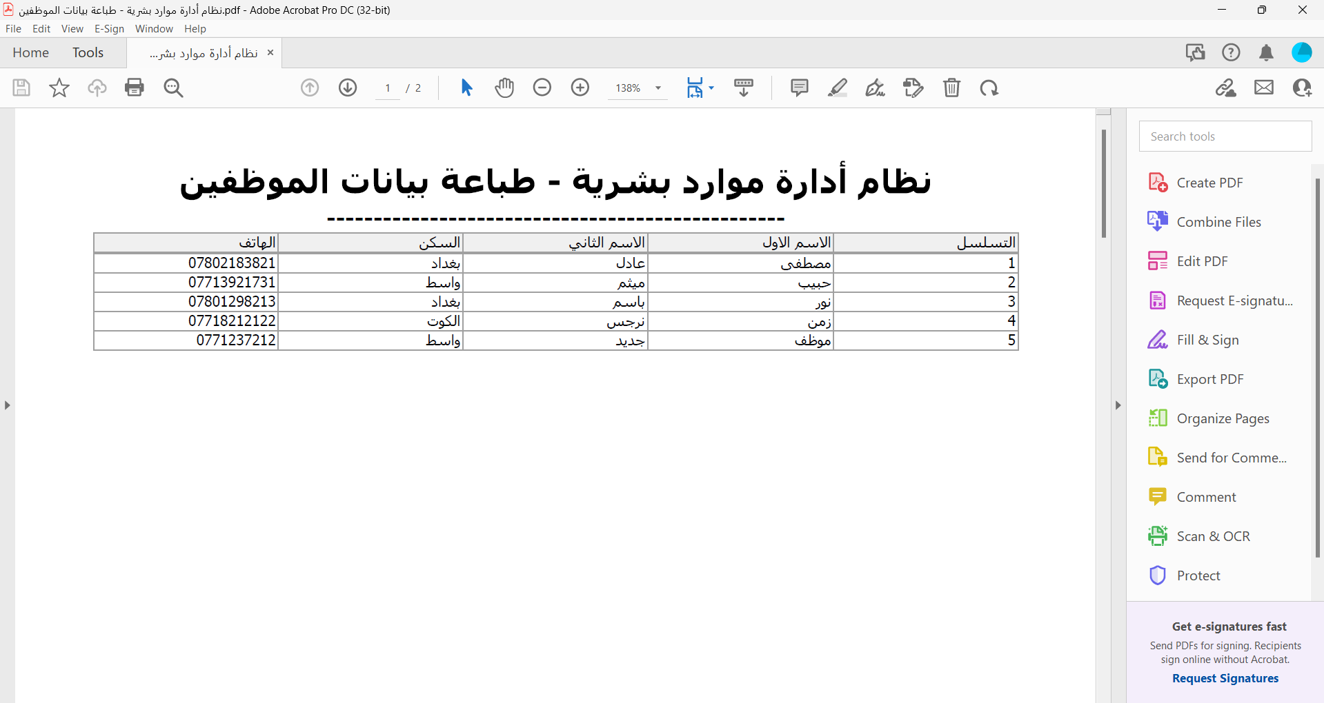

Figure 16 . Report Employee Information

## **4-5. Manage Employee:**

In this window, employee data is fully managed, such as the process of entering new employee data, and it is stored in the database within the employee table so that the data is displayed with ease. The data can be modified and deleted according to the employee number

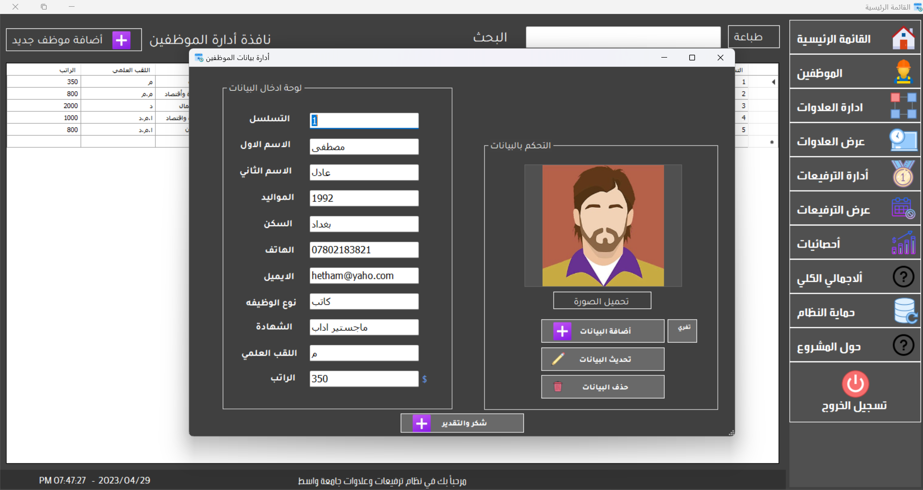

Figure 17 - Manage Employee

## **4-6. Reword:**

Rewards data is managed in this window such as adding, updating and deleting.

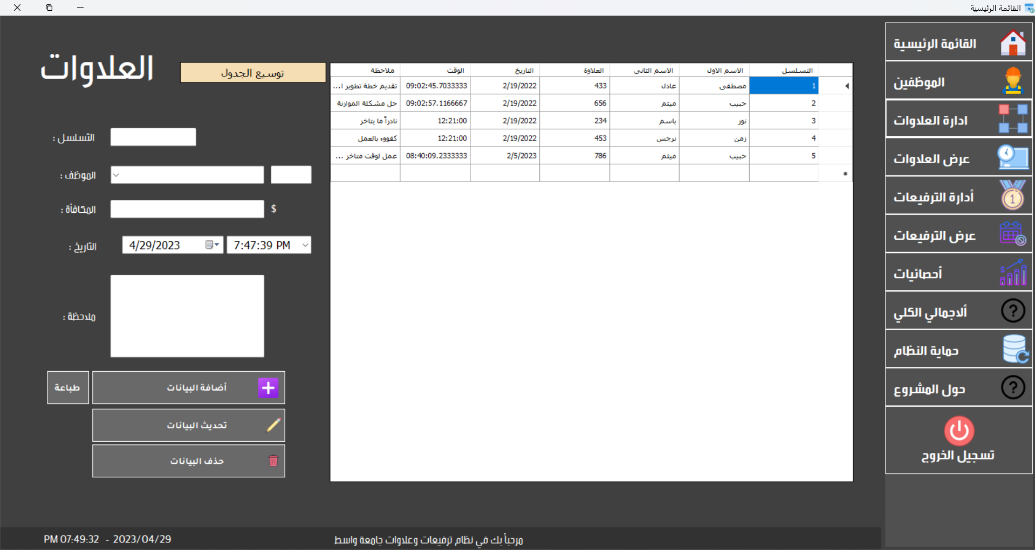

Figure 18 - Reword

Penalties and leave data are managed in these two windows, such as adding, updating and deleting

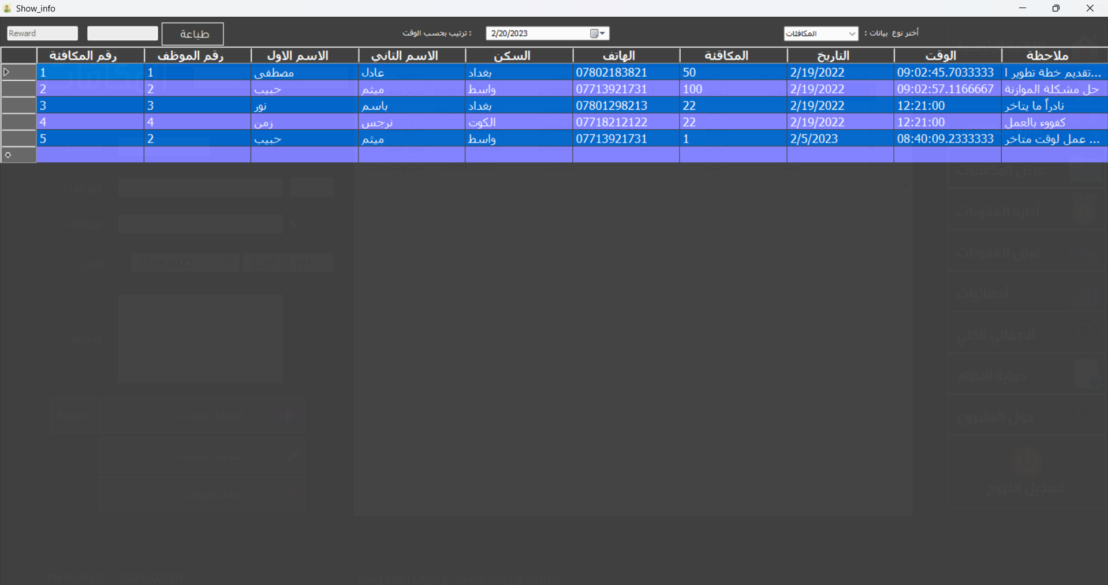

Figure 19 . reward information

It is possible to choose the classification of the data that is displayed through the drop-down list when selecting the category. Data is automatically updated and the data is arranged according to dates if you choose a specific date.

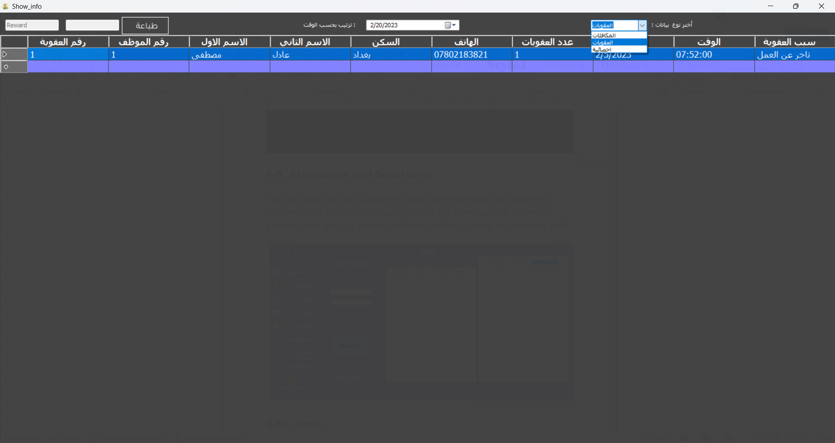

Figure 20 . show type infotainment

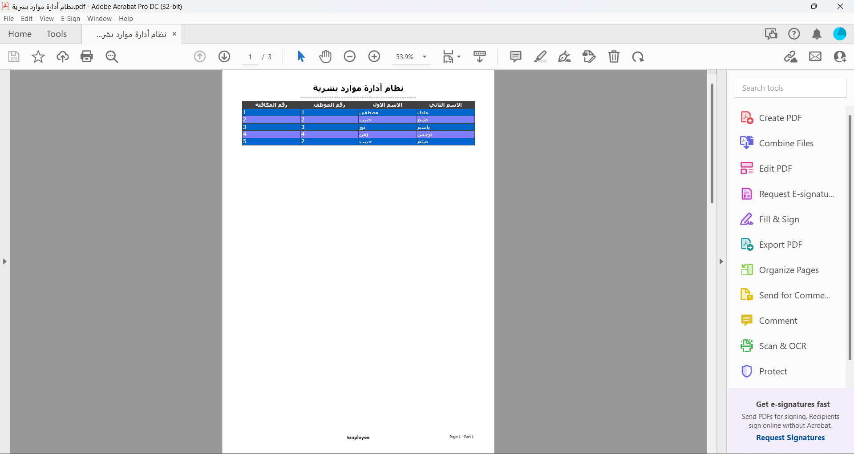

Figure 21 . report PDF

## **4-7. Upgrades:**

In this section, employee allowance data is managed and the employee's new salary is determined along with the date and reason. This data can be managed through the window that enables us to add, update and delete data.

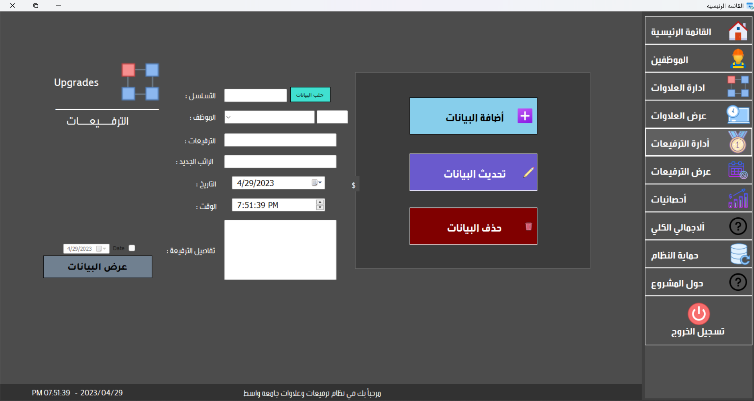

Figure 22 . Upgrades

## **4-8. Acknowledgments:**

In this window, the thanks and appreciation data is managed, through which letters of thanks and appreciation can be added to the employees, while preventing the addition of more than 3 books of thanks and appreciation in the same year.

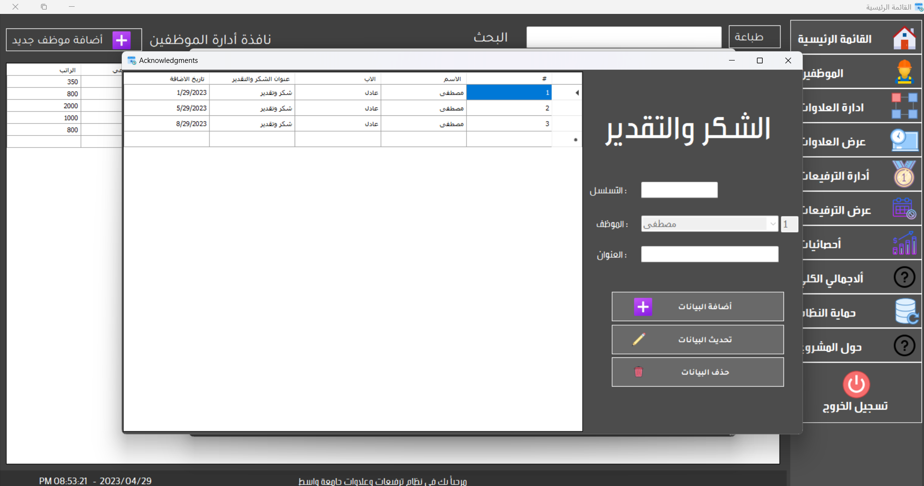

Figure 23 . Acknowledgments

## **4-9. Total:**

The company owner needs to know the total number of employees, the number of vacations, penalties, attendance and absence on a particular date.

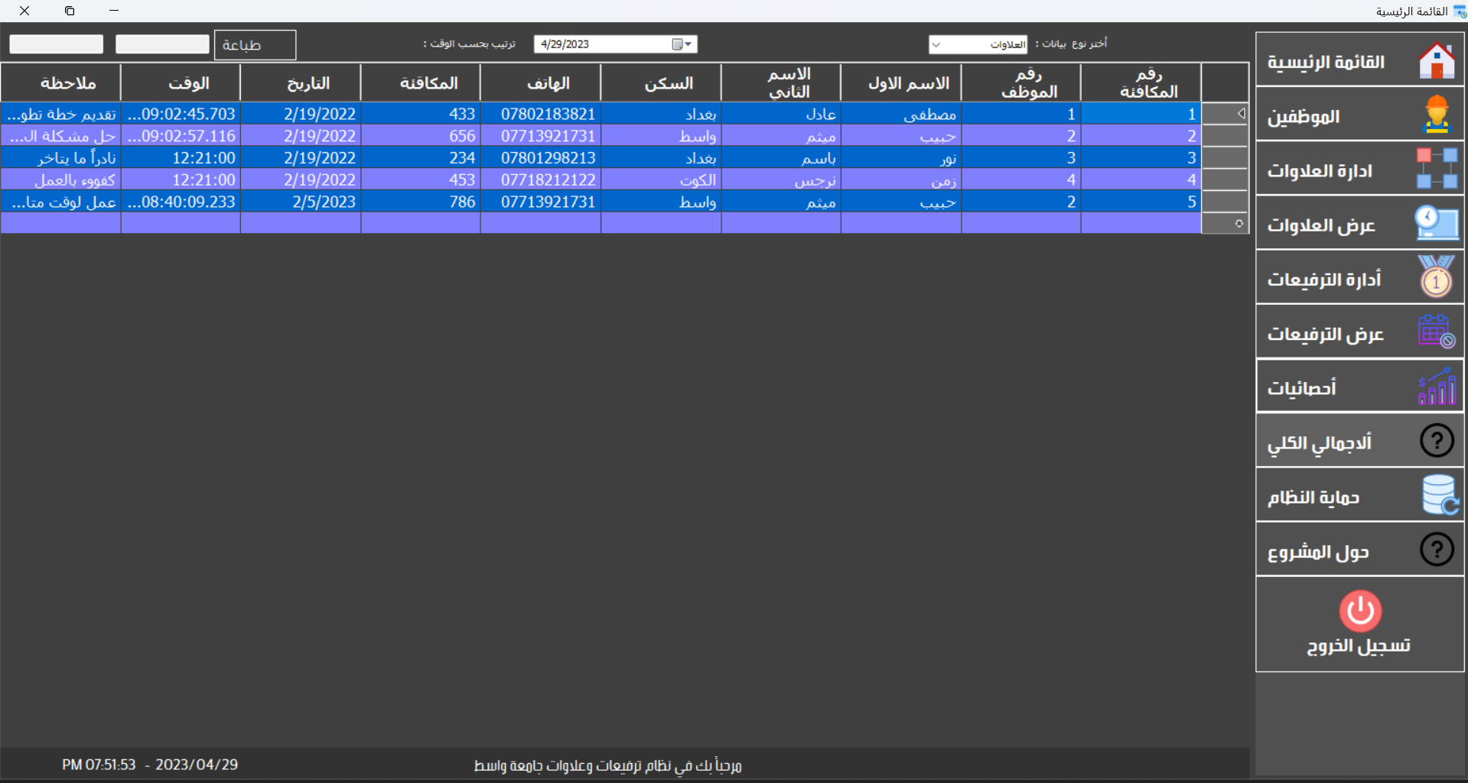

Figure 24 . Total

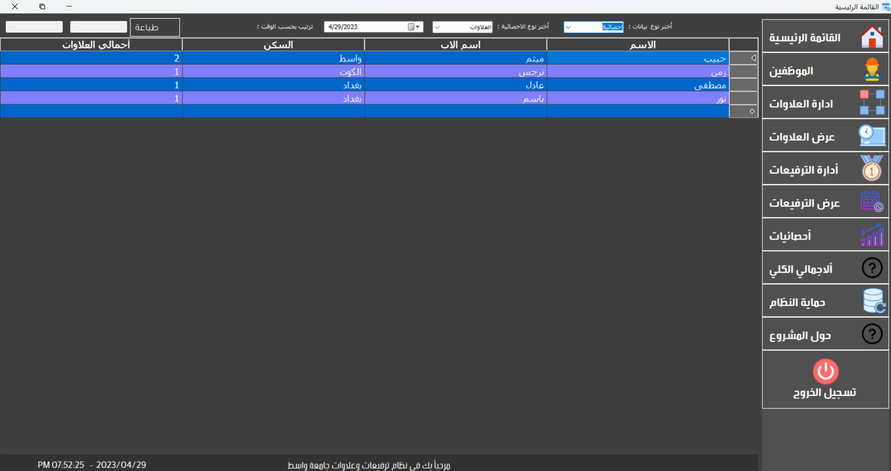

Figure 25 . Information Total

In this window, we notice all the data of the grand total and the total statistics of the data and the existing sections

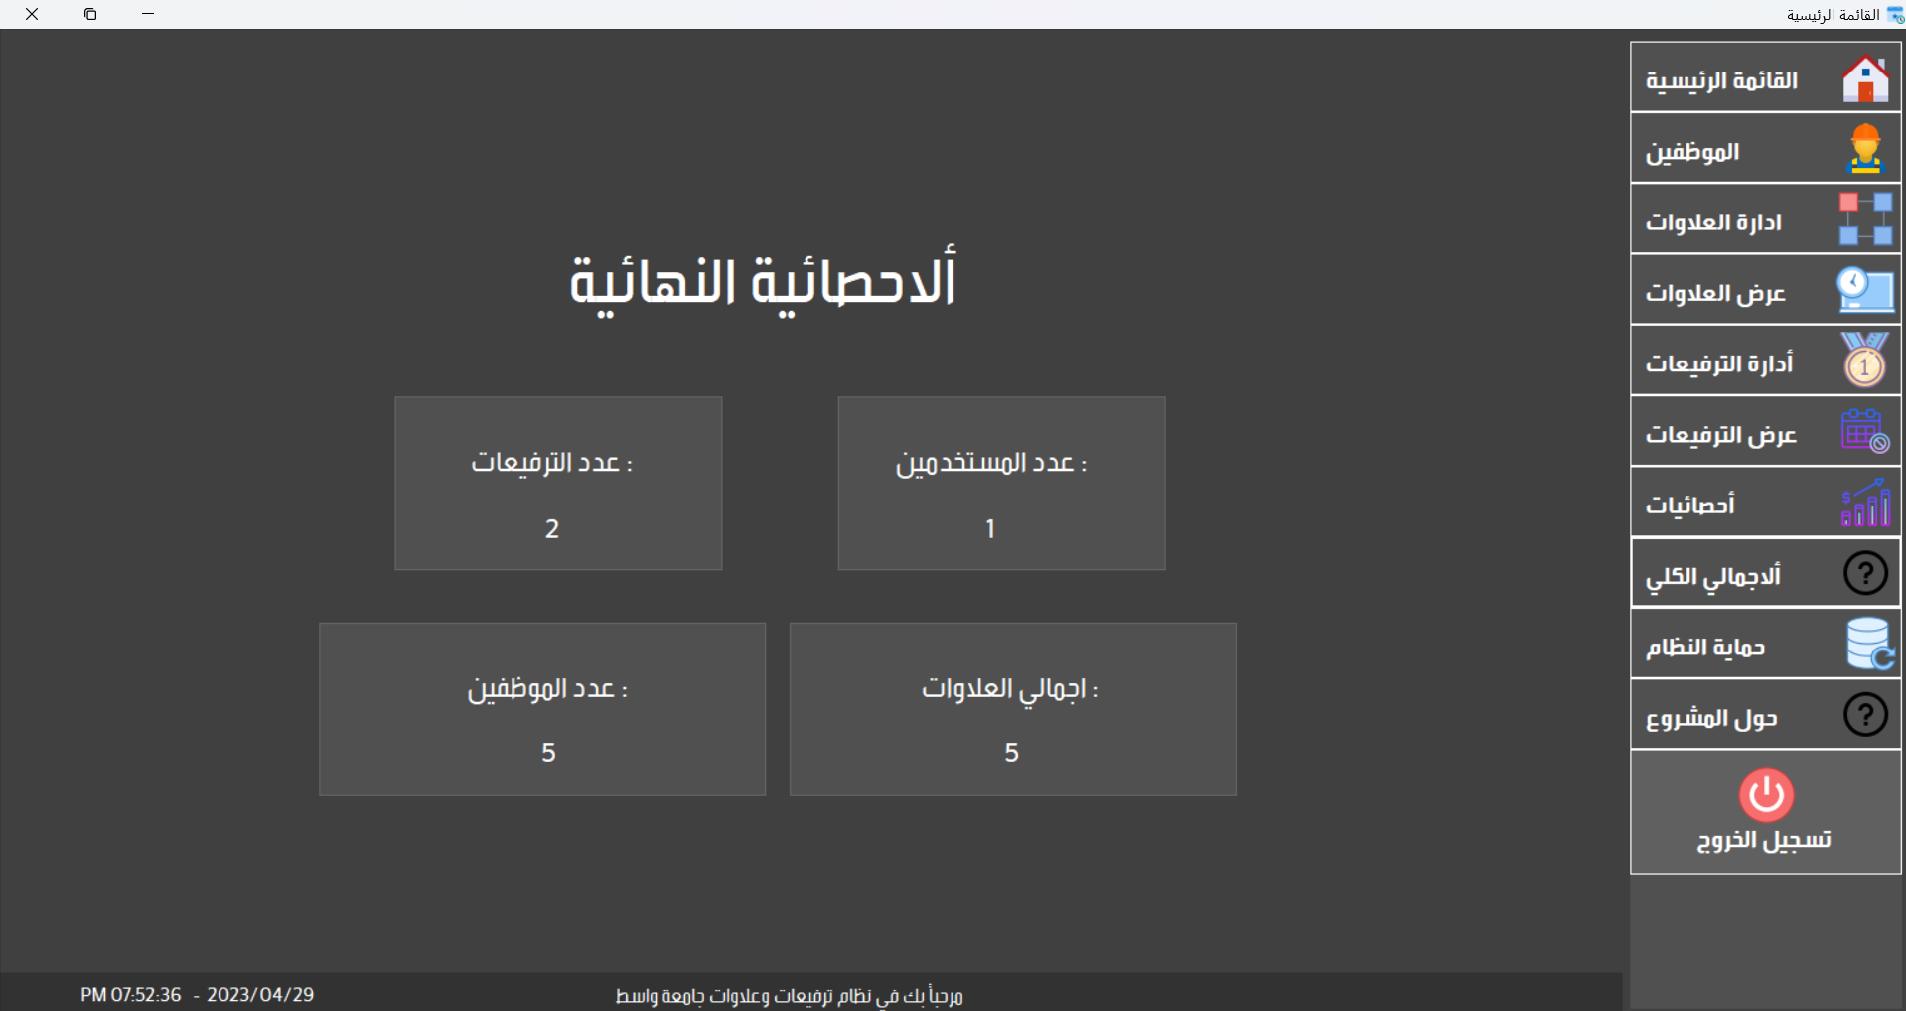

Figure 26 – Total

## **4-10. Backup:**

## In this window, a system backup is made to maintain the safety and protection of all data in a database so that it can be easily restored at any time we need it.

Figure 27 . Backup

## **4-11. About:**

Here in this window, the project data appears, such as the name of the project, the name of the programmer’s students, and the name of the doctor supervising the project.

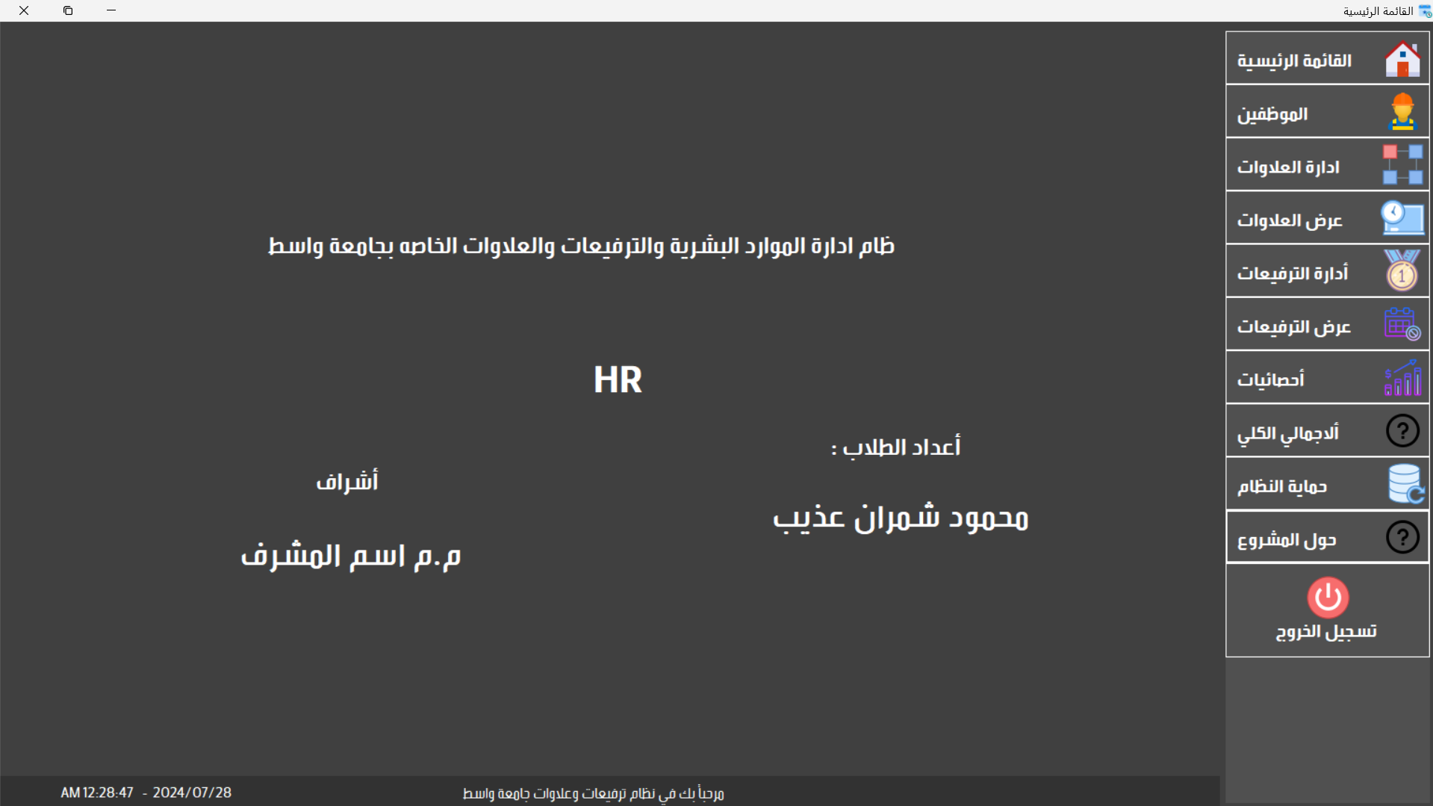

Figure 28 - About

# Chapter Five Conclusions and Recommendations

**5.1. Conclusions:**

A system for managing employee promotions and bonuses by determining the reward amount in the bonuses section, managing employee promotions, increasing their salaries, managing certificates of thanks and appreciation, and preventing adding more than 3 certificates in the same year, in addition to complete management of employee data, total data statistics, quick inventory, and high protection on the system by making a copy Backup and restore at any time.

**5.2. Recommendations:**

We recommend developing the system by uploading the database on hosting such as Microsoft hosting or Google hosting and converting the system from local to global connection so that the company or organization can be managed remotely, and the presence of user permissions is one of the reasons why the program is able to manage several branches and not one branch.

We also recommend that the data stored in the database be encrypted by an encryption algorithm to protect the data from hacking.

# References:

[1] تأثير الذکاء الاصطناعي وآثاره علي العمل والوظائف 2021,

<https://journals.ekb.eg/article_164993.html>

[2] Valverde, Camilo José Lopes , the case of a human resources consulting firm, 2021

<https://repositorio.ucp.pt/bitstream/10400.14/36914/1/202894550.pdf>

[3] Nishad Nawaz, Universities Human Resource Management System ,2020

<https://www.academia.edu/download/61946463/Universities_Human_Resource_Management_System20200130-102704-vn40ih.pdf>

[4] Mohamed, Abdullahi Said, Development of an improved Web-based System for the Human Resource Management Unit of Somali University, 2019

<https://ir.kiu.ac.ug/handle/20.500.12306/4811>

[5] Chithra Biju Menon, Vaibhav Narwane, Relevance of Database and Information Retrieval System in Mechanical Engineering Program: A Case Study, 2020

<https://ir.kiu.ac.ug/handle/20.500.12306/4811>

[6] Tengsi Mayang Nopita Sari, Application of the Simple Additive Weighting (SAW) Method in Recommended Skripsi Topics , 2022

<https://www.penerbitadm.com/index.php/KOMITEK/article/view/953>