Pitch Checker

Mikaela Cubon

University of Missouri – Kansas City

Table of Contents

Vision Statement 2

Requirements 2

Product Backlog 2

Sprint #1 2

Review 2

Retrospective 2

Sprint #2 2

Review 2

Retrospective 2

Sprint #3 2

Review 2

Retrospective 2

Sprint #4 2

Review 2

Retrospective 2

Sprint #5 2

Review 2

Retrospective 2

Sprint #6 2

Review 2

Retrospective 2

# **Vision Statement**

The project goal is to make a pitch checker for aspiring musicians and vocalists.

As a singer, the app should tell me the note I sing so that I can practice my pitch. As a pianist, the app should tell me the note I have played on my keyboard so that I can practice learning my keys. This is all that is planned for initial release.

Stretch Goal: Have a user enter the note they are trying to play/sing. Tell the user if they must sing higher/lower to reach the target. Check permissions before accessing storage.

# **Requirements**

A discussion of what your application is required to have in functionality. It should identify user roles and goals/actions, and what the key features of the app should be.

|  |  |
| --- | --- |
| **Actor** | **Goal** |
| Base User | Can record a sound (sung/played), and see the corresponding pitch. |
|  |  |
|  |  |
|  |  |
|  |  |
|  |  |
|  |  |
|  |  |
|  |  |
|  |  |
|  |  |
|  |  |
|  |  |
|  |  |
|  |  |

### Product Backlog

This will be updated throughout the semester as new PBIs are added, larger items are broken into smaller ones, and completed items removed.

|  |  |  |  |  |
| --- | --- | --- | --- | --- |
| **Story ID** | **Story** | **Story Points**  **(in est. hours)** | **Priority** | **Status** |
| 1 | The app must determine different pitches | 14 | 1 | IP |
| 2 | The app must detect audio with the speaker | 14 | 1 | Complete |
| 3 | The app will store different pitches with a corresponding note | 14 | 2 | IP |
| 4 | The app will record a user pitch and tell you which pitch it thinks it is | 14 | 2 | Waiting |
| 5 | The app will be tested to see that it successfully returns a guess for user input with voice and piano | 14 | 3 | Waiting |
| 6 | The app will be tested for improved accuracy | 14 | 3 | Waiting |

# **Sprint #1**

Sprint Backlog

|  |  |  |  |
| --- | --- | --- | --- |
| **Story ID** | **Story / Task** | **Estimated**  **Hours** | **Actual**  **Hours** |
| 1 | Access speaker | 4 | NA |
| 1 | Print letter when received | 4 | NA |
| 1 | Store Recording | 4 | NA |
| 2 | Base Note for reference | 7 | NA |
| 2 | Detect change from base note | 7 | NA |
|  |  |  |  |
|  |  |  |  |

## 

## Review

**New Velocity**: No work has been done towards iteration 1.

**Tasks Complete:** 0

## Retrospective

Very behind schedule. Will need to put in 28 hours within the next sprint in order to compensate. Will be cutting the sprint 2 task goals in half until work is accomplished.

**Sprint 2 goal:** The app detects audio, the app can distinguish pitch, and the app prints a note for each pitch it detects; print to the screen a different letter each time a different pitch is picked up; take in a user sound, and print a guess as to what pitch it is

# **Sprint #2**

Sprint Backlog

|  |  |  |  |
| --- | --- | --- | --- |
| **Story ID** | **Story / Task** | **Estimated**  **Hours** | **Actual**  **Hours** |
| 1 | Access speaker | 4 | 8 |
| 1 | Print letter when received | 4 | 8 |
| 1 | Store Recording | 4 | 8 |
| 2 | Base Note Reference | 7 | NA |
| 2 | Detect change from base note | 7 | NA |
|  |  |  |  |
|  |  |  |  |

## Review

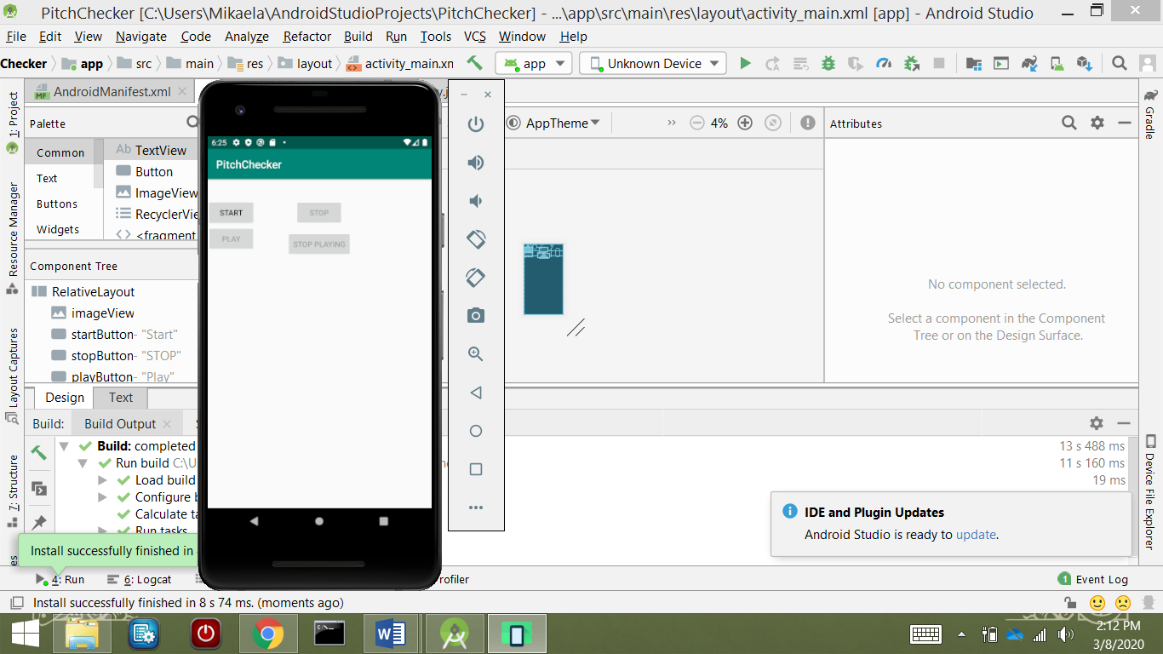

## <https://github.com/M1K43L4/CS449/tree/master/Iteration2>

The app can now successfully record audio and store it to a temporary file. It does not print a letter to the screen when audio is received and stored, but instead displays a message informing user of success. It does not yet have any sort of note identification, which was planned for this sprint.

**New Velocity**: Sum of estimates of the features completed = 12

## Retrospective

Still behind schedule. Research for tasks (modules to use, how they work, etc.) before coding can begin is taking longer than expected. Goals for next sprint will need to be reduced since velocity is just not what was expected.

**Sprint 3 goal:** The app can distinguish pitch in the audio it records

# **Sprint #3**

Sprint Backlog

|  |  |  |  |
| --- | --- | --- | --- |
| **Story ID** | **Story / Task** | **Estimated**  **Hours** | **Actual**  **Hours** |
|  |  |  |  |
|  |  |  |  |
|  |  |  |  |
|  |  |  |  |
|  |  |  |  |
|  |  |  |  |
|  |  |  |  |

## Review

[Screenshots, etc go here. This is where you discuss the product, describing what was done this sprint (potentially shippable product increment) and what was planned for the sprint but was not done. ]

## Retrospective

[This is where you discuss the process. What went well (and are you planning to do more of that?) What didn’t go so well (and do you have a way to do less of that)? What changes are you planning to make in how you plan & carry out the next sprint?]

# **Sprint #4**

Sprint Backlog

|  |  |  |  |
| --- | --- | --- | --- |
| **Story ID** | **Story / Task** | **Estimated**  **Hours** | **Actual**  **Hours** |
|  |  |  |  |
|  |  |  |  |
|  |  |  |  |
|  |  |  |  |
|  |  |  |  |
|  |  |  |  |
|  |  |  |  |

## Review

[Screenshots, etc go here. This is where you discuss the product, describing what was done this sprint (potentially shippable product increment) and what was planned for the sprint but was not done. ]

## Retrospective

[This is where you discuss the process. What went well (and are you planning to do more of that?) What didn’t go so well (and do you have a way to do less of that)? What changes are you planning to make in how you plan & carry out the next sprint?]

# **Sprint #5**

Sprint Backlog

|  |  |  |  |
| --- | --- | --- | --- |
| **Story ID** | **Story / Task** | **Estimated**  **Hours** | **Actual**  **Hours** |
|  |  |  |  |
|  |  |  |  |
|  |  |  |  |
|  |  |  |  |
|  |  |  |  |
|  |  |  |  |
|  |  |  |  |

## Review

[Screenshots, etc go here. This is where you discuss the product, describing what was done this sprint (potentially shippable product increment) and what was planned for the sprint but was not done. ]

## Retrospective

[This is where you discuss the process. What went well (and are you planning to do more of that?) What didn’t go so well (and do you have a way to do less of that)? What changes are you planning to make in how you plan & carry out the next sprint?]

# **Sprint #6**

Sprint Backlog

|  |  |  |  |
| --- | --- | --- | --- |
| **Story ID** | **Story / Task** | **Estimated**  **Hours** | **Actual**  **Hours** |
|  |  |  |  |
|  |  |  |  |
|  |  |  |  |
|  |  |  |  |
|  |  |  |  |
|  |  |  |  |
|  |  |  |  |

## Review

[Screenshots, etc go here. This is where you discuss the product, describing what was done this sprint (potentially shippable product increment) and what was planned for the sprint but was not done. ]

## Retrospective

[This is where you discuss the process. What went well (and are you planning to do more of that?) What didn’t go so well (and do you have a way to do less of that)? What changes are you planning to make in how you plan & carry out the next sprint?]