Part 2: Design Alternatives

Scenario:

**Scenario 1** – Aling Rosa, a sari-sari store owner, often forgets which items are low in stock and ends up missing sales opportunities because she doesn’t have an updated inventory system.

**Scenario 2** – Mang Jun, who runs a small carinderia, struggles to track how much money he earns daily, as most of his records are written on scattered notebooks and receipts that often get lost.

**Scenario 3** – Jenny, a young entrepreneur selling beauty products online, wants to expand her business, but she finds it difficult to show a clear income record when applying for a business loan due to her lack of formal tracking.

Storyboard (Based on Scenarios):

* Scenario 1 – Aling Rosa uses KITA KO's warehouse stock monitoring feature. She gets automatic alerts when items are low, allowing her to restock efficiently and avoid lost sales.
* Scenario 2 – Mang Jun logs his daily income through the KITA KO app using simple categories. He checks weekly summaries to ensure he’s staying within budget and hitting his savings goals.
* Scenario 3 – Jenny uses the income history and analytics feature to download a summary report, which she submits as proof of earnings when applying for a business loan.

Design

App Icon Sizes KITA KO’s application icon will be developed in standard sizes (36x36 to 192x192) to maintain clarity and brand identity across all screen resolutions and device types.



Color Palette

KITA KO uses a clean, modern palette with friendly tones to reflect simplicity and professionalism. Key colors include:

**Background color:** #ede5c3 (a soft light beige/yellow)

**House color:** #292929 (dark charcoal/near black)

**Text (KITAKO):** Pure black (#000000)

Font Style

The app will use Poppins for its clear readability and modern aesthetic, consistent across titles, inputs, and body text.

GUI

KITA KO will utilize a mobile-first Android GUI, designed in Figma, with easily accessible buttons, visual stock indicators, and category tabs to simplify navigation.

Sample Feature Flows

* 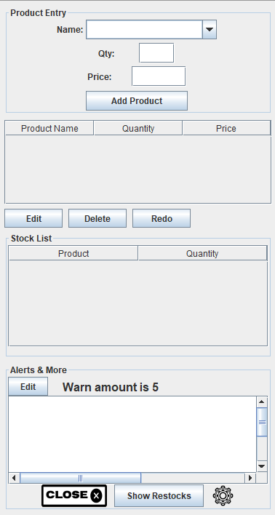Flow - CRUD Inventory: Users can Create, Read, Update, and Delete products in their inventory. This is available from the *Warehouse* tab and syncs with the main dashboard.
* Flow - Add Income: The user inputs income per day or per transaction, tags it by source (e.g., sales, delivery, commission), and the data is logged automatically.

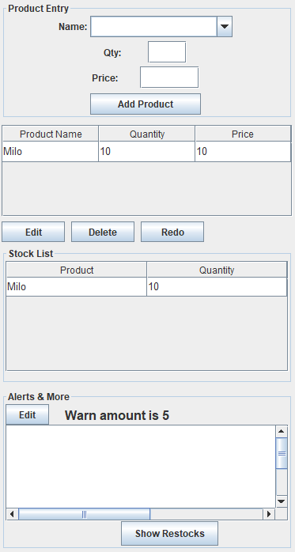

* Flow - Restock Alert: When item levels fall below a set threshold, the user receives a notification suggesting restock action and estimated cost.

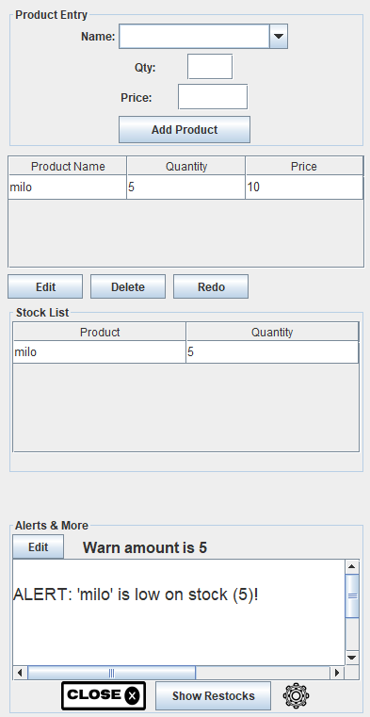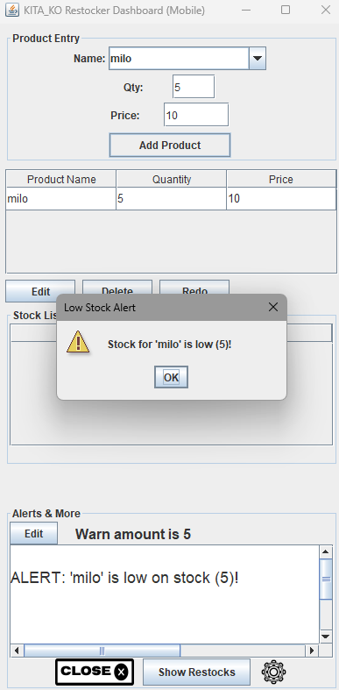

* Flow - Export Report: Users generate income and inventory reports (PDF/CSV) for use in business applications or audits.

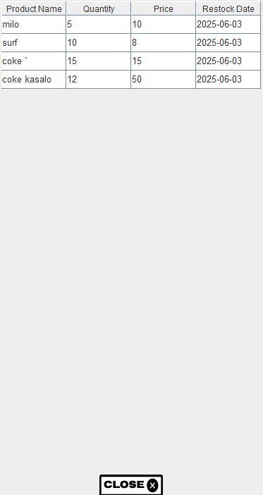

Design Sketches and Alternatives

Sketches include:

* Splash Screen with the KITA KO logo and tagline “Track. Restock. Grow.”
* Navigation Drawer including tabs for Dashboard, Inventory, Sales Log, Warehouse, Reports, and Settings.
* Main Dashboard displaying key metrics (e.g., Today’s Earnings, Low Stock Alerts).
* Income Entry Page with a simple form and category dropdown.
* Inventory Page with sortable and filterable stock lists.

Additional Feature Suggestions

* Notification System: Sends reminders for restocking, overdue updates, and weekly summaries.
* Multi-language Support: Optional Tagalog/English language toggle for better accessibility.
* Offline Mode: Allows data input offline and syncs when internet is available—crucial for users in rural or low-connectivity areas.