Restore default audio device

While installing the VB-Cable (virtual audio cable), the default audio device is switched to the Cable-Input. To restore the default audio device, right click on the speaker icon in the system tray (right side of the task bar), click on „playback devices“, select your default speaker (see image below, 1) and choose „as default“ on the bottom (see image below, 2).
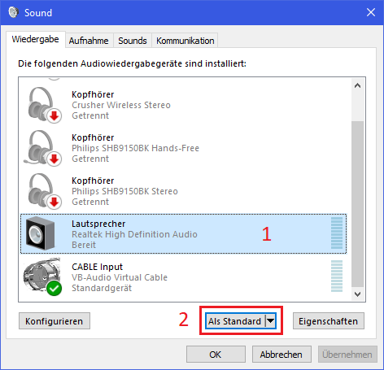

Click on Record, select the Cable-Output and open the properties. Go to the Listen to tab and tick the checkbox „Use this device as playback device“ and select the default device as playback device.

