Software Requirements Specification
for
Grocery Store Management App
Version 1.0 approved
Prepared by:
Muhammad Mikail Iqbal (23K-0841), Shayan Amir (23K-0623), Ahmed Mirza (23K-0010)
FAST-NUCES – BCS-5A
Date: October 2025

Table of Contents
- Introduction
1.1 Purpose
1.2 Document Conventions
1.3 Intended Audience and Reading Suggestions
1.4 Product Scope
1.5 References
- Overall Description
2.1 Product Perspective
2.2 Product Functions
2.3 User Classes and Characteristics
2.4 Operating Environment
2.5 Design and Implementation Constraints
2.6 User Documentation
2.7 Assumptions and Dependencies
- External Interface Requirements
3.1 User Interfaces
3.2 Hardware Interfaces
3.3 Software Interfaces
3.4 Communications Interfaces
- System Features
4.1 Inventory Management
4.2 Order Management
4.3 User Management
- Other Nonfunctional Requirements
5.1 Performance Requirements
5.2 Safety Requirements
5.3 Security Requirements
5.4 Software Quality Attributes
5.5 Business Rules
- Other Requirements
Appendices
1. Introduction
1.1 Purpose
The purpose of this document is to define the requirements for the Grocery Store Management App, a web-based application aimed at automating and streamlining daily grocery store operations, including inventory management, order handling, and customer interaction.
1.2 Document Conventions
- Requirement IDs will be labeled as REQ-#.
- High-level requirements are categorized under system features.
- Functional and nonfunctional requirements are clearly separated.
1.3 Intended Audience and Reading Suggestions
- Developers: Use this document to understand system features and implementation requirements.
- Project Managers: Track progress and ensure requirements are met.
- Testers: Verify that the system complies with specified requirements.
- End Users/Admins: Understand the scope and functions of the system.
1.4 Product Scope
The system will:
- Simplify inventory management by allowing admins to add, update, and delete products.
- Provide smooth order placement and tracking for customers.
- Ensure secure login and role-based access.
- Improve accuracy and efficiency while reducing manual workload.
1.5 References
- CL-2005 Database Systems Lab Project Proposal Document (2025).
- IEEE SRS Template by Karl E. Wiegers.
2. Overall Description
2.1 Product Perspective
The Grocery Store Management App is a new, self-contained product that integrates:
- A frontend (HTML, CSS, JavaScript)
- A backend (Python with Flask/Django)
- A structured SQL database
2.2 Product Functions
- Inventory Management (CRUD operations on products).
- Order Management (placing, fetching, tracking orders).
- User Management (login, authentication, role-based access).
2.3 User Classes and Characteristics
- Administrators: Manage inventory and oversee orders.
- Customers: Place and track orders.
- Store Managers: Monitor overall performance and stock.
2.4 Operating Environment
- Hardware: Standard PC or server.
- OS: Windows/Linux.
- Browser Support: Chrome, Firefox, Edge.
- Database: SQL.
- Backend: Python (Flask/Django).
2.5 Design and Implementation Constraints
- Must use SQL for database handling.
- Web-based interface accessible via browsers.
- Session management for secure access.
2.6 User Documentation
- Online help pages.
- User manual for customers and admins.
- Quick start guide.
2.7 Assumptions and Dependencies
- Users have internet access.
- Store inventory is updated regularly.
- Application will rely on stable hosting and SQL database availability.
3. External Interface Requirements
3.1 User Interfaces
- Web-based GUI (responsive design).
- Login/registration forms.
- Product list, cart, and order tracking screens.
3.2 Hardware Interfaces
- Standard web server hardware.
- No specialized hardware required initially.
3.3 Software Interfaces
- SQL database.
- Python backend.
- Browser-client interaction over HTTP/HTTPS.
3.4 Communications Interfaces
- Secure HTTPS protocol.
- Possible future integration with email/SMS for notifications.
4. System Features
4.1 Inventory Management
Description and Priority: High. Allows administrators to manage products.
Stimulus/Response: Admin adds, updates, deletes, or views inventory.
Functional Requirements:
- REQ-1: User/Admin can add new products with details (name, category, price, stock).
- REQ-2: User/Admin can update product prices.
- REQ-3: User/Admin can delete outdated products.
- REQ-4: System displays full inventory list.
4.2 Order Management
Description and Priority: High. Manages order placement and tracking.
Functional Requirements:
- REQ-5: User/Admin can place orders.
- REQ-6: System fetches and displays order details.
- REQ-7: User/Admin can view order history.
- REQ-8: User/Admins can analyze order patterns.
4.3 User Management
Description and Priority: High. Manages authentication
Functional Requirements:
- REQ-9: User/admin must log in securely.
- REQ-10: System ensures secure session handling.
5. Other Nonfunctional Requirements
5.1 Performance Requirements
- The system should be able to handle CRUD operations with a secure connections offering minimal latency.
5.2 Safety Requirements
- Regular database backups.
- Order history must be preserved in case of failure.
5.3 Security Requirements
- Encrypted passwords.
- Secure login and session management.
5.4 Software Quality Attributes
- Usability: Simple, intuitive UI.
- Scalability: Supports future expansion (supermarkets).
- Reliability: 99% uptime expected.
- Maintainability: Modular design for future enhancements.
5.5 Business Rules
- Only admins can manage products.
6. Other Requirements
- Future integration with payment gateways.
- Mobile app expansion.
- Barcode scanning support.
- Addition of customer based login.
- Role based verification on actions.
Appendix A: Glossary
- CRUD: Create, Read, Update, Delete.
- SQL: Structured Query Language.

Appendix B: Analysis Models

- ER Diagram
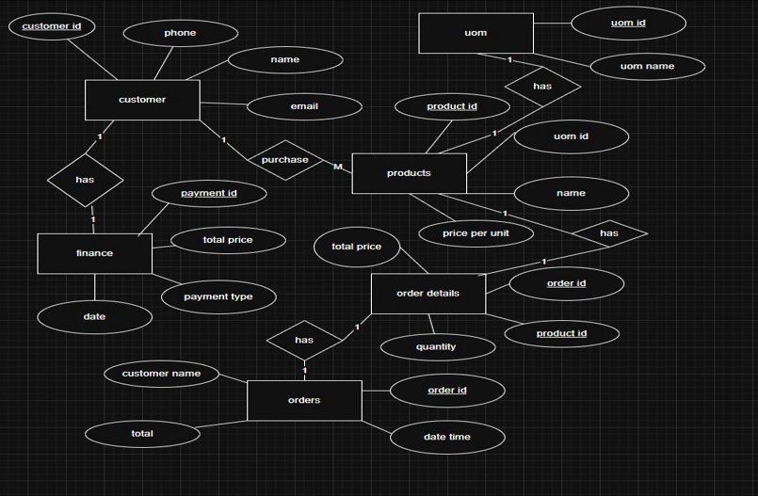

- Use Case Diagram.
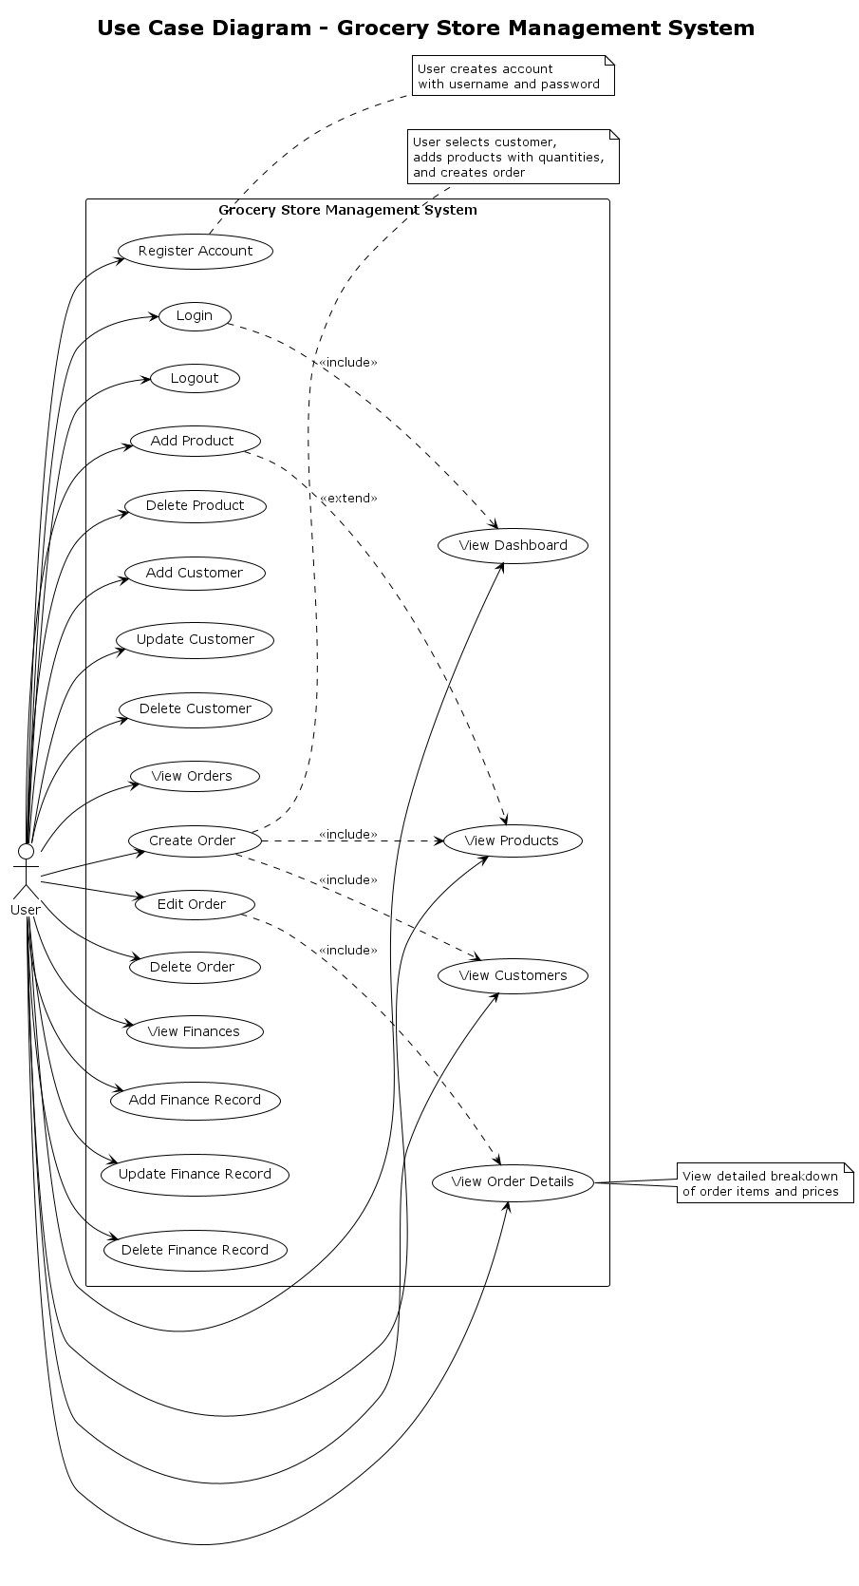

- Activity/Flow Diagram
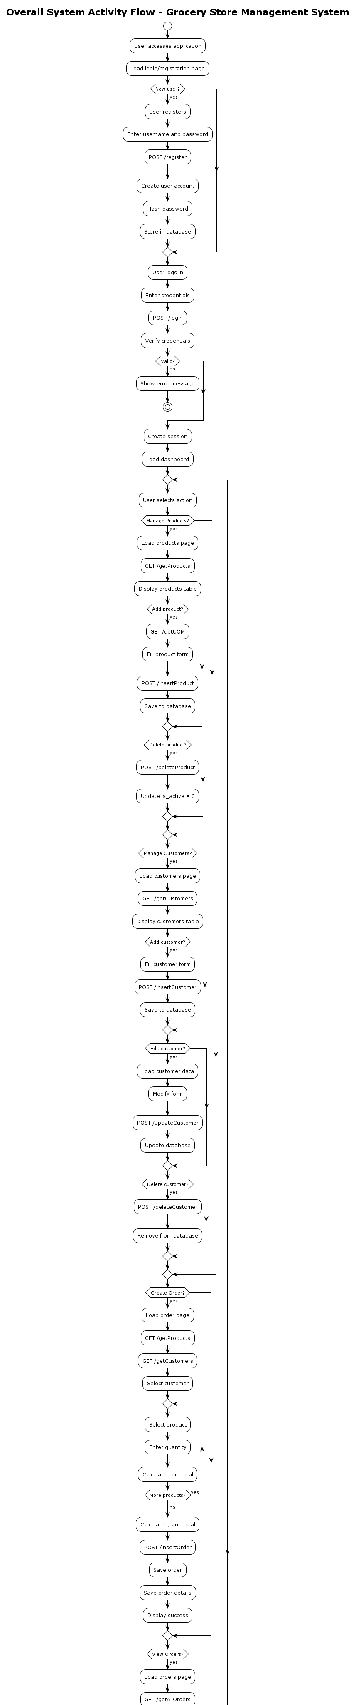

- Sequence Diagram
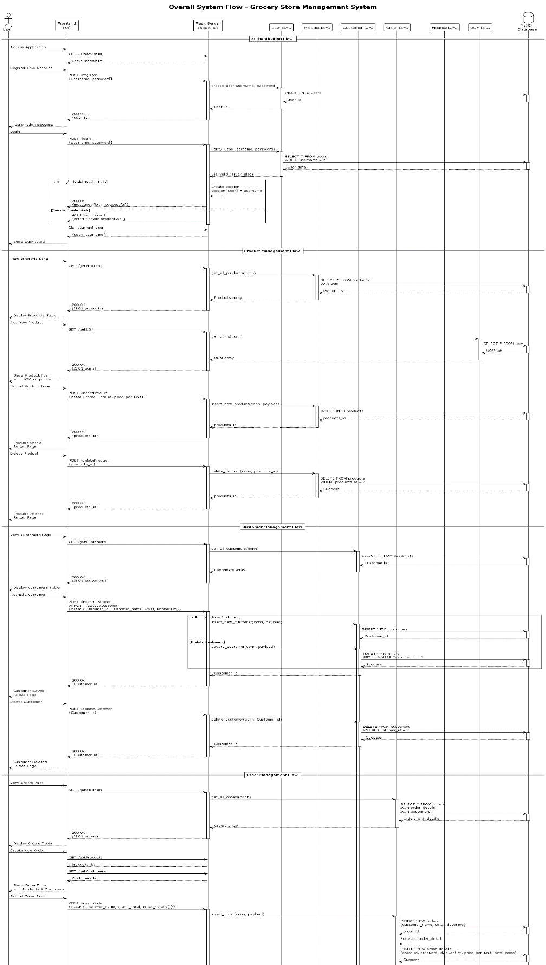

- Deployment diagram
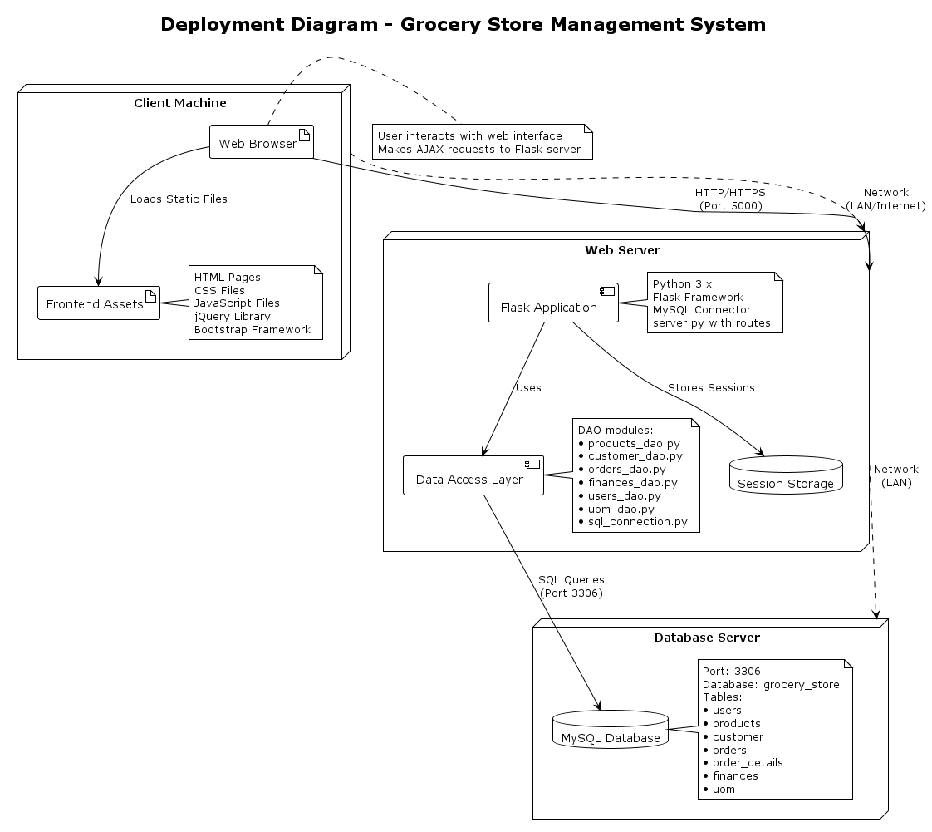

- Component diagram

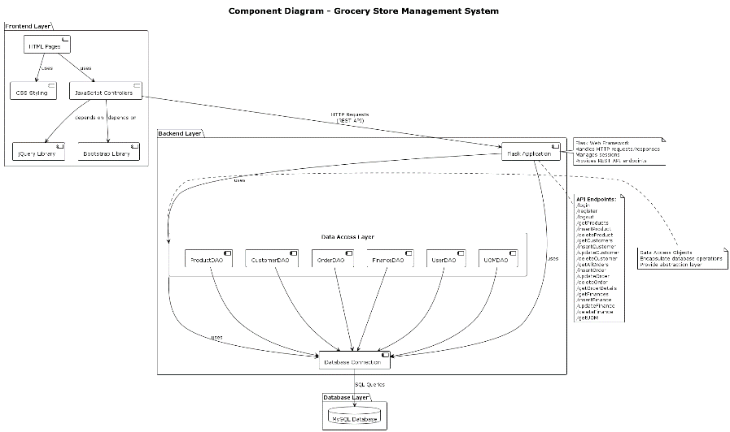
- Timing
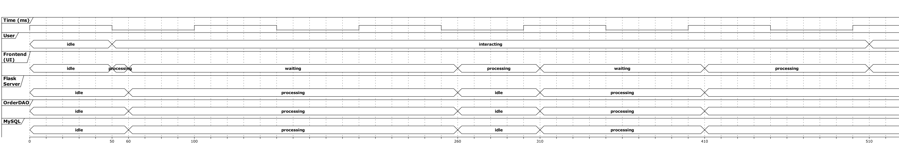
- Collaborative
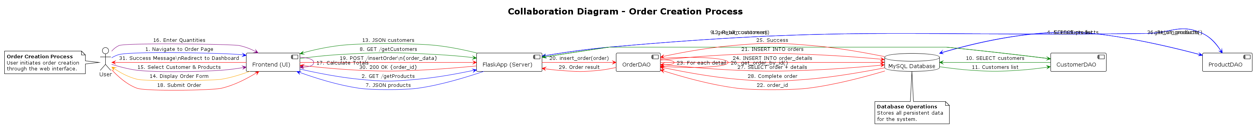

- Sequence
