Wizards of codes

2023 年 10 月 30日

Software requirements specification

Table of Contents

1 Introduction 3

1.1 Purpose of Preparation 3

1.2 Project Background 3

1.3 References 3

2 General Description 4

2.1 Objectives 4

2.1.1 Development Intent 4

2.1.2 Application Objectives and Scope of Use 4

2.1.3 Product Outlook 5

3 Specification 6

3.1 Usage diagram 6

3.2 Activity Diagram 6

3.3 Class Diagrams 7

3.4 Attributes 8

3.4.1 Usability 8

3.4.2 Security 9

4 Functional Description and Acceptance Validation Criteria 10

4.1 Specific Functional Description 10

4.1.1 User interface 10

4.1.2 Business Logic 10

4.1.3 Data access 11

4.2 Input and output formats 11

4.2.1 Input formats 11

4.2.2 Output Formats 12

4.3 Interface acceptance criteria 12

4.4 Functional acceptance criteria 13

**1 Introduction**

**1.1 Purpose of writing**

This document aims to provide a comprehensive description of the campus course management and check-in system's requirements and functions through textual content. It outlines the product's core objectives and future development prospects, ensuring readers gain a thorough understanding of the system. Additionally, it offers detailed insights into the frontend and backend interfaces and functionalities. This detailed overview serves as a guide for the development team, aiding in the system's design and development, and forms the foundation for project acceptance.

**1.2 Project Background**

This project aims to streamline our classroom's management by implementing a Campus Management and Check-in System. Faced with challenges in manual course management and attendance tracking, this system will leverage advanced technology to enhance efficiency and accuracy. By automating these processes, we anticipate a significant improvement in administrative tasks, ultimately creating a more seamless and productive educational environment for both students and staff.

With the expansion of school scale, the increase of course types and the increase in the number of students, the traditional course management and check-in methods can no longer meet the needs of fast and accurate management. Traditional paper-based class schedules and manual check-in methods are error-prone and cumbersome to manage, resulting in challenges for school administrators, teachers, and students in scheduling and check-ins. Therefore, in order to improve the efficiency, accuracy and transparency of education management, it has become an urgent need to develop a campus course management and check-in system. The introduction of this system will help schools better organize courses, manage teacher and student information, and improve the quality of teaching. In this context, the project was born and advanced.

**1.3 References**

1. 李园园.基于Web Services校园课程管理系统[J].数字技术与应用,2011(07):135+138. DOI:10.19695/j.cnki.cn12-1369.2011.07.093.
2. 秦虎.基于数字化校园的智能教务管理系统的教师、学生评价模型构建研究[D].华东师范大学:2008.
3. 刘金涛.基于Web的职业学校校园网课程学习管理系统设计与实现[D].中国海洋大学:2010.
4. 张超,李依静.智慧校园分层走班制课程管理系统的设计与实现[J].电脑编程技巧与维护,2020(05):82-84. DOI:10.16184/j.cnki.comprg.2020.05.029.
5. K. Xu, S. Yu, J. Ding, R. Hu and Q. Zhu, "Design and Implementation of Check-In System Based on Workflow Technology," 2017 International Conference on Smart Grid and Electrical Automation (ICSGEA), Changsha, China, 2017, pp. 60-63, doi: 10.1109/ICSGEA.2017.69.

[6]N. Sae-Lim, A. Sinchai, N. Yiangsupapaanontr and P. Tuwanut, "A Check-in System Supporting Multiple Attendees Check-in at a Time by Proximity-based Methods," 2021 18th International Conference on Electrical Engineering/Electronics, Computer, Telecommunications and Information Technology (ECTI-CON), Chiang Mai, Thailand, 2021, pp. 157-162, doi: 10.1109/ECTI-CON51831.2021.9454680.

2 General description

**2.1 Objectives**

The primary objective of our project is to develop and implement a robust Campus Management and Check-in System that revolutionizes administrative efficiency and student attendance tracking. Through seamless automation, the system aims to eliminate manual errors, optimize resource allocation, and enhance overall productivity. By providing real-time insights and intuitive interfaces, our goal is to empower faculty, staff, and students, fostering a technologically advanced learning environment. Ultimately, this initiative strives to create a streamlined, user-friendly system that significantly improves operational processes, ensuring a more enriching educational experience for everyone involved.

**2.1.1** **Development intention**

Our development intent is to craft an innovative, user-friendly Campus Management and Check-in System. By integrating advanced technology and intuitive design, our goal is to simplify administrative processes and user's operation. We strive to create a dynamic platform that adapts to evolving educational needs.

**2.1.2** **Apply goals and target objects**

1. Application Goals

1. Efficiency Enhancement: Streamline administrative processes to reduce time and effort, improving overall workflow efficiency.

2. Accuracy Improvement: Minimize errors in attendance records and data management, ensuring precise and reliable information for decision-making.

3. User Empowerment: Provide intuitive interfaces for students, faculty, and staff, empowering them to manage schedules and access information seamlessly.

4. Real-time Insights: Deliver timely data and analytics, enabling informed decision-making and proactive responses to academic needs.

5. Adaptability: Create a flexible system capable of adapting to changing academic requirements, ensuring long-term relevance and usability.

1. Target Objects

The primary target audience for our project includes students, faculty members, and administrative staff within our campus. By catering to these groups, the Campus Management and Check-in System aims to streamline interactions, simplify administrative tasks, and enhance the overall educational experience. Additionally, the system will be designed to benefit stakeholders involved in course management, attendance tracking, and resource allocation processes.

**2.1.3 Product prospect**

1. Enhanced Teaching Efficiency: By automating attendance and grade management, teachers can focus more on teaching content, thus improving teaching efficiency.
2. Increased Student Engagement: Through online course materials, discussions, and real-time grade feedback, students can actively participate in the learning process.
3. Improved School Management: School administrators can analyze data reports generated by the system to understand student attendance rates, academic performance, etc., enabling better school management strategies.
4. Enhanced School Image: By using modern technology and tools, schools can enhance their image, attracting more students and staff.
5. Increasing Market Demand: With the popularity of online education, the demand for such course management systems is on the rise. Educational institutions and schools are increasingly recognizing the importance of automated management.
6. Sustainable Development: With the emergence of new technologies and demands, your product can continuously be updated and expanded to meet new market needs.

**3 Specification**

**3.1 utilization chart**

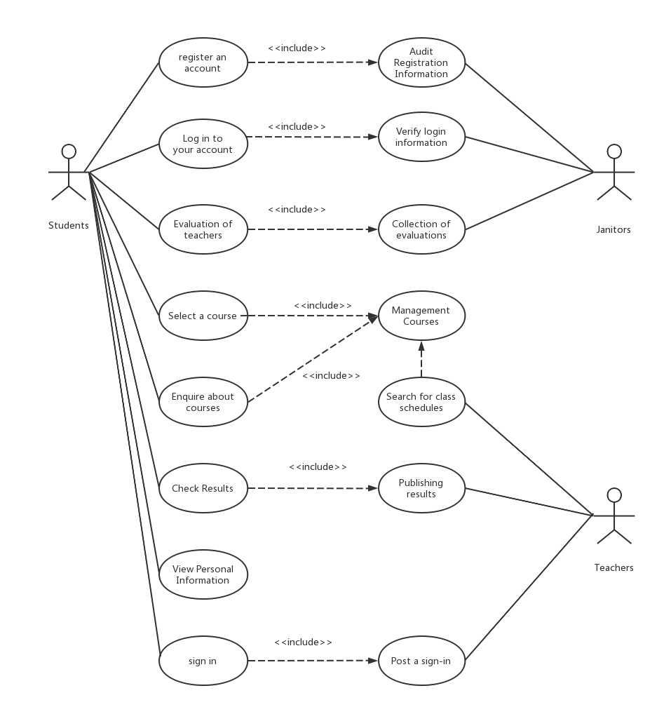

**3.2 Activity Map**

This includes user registration and login, updating personal information, and searching and selecting courses.

User login and registration:

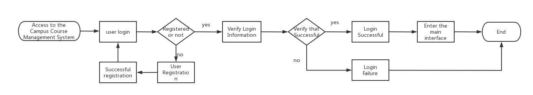

Updating Personal Information

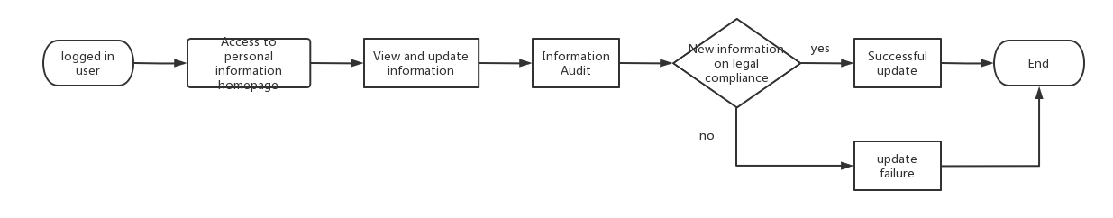

Course Selection Process 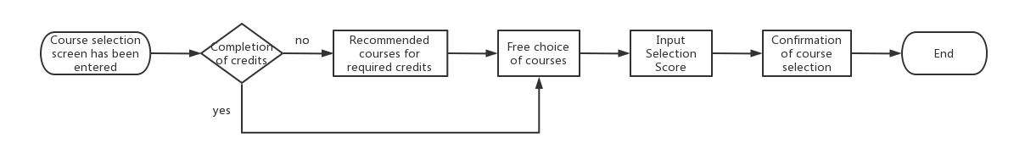

Check-in process

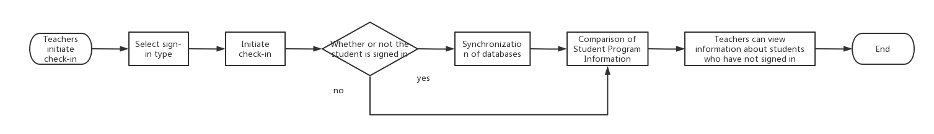

**3.3 Class diagram**

It includes the following core categories: Students, Teachers, and Courses. The Student category includes methods such as registration, login, and personal information management. Courses include methods for posting, searching, etc. Teacher class includes methods such as posting sign-in, modifying lesson plans, etc. These classes are related to each other, e.g. students can join multiple courses, teachers can belong to one course, courses are related to one teacher and multiple students.

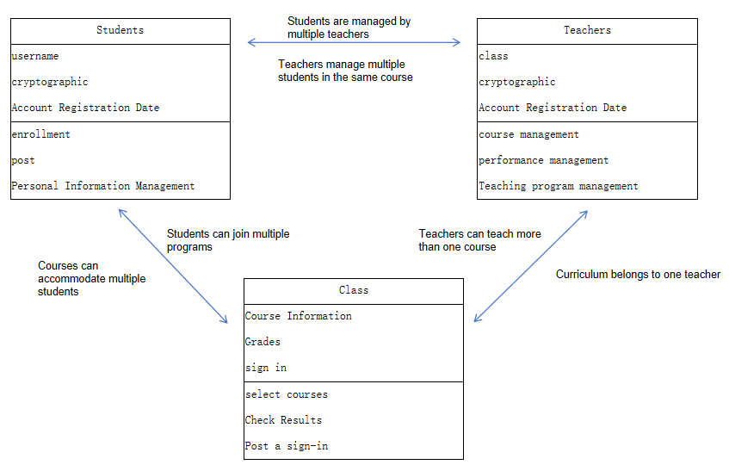

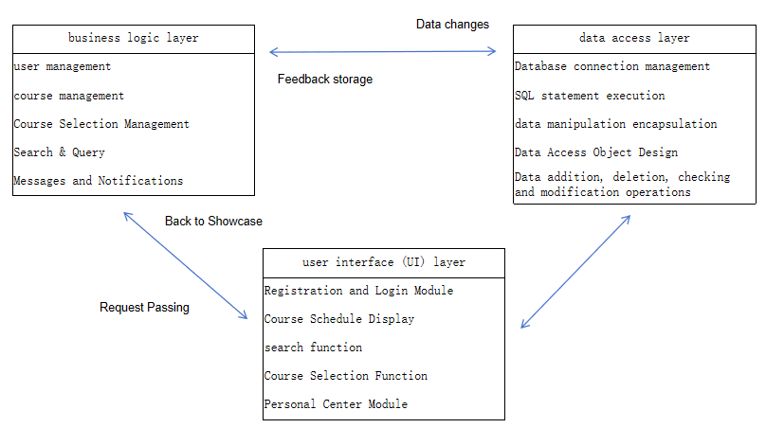

**3.4 Attribute**

**3.4.1 Usability**

1) Simple and clear user interface design, easy to operate and navigate.

2) Good fault tolerance, able to handle user input errors or other abnormal situations. 3) Provide search and categorization function, which is convenient for users to find the items they need quickly.

4) Provide a personal center page for users to manage their own information, posted items, and so on.

5) Provide message notification function to ensure that users can receive timely messages from the system or other users.

**3.4.2 Security**

1) User registration, login, password change and other functions require identity verification and encryption protection.

2) Payment and order information in the transaction process should be transmitted using secure encryption protocols to ensure data security.

3) Users' personal information shall be properly protected and shall not be leaked.

4) The platform establishes security mechanisms to prevent malicious attacks, fraud and information leakage.

**4 Functional Description and Acceptance Verification Criteria**

**4.1 Specific function description**

**4.1.1** **User Interface**

1. **Login and registration interface:**

Provide a user interface for logging in and registering, including input fields for username, password, and other authentication details.

Add registration options, such as verifying identity through school email.

1. **Personal Information Interface:**

After the user logs in, display their personal information, including profile picture, name, student ID, etc.

Allow users to edit personal information, such as changing passwords, updating profile pictures, etc.

1. **Course List and Details Interface:**

Display a list of courses that the user is currently enrolled in, including course name, teacher's name, class schedule, and location.

Clicking on a course should lead to a course details page showing the course description, syllabus, homework requirements, etc.

1. **Attendance Interface:**

Provide an interface for students to check in, including options like scanning QR codes, manually entering check-in codes, or NFC check-ins.

Display attendance status, such as checked in or not, and provide feedback for successful check-ins.

1. **Course Management and Teacher Interface:**

Teachers, upon logging in, can manage courses, including creating new courses, editing course information, and adding students.

Display teacher's personal information, including name and employee ID.

1. **Statistics and Reports Interface:**

Teachers and administrators can view statistics such as course attendance rates, student grade distribution, etc.

Provide visual charts to help users quickly understand data trends.

1. **Grades and Assessment Interface:**

Students can view course grades, exam scores, and homework evaluations.

Teachers can input student grades, add comments, etc.

**4.1.2** **Business Logic**

1. **User Authentication and Authorization:**

User registration, login, and password reset functionality.

User role management (student, teacher, administrator) and access control.

1. **Course Management:**

Create, edit, and delete courses.

Specify course timings, locations, and instructors.

Add, edit, and remove course materials, assignments, and exam information.

1. **Student Management:**

Management of student attendance records.

Management and publication of student grades.

1. **Teacher Management:**

Teachers create courses.

Teachers view and edit student rosters.

Teachers enter student grades and evaluations.

1. **Attendance Functionality:**

Generation of QR codes or other check-in codes for student attendance.

Verification of student check-in status by teachers.

1. **Reports and Statistics:**

Generate statistical reports such as course attendance rates, student grade distributions, etc.

Provide graphical interfaces to display data.

1. **Grade Management:**

Teachers can enter student grades and comments.

Students can view their course grades.

**4.1.3 Data Access**

You can add, delete, modify, and query the following data.

1. **Student Information:** Student name, student ID, class, contact information, profile pictures, etc.

**2)** **Course Information:** Course name, course code, instructor, class schedule, location, course description, syllabus, etc.

**3)** **Attendance Records:** Student attendance status (checked-in, not checked-in), check-in time, location, etc.

**4)** **Instructor Information:** Instructor name, employee ID, contact information, profile pictures, etc.

**5) Course Grades:** Student course grades, exam scores, assignment grades, etc.

**4.2**  **Input/output format**

1. **Login and Registration Interface:**

**Input Format:**

Username: Text input field

Password: Password input field

**Output Format:**

Login successful: Redirect to the personal information interface

Registration successful: Redirect to the login interface

1. **Personal Information Interface:**

**Input Format:**

Change password: Password input field

Edit personal information: Text input fields, upload avatar button

**Output Format:**

Save successful: Display save successful message

Avatar updated: Display new avatar

1. **Course List and Details Interface:**

**Input Format:**

Click on a course: Navigate to the course details interface

**Output Format:**

Course details: Display course name, instructor information, course description, syllabus, etc.

1. **Attendance Interface:**

**Input Format:**

Scan QR code: Activate camera for scanning

Manually enter check-in code: Text input field

**Output Format:**

Check-in successful: Display check-in successful message, update attendance status

1. **Course Management and Teacher Interface:**

**Input Format:**

Create new course: Course information form

Edit course information: Text input fields, dropdown menus

**Output Format:**

Operation successful: Display operation successful message

1. **Statistics and Reports Interface:**

**Input Format:**

Select statistical parameters: Date range, course name, etc.

**Output Format:**

Statistical charts: Display visual data such as course attendance rates, grade distributions, etc.

1. **Grades and Assessment Interface:**

**Input Format:**

View grades: Select course and semester

**Output Format:**

Grade details: Display course grades, exam scores, assignment grades, etc.

**4.3** **Interface Acceptance Criteria**

**1) Login and Registration Interface:**

Acceptance Criteria:

Users can successfully log in to the system and access the personal information interface.

New users can successfully register and log in to the system.

**2) Personal Information Interface:**

Acceptance Criteria:

Users can successfully change their password, and the new password allows successful login.

Users can successfully edit personal information, and the information updates correctly after saving.

**3) Course List and Details Interface:**

Acceptance Criteria:

Users can browse the course list and click to access the course details interface.

The course details interface displays accurate course information, including course name, instructor details, and course description.

**4) Attendance Interface:**

Acceptance Criteria:

Users can successfully check in, and the system accurately records the attendance status.

After successful check-in, the interface promptly updates to display the check-in status and related information.

1. **Course Management and Teacher Interface**

Acceptance Criteria:

Teachers can successfully create new courses, and the new courses appear in the course list.

Teachers can successfully edit course information, and the information is correctly saved after editing.

**6) Statistics and Reports Interface:**

Acceptance Criteria:

Users can select different statistical parameters, and the system generates corresponding statistical charts.

Statistical charts display relevant data clearly and are easy to understand.

**7) Grades and Assessment Interface:**

Acceptance Criteria:

Students can view course grades, and the grade information is displayed accurately.

Teachers can input student grades, and the grades are correctly saved after input.

**4.4**  **Functional Acceptance Criteria**

1. **User Authentication and Authorization:**

Users can successfully register accounts and log in to the system using the registered information.

Administrators can create, edit, and delete user accounts, assigning correct roles and permissions.

1. **Course Management:**

Teachers can successfully create new courses, specifying course timings, locations, and instructors.

Administrators can edit and delete existing course information.

Students can successfully register and enroll in courses from the course list.

1. **Attendance Functionality:**

Students can check in using the system-generated QR codes or Sign-in codes, and the system accurately records students' attendance status.

Teachers can view student attendance records and manually modify records if necessary.

1. **Grade Management:**

Teachers can enter student grades and comments.

Students can view their course grades, and the system ensures the privacy of grades.

1. **Statistics and Reports Functionality:**

The system can generate reports such as course attendance rates and grade distributions, presenting data graphically.

Reports should have export functionality, allowing administrators and teachers to conduct further analysis.

Acceptance Criteria:

Teachers can successfully create new courses, and the new courses appear in the course list.

Teachers can successfully edit course information, and the information is correctly saved after editing.

**6) Statistics and Reports Interface:**

Acceptance Criteria:

Users can select different statistical parameters, and the system generates corresponding statistical charts.

Statistical charts display relevant data clearly and are easy to understand.

**7) Grades and Assessment Interface:**

Acceptance Criteria:

Students can view course grades, and the grade information is displayed accurately.

Teachers can input student grades, and the grades are correctly saved after input.

**4.4**  **Functional Acceptance Criteria**

1. **User Authentication and Authorization:**

Users can successfully register accounts and log in to the system using the registered information.

Administrators can create, edit, and delete user accounts, assigning correct roles and permissions.

1. **Course Management:**

Teachers can successfully create new courses, specifying course timings, locations, and instructors.

Administrators can edit and delete existing course information.

Students can successfully register and enroll in courses from the course list.

1. **Attendance Functionality:**

Students can check in using the system-generated QR codes or Sign-in codes, and the system accurately records students' attendance status.

Teachers can view student attendance records and manually modify records if necessary.

1. **Grade Management:**

Teachers can enter student grades and comments.

Students can view their course grades, and the system ensures the privacy of grades.

1. **Statistics and Reports Functionality:**

The system can generate reports such as course attendance rates and grade distributions, presenting data graphically.

Reports should have export functionality, allowing administrators and teachers to conduct further analysis