Guided Capstone Project Report
Pricing Strategy for Big Mountain Resort

Problem Statement
Big Mountain Resort's leadership suspects the resort's ticket pricing does not reflect the value of its facilities. The resort currently charges an adult weekend ticket price of $81.00, set primarily by intuition rather than data. The goal of this project was to build a data-driven model of ticket price as a function of resort amenities, benchmark Big Mountain against comparable resorts nationally, and use that model to evaluate specific business scenarios for either increasing revenue or reducing costs — supporting decisions ahead of the coming season.

Data Wrangling
Ticket price and amenity data for over 300 US ski resorts were collected and cleaned. Records with missing target values (ticket price) were dropped, since price could not be imputed reliably. A small number of erroneous or inconsistent values in individual columns were corrected by hand. Categorical geographic labels (resort name, state, and region) were checked for any relationship with price; no meaningful pattern was found, so state/region were excluded from modeling and all resorts were treated as competing in a single national market.

Exploratory Data Analysis
EDA compared Big Mountain's facilities (vertical drop, skiable terrain, number of runs, chairlifts, snow-making acreage, longest run, and number of trams) against the distribution of the same features across all resorts in the dataset. Big Mountain ranks near the top of the distribution for vertical drop, number of runs, and snow-making coverage, but its current ticket price sits well below where those features would suggest it should be — an early signal that the resort may be underpricing relative to its market position.

Preprocessing and Feature Engineering
Missing feature values were imputed (median and mean strategies were both tested) and features were standardized prior to modeling. A dummy/mean-based regressor was first built as a naive baseline for comparison. Feature selection (SelectKBest with an F-regression score) was used to identify the subset of features most predictive of price for the linear model. Train/test splits (with cross-validation for hyperparameter tuning) were used throughout to guard against overfitting.

Algorithms Used and Evaluation Metrics
Two modeling approaches were compared using mean absolute error (MAE) as the primary evaluation metric, since MAE is directly interpretable in dollars:
- Baseline (mean/dummy regressor): always predicts the average ticket price.
- Linear Regression: tuned via GridSearchCV over the number of selected features (best-performing feature subset chosen by cross-validated R²).
- Random Forest Regressor: tuned via GridSearchCV over number of trees, imputation strategy, and use of feature scaling.
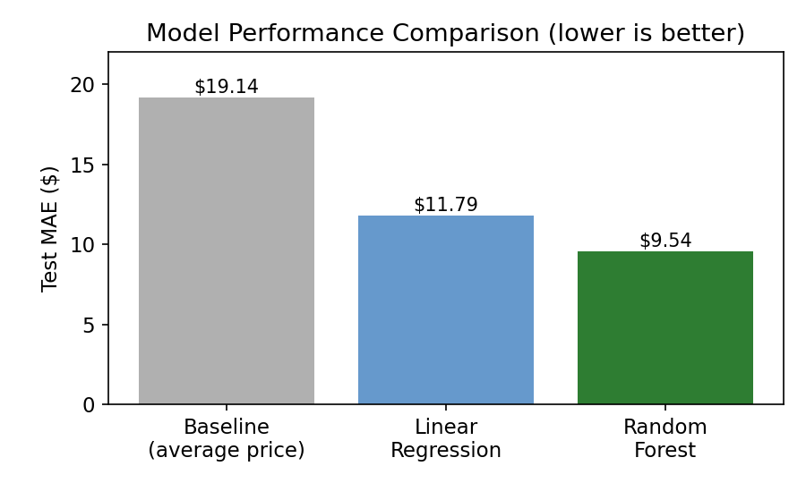
Figure 1. Test-set MAE by model. The baseline mean model errs by about $19; both trained models cut that error roughly in half.

Winning Model and Scenario Modeling
The Random Forest model was selected as the final model: its cross-validated MAE ($9.64 ± $1.35) was about $1 lower than the tuned linear model ($10.50 ± $1.62) and showed less variability across folds, and its held-out test MAE ($9.54) was consistent with the cross-validation estimate. In the Random Forest model, the four most influential features were fastQuads (number of high-speed quad chairlifts), Runs, Snow Making_ac, and vertical_drop — broadly consistent with the linear model, which also found vertical drop and snow-making acreage to be strong positive drivers of price.
The winning model was refit on all available resort data (excluding Big Mountain) and used to predict what Big Mountain's ticket price should be, given its facilities: $95.87, versus its actual price of $81.00 — a gap of nearly $15, well above the model's expected error of about $10.39. Several improvement scenarios were then simulated by adjusting Big Mountain's features and re-predicting price:
- Scenario 1 — Close up to 10 of the least-used runs (no other changes). Closing a single run costs nothing; closing 2–5 runs costs about $0.67 in supported price; losses grow beyond 6 closures. Closing up to 4–5 runs is essentially free from a pricing standpoint.
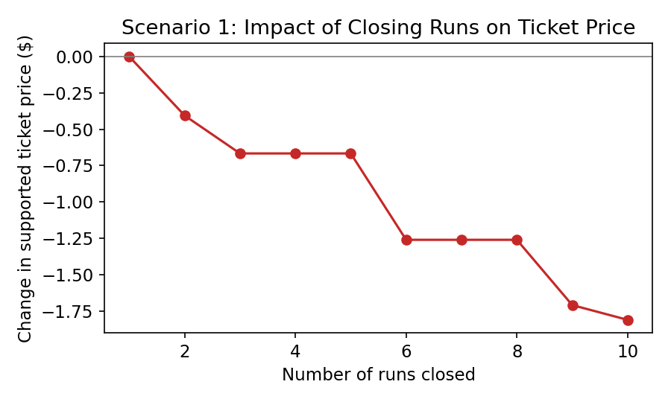
Figure 2. Predicted change in supported ticket price as more runs are closed.
- Scenario 2 — Add one run, increase vertical drop by 150 ft, and add one chair lift. Supports a $1.99 increase in ticket price, worth roughly $3.47M in additional season revenue (assuming 350,000 visitors buying 5 tickets each).
- Scenario 3 — Scenario 2 plus 2 additional acres of snow-making. Produces no additional benefit over Scenario 2; the extra snow-making investment would not be recovered in price.
- Scenario 4 — Add 0.2 miles to the longest run and 4 acres of snow-making. Produces no measurable increase in supported price or revenue; longest run length carries very little weight in the model.
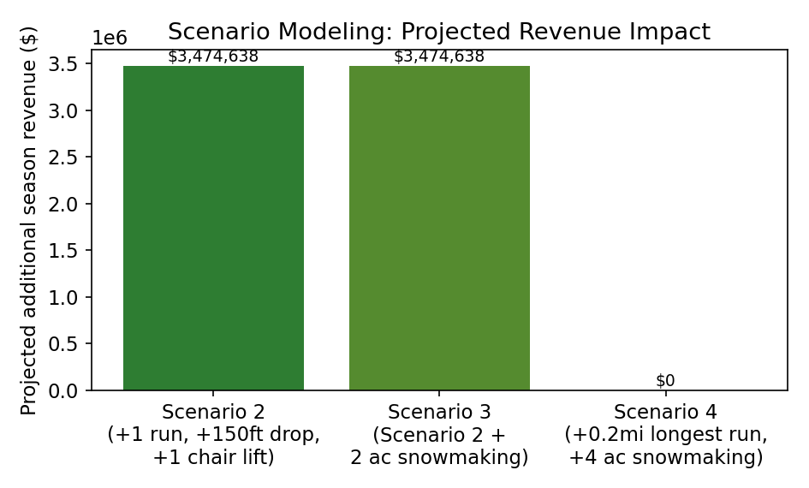
Figure 3. Projected season revenue impact across the modeled expansion scenarios.

Pricing Recommendation
Big Mountain Resort is currently underpriced relative to the value of its facilities. The model supports a price meaningfully above the current $81.00 — even allowing for the model's roughly $10 margin of error, there is room to raise the adult weekend ticket price. Combining a price increase with Scenario 2 (adding a run, increasing vertical drop, and adding a chair lift) offers the strongest return, supporting close to a $2 price increase and an estimated $3.47M in incremental season revenue. On the cost side, closing up to 4–5 of the least-used runs would reduce operating costs with essentially no negative impact on supportable ticket price.

Conclusion
The Random Forest model provides a reliable, cross-validated basis (MAE ≈ $9.5–$9.6) for pricing decisions and scenario evaluation. It confirms Big Mountain is undervalued relative to comparable resorts and identifies which facility investments (additional runs, vertical drop, lift capacity) actually move the needle on price, versus investments (extra snow-making acreage, longer runs) that do not. These findings give the business a quantified, defensible basis for both a price increase and targeted operating cost reductions.

Future Scope of Work
- Explore a broader random forest hyperparameter search (tree depth, min samples per leaf) and additional model families (gradient boosting) for further accuracy gains.
- Investigate removing low-importance features to produce a simpler, easier-to-explain model for stakeholders.
- Collect additional resort data points, particularly for underrepresented regions, to reduce model uncertainty.
- Test combined scenarios (e.g., run closures paired with lift additions) to find an overall-optimal package of changes.
- Revisit pricing recommendations periodically as competitor resorts update their own facilities and prices.

