### **Lab 1 Submission (ER Diagram) - Team 2 (Z43)**

Team members:

* Joel Tan
* Sreeja Tar
* Liu Liwen
* Agarwal Lakshya
* Luo Minjuan
* Shourya Kuchhal

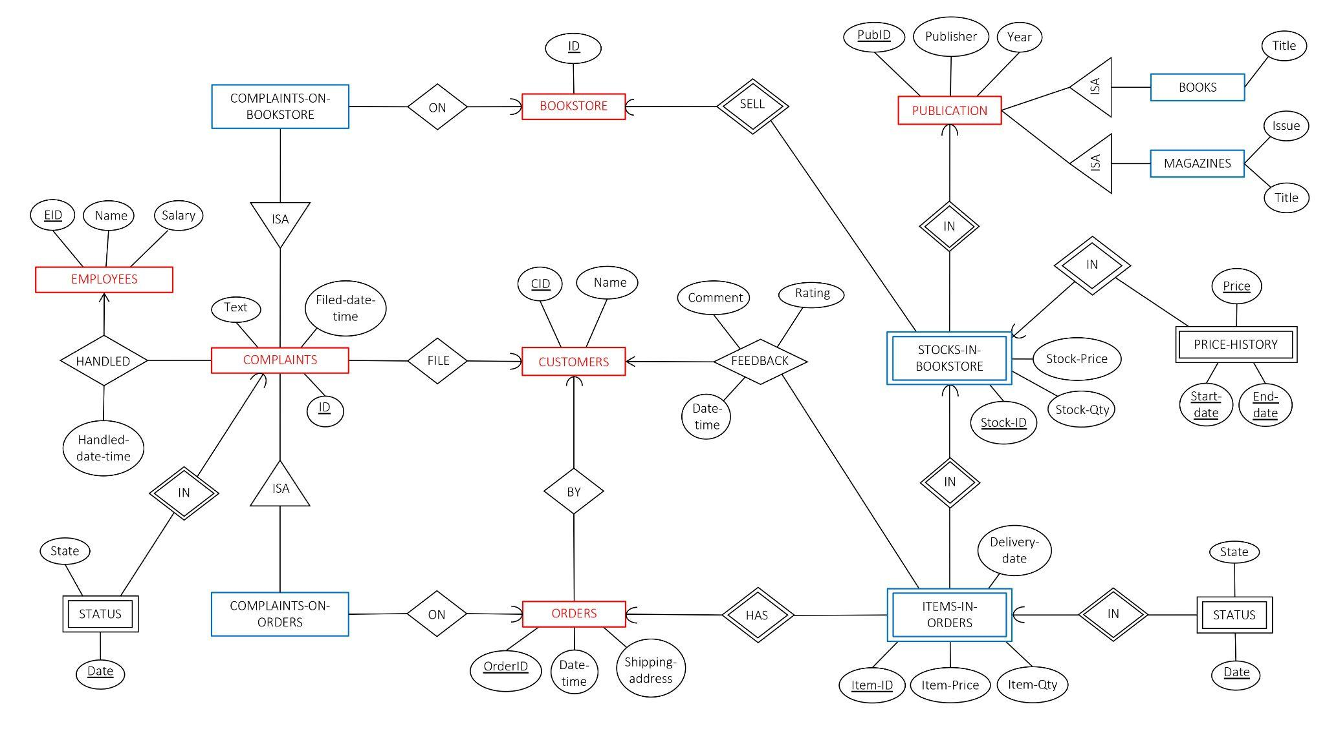

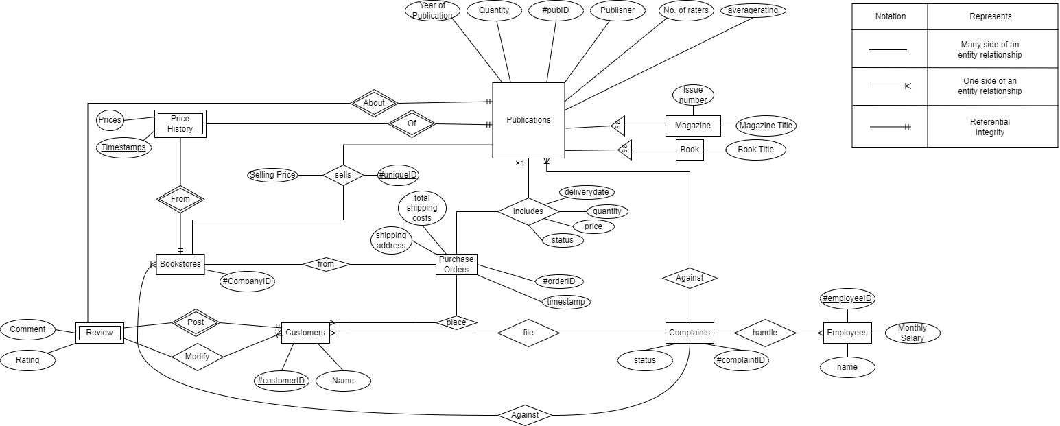

### **APPENDIX C: INDIVIDUAL CONTRIBUTION FORM**

| Full Name | Individual Contribution to Lab 1 Submission | Percentage of  Contribution | Signature |
| --- | --- | --- | --- |
| Tar Sreeja | Identified and drew out the entities to be used in the diagram.  Checked the diagram for errors and ensured all entities and relations satisfied the nuances of the description given in Appendix A.  Performed final checks. | 16.66 |  |
| Joel Tan | Identified and drew out the entities to be used in the diagram.  Reorganized the ER diagram to make it easier on the eyes. | 16.66 |  |
| Agarwal Lakshya | Identified and drew out the entities to be used in the diagram.  Rectified errors  Performed final checks. | 16.66 |  |
| Shourya  Kuchhal | Identified and drew out the entities to be used in the diagram.  Performed final checks | 16.66 | Shourya  Kuchhal |
| Liu Liwen | Drew diagram about Complaints side and identified the relationships  Performed final checks | 16.66 |  |
| Luo Minjuan | drew customer side ER diagram improved visual effect of ER diagram improved main content of the diagram to make it more suitable for the situation described | 16.66 |  |