Courtney Guo

Faculty Supervisor: Dr. Polina Golland

Student Supervisor: Danielle Pace

**Localization of the Heart in MRI Scans**

**Abstract**

Congenital heart defects affect many children around the world, which sometimes require extensive surgery planning. For doctors to be able to plan surgeries, scans of the heart must be segmented. This project aims to develop methods to localize the heart as well as internal structures in the heart in MRI scans of patients with congenital heart disease.

No specifics about solution, what techniques used etc.

Reference and explain figure

**Problem Statement**

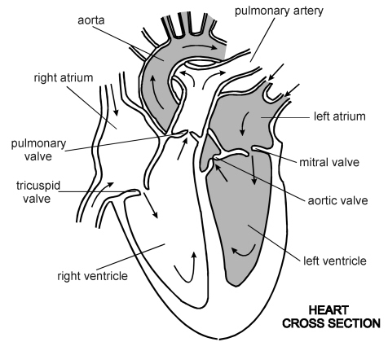

Figure : Heart Cross Section

Millions of children around the world are born with congenital heart defects, which may require surgery to be treated. For doctors to effectively plan surgery, it is useful if a model of the heart can be 3D-printed, which requires the scans of the patient to be segmented. Currently, patient-specific 3D heart models are underused because it takes around 4-8 hours to manually segment cardiac MRI images, since each contains approximately 1503 voxels. There have been algorithms developed to segment the heart in adult patients, but these methods have not been shown to work on children with congenital heart disease due to the higher variability in the structure of their hearts. This SuperUROP project aims to develop algorithms to localize the heart as well as structures within the heart in patients with congenital heart disease, which will greatly aid segmentation of the heart.

Good job with specifics. Add some citations

**Related Work**

There have been many different methods proposed for segmentation of the heart. For whole-heart segmentation in patients with congenital heart disease, atlas segmentation does not do well due to the irregular location or shapes of the organs. Danielle Pace has created an interactive algorithm to segment the heart: at each step of the algorithm, the user is directed to manually label one slice of the heart that will give the most information [1]. The algorithm then segments each target slice according to its closest reference slices. To segment a patch, the algorithm finds the *k* most similar patches in the set of relevant reference regions, and “similarity” depends on patch intensities, gradients, and positions, and each pixel is labeled according to a majority vote. This algorithm greatly reduces the amount of time needed to segment a heart.

You go into a lot of detail for one study. Maybe more breadth

Regression forests have also been shown to do well in image segmentation, specifically the detection and localization of organs. A. Criminisi has applied regression forests to learn the non-linear mapping from voxels directly to organ position and size [2]. The regression forest groups voxels with similar features or similar field of views together, and learns an estimate of the bounding boxes of each organ using the training data that reaches that node. Intuitively, each voxel contributes varying degrees of confidence to the estimates of the location and size of every organ. When applied on real datasets, the forest learns to recognize key indicators (such tips of the ribs or vertebrae) and those pixels provide high confidence estimates of where certain organs (such as the heart) are located. Criminisi then compared these results against other methods, including Elastix and Simplex methods, as well as atlas methods, and showed that the regression forest method was superior in accuracy.

You talk a lot about other research, but need to relate to your work

**Technical Approach**

This project aims to use regression forests to localize the heart in 3D MRI scans of the patient, and if all goes well, to localize structures within the heart as well. A regression tree is a tree structure in which each node makes a decision for whether the data point goes to its left child or right child, based on the data point’s features. Then, at each leaf node, a model is fitted to the data points that end up at that node, which can be a Bayesian linear model or a Gaussian model among other options. Therefore, a regression tree can be trained by minimizing some loss function at each node, and it can make predictions on new data points by running a data point through the regression tree until it reaches a leaf node.

Explain and reference figures

Good explanation

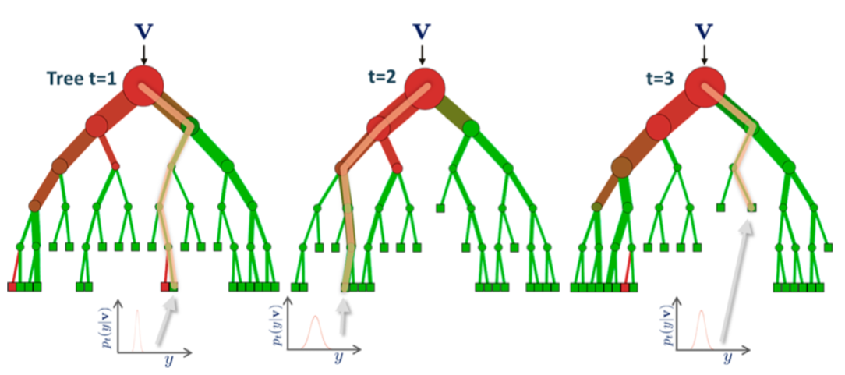

Figure2: Regression Trees

We will be training regression trees to predict the location of the bounding box of the heart given MRI scans of patients with congenital heart disease.

**Evaluation Metrics**

The main benchmark we will be using to measure the algorithm is accuracy. The regression forest will be trained on a training set, which will be scans of patients that have been manually labeled with bounding boxes of the heart and internal structures. Then, the algorithm will be run on a test set. Since the algorithm outputs a bounding box for each structure it localizes, which is a 6-dimensional vector for each structure, accuracy can be measured by computing the mean squared error of the vectors outputted by the algorithm.

Why mean square error, what about other measures

Since the purpose of this algorithm is to reduce the amount of time it takes to segment the heart, which is usually done manually, the runtime of the algorithm is also important. However, the runtime only needs to be faster than the 4-8 hours it would take to manually segment the heart.

No conclusion or timeline

**Works Cited:**

[1] D. Pace, A. Dalca, T. Geva, A. Powell, M. Moghari, P. Golland, *Interactive Whole-Heart Segmentation in Congenital Heart Disease*

[2] A. Criminisi, J. Shotton (eds.), *Decision Forests for Computer Vision and* *Medical Image Analysis*, Advances in Computer Vision and Pattern Recognition, DOI 10.1007/978-1-4471-4929-3_14