- Paired Comparison
  - Box plot
  - Scatterplot
  - Similarities/differences: Thunderstorm patterns in the two regions seen to be quite similar, so the null hypothesis is likely. That said, there are slight differences, meaning that hypothesis testing would be beneficial as a form of verification on the relationship.

  - Signed Rank test, alpha = 0.05, number of thunderstorms reported per year
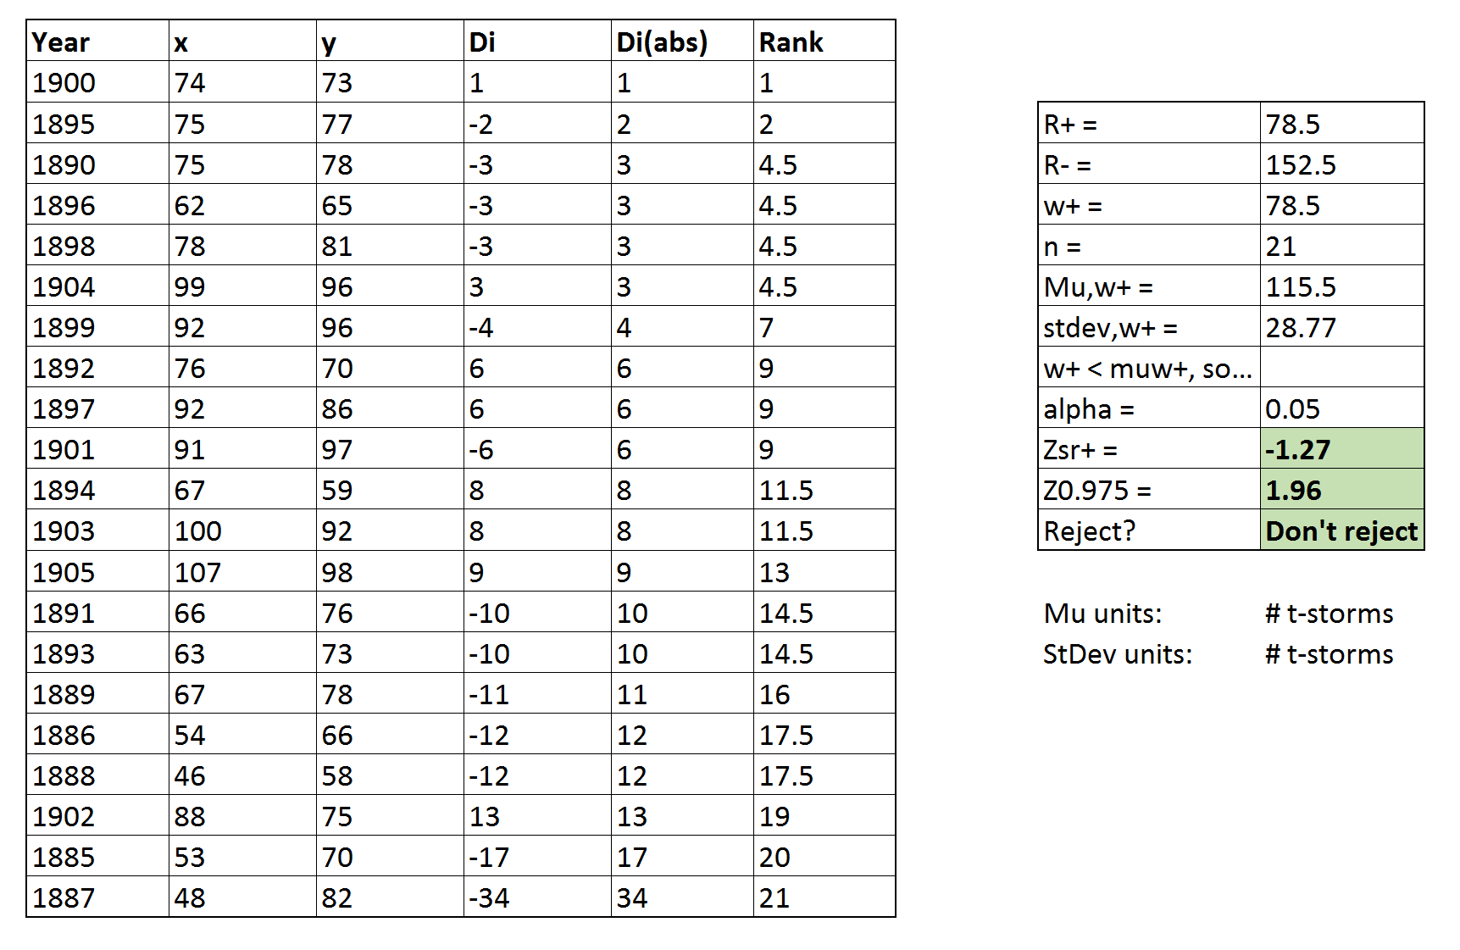
  - Paired t-test, alpha = 0.05, number of thunderstorms reported per year
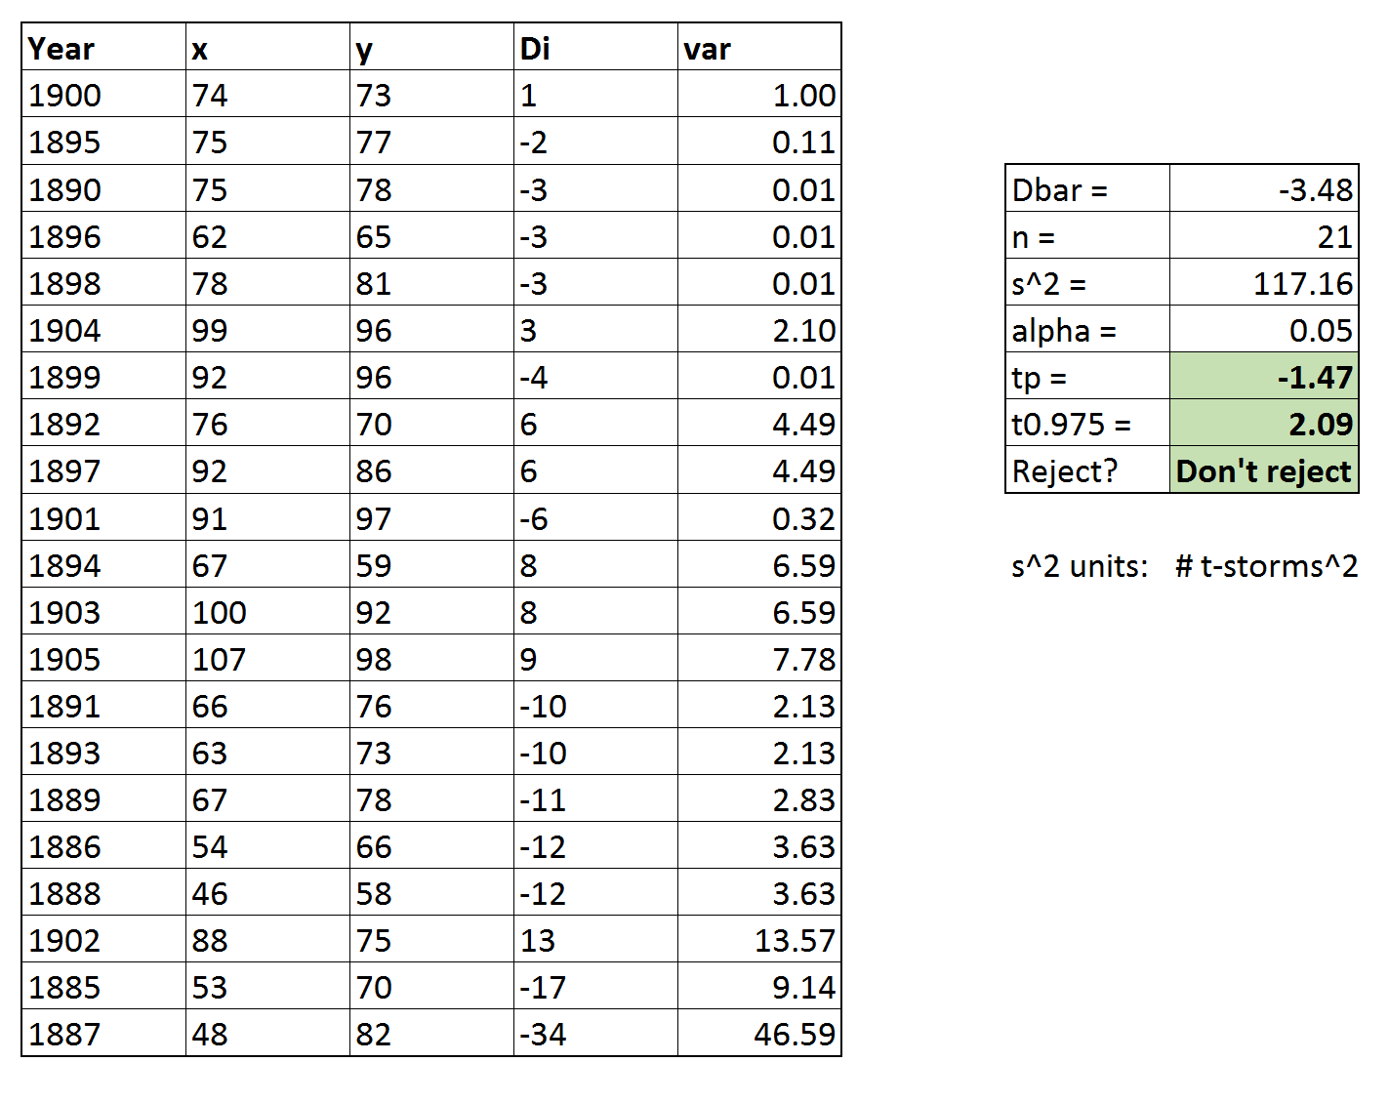

- Comparison of Independent Samples
  - Rank Sum test, alpha = 0.05, yield in gpm/ft

  - Two sample t-test, alpha = 0.05, yield in gpm/ft
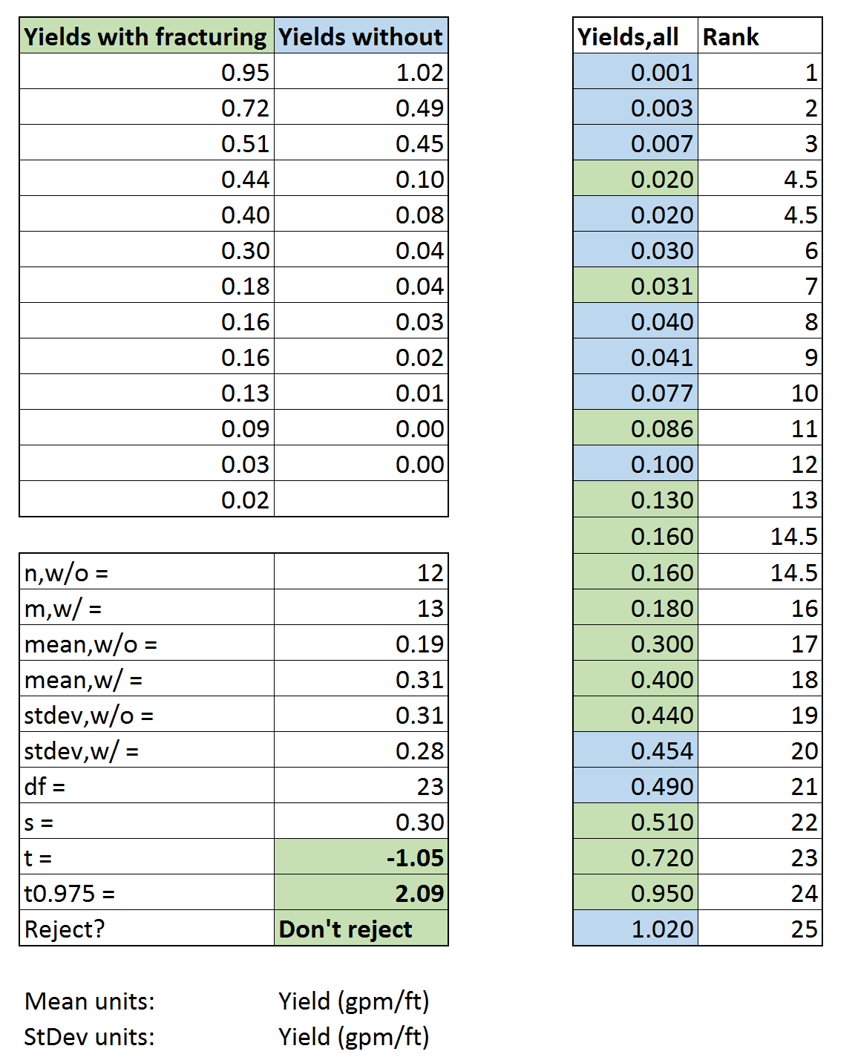
Comparison of Groups
  - Box plot.
Differences: These box plots clearly have significant variation in pH, where BP-2 goes as low as ~6.3 and BP-3 goes as high as ~9.3; a difference of 3 pH is a lot. Because of this observed difference, it is unlikely that the three piezometers will be determined to be similar based on the statistical testing that follows.
  - ANOVA test, alpha = 0.05, pH of shallow groundwater
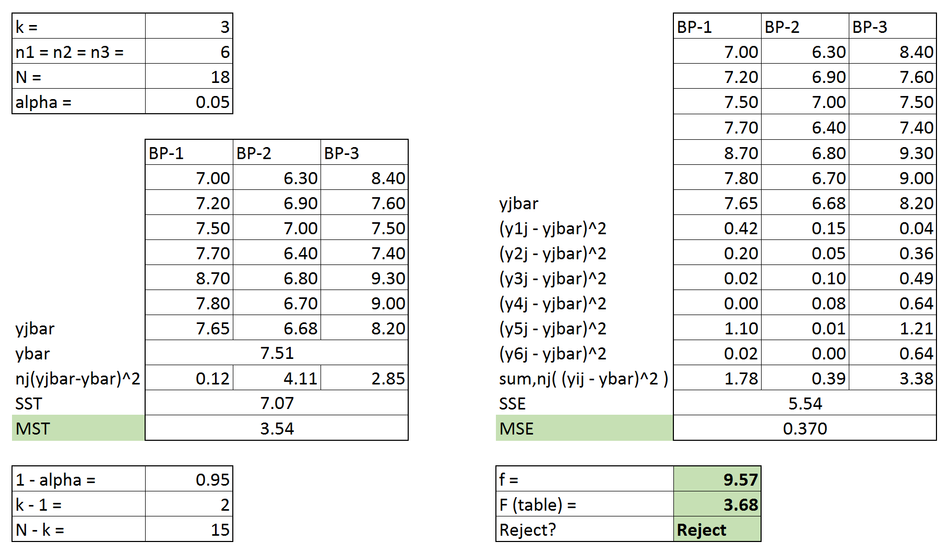

  - Kruskal-Wallis test, alpha = 0.05, pH of shallow groundwater
