Financial Data Analytics

Final Project Assignment

Marklina Yakopa

November 19th 2024

#"Answers-to-Questions-1-to-7"

## 1. Exploratory data analysis I: 15 points

### Problem 1  
da=read.table("d-sbux3dx-0715.txt",header=T)  
head(da)

## PERMNO date SBUX vwretd ewretd sprtrn  
## 1 77702 20070103 -0.004799 -0.001347 -0.000159 -0.001199  
## 2 77702 20070104 0.001135 0.000547 0.000591 0.001228  
## 3 77702 20070105 -0.004251 -0.007288 -0.009809 -0.006085  
## 4 77702 20070108 -0.003700 0.002567 0.001731 0.002220  
## 5 77702 20070109 -0.004284 -0.000001 0.000262 -0.000517  
## 6 77702 20070110 -0.003155 0.002096 0.001338 0.001940

rtn=da[,3:6]  
attach(rtn)  
require(fBasics)

## Loading required package: fBasics

# (a)  
basicStats(SBUX)

## SBUX  
## nobs 2266.000000  
## NAs 0.000000  
## Minimum -0.109742  
## Maximum 0.183798  
## 1. Quartile -0.009258  
## 3. Quartile 0.010326  
## Mean 0.000801  
## Median 0.000523  
## Sum 1.815383  
## SE Mean 0.000447  
## LCL Mean -0.000076  
## UCL Mean 0.001678  
## Variance 0.000453  
## Stdev 0.021289  
## Skewness 0.555707  
## Kurtosis 6.575662

basicStats(vwretd)

## vwretd  
## nobs 2266.000000  
## NAs 0.000000  
## Minimum -0.089763  
## Maximum 0.114898  
## 1. Quartile -0.004844  
## 3. Quartile 0.006177  
## Mean 0.000318  
## Median 0.000857  
## Sum 0.720300  
## SE Mean 0.000286  
## LCL Mean -0.000244  
## UCL Mean 0.000879  
## Variance 0.000186  
## Stdev 0.013630  
## Skewness -0.175139  
## Kurtosis 8.807872

basicStats(ewretd)

## ewretd  
## nobs 2266.000000  
## NAs 0.000000  
## Minimum -0.078240  
## Maximum 0.107422  
## 1. Quartile -0.004676  
## 3. Quartile 0.005991  
## Mean 0.000415  
## Median 0.001174  
## Sum 0.940663  
## SE Mean 0.000263  
## LCL Mean -0.000101  
## UCL Mean 0.000931  
## Variance 0.000157  
## Stdev 0.012521  
## Skewness -0.209028  
## Kurtosis 7.765289

basicStats(sprtrn)

## sprtrn  
## nobs 2266.000000  
## NAs 0.000000  
## Minimum -0.090350  
## Maximum 0.115800  
## 1. Quartile -0.004806  
## 3. Quartile 0.006093  
## Mean 0.000254  
## Median 0.000688  
## Sum 0.575829  
## SE Mean 0.000286  
## LCL Mean -0.000307  
## UCL Mean 0.000815  
## Variance 0.000185  
## Stdev 0.013619  
## Skewness -0.078865  
## Kurtosis 9.730943

***Simple return series show comparable average returns, volatility, symmetry, and tail characteristics, with similar minimum and maximum values****.*

# (b)  
densitySBUX=density(rtn$SBUX)  
plot(densitySBUX)

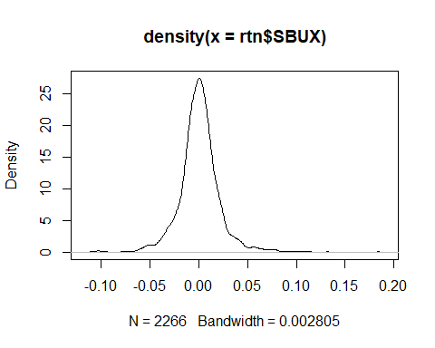

# This is the same density plot but with labels  
plot(densitySBUX,xlab='return',ylab='SBUX',main='Density')

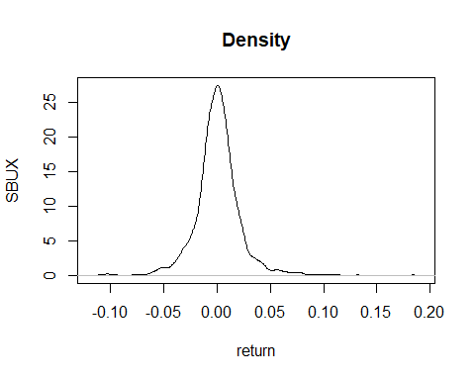

normalTest(SBUX)

##   
## Title:  
## Shapiro - Wilk Normality Test  
##   
## Test Results:  
## STATISTIC:  
## W: 0.9251  
## P VALUE:  
## < 2.2e-16

***Simple returns of Starbucks stock appear to follow a normal distribution, as indicated by the normality test.***

# (c)  
lrtn=log(rtn+1) ### log returns  
basicStats(lrtn$SBUX)

## X..lrtn.SBUX  
## nobs 2266.000000  
## NAs 0.000000  
## Minimum -0.116244  
## Maximum 0.168728  
## 1. Quartile -0.009301  
## 3. Quartile 0.010273  
## Mean 0.000576  
## Median 0.000523  
## Sum 1.305183  
## SE Mean 0.000445  
## LCL Mean -0.000297  
## UCL Mean 0.001449  
## Variance 0.000449  
## Stdev 0.021185  
## Skewness 0.302033  
## Kurtosis 5.910134

basicStats(lrtn$vwretd)

## X..lrtn.vwretd  
## nobs 2266.000000  
## NAs 0.000000  
## Minimum -0.094050  
## Maximum 0.108763  
## 1. Quartile -0.004856  
## 3. Quartile 0.006158  
## Mean 0.000225  
## Median 0.000857  
## Sum 0.509376  
## SE Mean 0.000287  
## LCL Mean -0.000338  
## UCL Mean 0.000787  
## Variance 0.000186  
## Stdev 0.013655  
## Skewness -0.392742  
## Kurtosis 8.693544

basicStats(lrtn$ewretd)

## X..lrtn.ewretd  
## nobs 2266.000000  
## NAs 0.000000  
## Minimum -0.081470  
## Maximum 0.102035  
## 1. Quartile -0.004687  
## 3. Quartile 0.005973  
## Mean 0.000337  
## Median 0.001173  
## Sum 0.762614  
## SE Mean 0.000263  
## LCL Mean -0.000180  
## UCL Mean 0.000853  
## Variance 0.000157  
## Stdev 0.012541  
## Skewness -0.389396  
## Kurtosis 7.661540

basicStats(lrtn$sprtrn)

## X..lrtn.sprtrn  
## nobs 2266.000000  
## NAs 0.000000  
## Minimum -0.094695  
## Maximum 0.109572  
## 1. Quartile -0.004818  
## 3. Quartile 0.006074  
## Mean 0.000161  
## Median 0.000688  
## Sum 0.365424  
## SE Mean 0.000286  
## LCL Mean -0.000401  
## UCL Mean 0.000723  
## Variance 0.000186  
## Stdev 0.013637  
## Skewness -0.314434  
## Kurtosis 9.496296

***The log return series of Starbucks stock shows a stable average return, moderate volatility, positive skewness (indicating a right tail), and kurtosis close to normal, with similar minimum and maximum values across the sample, while the other series display negative skewness.***

# (d)  
t.test(lrtn$SBUX)

##   
## One Sample t-test  
##   
## data: lrtn$SBUX  
## t = 1.2942, df = 2265, p-value = 0.1957  
## alternative hypothesis: true mean is not equal to 0  
## 95 percent confidence interval:  
## -0.0002967458 0.0014487168  
## sample estimates:  
## mean of x   
## 0.0005759855

t.test(lrtn$sprtrn)

##   
## One Sample t-test  
##   
## data: lrtn$sprtrn  
## t = 0.56293, df = 2265, p-value = 0.5735  
## alternative hypothesis: true mean is not equal to 0  
## 95 percent confidence interval:  
## -0.0004005110 0.0007230388  
## sample estimates:  
## mean of x   
## 0.0001612639

***The mean log returns for both Starbucks stock and the S&P Composite Index are not significantly different from zero.***

***The mean log returns for both Starbucks stock and the S&P Composite Index are not significantly different from zero.***

# (e)  
densitylogSBUX=density(lrtn$SBUX)  
densitylogvwretd=density(lrtn$vwretd)  
par(mfcol=c(1,2)) ## Put two plots in a frame (left and right)  
plot(densitylogSBUX,xlab='log-return',ylab='SBUX',main='Density')  
plot(densitylogSBUX,xlab='log-return',ylab='vw index',main='Density')

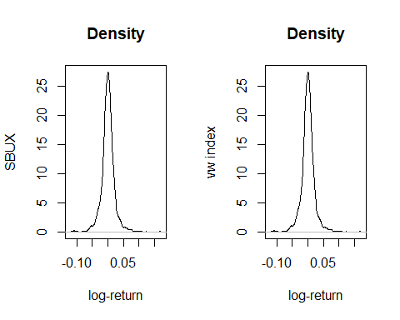

par(mfcol=c(1,1))

***The empirical density plots of daily log return for Starbucks stock and the value-weighted index show similar central peaks, with Starbucks displaying slight positive skewness compared to a more symmetrical distribution in the index.***

## 2. Factor models: 30 points

# Problem 2  
FFfactors <- read.csv("C:/Users/Administrator/Desktop/Assignment for Marklina/FamaFrenchFactors (1).csv",header=T) # Load csv data with names.  
head(FFfactors) # See the first 6 rows

## X Mkt SMB HML  
## 1 196307 -0.39 -0.46 -0.82  
## 2 196308 5.07 -0.85 1.63  
## 3 196309 -1.57 -0.50 0.19  
## 4 196310 2.53 -1.30 -0.11  
## 5 196311 -0.85 -0.83 1.66  
## 6 196312 1.83 -1.87 -0.11

attach(FFfactors) #Now you can refer directly to the names of the variables.  
#Note that you might receive a warning: "The following objects are masked from FFfactors ..."  
# This just means that you are overwriting variables with these names that you have used before.  
# For our purposes you can simply ignore this message.  
names(FFfactors)

## [1] "X" "Mkt" "SMB" "HML"

rf <- read.csv("C:/Users/Administrator/Desktop/Assignment for Marklina/RiskFreeRate.csv",header=T) # Load csv data with names.  
head(rf) # See the first 6 rows

## X RF  
## 1 196307 0.27  
## 2 196308 0.25  
## 3 196309 0.27  
## 4 196310 0.29  
## 5 196311 0.27  
## 6 196312 0.29

sv <- read.csv("C:/Users/Administrator/Desktop/Assignment for Marklina/SizeValuePortfolios.csv",header=T) # Load csv data with names.  
head(sv) # See the first 6 rows

## X SMALL.LoBM ME1.BM2 ME1.BM3 ME1.BM4 SMALL.HiBM ME2.BM1 ME2.BM2 ME2.BM3  
## 1 196307 0.85 0.24 0.56 -0.02 -1.22 -1.87 0.29 -0.84  
## 2 196308 3.80 2.15 1.32 2.29 4.73 5.40 4.65 4.36  
## 3 196309 -2.70 0.26 -1.09 -1.59 -0.38 -3.92 -1.57 -0.64  
## 4 196310 1.36 -0.63 1.24 0.05 2.37 1.19 4.30 2.34  
## 5 196311 -3.11 -4.32 -1.60 -1.00 -1.11 -4.18 -1.76 -0.71  
## 6 196312 -2.94 -0.55 -0.90 -1.75 -0.97 -0.68 -0.91 1.15  
## ME2.BM4 ME2.BM5 ME3.BM1 ME3.BM2 ME3.BM3 ME3.BM4 ME3.BM5 ME4.BM1 ME4.BM2  
## 1 -1.90 -1.19 -1.84 -1.87 -0.81 -2.21 -1.80 -0.93 -1.63  
## 2 4.33 8.23 5.36 4.62 5.63 4.72 5.15 5.59 4.81  
## 3 -1.13 -2.91 -4.65 -1.52 -0.69 -0.10 -1.82 -2.67 -1.95  
## 4 2.26 3.93 2.26 0.50 2.70 2.16 1.07 -0.25 0.93  
## 5 -0.09 -0.11 -2.92 -1.58 -0.91 -0.90 -1.21 -0.91 -0.86  
## 6 0.97 0.12 0.60 1.17 1.52 1.52 0.47 -0.17 1.27  
## ME4.BM3 ME4.BM4 ME4.BM5 BIG.LoBM ME5.BM2 ME5.BM3 ME5.BM4 BIG.HiBM  
## 1 -2.07 -1.67 -1.86 0.14 0.46 1.23 -0.45 -1.11  
## 2 6.12 7.56 5.35 5.77 4.22 4.77 8.16 6.25  
## 3 -2.00 -3.58 -1.99 -1.37 -0.77 -0.98 -0.12 -3.82  
## 4 2.30 5.34 0.61 5.33 1.73 -0.26 2.36 0.48  
## 5 -0.51 1.15 3.54 -1.26 0.98 -1.55 -2.05 1.37  
## 6 1.63 3.14 6.15 2.62 2.30 2.28 2.38 2.37

names(sv)

## [1] "X" "SMALL.LoBM" "ME1.BM2" "ME1.BM3" "ME1.BM4"   
## [6] "SMALL.HiBM" "ME2.BM1" "ME2.BM2" "ME2.BM3" "ME2.BM4"   
## [11] "ME2.BM5" "ME3.BM1" "ME3.BM2" "ME3.BM3" "ME3.BM4"   
## [16] "ME3.BM5" "ME4.BM1" "ME4.BM2" "ME4.BM3" "ME4.BM4"   
## [21] "ME4.BM5" "BIG.LoBM" "ME5.BM2" "ME5.BM3" "ME5.BM4"   
## [26] "BIG.HiBM"

Industry=read.csv("C:/Users/Administrator/Desktop/Assignment for Marklina/IndustryPortfolios.csv",header=T) # Load csv data with names.  
head(Industry) # See the first 6 rows

## X Food Beer Smoke Games Books Hshld Clths Hlth Chems Txtls Cnstr  
## 1 196307 0.05 -2.19 -2.54 -3.48 -0.04 -0.15 -0.42 0.56 -1.00 3.49 -0.78  
## 2 196308 4.82 2.14 7.15 6.08 4.66 6.22 4.59 9.56 4.61 4.30 6.04  
## 3 196309 -1.43 1.23 -4.23 -4.05 2.67 -1.37 -3.97 -4.06 -0.78 -1.14 -1.25  
## 4 196310 2.41 -1.28 5.78 10.34 -1.15 4.25 2.70 3.38 3.48 5.72 -0.52  
## 5 196311 -0.44 -0.72 -5.63 -1.96 -0.18 -0.18 -1.44 -1.65 2.22 1.99 -1.05  
## 6 196312 2.99 1.21 5.98 -2.13 -0.21 4.26 -0.50 1.54 4.51 3.30 0.81  
## Steel FabPr ElcEq Autos Carry Mines Coal Oil Util Telcm Servs BusEq Paper  
## 1 -1.59 -3.08 -2.43 -0.15 -3.67 -2.90 0.32 2.34 0.81 -0.23 -3.48 -0.55 -1.38  
## 2 8.31 4.62 5.17 7.20 3.27 4.02 7.48 3.85 4.22 4.29 2.68 5.23 7.70  
## 3 0.29 -2.55 -1.68 0.31 -4.60 -0.96 -4.48 -3.62 -2.49 2.36 -2.65 0.29 1.45  
## 4 1.58 4.19 -0.49 10.14 2.28 3.16 9.45 -0.52 -0.67 3.40 1.51 8.66 1.65  
## 5 -1.83 -0.79 -1.72 -5.42 5.54 1.56 0.67 -1.19 -1.02 4.16 -3.78 -0.27 -0.93  
## 6 1.51 1.86 -2.55 -1.20 -4.22 6.05 5.42 4.65 2.42 -0.14 0.93 3.26 0.31  
## Trans Whlsl Rtail Meals Fin Other  
## 1 -2.54 0.04 -1.06 -4.21 -0.61 -2.63  
## 2 7.37 4.22 6.62 1.07 4.28 5.63  
## 3 -3.85 -1.65 1.15 -2.51 -3.25 -3.23  
## 4 1.77 1.41 0.41 1.11 0.68 2.88  
## 5 3.78 -4.03 -1.07 -3.61 -2.29 1.44  
## 6 4.17 -0.66 0.35 1.75 1.61 -2.54

names(Industry)

## [1] "X" "Food" "Beer" "Smoke" "Games" "Books" "Hshld" "Clths" "Hlth"   
## [10] "Chems" "Txtls" "Cnstr" "Steel" "FabPr" "ElcEq" "Autos" "Carry" "Mines"  
## [19] "Coal" "Oil" "Util" "Telcm" "Servs" "BusEq" "Paper" "Trans" "Whlsl"  
## [28] "Rtail" "Meals" "Fin" "Other"

# (a)  
Industry=Industry[,2:31]  
attach(Industry) #Now you can refer directly to the names of the variables.  
#Note that you might receive a warning: "The following objects are masked from..."  
# This just means that you are overwriting variables with these names that you have used before.  
# For our purposes you can simply ignore this message.  
industrypca=prcomp(Industry)  
summary(industrypca)

## Importance of components:  
## PC1 PC2 PC3 PC4 PC5 PC6 PC7  
## Standard deviation 26.6625 9.41932 7.08614 5.96143 5.87202 4.92238 4.53696  
## Proportion of Variance 0.6195 0.07732 0.04376 0.03097 0.03005 0.02112 0.01794  
## Cumulative Proportion 0.6195 0.69684 0.74060 0.77157 0.80162 0.82273 0.84067  
## PC8 PC9 PC10 PC11 PC12 PC13 PC14  
## Standard deviation 4.13409 4.00556 3.67210 3.55002 3.42637 3.27602 3.13419  
## Proportion of Variance 0.01489 0.01398 0.01175 0.01098 0.01023 0.00935 0.00856  
## Cumulative Proportion 0.85557 0.86955 0.88130 0.89228 0.90251 0.91187 0.92043  
## PC15 PC16 PC17 PC18 PC19 PC20 PC21  
## Standard deviation 3.00135 2.94679 2.86401 2.80948 2.61719 2.53213 2.45083  
## Proportion of Variance 0.00785 0.00757 0.00715 0.00688 0.00597 0.00559 0.00523  
## Cumulative Proportion 0.92828 0.93584 0.94299 0.94987 0.95584 0.96143 0.96666  
## PC22 PC23 PC24 PC25 PC26 PC27 PC28  
## Standard deviation 2.39389 2.27062 2.21289 2.1145 2.0600 2.01431 1.91264  
## Proportion of Variance 0.00499 0.00449 0.00427 0.0039 0.0037 0.00354 0.00319  
## Cumulative Proportion 0.97166 0.97615 0.98042 0.9843 0.9880 0.99155 0.99474  
## PC29 PC30  
## Standard deviation 1.78116 1.6934  
## Proportion of Variance 0.00276 0.0025  
## Cumulative Proportion 0.99750 1.0000

plot(industrypca)

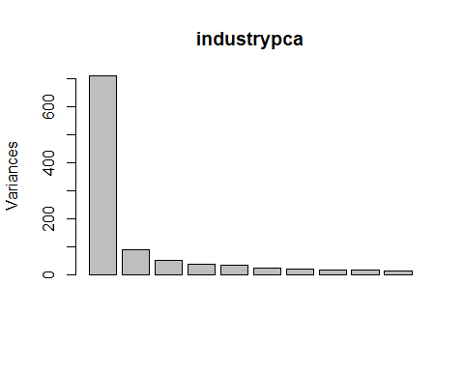

***While PC30 explains 100% of the variance; for 85% use PC8 factor, for 90% use PC12 and for 95% use PC19 factor where elbow of curve might occur.***

# (b)  
fitSteel=lm(Steel~industrypca$x[,1:3])  
summary(fitSteel)

##   
## Call:  
## lm(formula = Steel ~ industrypca$x[, 1:3])  
##   
## Residuals:  
## Min 1Q Median 3Q Max   
## -12.5130 -1.8227 0.0946 1.8095 14.1687   
##   
## Coefficients:  
## Estimate Std. Error t value Pr(>|t|)   
## (Intercept) 0.767904 0.126789 6.057 2.45e-09 ***  
## industrypca$x[, 1:3]PC1 0.227396 0.004759 47.780 < 2e-16 ***  
## industrypca$x[, 1:3]PC2 -0.178089 0.013472 -13.220 < 2e-16 ***  
## industrypca$x[, 1:3]PC3 0.322247 0.017907 17.995 < 2e-16 ***  
## ---  
## Signif. codes: 0 '***' 0.001 '**' 0.01 '*' 0.05 '.' 0.1 ' ' 1  
##   
## Residual standard error: 3.121 on 602 degrees of freedom  
## Multiple R-squared: 0.8221, Adjusted R-squared: 0.8212   
## F-statistic: 927.2 on 3 and 602 DF, p-value: < 2.2e-16

plot(Steel,fitSteel$fitted.values)  
abline(c(0,1))

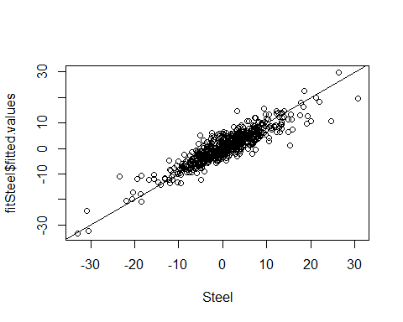

fitSteel2=lm(Steel~Mkt)  
summary(fitSteel2)

##   
## Call:  
## lm(formula = Steel ~ Mkt)  
##   
## Residuals:  
## Min 1Q Median 3Q Max   
## -19.1426 -2.8816 -0.1664 2.6262 24.9623   
##   
## Coefficients:  
## Estimate Std. Error t value Pr(>|t|)   
## (Intercept) 0.12522 0.18755 0.668 0.505   
## Mkt 1.28925 0.04158 31.007 <2e-16 ***  
## ---  
## Signif. codes: 0 '***' 0.001 '**' 0.01 '*' 0.05 '.' 0.1 ' ' 1  
##   
## Residual standard error: 4.589 on 604 degrees of freedom  
## Multiple R-squared: 0.6142, Adjusted R-squared: 0.6135   
## F-statistic: 961.5 on 1 and 604 DF, p-value: < 2.2e-16

plot(Steel,fitSteel2$fitted.values)  
abline(c(0,1))

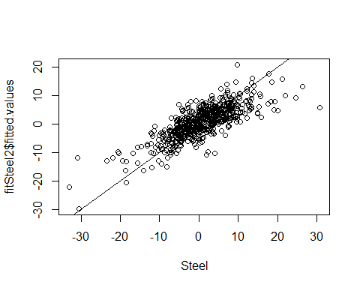

fitFood=lm(Food~industrypca$x[,1:3])  
summary(fitFood)

##   
## Call:  
## lm(formula = Food ~ industrypca$x[, 1:3])  
##   
## Residuals:  
## Min 1Q Median 3Q Max   
## -6.9077 -1.1683 -0.0056 0.9667 15.9115   
##   
## Coefficients:  
## Estimate Std. Error t value Pr(>|t|)   
## (Intercept) 1.074884 0.082316 13.06 <2e-16 ***  
## industrypca$x[, 1:3]PC1 0.120394 0.003090 38.96 <2e-16 ***  
## industrypca$x[, 1:3]PC2 0.093515 0.008746 10.69 <2e-16 ***  
## industrypca$x[, 1:3]PC3 -0.279068 0.011626 -24.00 <2e-16 ***  
## ---  
## Signif. codes: 0 '***' 0.001 '**' 0.01 '*' 0.05 '.' 0.1 ' ' 1  
##   
## Residual standard error: 2.026 on 602 degrees of freedom  
## Multiple R-squared: 0.7858, Adjusted R-squared: 0.7847   
## F-statistic: 736.2 on 3 and 602 DF, p-value: < 2.2e-16

plot(Food,fitFood$fitted.values)  
abline(c(0,1))

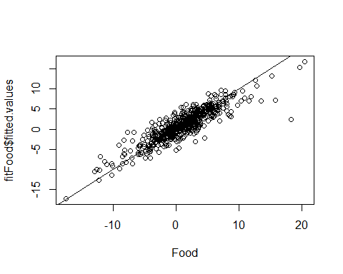

fitFood2=lm(Steel~Mkt)  
summary(fitFood2)

##   
## Call:  
## lm(formula = Steel ~ Mkt)  
##   
## Residuals:  
## Min 1Q Median 3Q Max   
## -19.1426 -2.8816 -0.1664 2.6262 24.9623   
##   
## Coefficients:  
## Estimate Std. Error t value Pr(>|t|)   
## (Intercept) 0.12522 0.18755 0.668 0.505   
## Mkt 1.28925 0.04158 31.007 <2e-16 ***  
## ---  
## Signif. codes: 0 '***' 0.001 '**' 0.01 '*' 0.05 '.' 0.1 ' ' 1  
##   
## Residual standard error: 4.589 on 604 degrees of freedom  
## Multiple R-squared: 0.6142, Adjusted R-squared: 0.6135   
## F-statistic: 961.5 on 1 and 604 DF, p-value: < 2.2e-16

plot(Food,fitFood2$fitted.values)  
abline(c(0,1))

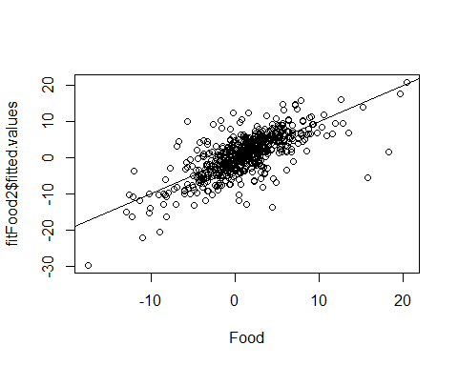

***From regression results using the first three principal components factors explains more of the variation in the steel and food industries’ returns than just the market factor, with the PCA model providing a better fit to the actual data.***

#(c)  
svrf=sv[,2:26]-rf$RF

***The second and fifteenth size-value sorted portfolios are constructed by combining rankings based on market capitalization and book-to-market ratios. The provided code calculates excess returns for these portfolios by subtracting the risk-free rate***.

# (d)   
fit1=lm(svrf[[2]]~Mkt)  
summary(fit1)

##   
## Call:  
## lm(formula = svrf[[2]] ~ Mkt)  
##   
## Residuals:  
## Min 1Q Median 3Q Max   
## -26.844 -2.390 -0.242 2.012 34.923   
##   
## Coefficients:  
## Estimate Std. Error t value Pr(>|t|)   
## (Intercept) 0.1971 0.1709 1.153 0.249   
## Mkt 1.2283 0.0379 32.413 <2e-16 ***  
## ---  
## Signif. codes: 0 '***' 0.001 '**' 0.01 '*' 0.05 '.' 0.1 ' ' 1  
##   
## Residual standard error: 4.182 on 604 degrees of freedom  
## Multiple R-squared: 0.635, Adjusted R-squared: 0.6344   
## F-statistic: 1051 on 1 and 604 DF, p-value: < 2.2e-16

fit3=lm(svrf[[15]]~Mkt)  
summary(fit3)

##   
## Call:  
## lm(formula = svrf[[15]] ~ Mkt)  
##   
## Residuals:  
## Min 1Q Median 3Q Max   
## -10.285 -1.732 -0.176 1.567 14.015   
##   
## Coefficients:  
## Estimate Std. Error t value Pr(>|t|)   
## (Intercept) 0.55721 0.12486 4.463 9.65e-06 ***  
## Mkt 1.02837 0.02768 37.152 < 2e-16 ***  
## ---  
## Signif. codes: 0 '***' 0.001 '**' 0.01 '*' 0.05 '.' 0.1 ' ' 1  
##   
## Residual standard error: 3.055 on 604 degrees of freedom  
## Multiple R-squared: 0.6956, Adjusted R-squared: 0.6951   
## F-statistic: 1380 on 1 and 604 DF, p-value: < 2.2e-16

***Interpretation of Results:***

***Portfolio 2:***

*The intercept (0.1971) is not statistically significant (p-value: 0.249), indicating that the average excess return of this portfolio is not significantly different from zero when the market excess return is zero.*

***Portfolio 15:***

*The intercept (0.55721) is statistically significant (p-value: 9.65e-06 ***), suggesting that, on average, Portfolio 15 has a positive excess return even when the market excess return is zero.*

# (e)  
fit1=lm(svrf[[2]]~Mkt)  
summary(fit1)

##   
## Call:  
## lm(formula = svrf[[2]] ~ Mkt)  
##   
## Residuals:  
## Min 1Q Median 3Q Max   
## -26.844 -2.390 -0.242 2.012 34.923   
##   
## Coefficients:  
## Estimate Std. Error t value Pr(>|t|)   
## (Intercept) 0.1971 0.1709 1.153 0.249   
## Mkt 1.2283 0.0379 32.413 <2e-16 ***  
## ---  
## Signif. codes: 0 '***' 0.001 '**' 0.01 '*' 0.05 '.' 0.1 ' ' 1  
##   
## Residual standard error: 4.182 on 604 degrees of freedom  
## Multiple R-squared: 0.635, Adjusted R-squared: 0.6344   
## F-statistic: 1051 on 1 and 604 DF, p-value: < 2.2e-16

fit3=lm(svrf[[15]]~Mkt)  
summary(fit3)

##   
## Call:  
## lm(formula = svrf[[15]] ~ Mkt)  
##   
## Residuals:  
## Min 1Q Median 3Q Max   
## -10.285 -1.732 -0.176 1.567 14.015   
##   
## Coefficients:  
## Estimate Std. Error t value Pr(>|t|)   
## (Intercept) 0.55721 0.12486 4.463 9.65e-06 ***  
## Mkt 1.02837 0.02768 37.152 < 2e-16 ***  
## ---  
## Signif. codes: 0 '***' 0.001 '**' 0.01 '*' 0.05 '.' 0.1 ' ' 1  
##   
## Residual standard error: 3.055 on 604 degrees of freedom  
## Multiple R-squared: 0.6956, Adjusted R-squared: 0.6951   
## F-statistic: 1380 on 1 and 604 DF, p-value: < 2.2e-16

**Interpretation and Conclusion:**

*For* ***2nd Portfolio****: We can accept the null hypothesis that the intercept is zero (p-value = 0.249), suggesting no significant evidence at 0.05 alpha.*

***For 15th Portfolio:*** *We reject the null hypothesis that the intercept is zero (p-value = 9.65e-06), indicating significant evidence at 0.05 alpha.*

# (f)  
fit2=lm(svrf[[2]]~Mkt+SMB+HML)  
summary(fit2)

##   
## Call:  
## lm(formula = svrf[[2]] ~ Mkt + SMB + HML)  
##   
## Residuals:  
## Min 1Q Median 3Q Max   
## -4.9039 -1.0194 -0.0210 0.8858 9.3661   
##   
## Coefficients:  
## Estimate Std. Error t value Pr(>|t|)   
## (Intercept) 0.008427 0.068121 0.124 0.902   
## Mkt 0.952416 0.016131 59.044 < 2e-16 ***  
## SMB 1.292597 0.022582 57.241 < 2e-16 ***  
## HML -0.124334 0.024276 -5.122 4.08e-07 ***  
## ---  
## Signif. codes: 0 '***' 0.001 '**' 0.01 '*' 0.05 '.' 0.1 ' ' 1  
##   
## Residual standard error: 1.639 on 602 degrees of freedom  
## Multiple R-squared: 0.9441, Adjusted R-squared: 0.9438   
## F-statistic: 3390 on 3 and 602 DF, p-value: < 2.2e-16

fit4=lm(svrf[[15]]~Mkt+SMB+HML)  
summary(fit4)

##   
## Call:  
## lm(formula = svrf[[15]] ~ Mkt + SMB + HML)  
##   
## Residuals:  
## Min 1Q Median 3Q Max   
## -7.6577 -1.1512 -0.1066 0.9625 9.1959   
##   
## Coefficients:  
## Estimate Std. Error t value Pr(>|t|)   
## (Intercept) 0.11962 0.07434 1.609 0.108   
## Mkt 1.05867 0.01760 60.141 <2e-16 ***  
## SMB 0.54495 0.02464 22.113 <2e-16 ***  
## HML 0.70857 0.02649 26.747 <2e-16 ***  
## ---  
## Signif. codes: 0 '***' 0.001 '**' 0.01 '*' 0.05 '.' 0.1 ' ' 1  
##   
## Residual standard error: 1.789 on 602 degrees of freedom  
## Multiple R-squared: 0.896, Adjusted R-squared: 0.8955   
## F-statistic: 1729 on 3 and 602 DF, p-value: < 2.2e-16

**Interpretation:**

***2nd Portfolio****: We can accept the null hypothesis that the intercept is zero (p-value = 0.902), suggesting no significant evidence at 0.05 alpha.*

***15th Portfolio****: We can accept the null hypothesis that the intercept is zero (p-value = 0.108), indicating no significant evidence at 0.05 alpha.*

# (g)  
library(lmtest)

## Loading required package: zoo

##   
## Attaching package: 'zoo'

## The following objects are masked from 'package:base':  
##   
## as.Date, as.Date.numeric

library(sandwich)  
coeftest(fit1, vcov = vcov(fit1))

##   
## t test of coefficients:  
##   
## Estimate Std. Error t value Pr(>|t|)   
## (Intercept) 0.197141 0.170935 1.1533 0.2492   
## Mkt 1.228318 0.037896 32.4130 <2e-16 ***  
## ---  
## Signif. codes: 0 '***' 0.001 '**' 0.01 '*' 0.05 '.' 0.1 ' ' 1

coeftest(fit1, vcov = NeweyWest(fit1))

##   
## t test of coefficients:  
##   
## Estimate Std. Error t value Pr(>|t|)   
## (Intercept) 0.197141 0.178033 1.1073 0.2686   
## Mkt 1.228318 0.042979 28.5795 <2e-16 ***  
## ---  
## Signif. codes: 0 '***' 0.001 '**' 0.01 '*' 0.05 '.' 0.1 ' ' 1

coeftest(fit2, vcov = vcov(fit2))

##   
## t test of coefficients:  
##   
## Estimate Std. Error t value Pr(>|t|)   
## (Intercept) 0.0084275 0.0681207 0.1237 0.9016   
## Mkt 0.9524163 0.0161306 59.0441 < 2.2e-16 ***  
## SMB 1.2925966 0.0225817 57.2409 < 2.2e-16 ***  
## HML -0.1243336 0.0242759 -5.1217 4.082e-07 ***  
## ---  
## Signif. codes: 0 '***' 0.001 '**' 0.01 '*' 0.05 '.' 0.1 ' ' 1

coeftest(fit2, vcov = NeweyWest(fit2))

##   
## t test of coefficients:  
##   
## Estimate Std. Error t value Pr(>|t|)   
## (Intercept) 0.0084275 0.0745373 0.1131 0.91002   
## Mkt 0.9524163 0.0244968 38.8793 < 2e-16 ***  
## SMB 1.2925966 0.0651197 19.8496 < 2e-16 ***  
## HML -0.1243336 0.0599509 -2.0739 0.03851 *   
## ---  
## Signif. codes: 0 '***' 0.001 '**' 0.01 '*' 0.05 '.' 0.1 ' ' 1

coeftest(fit3, vcov = vcov(fit3))

##   
## t test of coefficients:  
##   
## Estimate Std. Error t value Pr(>|t|)   
## (Intercept) 0.55721 0.12486 4.4628 9.653e-06 ***  
## Mkt 1.02837 0.02768 37.1517 < 2.2e-16 ***  
## ---  
## Signif. codes: 0 '***' 0.001 '**' 0.01 '*' 0.05 '.' 0.1 ' ' 1

coeftest(fit3, vcov = NeweyWest(fit3))

##   
## t test of coefficients:  
##   
## Estimate Std. Error t value Pr(>|t|)   
## (Intercept) 0.557210 0.155085 3.5929 0.0003536 ***  
## Mkt 1.028372 0.048553 21.1802 < 2.2e-16 ***  
## ---  
## Signif. codes: 0 '***' 0.001 '**' 0.01 '*' 0.05 '.' 0.1 ' ' 1

coeftest(fit4, vcov = vcov(fit4))

##   
## t test of coefficients:  
##   
## Estimate Std. Error t value Pr(>|t|)   
## (Intercept) 0.119616 0.074340 1.6091 0.1081   
## Mkt 1.058674 0.017603 60.1411 <2e-16 ***  
## SMB 0.544946 0.024643 22.1134 <2e-16 ***  
## HML 0.708573 0.026492 26.7466 <2e-16 ***  
## ---  
## Signif. codes: 0 '***' 0.001 '**' 0.01 '*' 0.05 '.' 0.1 ' ' 1

coeftest(fit4, vcov = NeweyWest(fit4))

##   
## t test of coefficients:  
##   
## Estimate Std. Error t value Pr(>|t|)   
## (Intercept) 0.119616 0.085994 1.3910 0.1647   
## Mkt 1.058674 0.030630 34.5634 <2e-16 ***  
## SMB 0.544946 0.059167 9.2104 <2e-16 ***  
## HML 0.708573 0.063483 11.1617 <2e-16 ***  
## ---  
## Signif. codes: 0 '***' 0.001 '**' 0.01 '*' 0.05 '.' 0.1 ' ' 1

**Comparison and Conclusion:**

***2nd Portfolio (CAPM) and 2nd Portfolio (Fama-French****): The intercept remains insignificant under both standard and Newey-West standard errors given their p-values.*

***15th Portfolio (CAPM) and 15th Portfolio (Fama-French):*** *The intercept becomes even less significant with Newey-West standard errors.*

# (h)  
pcasv=prcomp(svrf)  
plot(pcasv)

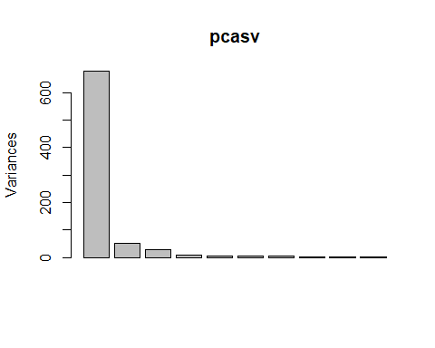

*By examining the elbow plot, there are three statistical factors needed to capture the variance from the* ***initial steep slope*** *where it indicates or explains a large portion of the variance as seen from the graph above.*

# (i)  
fit5=lm(Mkt~pcasv$x[,(1:3)])  
summary(fit5)

##   
## Call:  
## lm(formula = Mkt ~ pcasv$x[, (1:3)])  
##   
## Residuals:  
## Min 1Q Median 3Q Max   
## -4.3581 -0.3673 -0.0185 0.4113 4.1285   
##   
## Coefficients:  
## Estimate Std. Error t value Pr(>|t|)   
## (Intercept) 0.498498 0.031558 15.80 <2e-16 ***  
## pcasv$x[, (1:3)]PC1 -0.160839 0.001213 -132.56 <2e-16 ***  
## pcasv$x[, (1:3)]PC2 -0.096706 0.004372 -22.12 <2e-16 ***  
## pcasv$x[, (1:3)]PC3 -0.235693 0.006050 -38.96 <2e-16 ***  
## ---  
## Signif. codes: 0 '***' 0.001 '**' 0.01 '*' 0.05 '.' 0.1 ' ' 1  
##   
## Residual standard error: 0.7769 on 602 degrees of freedom  
## Multiple R-squared: 0.9702, Adjusted R-squared: 0.97   
## F-statistic: 6526 on 3 and 602 DF, p-value: < 2.2e-16

plot(Mkt,fit5$fitted.values,ylab="fitted values")  
abline(c(0,1))

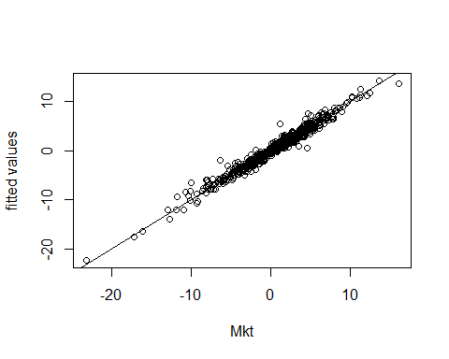

fit6=lm(SMB~pcasv$x[,(1:3)])  
summary(fit6)

##   
## Call:  
## lm(formula = SMB ~ pcasv$x[, (1:3)])  
##   
## Residuals:  
## Min 1Q Median 3Q Max   
## -3.8730 -0.4823 0.0128 0.4786 5.8184   
##   
## Coefficients:  
## Estimate Std. Error t value Pr(>|t|)   
## (Intercept) 0.288416 0.036432 7.917 1.18e-14 ***  
## pcasv$x[, (1:3)]PC1 -0.069551 0.001401 -49.653 < 2e-16 ***  
## pcasv$x[, (1:3)]PC2 0.248744 0.005047 49.286 < 2e-16 ***  
## pcasv$x[, (1:3)]PC3 0.282664 0.006984 40.473 < 2e-16 ***  
## ---  
## Signif. codes: 0 '***' 0.001 '**' 0.01 '*' 0.05 '.' 0.1 ' ' 1  
##   
## Residual standard error: 0.8968 on 602 degrees of freedom  
## Multiple R-squared: 0.9156, Adjusted R-squared: 0.9152   
## F-statistic: 2178 on 3 and 602 DF, p-value: < 2.2e-16

plot(SMB,fit6$fitted.values,ylab="fitted values")  
abline(c(0,1))

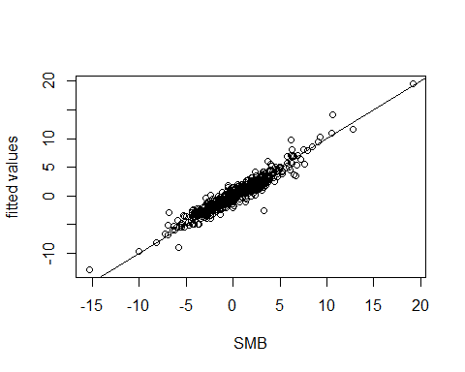

fit7=lm(HML~pcasv$x[,(1:3)])  
summary(fit7)

##   
## Call:  
## lm(formula = HML ~ pcasv$x[, (1:3)])  
##   
## Residuals:  
## Min 1Q Median 3Q Max   
## -3.13357 -0.38904 0.00342 0.39520 2.49947   
##   
## Coefficients:  
## Estimate Std. Error t value Pr(>|t|)   
## (Intercept) 0.374439 0.027573 13.58 <2e-16 ***  
## pcasv$x[, (1:3)]PC1 0.022227 0.001060 20.96 <2e-16 ***  
## pcasv$x[, (1:3)]PC2 -0.237740 0.003820 -62.24 <2e-16 ***  
## pcasv$x[, (1:3)]PC3 0.408564 0.005286 77.29 <2e-16 ***  
## ---  
## Signif. codes: 0 '***' 0.001 '**' 0.01 '*' 0.05 '.' 0.1 ' ' 1  
##   
## Residual standard error: 0.6788 on 602 degrees of freedom  
## Multiple R-squared: 0.9447, Adjusted R-squared: 0.9444   
## F-statistic: 3429 on 3 and 602 DF, p-value: < 2.2e-16

plot(HML,fit7$fitted.values,ylab="fitted values")  
abline(c(0,1))

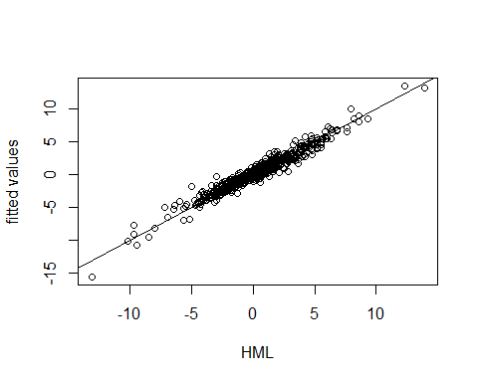

**Comment on the Statement:**

*"The Fama-French factors are simply the first three principal components based on the size-value sorted portfolios."*

**Interpretation**:

• *Fama-French factors are defined based on economic theory and portfolio construction rules.*

*• PCA is a statistical method, whereas the Fama-French factors have economic interpretations related to market risk, size, and value.*

*• Therefore, while there may be overlap in variance explained, the Fama-French factors and the principal components are conceptually different.*

## Bonus Questions: Note these questions are optional.

1. Exploratory data analysis II: 15 points

## Problem 3  
da <- read.table("d-exuseu-0516.txt",header=T)  
head(da)

## year mon day euro  
## 1 2005 1 3 1.3476  
## 2 2005 1 4 1.3295  
## 3 2005 1 5 1.3292  
## 4 2005 1 6 1.3187  
## 5 2005 1 7 1.3062  
## 6 2005 1 10 1.3109

# (a)  
rtn=diff(log(da$euro)) ## Compute log return

***All positives log returns indicates that the Euro appreciated relative to the US Dollar from one day to the next.***

# (b)  
basicStats(rtn)

## rtn  
## nobs 2816.000000  
## NAs 0.000000  
## Minimum -0.030031  
## Maximum 0.046208  
## 1. Quartile -0.003446  
## 3. Quartile 0.003304  
## Mean -0.000063  
## Median 0.000000  
## Sum -0.176816  
## SE Mean 0.000120  
## LCL Mean -0.000298  
## UCL Mean 0.000172  
## Variance 0.000040  
## Stdev 0.006363  
## Skewness 0.206116  
## Kurtosis 2.890412

# (c)  
densityEX=density(rtn)  
plot(densityEX,xlab="ln-rtn",ylab='euro',main='Density EX')

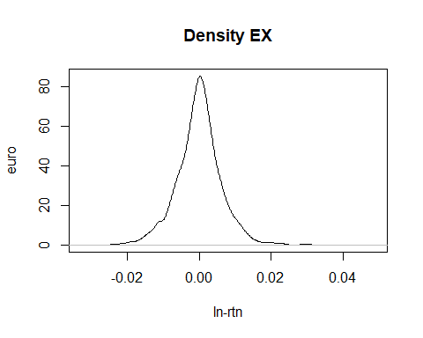

# (d)  
t.test(rtn)

##   
## One Sample t-test  
##   
## data: rtn  
## t = -0.52367, df = 2815, p-value = 0.6005  
## alternative hypothesis: true mean is not equal to 0  
## 95 percent confidence interval:  
## -0.0002978961 0.0001723167  
## sample estimates:  
## mean of x   
## -6.278971e-05

*Since the p-value (0.6005) is much greater than the typical significance level of 0.05, we* ***fail to reject the null hypothesis****. This means that there is insufficient evidence to conclude that the mean of the daily log returns is different from zero.*

# (e)  
normalTest(rtn)

##   
## Title:  
## Shapiro - Wilk Normality Test  
##   
## Test Results:  
## STATISTIC:  
## W: 0.9732  
## P VALUE:  
## < 2.2e-16

qqnorm(rtn) # Quantile-quantile plot  
qqline(rtn) # Include a line in the quantile-quantile plot.

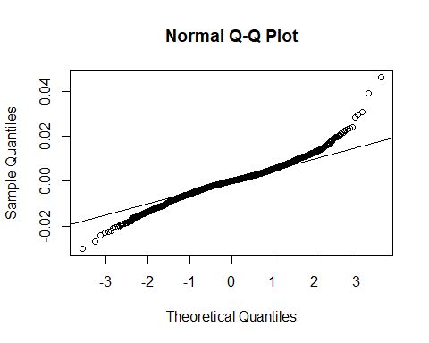

# If empirical values are normally distributed  
# then the quantiles should all be on the line.

***p-value is extremely small (< 2.2e-16)****, which means we* ***reject the null hypothesis*** *and conclude that the log returns are* ***not normally distributed****. Also, from the QQ plot generated the data points do not closely follow the reference line provides additional evidence that the log returns are* ***not normally distributed****.*

## 4. Time-series model: 20 points

### Problem 4  
da=read.table("m-COILWTICO.txt",header=T)  
head(da)

## DATE VALUE  
## 1 1986-01-01 22.93  
## 2 1986-02-01 15.46  
## 3 1986-03-01 12.61  
## 4 1986-04-01 12.84  
## 5 1986-05-01 15.38  
## 6 1986-06-01 13.43

# (a)  
oil=da$VALUE  
doil=diff(oil)  
dim(da)

## [1] 362 2

# (b)  
tdx <- c(1:362)/12+1986  
plot(tdx,oil,xlab='year',ylab='coil',type='l')

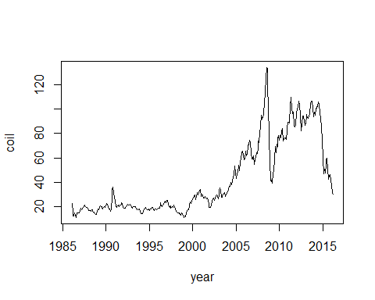

plot(tdx[-1],doil,xlab='year',ylab='diff(oil)',type='l')

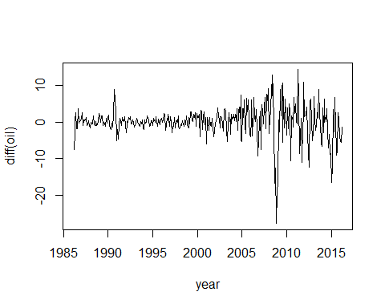

***Original series (oil)*** *is* ***non-stationary*** *because of upwards and downwards trend while* ***Differenced series (diff(oil))******is weakly stationary due to no obvious trend or seasonality.***

# (c)  
# If you have not installed the package fUnitRoots please use the following command:  
#install.packages("fUnitRoots")  
require(fUnitRoots)

## Loading required package: fUnitRoots

adfTest(oil,lags=11,type="c")

##   
## Title:  
## Augmented Dickey-Fuller Test  
##   
## Test Results:  
## PARAMETER:  
## Lag Order: 11  
## STATISTIC:  
## Dickey-Fuller: -1.6257  
## P VALUE:  
## 0.4521   
##   
## Description:  
## Tue Nov 19 11:37:58 2024 by user: Administrator

adfTest(doil,lags=11,type="c")

## Warning in adfTest(doil, lags = 11, type = "c"): p-value smaller than printed  
## p-value

##   
## Title:  
## Augmented Dickey-Fuller Test  
##   
## Test Results:  
## PARAMETER:  
## Lag Order: 11  
## STATISTIC:  
## Dickey-Fuller: -5.7315  
## P VALUE:  
## 0.01   
##   
## Description:  
## Tue Nov 19 11:37:58 2024 by user: Administrator

*Since* ***p-value*** *of* ***0.4521*** *which is greater than the common significance level of* ***0.05****, we* ***fail*** *to* ***reject the null hypothesis****. Thus, indicates oil prices is likely non-stationary.*

# (d)  
acf(oil)

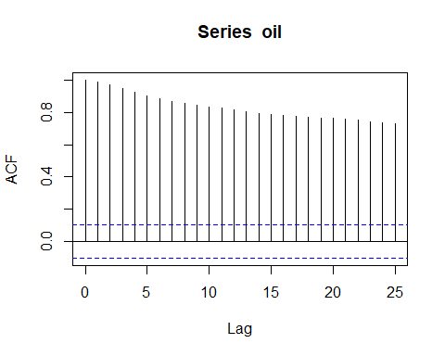

pacf(oil)

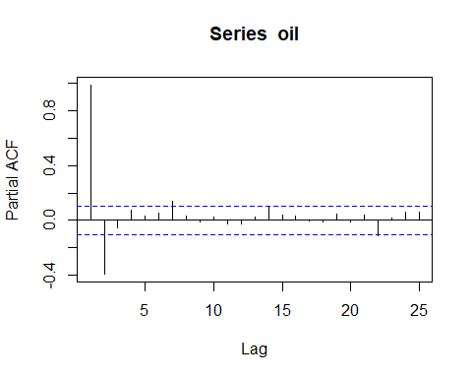

acf(doil)

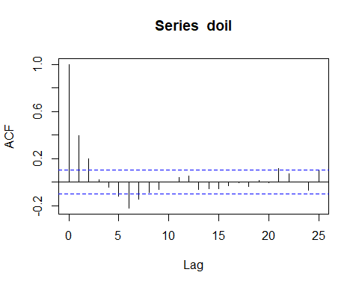

pacf(doil)

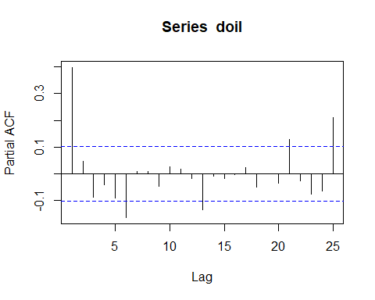

*ACF of the original series shows slow decay, it indicates non-stationarity. PACF plot also show significant lags, which can help identify the order of differencing needed.*

# (e)  
Box.test(doil,lag=12,type="Ljung")

##   
## Box-Ljung test  
##   
## data: doil  
## X-squared = 110.11, df = 12, p-value < 2.2e-16

*Since p-value is less than 0.05 common significance value, we reject null hypothesis.*

# (f)  
library("forecast")

## Registered S3 method overwritten by 'quantmod':  
## method from  
## as.zoo.data.frame zoo

ARoil=arima(doil,c(6,0,0))  
ARoil

##   
## Call:  
## arima(x = doil, order = c(6, 0, 0))  
##   
## Coefficients:  
## ar1 ar2 ar3 ar4 ar5 ar6 intercept  
## 0.362 0.0779 -0.0761 0.0059 -0.0291 -0.1626 0.0260  
## s.e. 0.052 0.0554 0.0556 0.0555 0.0553 0.0520 0.2483  
##   
## sigma^2 estimated as 14.95: log likelihood = -1000.7, aic = 2017.4

tsdiag(ARoil)

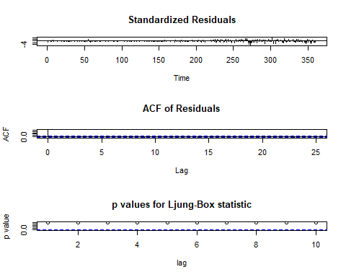

# You can also use the auto.arima command to fit an AR model  
# ARoil2=auto.arima(doil,max.p = 20, max.q = 0, d = 0)  
# ARoil2  
# tsdiag(ARoil2)  
# (g)  
#You can use the auto.arima command to fit an ARMA model  
# ARIMAoil=auto.arima(doil)  
# ARIMAoil  
# tsdiag(ARIMAoil)  
ARIMAoil2=arima(doil,order=c(1,0,6))  
ARIMAoil2

##   
## Call:  
## arima(x = doil, order = c(1, 0, 6))  
##   
## Coefficients:  
## ar1 ma1 ma2 ma3 ma4 ma5 ma6 intercept  
## 0.6892 -0.3330 -0.0384 -0.1289 -0.0149 -0.0312 -0.1717 0.0599  
## s.e. 0.1240 0.1274 0.0672 0.0585 0.0543 0.0547 0.0551 0.1897  
##   
## sigma^2 estimated as 14.91: log likelihood = -1000.14, aic = 2018.28

tsdiag(ARIMAoil2,gof=24)

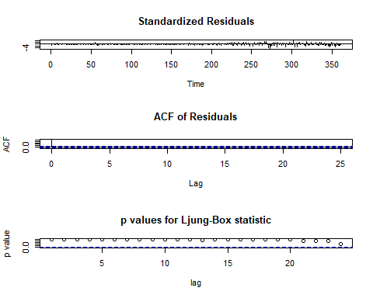

# (h)  
Oilpredict=predict(ARIMAoil2,4)  
Oilpredict

## $pred  
## Time Series:  
## Start = 362   
## End = 365   
## Frequency = 1   
## [1] -0.4453396 0.8000120 1.8028413 2.3216605  
##   
## $se  
## Time Series:  
## Start = 362   
## End = 365   
## Frequency = 1   
## [1] 3.860809 4.098314 4.175542 4.175879

lcl=Oilpredict$pred-1.96*Oilpredict$se  
ucl=Oilpredict$pred+1.96*Oilpredict$se  
cf=cbind(lcl,ucl)  
cf

## Time Series:  
## Start = 362   
## End = 365   
## Frequency = 1   
## lcl ucl  
## 362 -8.012524 7.121845  
## 363 -7.232684 8.832708  
## 364 -6.381221 9.986903  
## 365 -5.863062 10.506383

Oilforecast=forecast(ARIMAoil2,4)  
Oilforecast

## Point Forecast Lo 80 Hi 80 Lo 95 Hi 95  
## 362 -0.4453396 -5.393165 4.502486 -8.012385 7.121706  
## 363 0.8000120 -4.452189 6.052213 -7.232536 8.832560  
## 364 1.8028413 -3.548331 7.154013 -6.381070 9.986753  
## 365 2.3216605 -3.029943 7.673264 -5.862911 10.506232

plot(Oilforecast)

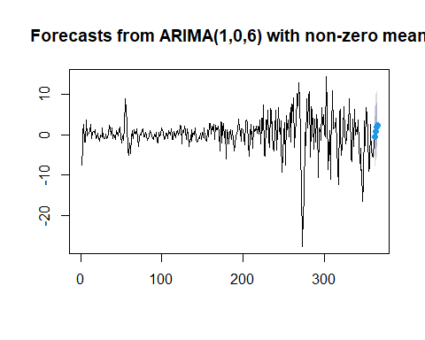

# The next plot includes only the last 24 observations and labels  
plot(Oilforecast,include=24,xlab="time",ylab="oil return",main="Prediction")

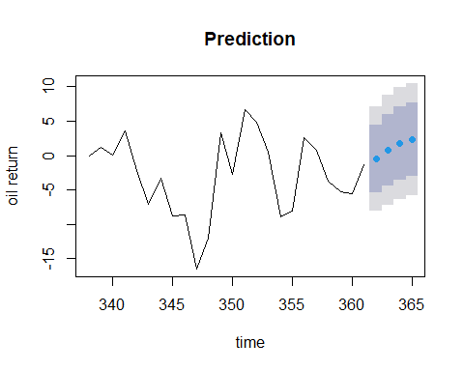

## 5. GARCH: 20 points

#Problem 5  
require(forecast)  
da=read.table("d-amzn3dx0914.txt",header=T)  
head(da)

## PERMNO date amzn vwretd ewretd sprtrn  
## 1 84788 20090102 0.060062 0.030501 0.038274 0.031608  
## 2 84788 20090105 -0.005519 -0.000579 0.016764 -0.004668  
## 3 84788 20090106 0.061043 0.011298 0.033647 0.007817  
## 4 84788 20090107 -0.020223 -0.030489 -0.022271 -0.030010  
## 5 84788 20090108 0.017082 0.006284 0.011896 0.003397  
## 6 84788 20090109 -0.028866 -0.022409 -0.018748 -0.021303

rt=log(da$amzn+1)*100  
# (a)  
t.test(rt)

##   
## One Sample t-test  
##   
## data: rt  
## t = 2.0296, df = 1509, p-value = 0.04257  
## alternative hypothesis: true mean is not equal to 0  
## 95 percent confidence interval:  
## 0.003999691 0.234462533  
## sample estimates:  
## mean of x   
## 0.1192311

# (b)  
acf(rt)

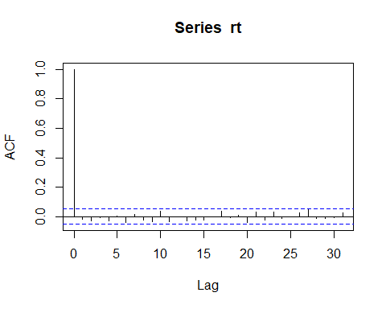

Box.test(rt,lag=10,type='Ljung')

##   
## Box-Ljung test  
##   
## data: rt  
## X-squared = 10.974, df = 10, p-value = 0.3595

# (c)  
library(rugarch)

## Loading required package: parallel

##   
## Attaching package: 'rugarch'

## The following objects are masked from 'package:fBasics':  
##   
## qgh, qnig

## The following object is masked from 'package:stats':  
##   
## sigma

garch.norm = ugarchspec(mean.model=list(armaOrder=c(0,0)),  
variance.model=list(garchOrder=c(1,1)))  
amazonGarch = ugarchfit(data=rt, spec=garch.norm)  
show(amazonGarch)

##   
## *---------------------------------*  
## * GARCH Model Fit *  
## *---------------------------------*  
##   
## Conditional Variance Dynamics   
## -----------------------------------  
## GARCH Model : sGARCH(1,1)  
## Mean Model : ARFIMA(0,0,0)  
## Distribution : norm   
##   
## Optimal Parameters  
## ------------------------------------  
## Estimate Std. Error t value Pr(>|t|)  
## mu 0.109363 0.056675 1.9297 0.053650  
## omega 0.023032 0.005897 3.9059 0.000094  
## alpha1 0.007252 0.001621 4.4739 0.000008  
## beta1 0.987686 0.000758 1302.8981 0.000000  
##   
## Robust Standard Errors:  
## Estimate Std. Error t value Pr(>|t|)  
## mu 0.109363 0.052929 2.0662 0.038808  
## omega 0.023032 0.014680 1.5689 0.116678  
## alpha1 0.007252 0.004172 1.7382 0.082168  
## beta1 0.987686 0.000882 1119.9290 0.000000  
##   
## LogLikelihood : -3365.187   
##   
## Information Criteria  
## ------------------------------------  
##   
## Akaike 4.4625  
## Bayes 4.4766  
## Shibata 4.4625  
## Hannan-Quinn 4.4677  
##   
## Weighted Ljung-Box Test on Standardized Residuals  
## ------------------------------------  
## statistic p-value  
## Lag[1] 0.913 0.3393  
## Lag[2*(p+q)+(p+q)-1][2] 1.184 0.4424  
## Lag[4*(p+q)+(p+q)-1][5] 2.094 0.5964  
## d.o.f=0  
## H0 : No serial correlation  
##   
## Weighted Ljung-Box Test on Standardized Squared Residuals  
## ------------------------------------  
## statistic p-value  
## Lag[1] 1.240 0.2654  
## Lag[2*(p+q)+(p+q)-1][5] 1.386 0.7679  
## Lag[4*(p+q)+(p+q)-1][9] 1.610 0.9461  
## d.o.f=2  
##   
## Weighted ARCH LM Tests  
## ------------------------------------  
## Statistic Shape Scale P-Value  
## ARCH Lag[3] 0.05111 0.500 2.000 0.8211  
## ARCH Lag[5] 0.25510 1.440 1.667 0.9520  
## ARCH Lag[7] 0.40838 2.315 1.543 0.9859  
##   
## Nyblom stability test  
## ------------------------------------  
## Joint Statistic: 0.6148  
## Individual Statistics:   
## mu 0.23836  
## omega 0.10117  
## alpha1 0.12173  
## beta1 0.09862  
##   
## Asymptotic Critical Values (10% 5% 1%)  
## Joint Statistic: 1.07 1.24 1.6  
## Individual Statistic: 0.35 0.47 0.75  
##   
## Sign Bias Test  
## ------------------------------------  
## t-value prob sig  
## Sign Bias 0.7049 0.4810   
## Negative Sign Bias 0.1673 0.8671   
## Positive Sign Bias 0.9319 0.3515   
## Joint Effect 1.1292 0.7700   
##   
##   
## Adjusted Pearson Goodness-of-Fit Test:  
## ------------------------------------  
## group statistic p-value(g-1)  
## 1 20 101.3 3.098e-13  
## 2 30 114.3 4.486e-12  
## 3 40 124.0 8.834e-11  
## 4 50 138.8 1.605e-10  
##   
##   
## Elapsed time : 0.1822562

plot(amazonGarch, which="all")

##   
## please wait...calculating quantiles...

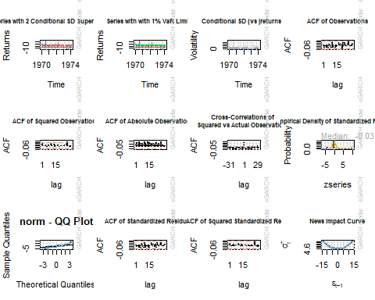

plot(amazonGarch, which=9)

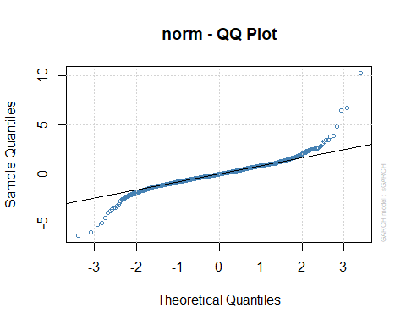

plot(amazonGarch, which=10)

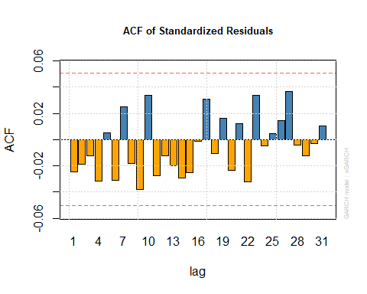

plot(amazonGarch, which=11)

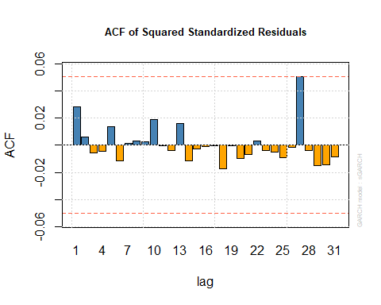

# (d)  
arma.garch.t = ugarchspec(mean.model=list(armaOrder=c(0,0)),  
variance.model=list(garchOrder=c(1,1)),  
distribution.model = "std")  
amazonGarch.t = ugarchfit(data=rt, spec=arma.garch.t)  
show(amazonGarch.t)

##   
## *---------------------------------*  
## * GARCH Model Fit *  
## *---------------------------------*  
##   
## Conditional Variance Dynamics   
## -----------------------------------  
## GARCH Model : sGARCH(1,1)  
## Mean Model : ARFIMA(0,0,0)  
## Distribution : std   
##   
## Optimal Parameters  
## ------------------------------------  
## Estimate Std. Error t value Pr(>|t|)  
## mu 0.087060 0.046113 1.8880 0.059032  
## omega 0.060535 0.017407 3.4776 0.000506  
## alpha1 0.017064 0.003726 4.5796 0.000005  
## beta1 0.968300 0.004272 226.6839 0.000000  
## shape 4.311221 0.428313 10.0656 0.000000  
##   
## Robust Standard Errors:  
## Estimate Std. Error t value Pr(>|t|)  
## mu 0.087060 0.041887 2.0785 0.037665  
## omega 0.060535 0.015855 3.8181 0.000134  
## alpha1 0.017064 0.003701 4.6111 0.000004  
## beta1 0.968300 0.001813 534.1900 0.000000  
## shape 4.311221 0.452458 9.5284 0.000000  
##   
## LogLikelihood : -3195.838   
##   
## Information Criteria  
## ------------------------------------  
##   
## Akaike 4.2395  
## Bayes 4.2571  
## Shibata 4.2395  
## Hannan-Quinn 4.2461  
##   
## Weighted Ljung-Box Test on Standardized Residuals  
## ------------------------------------  
## statistic p-value  
## Lag[1] 0.9535 0.3288  
## Lag[2*(p+q)+(p+q)-1][2] 1.1516 0.4516  
## Lag[4*(p+q)+(p+q)-1][5] 2.0691 0.6022  
## d.o.f=0  
## H0 : No serial correlation  
##   
## Weighted Ljung-Box Test on Standardized Squared Residuals  
## ------------------------------------  
## statistic p-value  
## Lag[1] 0.2485 0.6182  
## Lag[2*(p+q)+(p+q)-1][5] 0.4458 0.9657  
## Lag[4*(p+q)+(p+q)-1][9] 0.6631 0.9962  
## d.o.f=2  
##   
## Weighted ARCH LM Tests  
## ------------------------------------  
## Statistic Shape Scale P-Value  
## ARCH Lag[3] 0.2343 0.500 2.000 0.6284  
## ARCH Lag[5] 0.3352 1.440 1.667 0.9308  
## ARCH Lag[7] 0.5063 2.315 1.543 0.9778  
##   
## Nyblom stability test  
## ------------------------------------  
## Joint Statistic: 1.4469  
## Individual Statistics:   
## mu 0.01125  
## omega 0.51229  
## alpha1 0.92420  
## beta1 0.62430  
## shape 0.73278  
##   
## Asymptotic Critical Values (10% 5% 1%)  
## Joint Statistic: 1.28 1.47 1.88  
## Individual Statistic: 0.35 0.47 0.75  
##   
## Sign Bias Test  
## ------------------------------------  
## t-value prob sig  
## Sign Bias 0.6780 0.4979   
## Negative Sign Bias 0.3314 0.7404   
## Positive Sign Bias 0.4491 0.6534   
## Joint Effect 0.4823 0.9228   
##   
##   
## Adjusted Pearson Goodness-of-Fit Test:  
## ------------------------------------  
## group statistic p-value(g-1)  
## 1 20 19.38 0.4329  
## 2 30 22.82 0.7847  
## 3 40 31.03 0.8146  
## 4 50 36.29 0.9109  
##   
##   
## Elapsed time : 0.2266591

plot(amazonGarch.t, which="all")

##   
## please wait...calculating quantiles...

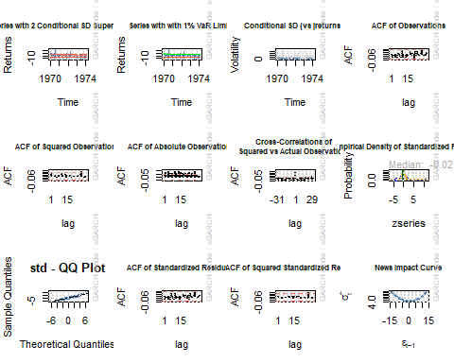

plot(amazonGarch.t, which=9)

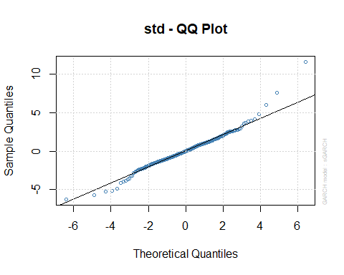

plot(amazonGarch.t, which=10)

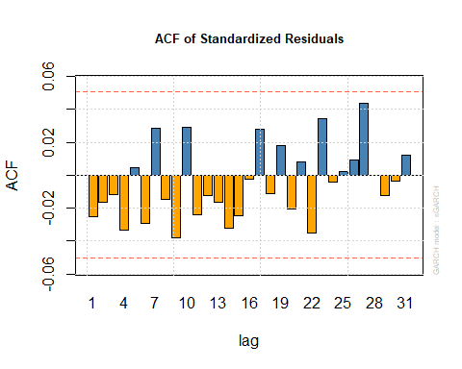

plot(amazonGarch.t, which=11)

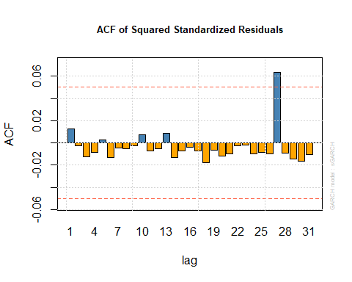

# (f)  
amazonforecast=ugarchforecast(amazonGarch.t, data = rt, n.ahead = 5)  
show(amazonforecast)

##   
## *------------------------------------*  
## * GARCH Model Forecast *  
## *------------------------------------*  
## Model: sGARCH  
## Horizon: 5  
## Roll Steps: 0  
## Out of Sample: 0  
##   
## 0-roll forecast [T0=1974-02-19]:  
## Series Sigma  
## T+1 0.08706 1.873  
## T+2 0.08706 1.876  
## T+3 0.08706 1.878  
## T+4 0.08706 1.881  
## T+5 0.08706 1.883

plot(amazonforecast,which=1)

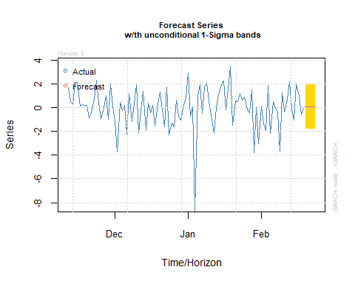

plot(amazonforecast,which=3)

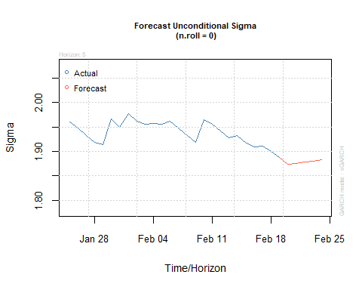

## 6.Time-series model II: 30 bonus points

#### Problem 6  
require(forecast)  
da <- read.table("m-globaltemp.txt",header=T)  
dd <- da[,2:13]  
xt <- c(t(dd))  
zt <- diff(xt)  
length(xt)

## [1] 1632

tdx <- c(1:1632)/12+1880  
# (a)  
par(mfcol=c(2,1))  
plot(tdx,xt,xlab='year',ylab='temp',type='l')  
plot(tdx[-1],zt,xlab='year',ylab='diff(temp)',type='l')

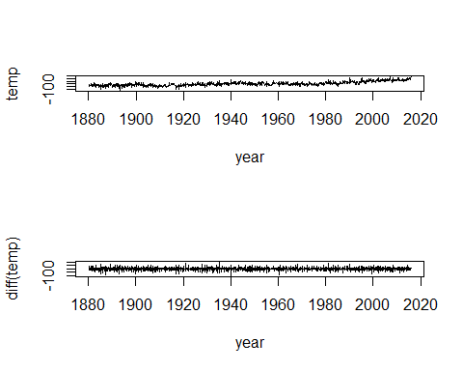

par(mfcol=c(1,1))  
# (b)  
require(fUnitRoots)  
adfTest(xt,lags=11,type="c")

##   
## Title:  
## Augmented Dickey-Fuller Test  
##   
## Test Results:  
## PARAMETER:  
## Lag Order: 11  
## STATISTIC:  
## Dickey-Fuller: -1.7197  
## P VALUE:  
## 0.4179   
##   
## Description:  
## Tue Nov 19 11:38:08 2024 by user: Administrator

adfTest(zt,lags=11,type="c")

## Warning in adfTest(zt, lags = 11, type = "c"): p-value smaller than printed  
## p-value

##   
## Title:  
## Augmented Dickey-Fuller Test  
##   
## Test Results:  
## PARAMETER:  
## Lag Order: 11  
## STATISTIC:  
## Dickey-Fuller: -17.6881  
## P VALUE:  
## 0.01   
##   
## Description:  
## Tue Nov 19 11:38:08 2024 by user: Administrator

# (c)  
t.test(zt)

##   
## One Sample t-test  
##   
## data: zt  
## t = 0.22712, df = 1630, p-value = 0.8204  
## alternative hypothesis: true mean is not equal to 0  
## 95 percent confidence interval:  
## -0.9270074 1.1698033  
## sample estimates:  
## mean of x   
## 0.1213979

# (d)  
par(mfcol=c(2,1))  
acf(zt)  
pacf(zt)

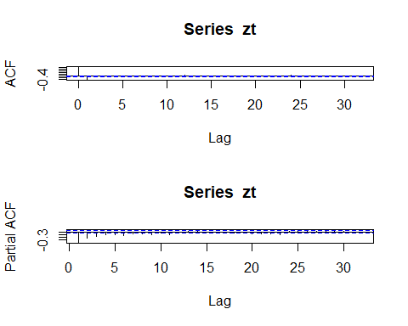

par(mfcol=c(1,1))  
# (e)  
Box.test(zt,lag=12,type='Ljung')

##   
## Box-Ljung test  
##   
## data: zt  
## X-squared = 253.49, df = 12, p-value < 2.2e-16

# (f)  
ARtemp=auto.arima(zt,max.p = 20, max.q = 0, d = 0)  
ARtemp

## Series: zt   
## ARIMA(11,0,0) with zero mean   
##   
## Coefficients:  
## ar1 ar2 ar3 ar4 ar5 ar6 ar7 ar8  
## -0.5723 -0.4264 -0.3559 -0.3062 -0.2923 -0.2732 -0.2137 -0.2041  
## s.e. 0.0247 0.0283 0.0299 0.0308 0.0313 0.0314 0.0313 0.0308  
## ar9 ar10 ar11  
## -0.1894 -0.1132 -0.0929  
## s.e. 0.0299 0.0283 0.0247  
##   
## sigma^2 = 346.1: log likelihood = -7077.32  
## AIC=14178.64 AICc=14178.83 BIC=14243.4

tsdiag(ARtemp)

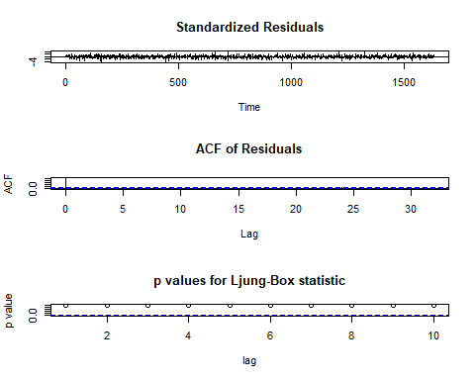

ARtemp2=arima(zt,order=c(11,0,0),include.mean=F)  
ARtemp2

##   
## Call:  
## arima(x = zt, order = c(11, 0, 0), include.mean = F)  
##   
## Coefficients:  
## ar1 ar2 ar3 ar4 ar5 ar6 ar7 ar8  
## -0.5723 -0.4264 -0.3559 -0.3062 -0.2923 -0.2732 -0.2137 -0.2041  
## s.e. 0.0247 0.0283 0.0299 0.0308 0.0313 0.0314 0.0313 0.0308  
## ar9 ar10 ar11  
## -0.1894 -0.1132 -0.0929  
## s.e. 0.0299 0.0283 0.0247  
##   
## sigma^2 estimated as 343.8: log likelihood = -7077.32, aic = 14178.64

tsdiag(ARtemp2,gof=24)

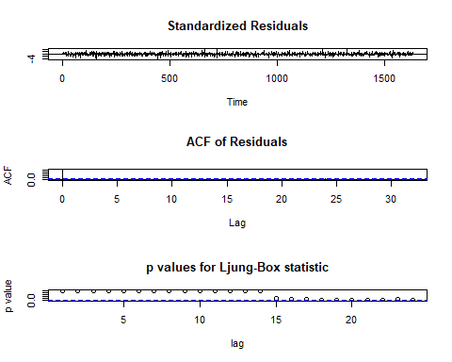

# (g)  
ARtemp3=arima(xt,order=c(11,1,0))  
ARtemp3

##   
## Call:  
## arima(x = xt, order = c(11, 1, 0))  
##   
## Coefficients:  
## ar1 ar2 ar3 ar4 ar5 ar6 ar7 ar8  
## -0.5723 -0.4264 -0.3559 -0.3062 -0.2923 -0.2732 -0.2137 -0.2041  
## s.e. 0.0247 0.0283 0.0299 0.0308 0.0313 0.0314 0.0313 0.0308  
## ar9 ar10 ar11  
## -0.1894 -0.1132 -0.0929  
## s.e. 0.0299 0.0283 0.0247  
##   
## sigma^2 estimated as 343.8: log likelihood = -7077.32, aic = 14178.64

PredictTemp <- predict(ARtemp3,12)  
PredictTemp

## $pred  
## Time Series:  
## Start = 1633   
## End = 1644   
## Frequency = 1   
## [1] 129.1232 123.5386 121.3828 118.4179 115.6651 115.6414 115.1640 115.9398  
## [9] 118.1312 120.5299 121.8315 122.8075  
##   
## $se  
## Time Series:  
## Start = 1633   
## End = 1644   
## Frequency = 1   
## [1] 18.54211 20.16716 21.06854 21.67045 22.14065 22.45831 22.71378 23.04834  
## [9] 23.31226 23.55386 23.96549 24.35400

# (h)  
lcl <- PredictTemp$pred-1.96*PredictTemp$se  
ucl <- PredictTemp$pred+1.96*PredictTemp$se  
cf <- cbind(lcl,ucl)  
cf[1:2,]

## lcl ucl  
## [1,] 92.78064 165.4657  
## [2,] 84.01097 163.0662

cf[1:12,]

## lcl ucl  
## [1,] 92.78064 165.4657  
## [2,] 84.01097 163.0662  
## [3,] 80.08851 162.6772  
## [4,] 75.94382 160.8920  
## [5,] 72.26940 159.0607  
## [6,] 71.62310 159.6597  
## [7,] 70.64502 159.6830  
## [8,] 70.76509 161.1146  
## [9,] 72.43918 163.8232  
## [10,] 74.36439 166.6955  
## [11,] 74.85917 168.8039  
## [12,] 75.07368 170.5414

# (i)  
require(forecast)  
ARIMAtemp=auto.arima(xt)  
ARIMAtemp

## Series: xt   
## ARIMA(1,1,2) with drift   
##   
## Coefficients:  
## ar1 ma1 ma2 drift  
## 0.7189 -1.3106 0.3329 0.0795  
## s.e. 0.0472 0.0593 0.0540 0.0369  
##   
## sigma^2 = 342.5: log likelihood = -7072.41  
## AIC=14154.82 AICc=14154.86 BIC=14181.8

tsdiag(ARIMAtemp,gof=24)

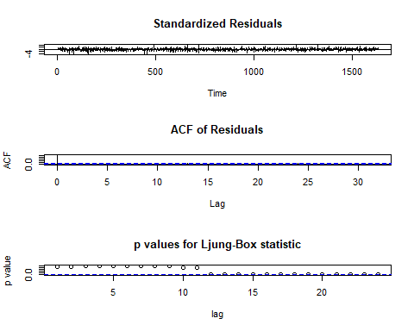

ARIMAtemp2=arima(zt,order=c(1,0,2),seasonal=list(order=c(1,0,0),period=12))  
ARIMAtemp2

##   
## Call:  
## arima(x = zt, order = c(1, 0, 2), seasonal = list(order = c(1, 0, 0), period = 12))  
##   
## Coefficients:  
## ar1 ma1 ma2 sar1 intercept  
## 0.7423 -1.3429 0.3600 0.0937 0.0793  
## s.e. 0.0413 0.0546 0.0511 0.0252 0.0342  
##   
## sigma^2 estimated as 338.8: log likelihood = -7065.56, aic = 14143.12

tsdiag(ARIMAtemp2,gof=24)

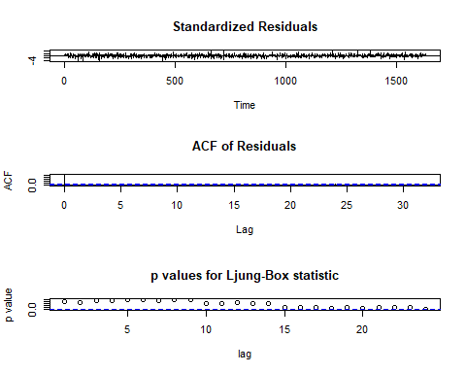

# (j)  
ARIMAtemp3=arima(xt,order=c(1,1,2),seasonal=list(order=c(1,0,0),period=12))  
ARIMAtemp3

##   
## Call:  
## arima(x = xt, order = c(1, 1, 2), seasonal = list(order = c(1, 0, 0), period = 12))  
##   
## Coefficients:  
## ar1 ma1 ma2 sar1  
## 0.7320 -1.3288 0.3503 0.0921  
## s.e. 0.0441 0.0570 0.0526 0.0253  
##   
## sigma^2 estimated as 339.7: log likelihood = -7067.82, aic = 14145.65

tsdiag(ARIMAtemp3,gof=24)

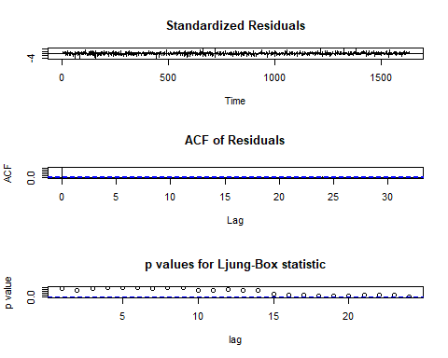

PredictTemp=predict(ARIMAtemp3,12)  
PredictTemp

## $pred  
## Time Series:  
## Start = 1633   
## End = 1644   
## Frequency = 1   
## [1] 122.06472 115.74604 111.78999 106.32858 103.62970 102.24940 99.42832  
## [8] 99.45501 100.02232 100.41474 101.22510 101.77075  
##   
## $se  
## Time Series:  
## Start = 1633   
## End = 1644   
## Frequency = 1   
## [1] 18.43157 19.87371 20.71308 21.23270 21.57245 21.80668 21.97682 22.10682  
## [9] 22.21097 22.29805 22.37360 22.44122

lcl <- PredictTemp$pred-1.96*PredictTemp$se  
ucl <- PredictTemp$pred+1.96*PredictTemp$se  
cf <- cbind(lcl,ucl)  
cf[1:2,]

## lcl ucl  
## [1,] 85.93885 158.1906  
## [2,] 76.79356 154.6985

cf[1:12,]

## lcl ucl  
## [1,] 85.93885 158.1906  
## [2,] 76.79356 154.6985  
## [3,] 71.19235 152.3876  
## [4,] 64.71247 147.9447  
## [5,] 61.34770 145.9117  
## [6,] 59.50831 144.9905  
## [7,] 56.35376 142.5029  
## [8,] 56.12564 142.7844  
## [9,] 56.48882 143.5558  
## [10,] 56.71057 144.1189  
## [11,] 57.37285 145.0774  
## [12,] 57.78596 145.7555

Tempforecast=forecast(ARIMAtemp3,12)  
Tempforecast

## Point Forecast Lo 80 Hi 80 Lo 95 Hi 95  
## 1633 122.06472 98.44372 145.6857 85.93951 158.1899  
## 1634 115.74604 90.27685 141.2152 76.79427 154.6978  
## 1635 111.78999 85.24511 138.3349 71.19309 152.3869  
## 1636 106.32858 79.11777 133.5394 64.71324 147.9439  
## 1637 103.62970 75.98350 131.2759 61.34848 145.9109  
## 1638 102.24940 74.30302 130.1958 59.50910 144.9897  
## 1639 99.42832 71.26390 127.5928 56.35455 142.5021  
## 1640 99.45501 71.12398 127.7860 56.12643 142.7836  
## 1641 100.02232 71.55782 128.4868 56.48962 143.5550  
## 1642 100.41474 71.83864 128.9908 56.71137 144.1181  
## 1643 101.22510 72.55218 129.8980 57.37365 145.0766  
## 1644 101.77075 73.01117 130.5303 57.78677 145.7547

plot(Tempforecast)

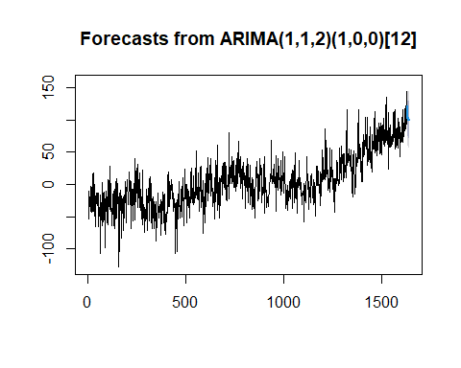

plot(Tempforecast,include=24,xlab="time",ylab="temperature",main="Prediction")

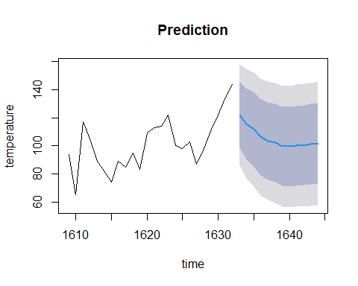

## 7. GARCH II: 30 bonus points

#Problem 7  
da=read.table("d-sbux3dx-0715.txt",header=T)  
head(da)

## PERMNO date SBUX vwretd ewretd sprtrn  
## 1 77702 20070103 -0.004799 -0.001347 -0.000159 -0.001199  
## 2 77702 20070104 0.001135 0.000547 0.000591 0.001228  
## 3 77702 20070105 -0.004251 -0.007288 -0.009809 -0.006085  
## 4 77702 20070108 -0.003700 0.002567 0.001731 0.002220  
## 5 77702 20070109 -0.004284 -0.000001 0.000262 -0.000517  
## 6 77702 20070110 -0.003155 0.002096 0.001338 0.001940

rtn=da[,3:6]  
attach(rtn)

## The following objects are masked from rtn (pos = 13):  
##   
## ewretd, SBUX, sprtrn, vwretd

vw=log(da$vwretd+1)  
# (a)  
t.test(vw)

##   
## One Sample t-test  
##   
## data: vw  
## t = 0.78365, df = 2265, p-value = 0.4333  
## alternative hypothesis: true mean is not equal to 0  
## 95 percent confidence interval:  
## -0.0003377266 0.0007873080  
## sample estimates:  
## mean of x   
## 0.0002247907

Box.test(vw,lag=12,type='Ljung')

##   
## Box-Ljung test  
##   
## data: vw  
## X-squared = 41.512, df = 12, p-value = 4.023e-05

acf(vw)

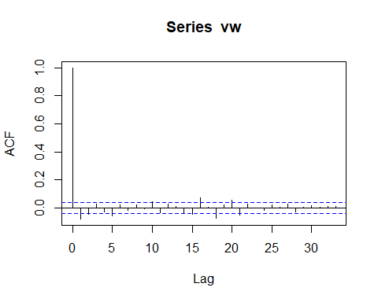

acf(vw^2)

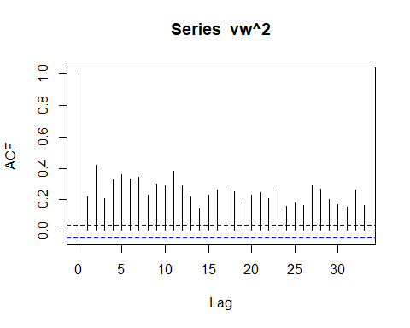

garch.norm = ugarchspec(mean.model=list(armaOrder=c(0,0),include.mean = FALSE),  
variance.model=list(garchOrder=c(1,1)))  
vwGarch = ugarchfit(data=vw, spec=garch.norm)  
show(vwGarch)

##   
## *---------------------------------*  
## * GARCH Model Fit *  
## *---------------------------------*  
##   
## Conditional Variance Dynamics   
## -----------------------------------  
## GARCH Model : sGARCH(1,1)  
## Mean Model : ARFIMA(0,0,0)  
## Distribution : norm   
##   
## Optimal Parameters  
## ------------------------------------  
## Estimate Std. Error t value Pr(>|t|)  
## omega 0.000003 0.000001 1.9402 0.052357  
## alpha1 0.106140 0.013764 7.7113 0.000000  
## beta1 0.875661 0.015626 56.0379 0.000000  
##   
## Robust Standard Errors:  
## Estimate Std. Error t value Pr(>|t|)  
## omega 0.000003 0.000007 0.38952 0.696889  
## alpha1 0.106140 0.039123 2.71298 0.006668  
## beta1 0.875661 0.057114 15.33175 0.000000  
##   
## LogLikelihood : 7118.418   
##   
## Information Criteria  
## ------------------------------------  
##   
## Akaike -6.2802  
## Bayes -6.2726  
## Shibata -6.2802  
## Hannan-Quinn -6.2774  
##   
## Weighted Ljung-Box Test on Standardized Residuals  
## ------------------------------------  
## statistic p-value  
## Lag[1] 3.482 0.06204  
## Lag[2*(p+q)+(p+q)-1][2] 3.483 0.10387  
## Lag[4*(p+q)+(p+q)-1][5] 4.826 0.16751  
## d.o.f=0  
## H0 : No serial correlation  
##   
## Weighted Ljung-Box Test on Standardized Squared Residuals  
## ------------------------------------  
## statistic p-value  
## Lag[1] 6.885 0.008693  
## Lag[2*(p+q)+(p+q)-1][5] 13.513 0.001110  
## Lag[4*(p+q)+(p+q)-1][9] 15.073 0.003435  
## d.o.f=2  
##   
## Weighted ARCH LM Tests  
## ------------------------------------  
## Statistic Shape Scale P-Value  
## ARCH Lag[3] 0.003359 0.500 2.000 0.9538  
## ARCH Lag[5] 0.474006 1.440 1.667 0.8913  
## ARCH Lag[7] 0.589874 2.315 1.543 0.9695  
##   
## Nyblom stability test  
## ------------------------------------  
## Joint Statistic: 12.9665  
## Individual Statistics:   
## omega 0.791  
## alpha1 1.023  
## beta1 1.233  
##   
## Asymptotic Critical Values (10% 5% 1%)  
## Joint Statistic: 0.846 1.01 1.35  
## Individual Statistic: 0.35 0.47 0.75  
##   
## Sign Bias Test  
## ------------------------------------  
## t-value prob sig  
## Sign Bias 3.051 2.304e-03 ***  
## Negative Sign Bias 1.529 1.264e-01   
## Positive Sign Bias 2.063 3.919e-02 **  
## Joint Effect 25.186 1.411e-05 ***  
##   
##   
## Adjusted Pearson Goodness-of-Fit Test:  
## ------------------------------------  
## group statistic p-value(g-1)  
## 1 20 125.2 1.151e-17  
## 2 30 134.8 1.392e-15  
## 3 40 160.9 9.583e-17  
## 4 50 181.2 4.756e-17  
##   
##   
## Elapsed time : 0.178808

plot(vwGarch, which="all")

##   
## please wait...calculating quantiles...

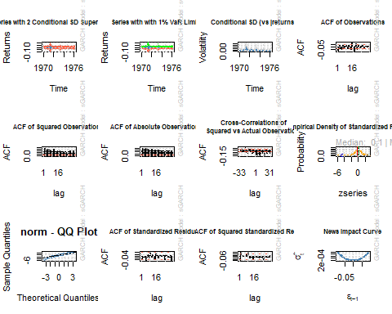

plot(vwGarch, which=9)

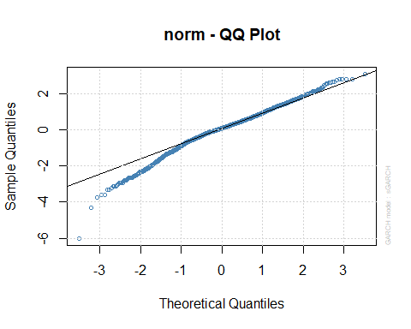

arma.garch.t = ugarchspec(mean.model=list(armaOrder=c(0,0),include.mean = FALSE),  
variance.model=list(garchOrder=c(1,1)),  
distribution.model = "std")  
vwGarch.t = ugarchfit(data=vw, spec=arma.garch.t)  
show(vwGarch.t)

##   
## *---------------------------------*  
## * GARCH Model Fit *  
## *---------------------------------*  
##   
## Conditional Variance Dynamics   
## -----------------------------------  
## GARCH Model : sGARCH(1,1)  
## Mean Model : ARFIMA(0,0,0)  
## Distribution : std   
##   
## Optimal Parameters  
## ------------------------------------  
## Estimate Std. Error t value Pr(>|t|)  
## omega 0.000002 0.000002 1.1069 0.268325  
## alpha1 0.114004 0.026049 4.3765 0.000012  
## beta1 0.876326 0.025452 34.4308 0.000000  
## shape 6.980602 1.244478 5.6093 0.000000  
##   
## Robust Standard Errors:  
## Estimate Std. Error t value Pr(>|t|)  
## omega 0.000002 0.000008 0.25476 0.798908  
## alpha1 0.114004 0.096632 1.17978 0.238089  
## beta1 0.876326 0.098073 8.93549 0.000000  
## shape 6.980602 2.846402 2.45243 0.014189  
##   
## LogLikelihood : 7151.623   
##   
## Information Criteria  
## ------------------------------------  
##   
## Akaike -6.3086  
## Bayes -6.2985  
## Shibata -6.3086  
## Hannan-Quinn -6.3049  
##   
## Weighted Ljung-Box Test on Standardized Residuals  
## ------------------------------------  
## statistic p-value  
## Lag[1] 3.390 0.0656  
## Lag[2*(p+q)+(p+q)-1][2] 3.393 0.1099  
## Lag[4*(p+q)+(p+q)-1][5] 4.779 0.1716  
## d.o.f=0  
## H0 : No serial correlation  
##   
## Weighted Ljung-Box Test on Standardized Squared Residuals  
## ------------------------------------  
## statistic p-value  
## Lag[1] 6.988 0.008208  
## Lag[2*(p+q)+(p+q)-1][5] 11.808 0.003128  
## Lag[4*(p+q)+(p+q)-1][9] 12.862 0.011494  
## d.o.f=2  
##   
## Weighted ARCH LM Tests  
## ------------------------------------  
## Statistic Shape Scale P-Value  
## ARCH Lag[3] 0.01185 0.500 2.000 0.9133  
## ARCH Lag[5] 0.19013 1.440 1.667 0.9678  
## ARCH Lag[7] 0.20868 2.315 1.543 0.9967  
##   
## Nyblom stability test  
## ------------------------------------  
## Joint Statistic: 38.3296  
## Individual Statistics:   
## omega 5.3989  
## alpha1 0.6390  
## beta1 0.7948  
## shape 0.1110  
##   
## Asymptotic Critical Values (10% 5% 1%)  
## Joint Statistic: 1.07 1.24 1.6  
## Individual Statistic: 0.35 0.47 0.75  
##   
## Sign Bias Test  
## ------------------------------------  
## t-value prob sig  
## Sign Bias 3.081 2.087e-03 ***  
## Negative Sign Bias 1.845 6.519e-02 *  
## Positive Sign Bias 2.230 2.583e-02 **  
## Joint Effect 26.475 7.586e-06 ***  
##   
##   
## Adjusted Pearson Goodness-of-Fit Test:  
## ------------------------------------  
## group statistic p-value(g-1)  
## 1 20 83.78 4.114e-10  
## 2 30 107.12 6.871e-11  
## 3 40 120.23 3.280e-10  
## 4 50 132.68 1.218e-09  
##   
##   
## Elapsed time : 0.318897

plot(vwGarch.t, which="all")

##   
## please wait...calculating quantiles...

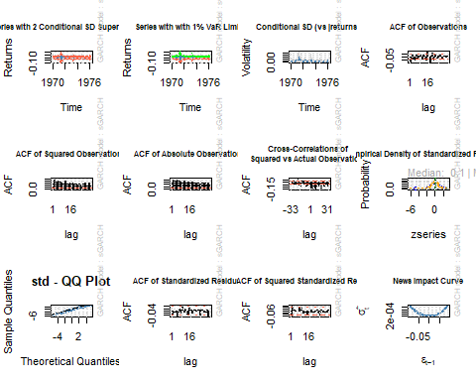

plot(vwGarch.t, which=9)

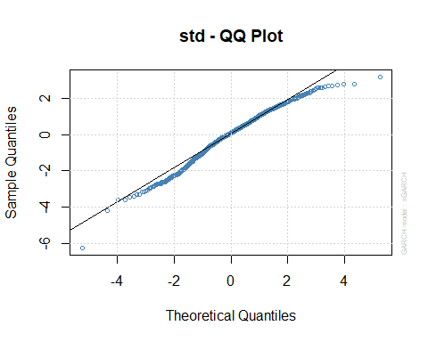

# (b)  
vwforecast=ugarchforecast(vwGarch.t, data = vw, n.ahead = 5)  
show(vwforecast)

##   
## *------------------------------------*  
## * GARCH Model Forecast *  
## *------------------------------------*  
## Model: sGARCH  
## Horizon: 5  
## Roll Steps: 0  
## Out of Sample: 0  
##   
## 0-roll forecast [T0=1976-03-16]:  
## Series Sigma  
## T+1 0 0.01014  
## T+2 0 0.01020  
## T+3 0 0.01025  
## T+4 0 0.01031  
## T+5 0 0.01036

plot(vwforecast,which=1)

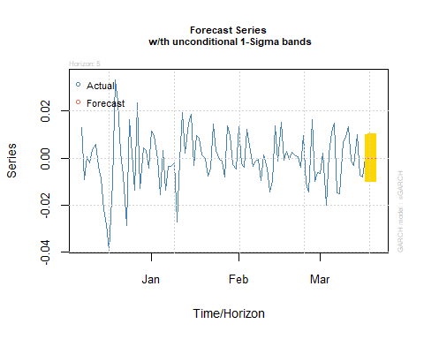

plot(vwforecast,which=3)

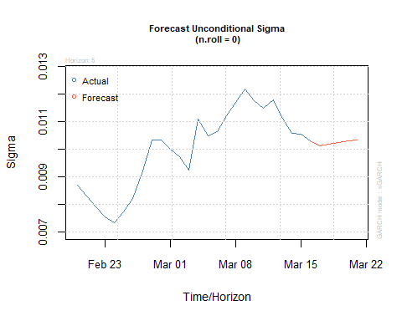

# (c)  
arma.aparch.t = ugarchspec(mean.model=list(armaOrder=c(0,0),include.mean = FALSE),  
variance.model=list(model="apARCH",  
garchOrder=c(1,1)),  
distribution.model = "std")  
vwGarch.a = ugarchfit(data=vw, spec=arma.aparch.t)  
show(vwGarch.a)

##   
## *---------------------------------*  
## * GARCH Model Fit *  
## *---------------------------------*  
##   
## Conditional Variance Dynamics   
## -----------------------------------  
## GARCH Model : apARCH(1,1)  
## Mean Model : ARFIMA(0,0,0)  
## Distribution : std   
##   
## Optimal Parameters  
## ------------------------------------  
## Estimate Std. Error t value Pr(>|t|)  
## omega 0.000487 0.000329 1.4784 0.139313  
## alpha1 0.100537 0.021684 4.6365 0.000004  
## beta1 0.904242 0.024547 36.8374 0.000000  
## gamma1 1.000000 0.000980 1020.6524 0.000000  
## delta 0.900756 0.123228 7.3097 0.000000  
## shape 7.872547 1.297146 6.0691 0.000000  
##   
## Robust Standard Errors:  
## Estimate Std. Error t value Pr(>|t|)  
## omega 0.000487 NaN NaN NaN  
## alpha1 0.100537 NaN NaN NaN  
## beta1 0.904242 NaN NaN NaN  
## gamma1 1.000000 NaN NaN NaN  
## delta 0.900756 NaN NaN NaN  
## shape 7.872547 NaN NaN NaN  
##   
## LogLikelihood : 7215.757   
##   
## Information Criteria  
## ------------------------------------  
##   
## Akaike -6.3634  
## Bayes -6.3483  
## Shibata -6.3634  
## Hannan-Quinn -6.3579  
##   
## Weighted Ljung-Box Test on Standardized Residuals  
## ------------------------------------  
## statistic p-value  
## Lag[1] 3.802 0.05118  
## Lag[2*(p+q)+(p+q)-1][2] 3.862 0.08214  
## Lag[4*(p+q)+(p+q)-1][5] 4.653 0.18309  
## d.o.f=0  
## H0 : No serial correlation  
##   
## Weighted Ljung-Box Test on Standardized Squared Residuals  
## ------------------------------------  
## statistic p-value  
## Lag[1] 12.56 0.0003951  
## Lag[2*(p+q)+(p+q)-1][5] 12.88 0.0016288  
## Lag[4*(p+q)+(p+q)-1][9] 13.90 0.0065675  
## d.o.f=2  
##   
## Weighted ARCH LM Tests  
## ------------------------------------  
## Statistic Shape Scale P-Value  
## ARCH Lag[3] 0.1770 0.500 2.000 0.6740  
## ARCH Lag[5] 0.3049 1.440 1.667 0.9390  
## ARCH Lag[7] 1.2287 2.315 1.543 0.8738  
##   
## Nyblom stability test  
## ------------------------------------  
## Joint Statistic: NaN  
## Individual Statistics:   
## omega 1.737  
## alpha1 1.514  
## beta1 2.060  
## gamma1 NaN  
## delta 1.805  
## shape 0.136  
##   
## Asymptotic Critical Values (10% 5% 1%)  
## Joint Statistic: 1.49 1.68 2.12  
## Individual Statistic: 0.35 0.47 0.75  
##   
## Sign Bias Test  
## ------------------------------------  
## t-value prob sig  
## Sign Bias 1.363 0.1730265   
## Negative Sign Bias 2.973 0.0029797 ***  
## Positive Sign Bias 2.460 0.0139612 **  
## Joint Effect 16.909 0.0007378 ***  
##   
##   
## Adjusted Pearson Goodness-of-Fit Test:  
## ------------------------------------  
## group statistic p-value(g-1)  
## 1 20 85.37 2.171e-10  
## 2 30 104.29 1.990e-10  
## 3 40 110.24 1.012e-08  
## 4 50 134.53 6.632e-10  
##   
##   
## Elapsed time : 2.761971