Step 1. Open below link in Chrome or Firefox

<https://github.com/>

Step 2. Click on Sign up button

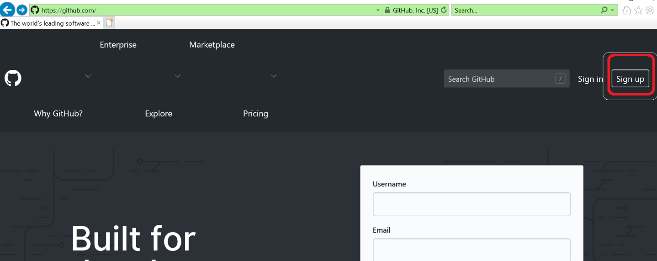

Step 3. Then enter user name which already not presented then email address and password then click on verify

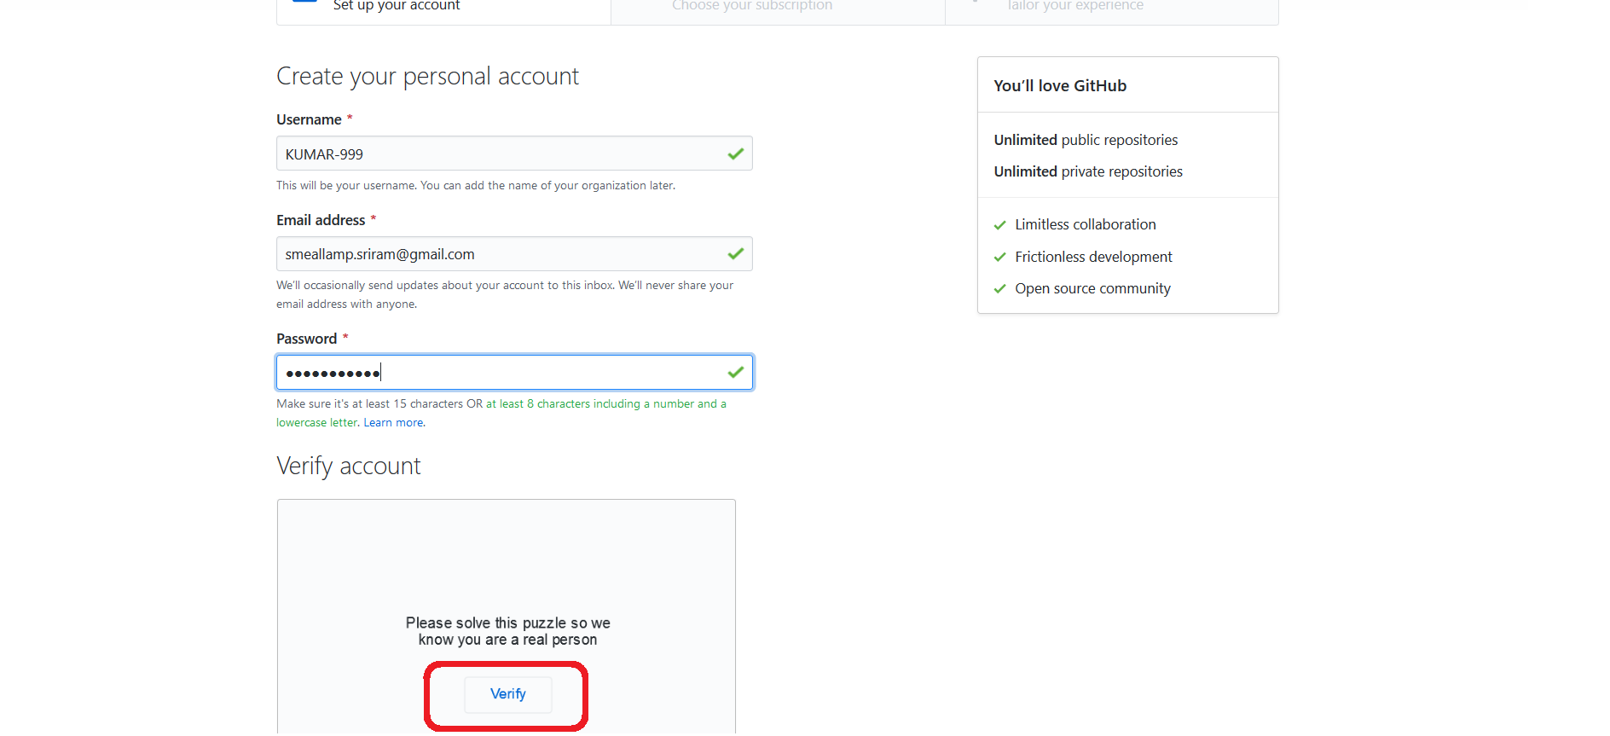

Step 4. After clicking verify image will appear, arrange this image in proper shape then click on Done.

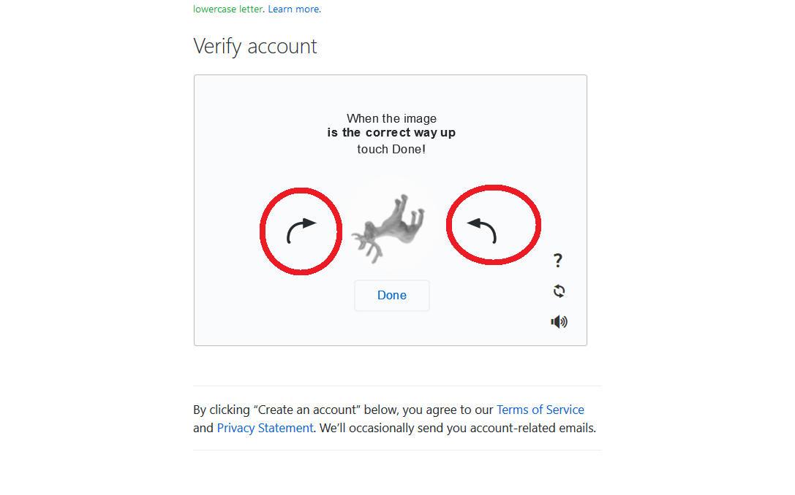

Step 5. Then click on Create an account button

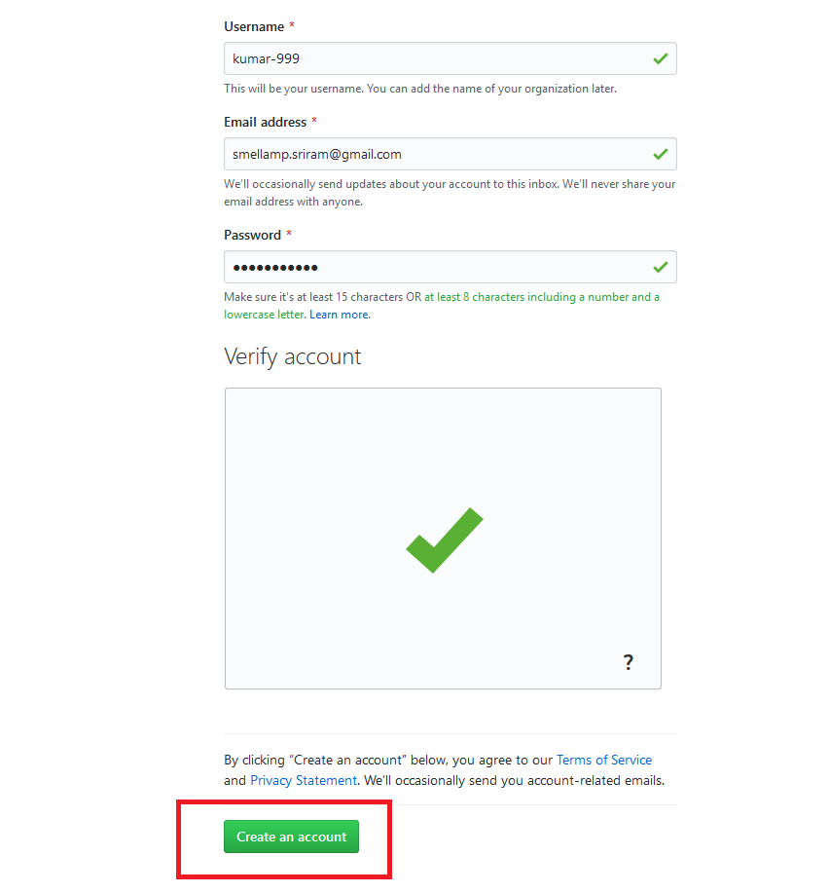

Step 6. Select free subscription and click on continue

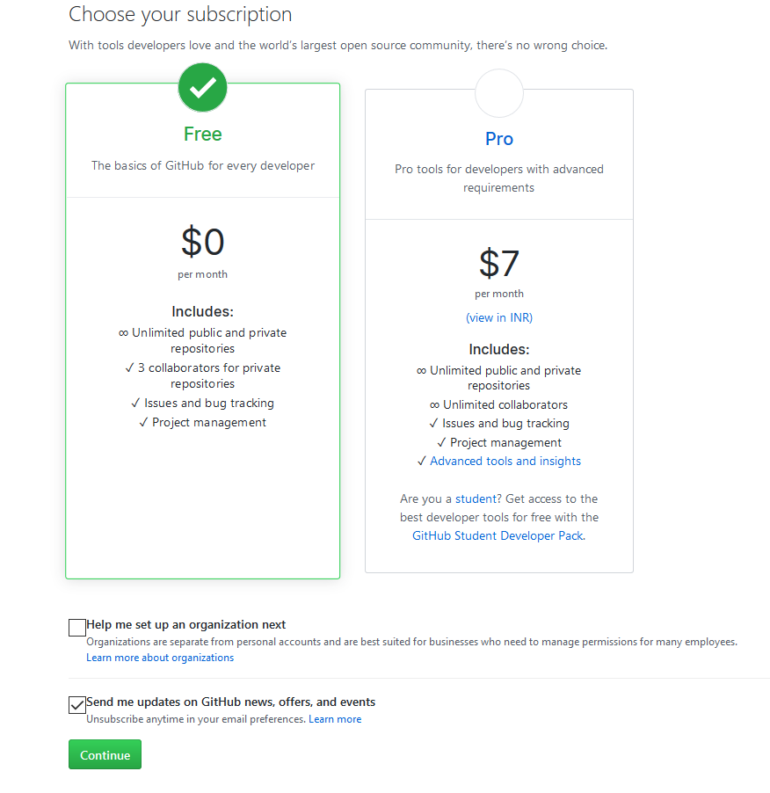

Step 7. Click on Submit

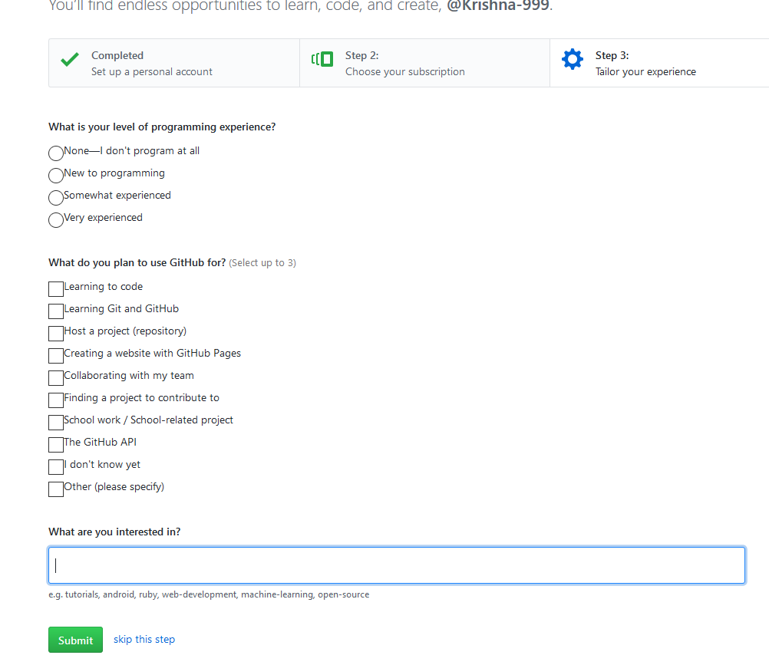

Step 8. Then it will ask email verification

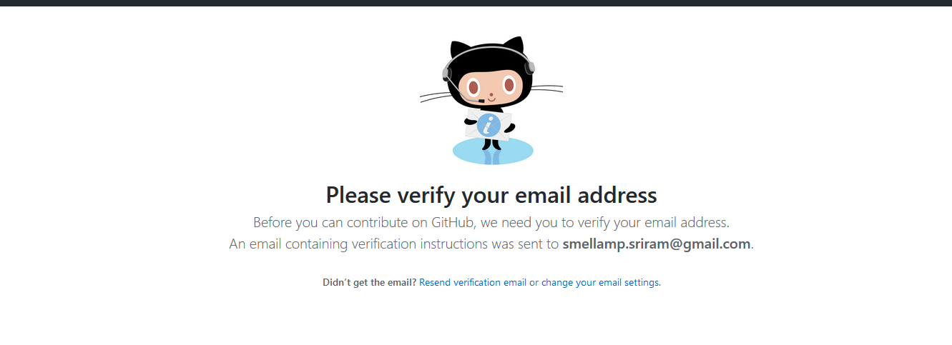

Step 9. Login email and click on verify email address

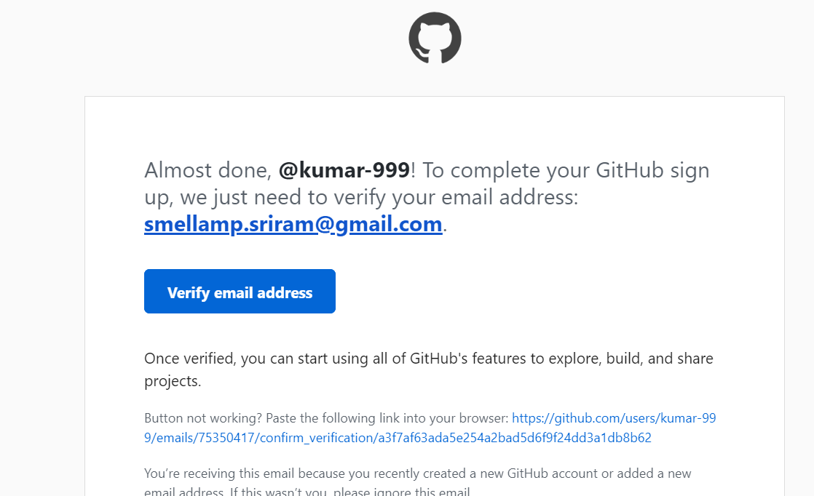

Step 10. Click on + Symbol, then click new repository

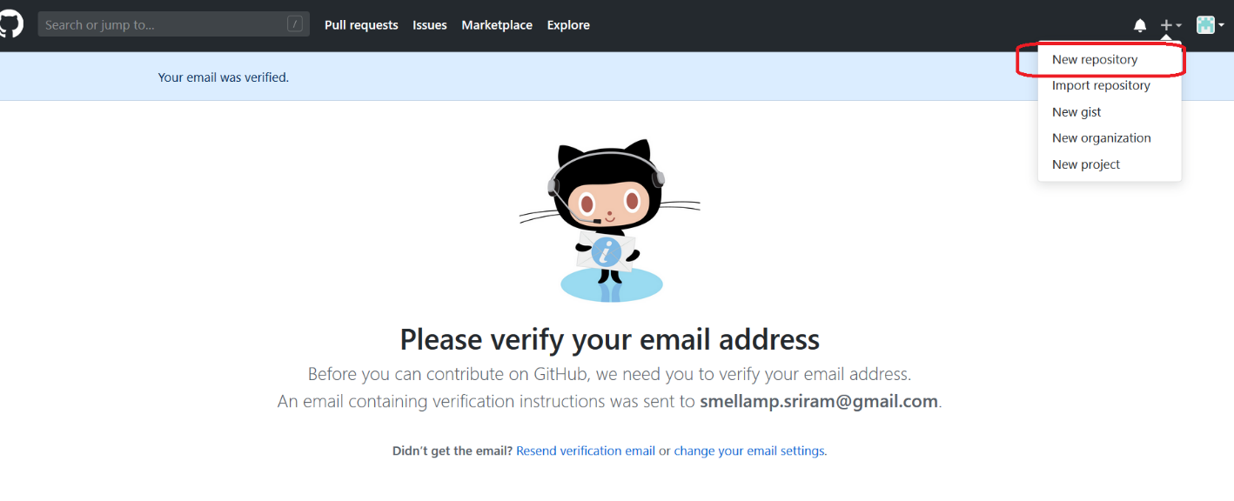

Step 11. Enter repository name and description then click on create repository button.

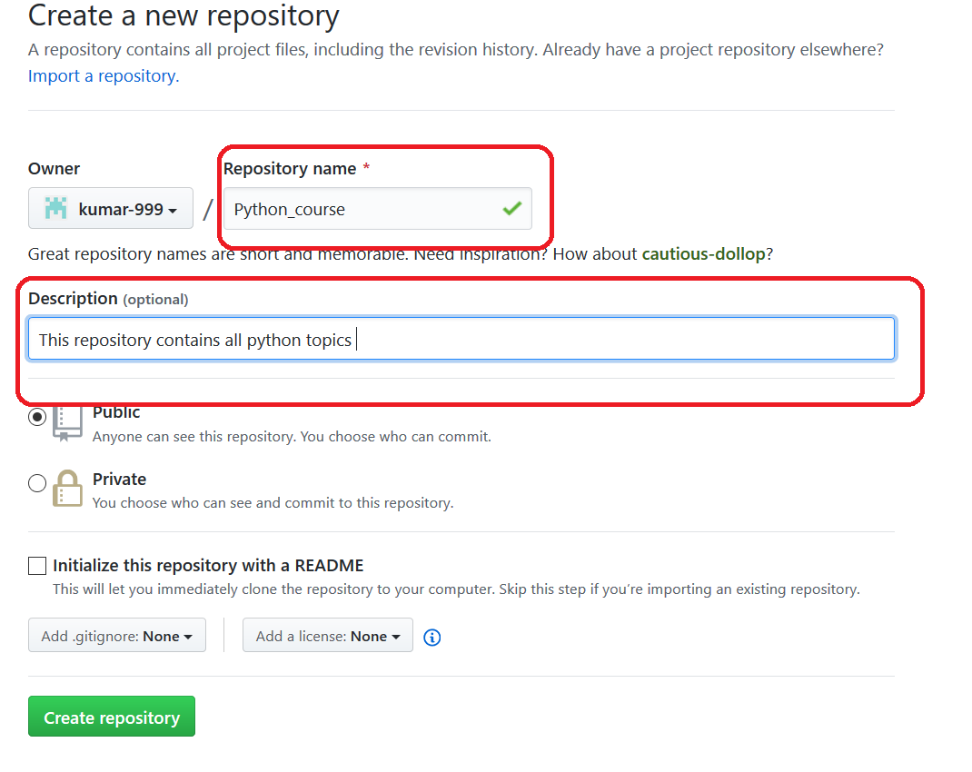

Step 12. Copy git repository link

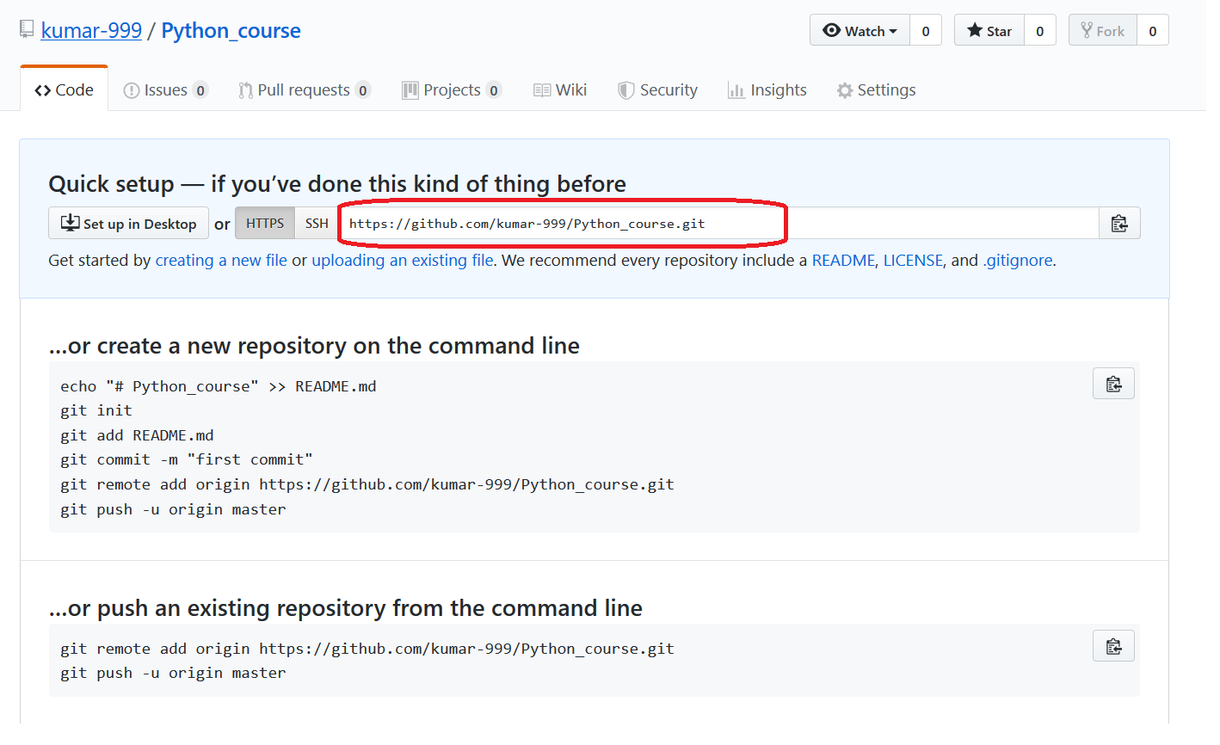

Step 13. Then run below command to get remote repository into your local system.

Git clone https://github.com/kumar-999/Python_course.git