travelr – Database

|  |  |
| --- | --- |
| requests |  |
| request_id | BIGINT (20) |
| destination | VARCHAR (50) |
| departure | VARCHAR (50) |
| datetime | DATETIME |
| user_id__fk | BIGINT |

|  |  |
| --- | --- |
| user |  |
| user_id | BIGINT (20) |
| email | VARCHAR (50) |
| password | VARCHAR (100) |
| first_name | VARCHAR (30) |
| last_name | VARCHAR (30) |

**ERM:**

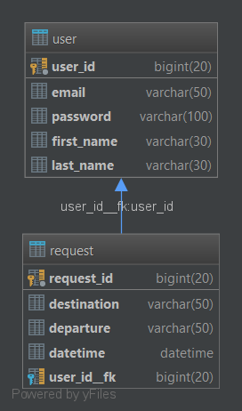

**SQL:**

**User-table:**

create table user

(

user_id bigint auto_increment

primary key,

email varchar(50) null,

password varchar(100) null,

first_name varchar(30) null,

last_name varchar(30) null,

constraint user_user_id_uindex

unique (user_id)

)

;

**Request-table:**

create table request

(

request_id bigint auto_increment

primary key,

destination varchar(50) null,

departure varchar(50) null,

datetime datetime null,

user_id__fk bigint null,

constraint request_request_id_uindex

unique (request_id),

constraint user_id__fk

foreign key (user_id__fk) references user (user_id)

)

;

create index user_id__fk

on request (user_id__fk)

;

**INSERT Statement:**

Die insert Statements befinden sich in externen Files.