Java III AT2.1

L. E. Liston

2020

Contents

1 Description 1

2 UML Diagram 1

3 Test Table 1

4 Debugging 1

5 Junit Testing 2

6 Source Control 2

# Description

This program is designed to demonstrate inner classes. The objects created are stored in a list and displayed in the console.

# UML Diagram

Below is the UML diagram for this project.

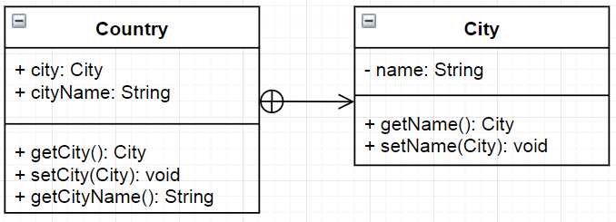

# Test Table

|  |  |  |
| --- | --- | --- |
| Run the program | Outputs Berlin, Paris, Madrid, London |  |
| Edit the names then run | Outputs Canberra, Paris, Madrid, London |  |
| Add a city | Outputs Canberra, Paris, Madrid, London, Perth |  |
| Remove a city | Outputs Paris, Madrid, London |  |

# Debugging

The list may be read incorrectly and display an out of bounds error.

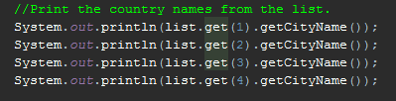

Also the first city’s name is not appearing.

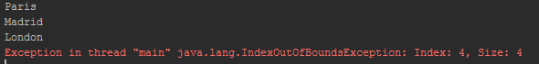

This is because the list index starts from zero. It can be fixed by reading from zero instead of one.

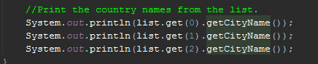

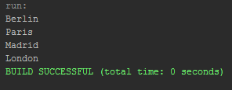

# Junit Testing

Junit testing was performed on the getCityName function with all tests passing.

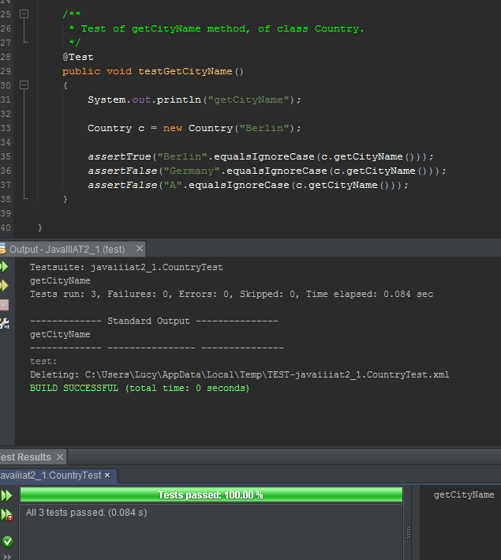

# Source Control

All files related to this project are stored on Github and can be found here: <https://github.com/M227545/JavaIIIAT2_1>