Java III AT2.7

L. E. Liston

2020

Contents

1 Description 1

2 UML Diagram 1

3 Test Table 1

4 Debugging 1

5 Junit Testing 2

6 Source Control 2

# Description

This program is designed to demonstrate files over a socket connection through client server applications.

# UML Diagram

Below is the UML diagram for the Client and Server applications.

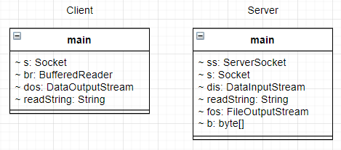

# Test Table

|  |  |  |
| --- | --- | --- |
| Run the application | Writes “input.txt” to “output.txt” in the server directory |  |
| Modify the contents of “input.txt” then run | Writes the changes to “output.txt” |  |
| Run client without server | Displays an error |  |
| Delete “input.txt” then run | Displays an error |  |

# Debugging

The client will not connect properly if the port is not properly set. Here it is set to “123”, while in the server application it is “888”.





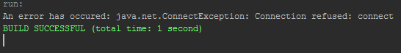

The ports in the client and server applications must match in order to work.





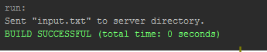

# Junit Testing

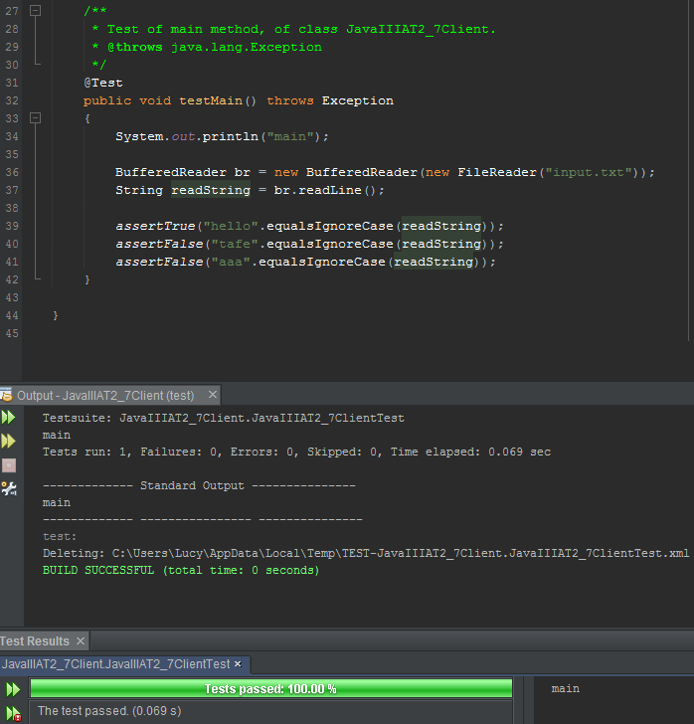

# Source Control

All files related to this project are stored on Github and can be found here: <https://github.com/M227545/JavaIIIAT2_7>