Java III AT3 – Predesign Specification Document

L. E. Liston

2020

Contents

1 UML Diagram 1

2 Test Table 1

3 Unit tests 3

4 Github Repo 4

# UML Diagram

Below is the UML Diagram of the program.

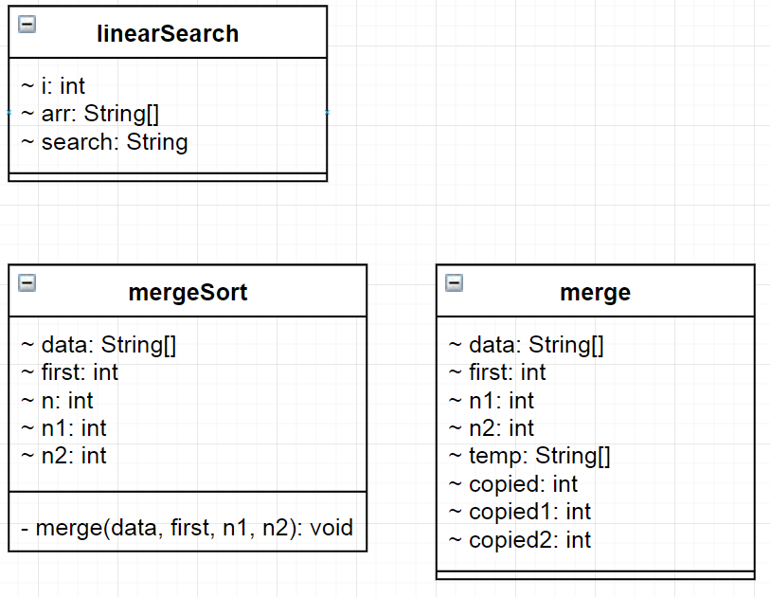

# Test Table

|  |  |  |
| --- | --- | --- |
| Test case | Expected outcome | Screenshot |
| Click sort button | The list is sorted alphabetically |  |
| Type “May” then click search button | The item “May” in the list is highlighted |  |

|  |  |  |
| --- | --- | --- |
| Type “Month” then click search button | No new item is highlighted |  |
| Click next button | The next item in the linked list is displayed |  |
| Click previous button | The previous item in the linked list is displayed |  |
| Click next button at end of list | The item displayed is not changed after the last item |  |

|  |  |  |
| --- | --- | --- |
| Click previous button at start of list | The item displayed is not changed after the first item |  |
| Type “hello” into textbox then click hash | The text “hello” is hashed and saved | The textbox is cleared automatically after pressing the hash button |
| Type “hello” into textbox then click compare | A success message is displayed |  |
| Type “hi” into textbox then click compare | A failure message is displayed |  |

# Unit tests

Below is an image of the unit tests having been performed on the Linear search and Mergesort methods.

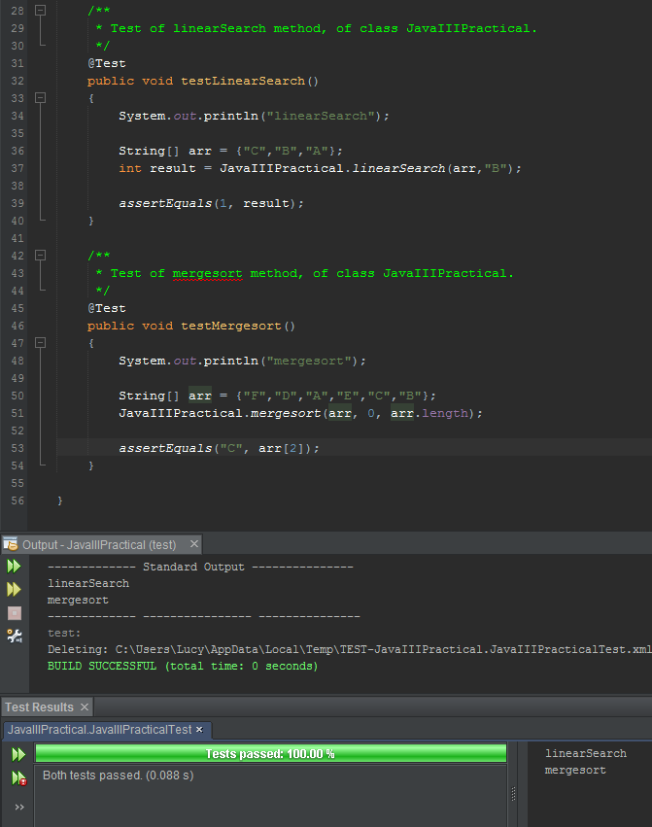

# Github Repo

The Github link to all files relating to this project can be found here: <https://github.com/M227545/JavaIIIAT3_Project>