SVKM'S NMIMS
Mukesh Patel School of Technology Management & Engineering
A.Y. 2025 – 26
Course: Machine Learning
Project Report
Grahak Gyaan
Mall Customer Spending Analysis & Strategy Recommendation
Using Machine Learning & Game Theory
Program | B.Tech – Artificial Intelligence and Machine Learning
Semester | Semester IV (A.Y. 2025–26)
Project Title | Grahak Gyaan – Mall Customer Spending Analysis & Strategy Recommendation Using ML
Dataset | Mall_Customers.csv – 200 customers, 5 features
Date of Submission | April 2026

Project Members
Roll No. | Name | SAP ID | Batch
A216 | Mehi Manswa Bhagat | 70012400107 | F-2
C264 | Dipanshu Yadav | 70532400076 | F-2

Contribution of each Project Member
Roll No. | Name | Contribution
A216 | Mehi Manswa Bhagat | Data loading, preprocessing, model training (DT Regressor, LR, DT Classifier), evaluation, game theory payoff, Streamlit dashboard
C264 | Dipanshu Yadav | Research work, presentation and Word file content

GitHub Link of Project: https://github.com/M270706/Mall-Customer-Spending-Analysis-Strategy-Recommendation

Table of Contents
Sr No. | Topic
1 | Introduction
2 | Literature Survey
3 | Methodology
4 | Result and Discussion
5 | Conclusion
6 | References

1. Introduction
Malls collect large amounts of customer data, yet most of it never becomes a personalised offer. Blanket promotions give discounts to shoppers who would have bought at full price anyway. The question behind this project is: which customers does a mall actually need to offer a discount to, and which will buy regardless?
Grahak Gyaan (“customer knowledge”) combines Machine Learning with Game Theory. It predicts how much a customer spends, sorts customers into spending segments, and then uses a payoff matrix to recommend a marketing action for each segment. A Streamlit dashboard makes the results usable by non-programmers.

1.1 Project Phases
- Regression. Predict the Spending Score (1–100) from Age, Annual Income and Gender, using Linear Regression and a Decision Tree Regressor.
- Classification. Group customers into Low (0–39), Medium (40–69) and High (70–100) spenders with a Decision Tree Classifier, which reached 80% accuracy on the test set.
- Game Theory. Use a payoff matrix to choose between “No Discount” and “Discount” for each segment.
- Dashboard. A Streamlit app to explore the data, compare segments and export customer lists.

1.2 The Shoppers at a Glance
Table 1.1 – Dataset Summary
Metric | Detail
Demographics | 112 women, 88 men
Age | 18 – 70 years (average 38.9)
Annual income | $15k – $137k (average $60.6k)
Spending score | 1 – 99 (average 50.2)

The dataset has 200 records, no missing values and no duplicates. It was processed in Python.
Table 1.2 – Data Dictionary
Feature | Type | Range / values
CustomerID | Integer | 1 – 200
Gender | Categorical | Male (88), Female (112)
Age | Integer | 18 – 70 years (mean 38.85)
Annual Income (k$) | Integer | 15 – 137 (mean 60.56)
Spending Score (1-100) | Integer | 1 – 99 (mean 50.2)

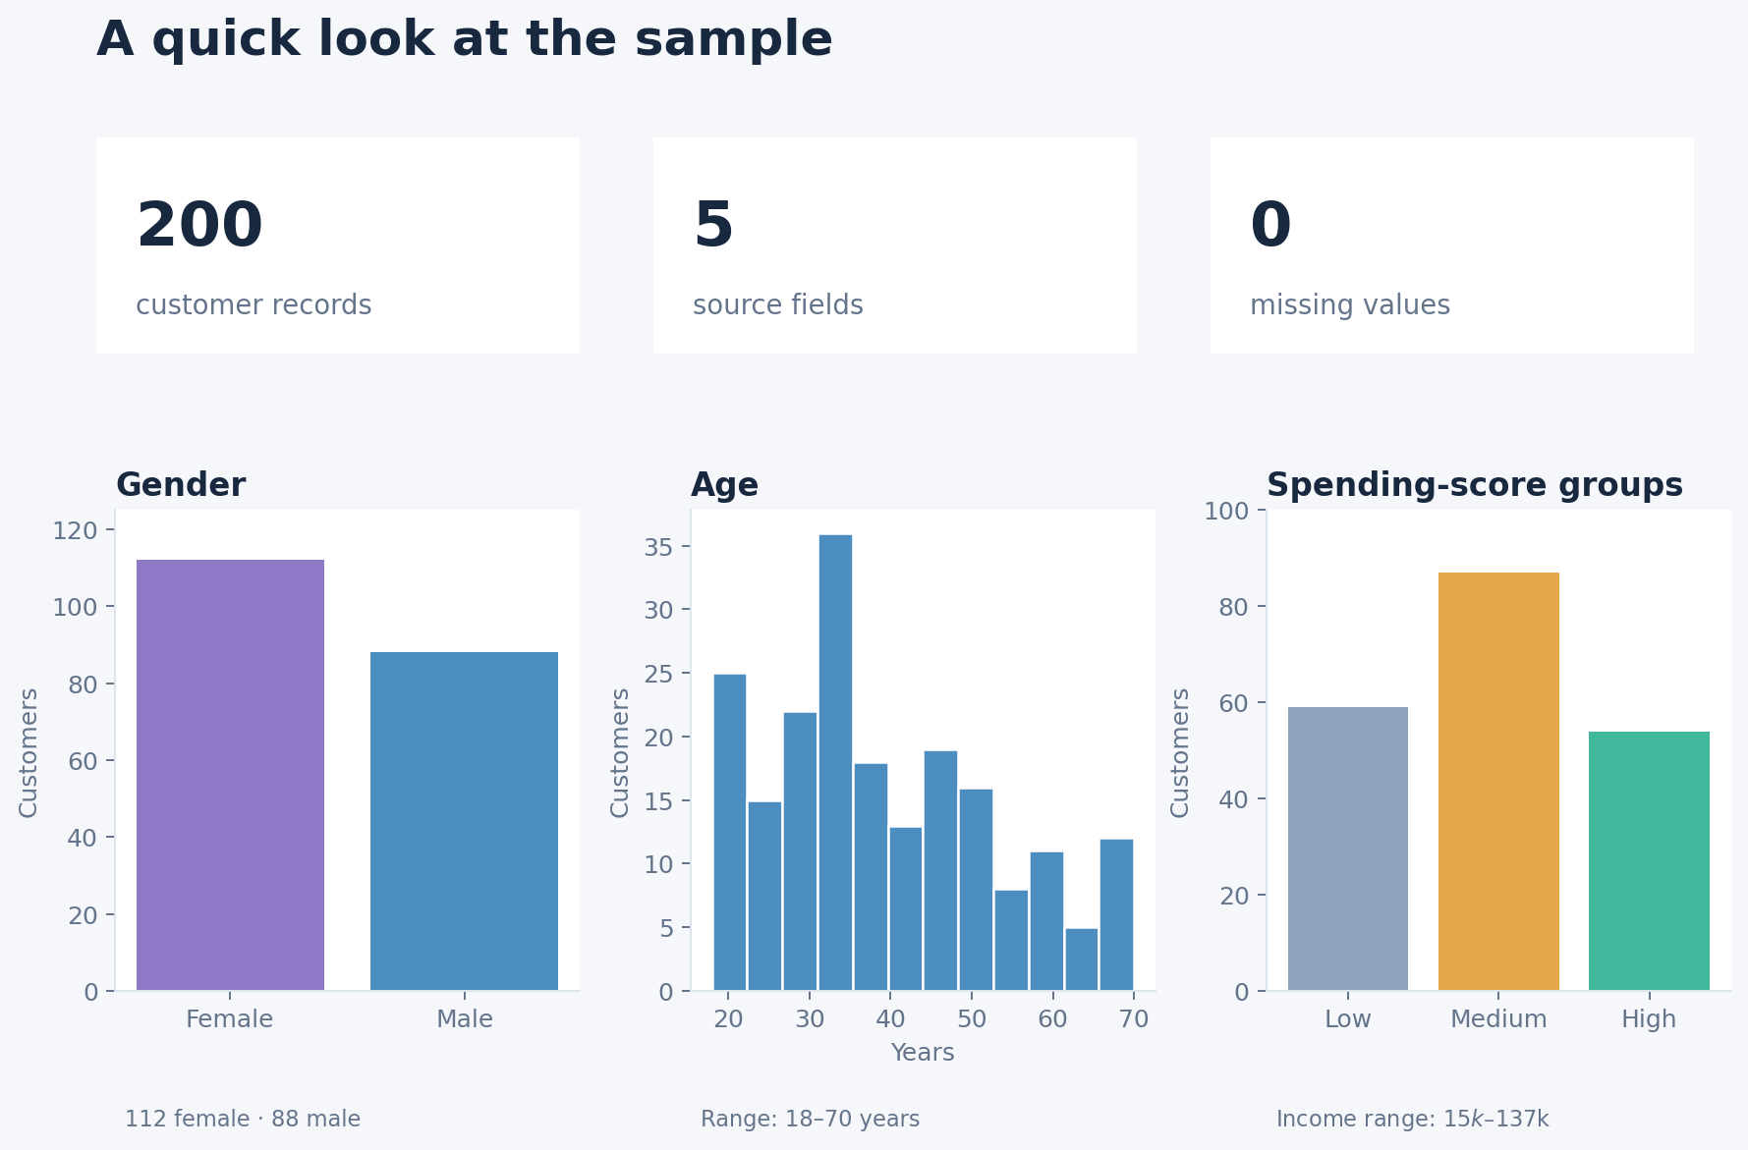
Figure 1.1 – Dataset summary: records, gender, age and spending-score groups
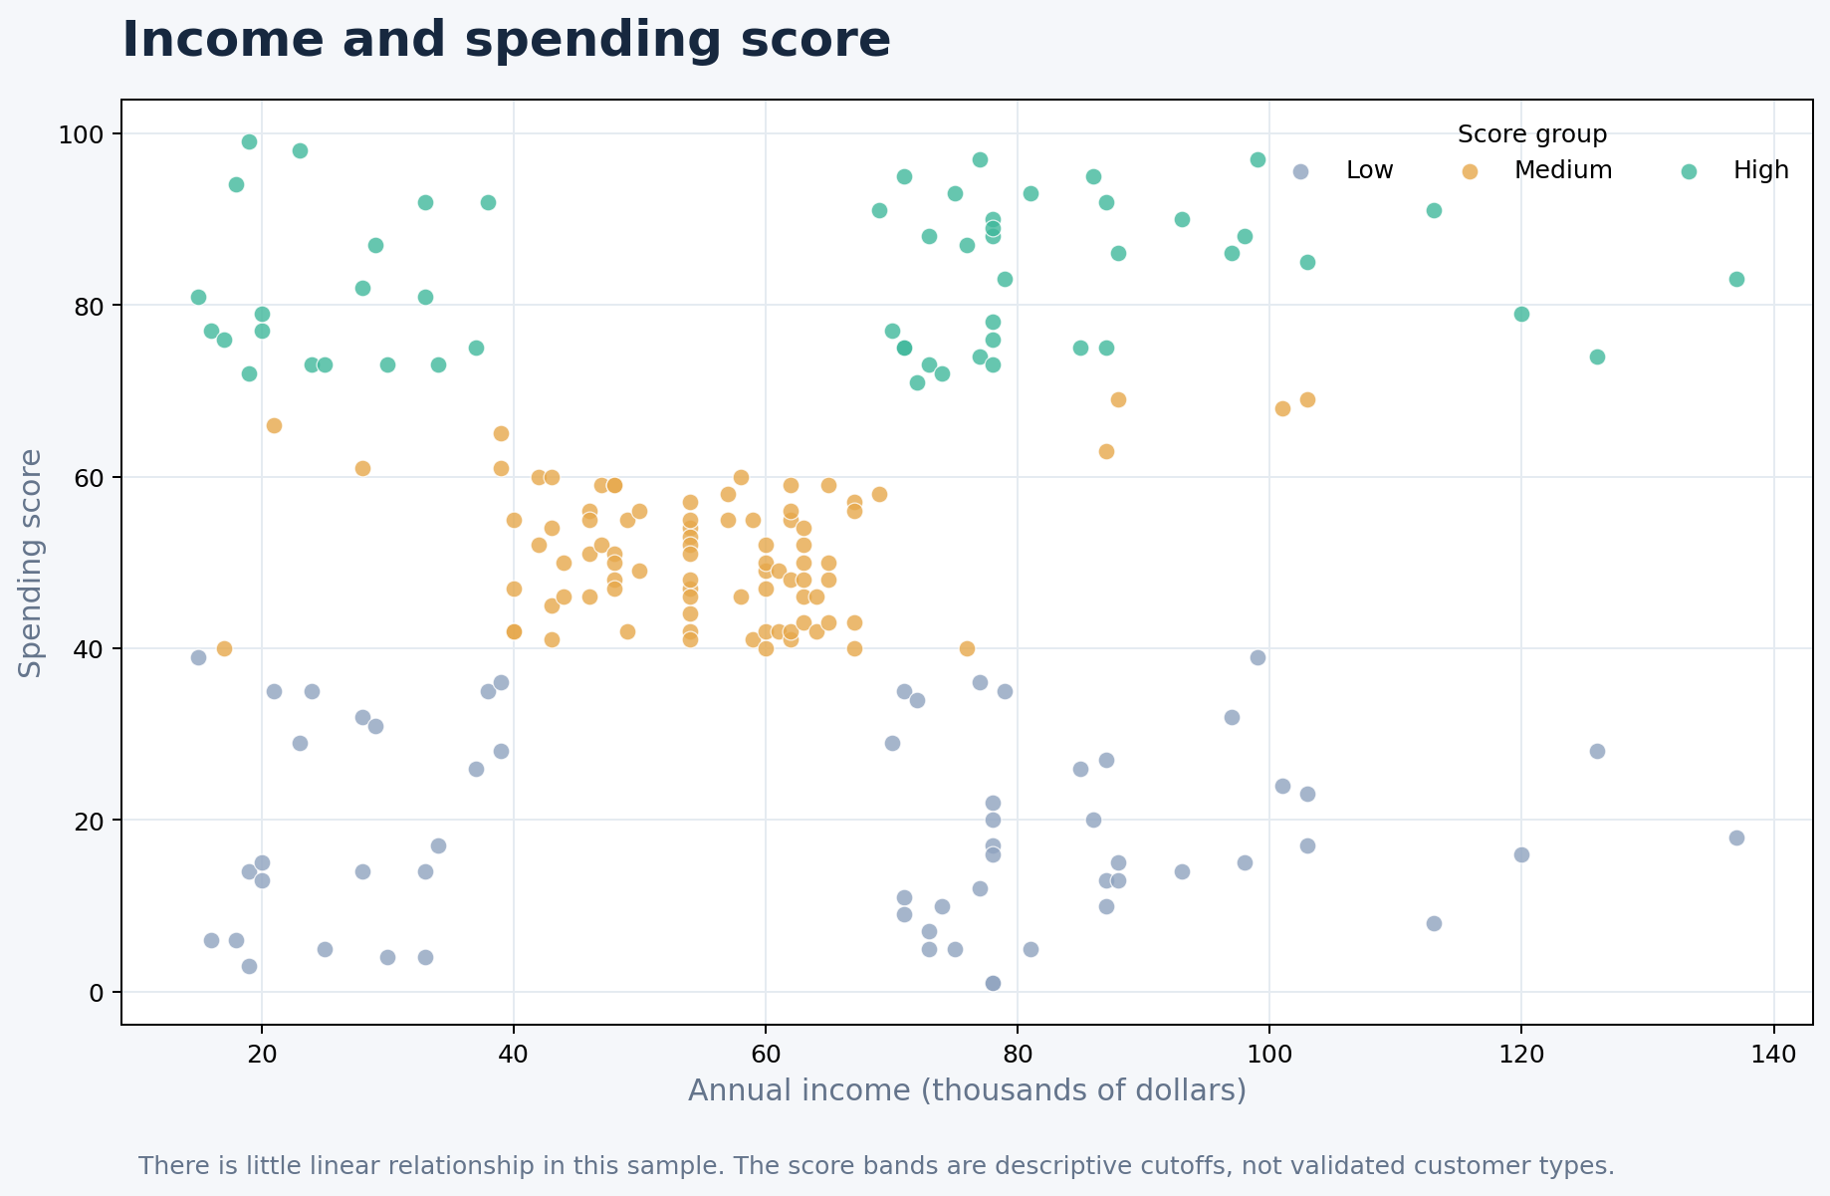
Figure 1.2 – Income and spending score by band

2. Literature Survey
Customer segmentation and discount strategy draw on several older bodies of work. The projects below shaped the approach.
- Grouping shoppers (1967). MacQueen introduced k-means clustering, the standard starting point for grouping customers by similarity.
- Past spending predicts future value (1994). Hughes’ work on strategic database marketing, including Recency-Frequency-Monetary (RFM) analysis, argued that past purchase behaviour is a strong predictor of future behaviour.
- Game theory (1950). Nash’s equilibrium concept underlies the way pricing and discount decisions are framed as a game between business and customer.
- Tree-based learning (2001 onward). Breiman’s work on random forests builds on decision trees, which remain popular because their rules are easy for managers to read.

2.1 What This Project Adds
- Both views of the same data. Regression gives a precise score; classification gives a simple segment. Both are run on the same dataset.
- ML linked to a payoff matrix. The classifier’s segments feed directly into a game-theory decision, moving from “who the customers are” to “what to do with them”.
- An interface for managers. A Streamlit dashboard lets management filter, compare and export without writing code.

2.2 Related Open Research
Four recent or open sources relate directly to the parts of this project. Details below are taken from their abstracts and record pages.
- Mall customer segmentation with K-Means (Yuliana, Ulya & Jamhuri, 2025). Applies K-Means to age, income, spending score and a derived spending-to-income ratio, uses the Elbow Method to choose 5 clusters, and compares K-Means with GMM, DBSCAN and hierarchical clustering using Silhouette, Davies-Bouldin and Calinski-Harabasz scores. It links each cluster to marketing advice. This project also runs K-means with silhouette scores (Section 4.9), but chooses k by silhouette over 2–6 groups and treats the result as exploratory.
- Improved K-Means for mall customers (Gong, Lai & Liu, 2026, preprint). Adds outlier filtering, automatic choice of K and density-peak initialisation, and reports better scores than K-means, K-medoids and DBSCAN on a 1,500-record version of the data. It is not peer-reviewed and uses a larger dataset and two features, so its scores cannot be compared with this project’s.
- Ensemble methods for spending-score prediction (Prathiba et al., 2024). Compares Linear Regression, Random Forest, Gradient Boosting, KNN and Lasso on age, gender and income with 3-fold cross-validation, and reports R² of 0.9997 for Random Forest. The full text is restricted, so only the abstract was read. That result is far above the best held-out R² here (0.15), and the reason for the gap (features or setup) could not be checked.
- Dynamic pricing with customer segments (Raju, Narahari & Ravikumar, 2006). Models loyal “captive” customers and price-sensitive “shoppers” with promotions and volume discounts, and sets prices with Q-learning. It is a learning-based alternative to the fixed payoff table used in Section 3.6.
Where this project differs: The two clustering papers group customers by distance, whereas this project cuts the spending score into fixed bands and classifies them, then adds K-means as a comparison.
Note on scope: the dataset has no purchase history, so RFM could not be computed. K-means clustering is run as an exploratory step (Section 4.9), not as a validated segmentation.

3. Methodology
The pipeline runs from raw data to a recommendation for each customer.

3.1 Data Ingestion and Health Check
Mall_Customers.csv was loaded and audited: 200 shoppers, 5 variables (CustomerID, Gender, Age, Annual Income in k$, Spending Score), zero missing values and no duplicates. No imputation was needed.

3.2 Preprocessing
- Encoding. Gender was one-hot encoded with the first category dropped (Gender_Male = 1 for male, 0 for female).
- Dropped column. CustomerID was removed because a unique identifier has no predictive value.
- Pipelines. In the notebook, one-hot encoding of Gender and scaling of Age and Annual Income are kept inside each scikit-learn pipeline, so test data do not influence training.
- Validation checks. The loader flags missing required values, blank or repeated customer IDs, invalid numbers, and ages, incomes or scores outside the expected range.

3.3 Outlier Analysis
The IQR method and box plots were used to check for anomalies. Age and Spending Score showed none. Two customers (IDs 199 and 200, both with an income of $137k) fall above the IQR upper fence for Annual Income and were kept in the data, as they are valid customers.
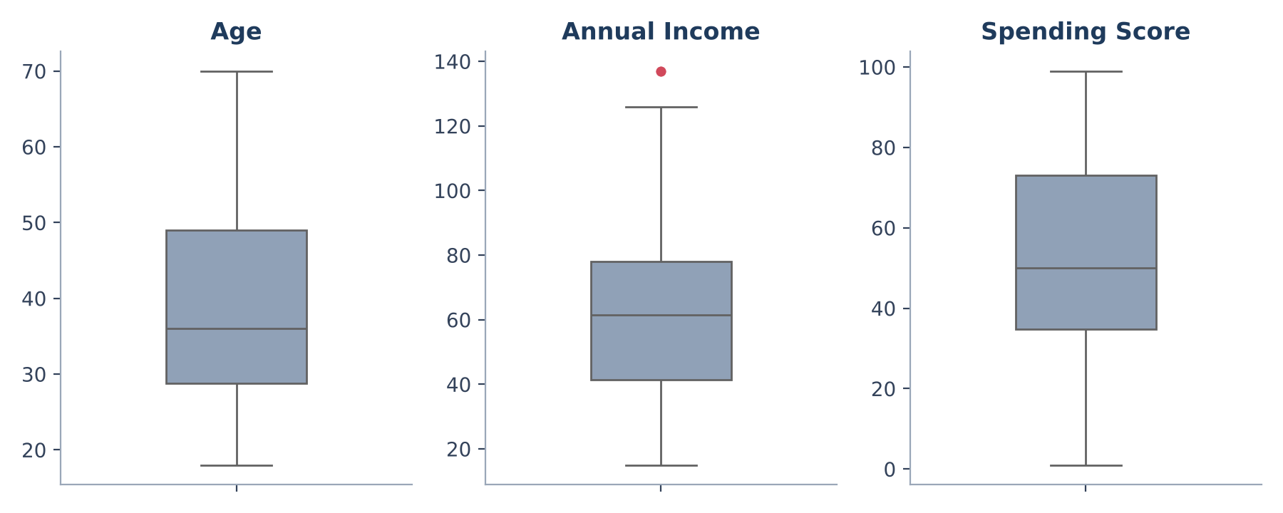
Figure 3.1 – Box plots of Age, Annual Income and Spending Score

3.4 Train–Test Split
- Regression (Section 4.1): 80% training / 20% testing (40 test customers), random_state = 50.
- Classification (Section 4.3): 80/20 stratified split so each segment appears in both sets, random_state = 42.
- Notebook re-evaluation (Sections 4.7 and 4.8): 80/20 split with random_state = 42 (stratified for classification), followed by 5-fold cross-validation on the 160 training customers.

3.5 Dual-Track Modelling
Track A: Regression.
A Decision Tree Regressor was compared with Linear Regression using Age, Annual Income and Gender_Male as inputs. Both were scored with MAE, MSE, RMSE and R².
Track B: Classification.
Spending Score was binned into three segments, and a Decision Tree Classifier was trained to predict the segment. Results are checked with a classification report and confusion matrix.
Table 3.1 – Spending Segments
Segment | Score range | Customers
Low | 0 – 39 | 59
Medium | 40 – 69 | 87
High | 70 – 100 | 54

Cross-validated evaluation. The notebook compares each model with a simple baseline and uses a shallow decision tree (maximum depth 3, at least 5 customers per leaf). Regression models are compared with a mean-only baseline and scored by cross-validated MAE; the classifier is compared with a most-frequent-class baseline using accuracy and macro F1. The best regression model is then checked once on the held-out test set.
Exploratory K-means. K-means groups customers on standardised Age, Annual Income and Spending Score. Group counts from 2 to 6 are compared by silhouette score, and stability is checked by refitting with 10 different random seeds and averaging the adjusted Rand index (ARI).

3.6 Game Theory Integration
A payoff matrix compares two marketing actions. A discount costs margin if the customer would have bought anyway, but it can win a customer who would not. High spenders already buy, so they receive no discount. Low and Medium spenders receive a discount.
Table 3.2 – Strategy by Segment
Segment | Strategy | Reasoning
High spenders | No Discount | Protect margin; these customers already show strong intent.
Medium / Low spenders | Discount | Offer an incentive to win price-sensitive or low-engagement customers.

3.7 Dashboard
The Streamlit dashboard has three views: At a glance (summary figures and distributions), Compare groups (segments side by side) and Customer list (filtered table with CSV export). Filters apply to all views. The dashboard describes the dataset; it does not predict individual customers’ future behaviour.
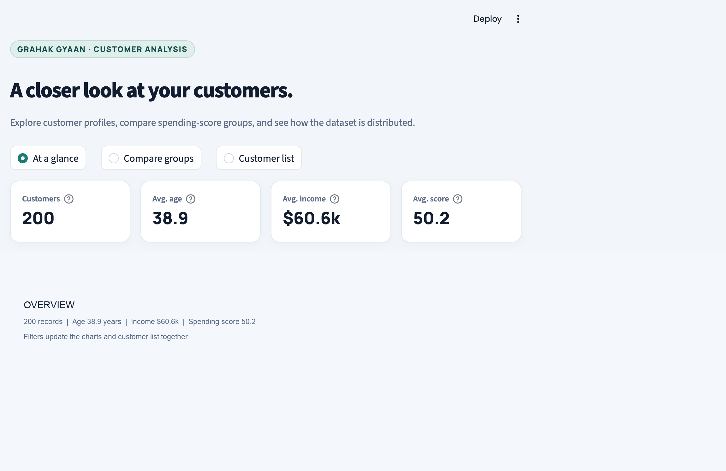
Figure 3.2 – Dashboard, “At a glance” view
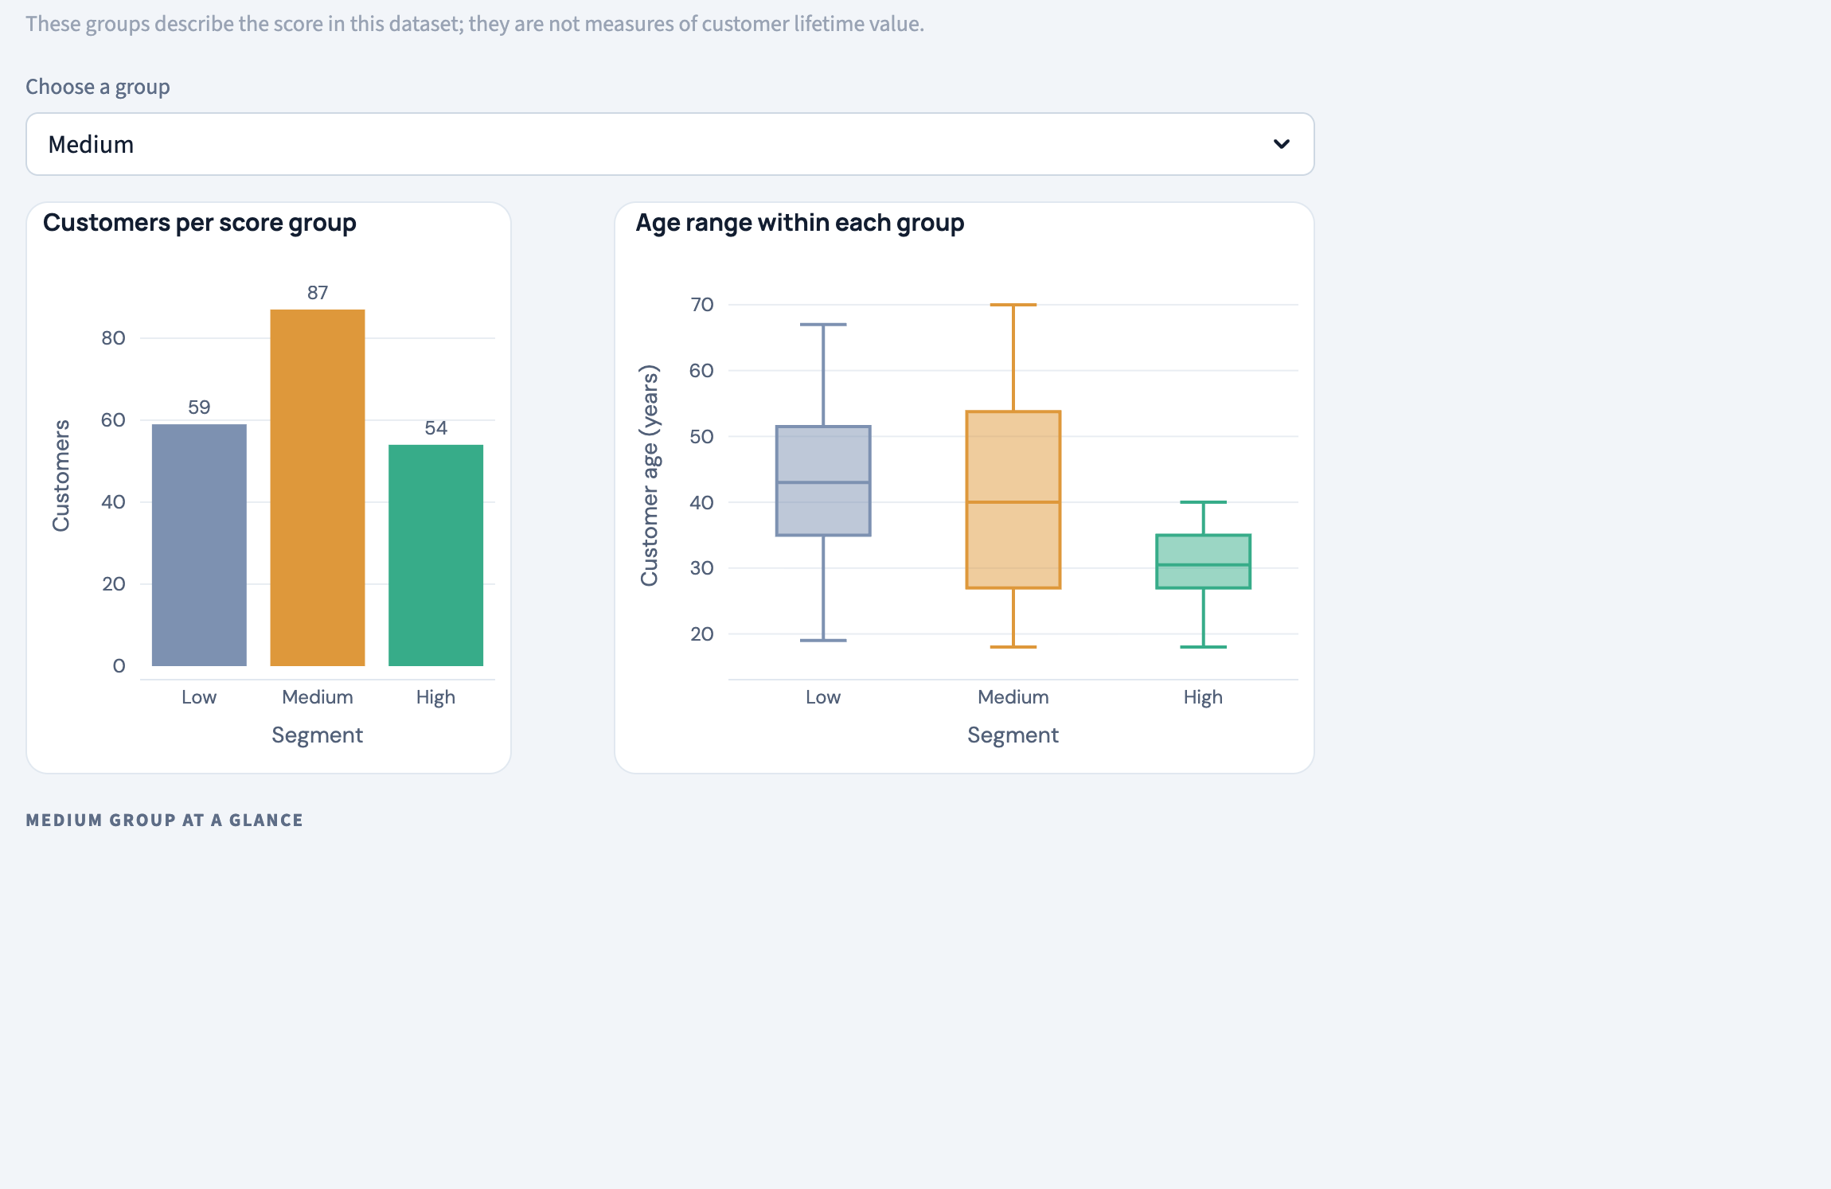
Figure 3.3 – Dashboard, “Compare groups” view

4. Result and Discussion

4.1 Regression: Predicting the Spending Score
Linear Regression generalised better than the Decision Tree Regressor, although neither model is strong.
Table 4.1 – Regression Model Evaluation (40 test customers)
Model | MAE | MSE | RMSE | R² | Verdict
Decision Tree Regressor | 19.32 | 967.17 | 31.10 | −0.49 | Overfit / Weak
Linear Regression ★ | 20.46 | 598.52 | 24.46 | 0.08 | Moderate (Better)

The takeaway: The negative R² of the Decision Tree means it did worse than predicting the average score for everyone. It fits the training data too closely and fails on new customers. Linear Regression has a small positive R² (0.08), so it explains only a little of the variation. Errors of about 20 points on a 1–100 scale show that Age, Income and Gender alone say little about spending.
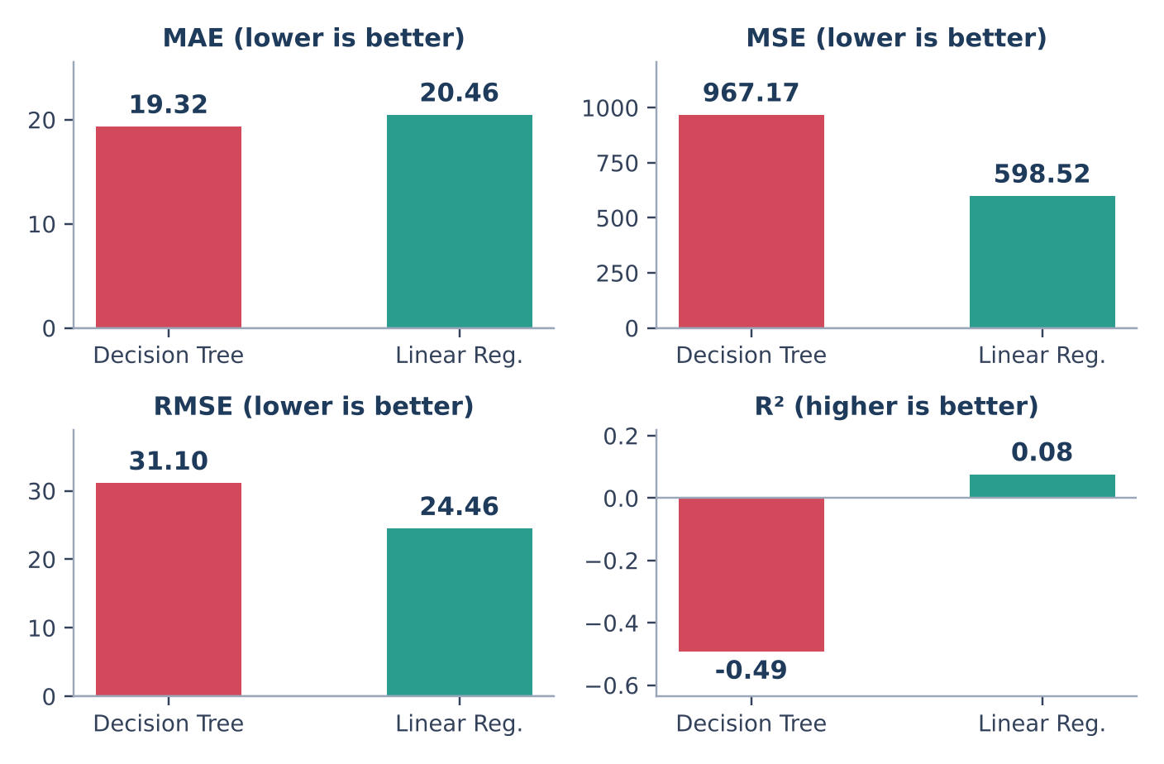
Figure 4.1 – Regression metrics by model
How to read this section: Sections 4.1–4.4 use the original single-split run. Sections 4.5–4.9 add the notebook’s cross-validated re-evaluation, baselines and K-means exploration; results differ because the models and evaluation differ.

4.2 Segment Distribution
Medium spenders are the largest group (87 of 200).
Table 4.2 – Spending Category Distribution
Category | Score range | Count
Low | 0 – 39 | 59
Medium | 40 – 69 | 87
High | 70 – 100 | 54

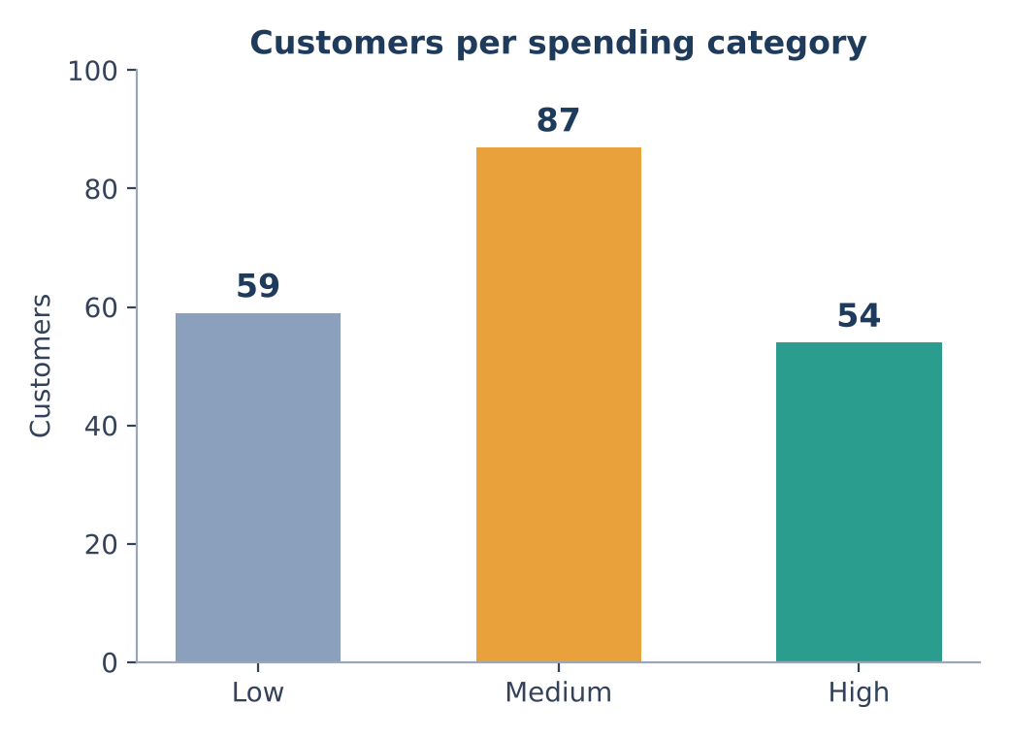
Figure 4.2 – Customers per spending segment

4.3 Classification: Sorting the Shoppers
The Decision Tree Classifier placed 80% of the 40 test customers in the correct segment.
Table 4.3 – Classification Report
Class | Precision | Recall | F1-score | Support
High | 0.62 | 0.73 | 0.67 | 11
Low | 0.90 | 0.75 | 0.82 | 12
Medium | 0.88 | 0.88 | 0.88 | 17
Weighted avg | 0.81 | 0.80 | 0.80 | 40

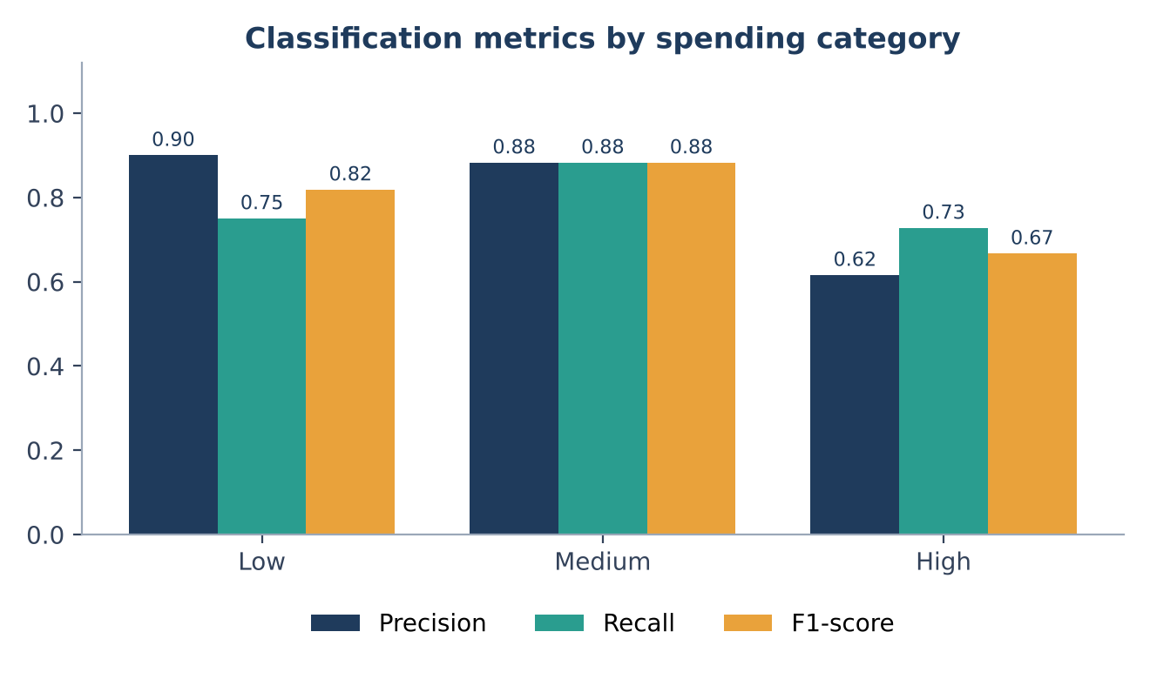
Figure 4.3 – Precision, recall and F1 by spending band (first run)
The takeaway: Low and Medium spenders are predicted well. High spenders have a good recall (0.73) but the lowest precision (0.62), so some customers are wrongly flagged as High. In the confusion matrix, 3 Low and 2 Medium customers were wrongly labelled High, and 3 High customers were labelled Low or Medium. With only 40 test customers, each mistake moves the percentages noticeably, so these figures are best read as indicative.
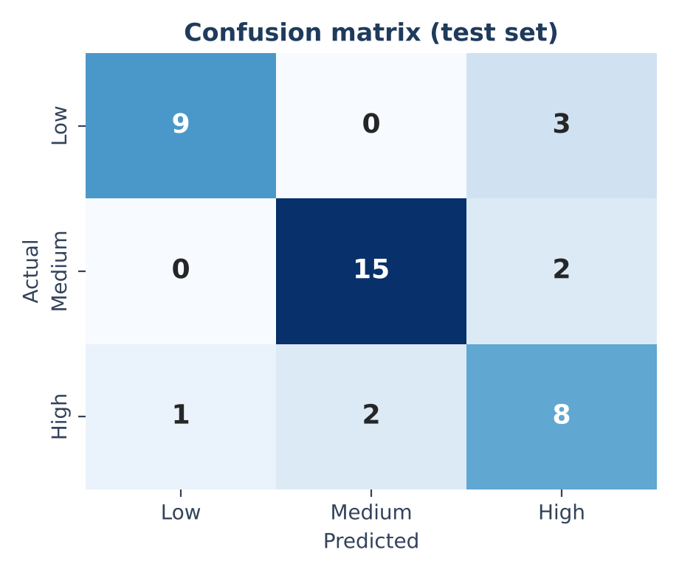
Figure 4.4 – Confusion matrix (rows: actual, columns: predicted)

4.4 Strategy: The Game Theory Payoff
The payoff matrix decides the financial move for each segment.
Table 4.4 – Marketing Strategy Matrix
Strategy | Customer accepts | Customer rejects | Recommended for
No Discount | +80 (max profit) | 0 | High spenders (n=54)
Discount | +50 (conversion) | −10 (cost) | Low / Medium spenders (n=146)

- Revenue retention. 54 High spenders get No Discount. They already show intent, so a discount would only reduce profit.
- Incentivised growth. 146 Low and Medium spenders get a Discount, to help convert customers who might not otherwise buy.
Note: The payoff values (+80, +50, −10, 0) are fixed values set in the code, not measured from real campaigns, because the dataset has no campaign data. Replacing them with real campaign data is the most important next step.
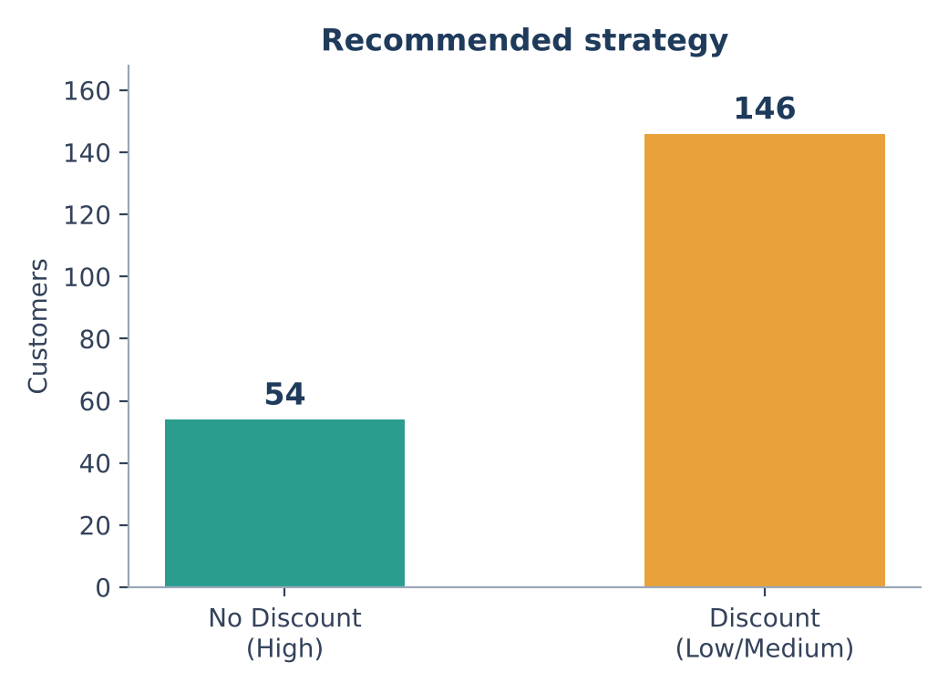
Figure 4.5 – Strategy assigned to the 200 customers

4.5 Data Checks, Outliers and Correlations
The notebook's checks found no missing values, no duplicate rows and no duplicate customer IDs among the 200 records. Passing them shows the file is consistent; it does not prove the sample represents all mall customers.
Table 4.5 – Data Quality Checks
Check | Result
Rows | 200
Missing values | 0
Duplicate rows | 0
Duplicate customer IDs | 0

The IQR rule flagged two values, both for Annual Income. They are kept in the data because the file gives no reason to think they are errors, and they should be verified before conclusions are drawn.
Table 4.6 – Outliers Flagged by the IQR Rule
Field | Customer ID | Value | IQR upper fence
Annual Income (k$) | 199 | 137 | 132.75
Annual Income (k$) | 200 | 137 | 132.75

Correlations. Correlations with the spending score are weak: Age −0.33, Annual Income 0.01. Age and Annual Income are also unrelated (−0.01).
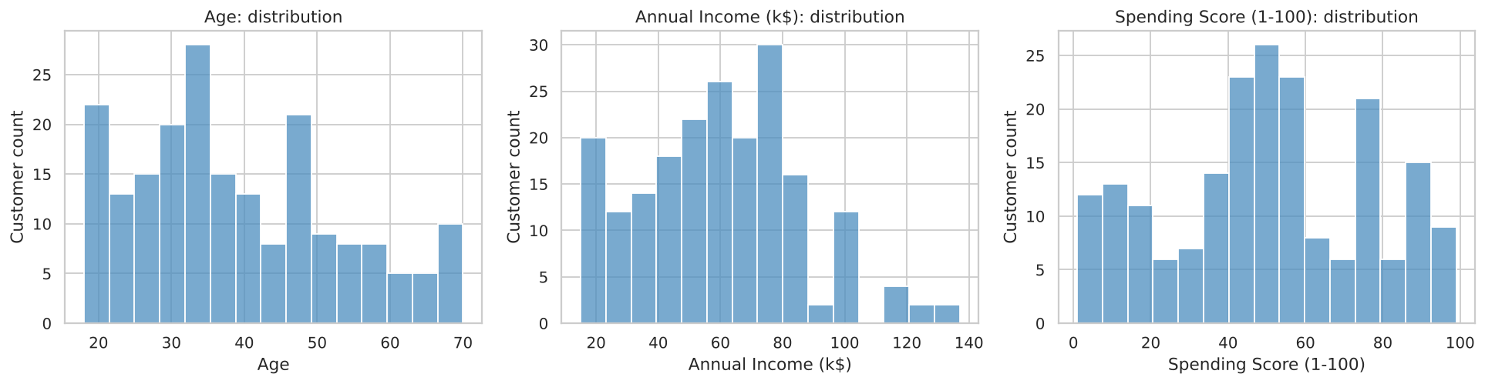
Figure 4.6 – Distributions of Age, Annual Income and Spending Score
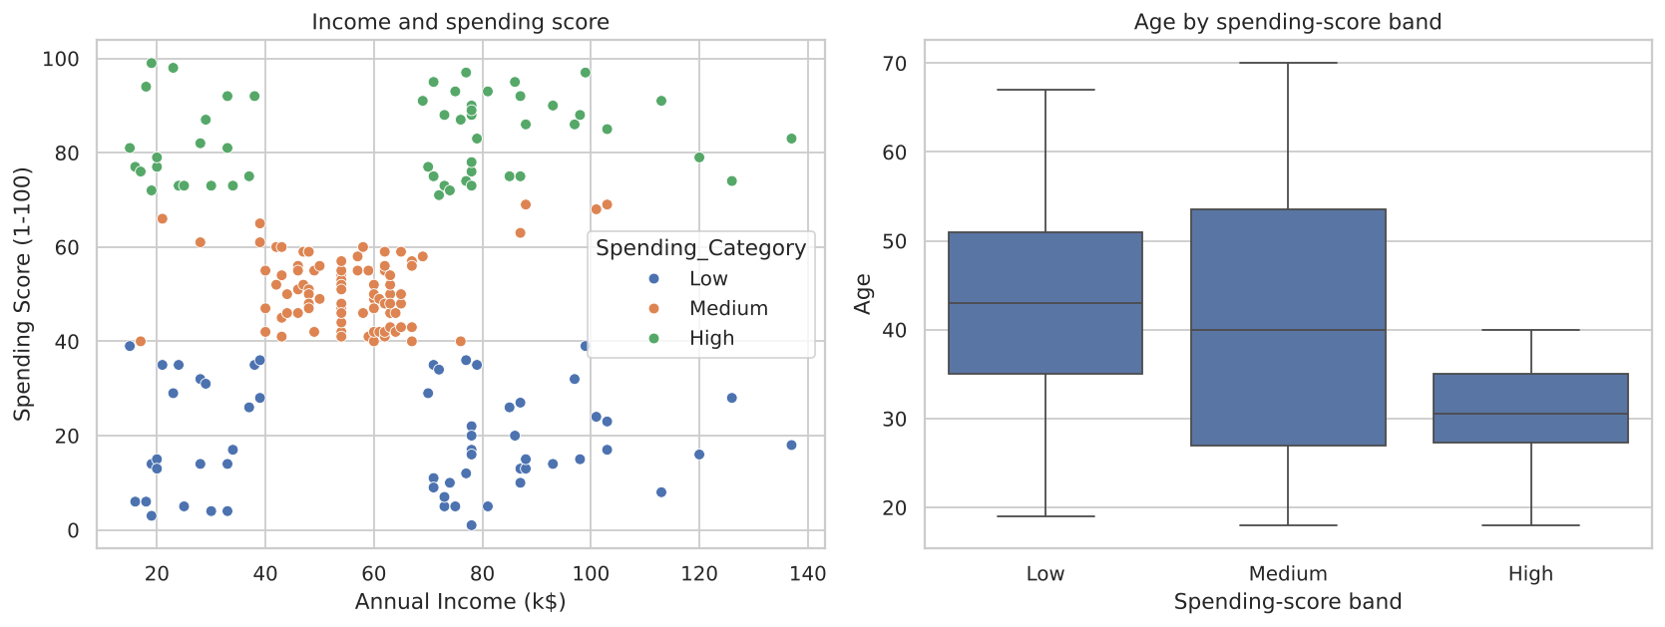
Figure 4.7 – Income against spending score by band, and age by band

4.6 Spending-Band Profiles
Table 4.7 – Profile of Each Spending-Score Band
Band | Customers | Avg age | Avg income (k$) | Avg score | Illustrative idea
Low | 59 | 42.6 | 64.7 | 18.8 | Engage & grow
Medium | 87 | 41.6 | 55.4 | 51.1 | Build loyalty
High | 54 | 30.2 | 64.3 | 83.1 | Reward & retain

High spenders are younger on average (30.2 years against 41.6–42.6 for the other bands), while average income is similar across the three bands. The engagement ideas are examples only: the dataset holds no discount response, revenue or return, so they are not backed by campaign results.

4.7 Regression with Cross-Validation and a Baseline
The regression comparison was repeated with a mean-only baseline, linear regression and a depth-3 decision tree, using 5-fold cross-validation on the 160 training customers and then a final check on the 40 held-out customers.
Table 4.8 – Cross-Validation Results (MAE, score points)
Model | CV MAE | CV MAE SD
Shallow decision tree | 17.22 | 1.76
Mean baseline | 21.57 | 1.99
Linear regression | 21.80 | 1.09

Table 4.9 – Held-out Test Results
Model | Test MAE | Test RMSE | Test R²
Shallow decision tree | 13.37 | 20.50 | 0.15
Mean baseline | 18.67 | 23.56 | −0.13

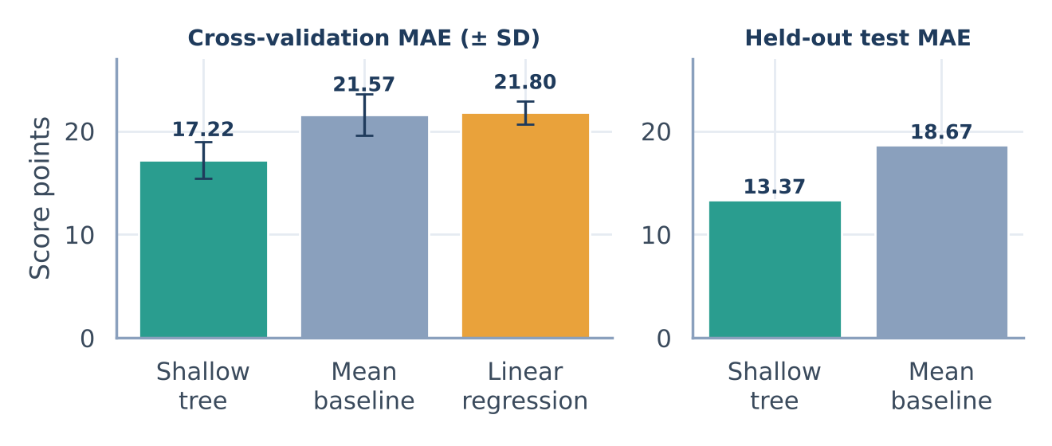
Figure 4.8 – Cross-validated and held-out MAE
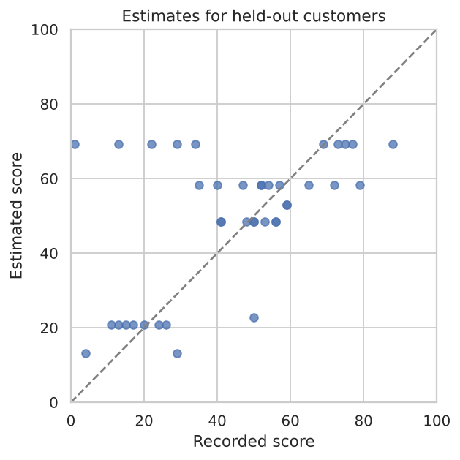
Figure 4.9 – Estimated against recorded scores for held-out customers
The takeaway: The depth-3 tree had the lowest cross-validation MAE (17.22 against 21.57 for the baseline), and on the held-out customers it reached MAE 13.37 and R² 0.15. Linear Regression (21.80) did no better than predicting the mean. Even the best model is too inaccurate for practical use in this sample and would need testing on new, relevant data.

4.8 Score-Band Classifier with a Baseline
Table 4.10 – Classification Cross-Validation Results
Model | CV accuracy | CV accuracy SD | CV macro F1
Most-frequent baseline | 0.438 | 0.000 | 0.203
Shallow decision tree | 0.831 | 0.038 | 0.819

Table 4.11 – Held-out Classification Report (depth-3 tree)
Class | Precision | Recall | F1-score | Support
Low | 1.00 | 0.67 | 0.80 | 12
Medium | 1.00 | 0.88 | 0.94 | 17
High | 0.65 | 1.00 | 0.79 | 11
Macro average | 0.88 | 0.85 | 0.84 | 40

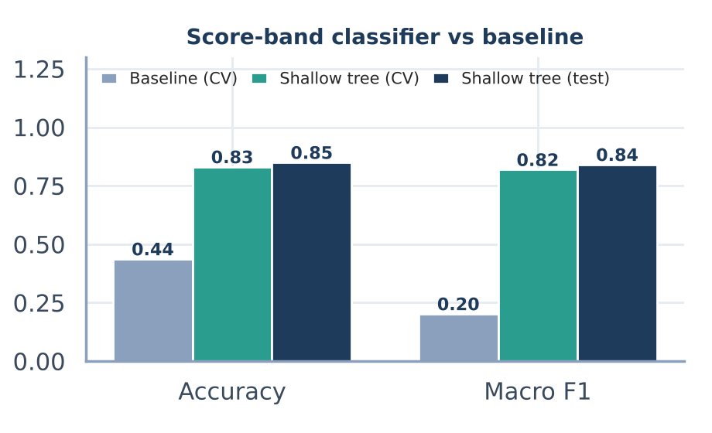
Figure 4.10 – Classifier against baseline
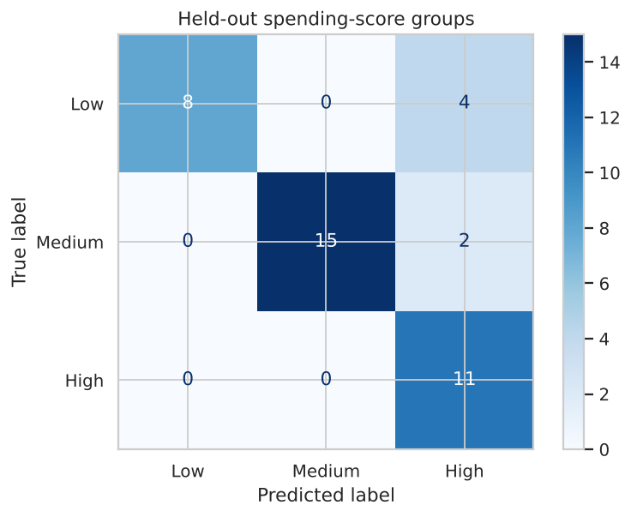
Figure 4.11 – Confusion matrix of the depth-3 tree on held-out customers
The takeaway: On the 40 held-out customers the depth-3 tree reached 85% accuracy, macro F1 0.841 and balanced accuracy 0.85. Section 4.3 reports the earlier unrestricted tree (80%). Every High spender was found (recall 1.00), but precision for High is only 0.65: 4 Low and 2 Medium customers were labelled High. The bands are hand-set cutoffs, so this tests whether age, gender and income can approximate them. It does not show that the bands are natural customer types.

4.9 K-means: Exploratory Customer Groups
K-means was run on standardised Age, Annual Income and Spending Score for 2 to 6 groups. The silhouette score rises with the number of groups and is highest at 6 groups.
Table 4.12 – Silhouette Score by Number of Groups
Groups (k) | 2 | 3 | 4 | 5 | 6
Silhouette | 0.335 | 0.358 | 0.404 | 0.417 | 0.427

Table 4.13 – Profile of the 6 K-means Groups
Group | Customers | Avg age | Avg income (k$) | Avg score
0 | 33 | 41.9 | 88.9 | 17.0
1 | 45 | 56.3 | 54.3 | 49.1
2 | 24 | 25.2 | 25.8 | 76.9
3 | 39 | 32.7 | 86.5 | 82.1
4 | 38 | 26.7 | 57.6 | 47.8
5 | 21 | 45.5 | 26.3 | 19.4

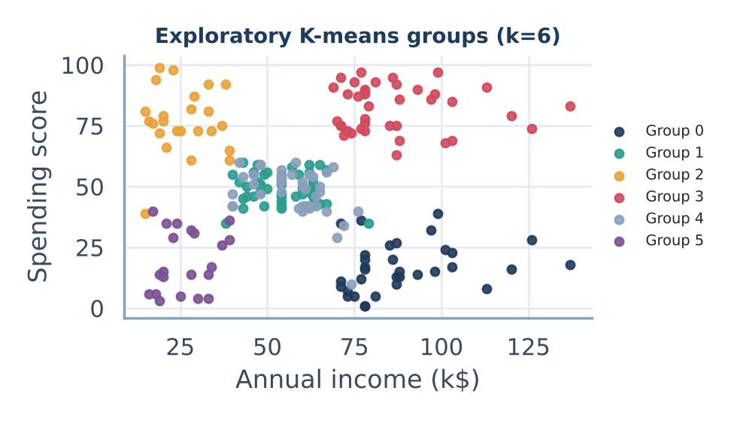
Figure 4.12 – K-means groups on income and spending score
Reading the result: Across 10 refits with different seeds the adjusted Rand index averaged 0.999 (lowest 0.989), so the grouping is stable. Silhouette only measures how well separated the groups are; it does not show that they are useful. The group numbers are labels, not customer-value tiers, and the groups need checking on other data before they guide any decision.

5. Conclusion

5.1 What Was Achieved
- In the original single-split run, Linear Regression generalised better than the Decision Tree Regressor (R² 0.08 vs −0.49), but neither predicts the exact Spending Score well.
- With 5-fold cross-validation and a mean baseline, a depth-3 tree had the lowest MAE (17.22 vs 21.57); Linear Regression (21.80) did no better than the mean.
- The Decision Tree Classifier sorted 80% of test customers into the right segment (full-depth tree) and 85% with a depth-3 tree, against a most-frequent baseline of 0.44 in cross-validation.
- K-means gave 6 stable but exploratory groups (silhouette 0.427, ARI 0.999).
- A game-theory payoff matrix turned the segments into an action: No Discount for 54 High spenders, Discount for 146 Low and Medium spenders.
- A Streamlit dashboard lets management explore, compare and export customer groups without code.

5.2 Limitations
- Small dataset: 200 customers and a 40-customer test set, so metrics vary with the split.
- Only Age, Income and Gender are used; the dataset has no purchase history, visit frequency or product data.
- Payoffs in the game-theory model are assumed, not measured.
- Spending Score is a ready-made label from the dataset, not observed spending.
- The classifier reproduces hand-set cutoffs; it does not validate them as customer types.
- K-means groups are exploratory and need validation on other data.
- The file has no transactions, dates, campaign responses or revenue, so it cannot show campaign lift, customer lifetime value or financial impact.

5.3 Future Work
- Collect campaign data: who saw an offer, who accepted, and the cost and margin, so the assumed payoffs can be replaced with measured ones.
- Compare outcomes fairly, for example with a randomized holdout group.
- Test the models and the K-means groups on new, relevant data before using them for decisions.

6. References

6.1 Dataset and Tools
- Dataset: Mall Customer Segmentation Data (Kaggle / UCI), Mall_Customers.csv – 200 records with CustomerID, Gender, Age, Annual Income (k$) and Spending Score (1–100).
- Python and Pandas: data loading, cleaning, one-hot encoding and IQR outlier detection.
- Scikit-learn: Linear Regression, Decision Tree Regressor, Decision Tree Classifier, train-test split and evaluation metrics.
- Matplotlib and Seaborn: charts, box plots and the confusion-matrix heatmap.
- Streamlit: the interactive dashboard.

6.2 Academic References
- MacQueen, J. (1967). Some Methods for Classification and Analysis of Multivariate Observations. Proceedings of the Fifth Berkeley Symposium on Mathematical Statistics and Probability, 1, 281–297.
- Hughes, A. M. (1994). Strategic Database Marketing. Probus Publishing, Chicago.
- Nash, J. (1950). Equilibrium Points in n-Person Games. Proceedings of the National Academy of Sciences, 36(1), 48–49. DOI: 10.1073/pnas.36.1.48
- Breiman, L. (2001). Random Forests. Machine Learning, 45(1), 5–32.
- Romero, C. & Ventura, S. (2010). Educational Data Mining: A Review of the State of the Art. IEEE Transactions on Systems, Man, and Cybernetics, Part C, 40(6), 601–618. DOI: 10.1109/TSMCC.2010.2053532 (background on applying data mining and decision trees to prediction tasks).
- Yuliana, R. E., Ulya, D. M. & Jamhuri, M. (2025). Mall Customer Segmentation Using K-Means Clustering Optimized by the Elbow Method. Jurnal Riset Mahasiswa Matematika, 4(5), 273–286. DOI: 10.18860/jrmm.v4i5.33389. https://ejournal.uin-malang.ac.id/index.php/jrmm/article/view/33389
- Gong, J., Lai, D. & Liu, Y. (2026). Improved K-Means Algorithm: Integrating Density Peaks and Adaptive K-Value for Mall Customer Segmentation. Preprints.org (not peer-reviewed). DOI: 10.20944/preprints202604.1238.v1.
- Prathiba, L., Raja, S., Umadevi, A., Sucharitha, M. M. & Basha, M. S. A. (2024). Leveraging Ensemble Methods for Accurate Prediction of Customer Spending Scores in Retail. 2024 3rd International Conference for Advancement in Technology (ICONAT), IEEE. DOI: 10.1109/ICONAT61936.2024.10774867 (restricted access; abstract only).
- Raju, C. V. L., Narahari, Y. & Ravikumar, K. (2006). Learning dynamic prices in electronic retail markets with customer segmentation. Annals of Operations Research, 143(1), 59–75. https://repository.ias.ac.in/30340

