SVKM’S NMIMS

Mukesh Patel School of Technology Management & Engineering
A.Y. 2025 – 26

Course: Machine Learning
Project Report

Grahak Gyaan
An exploratory analysis and model comparison
Program | B.Tech – Artificial Intelligence and Machine Learning
Semester | Semester IV (A.Y. 2025–26)
Project Title | Grahak Gyaan: Customer Analysis
Dataset | Mall_Customers.csv – 200 customers, 5 features
Project Members | Roll No. Name
Batch: F-2 | A216 Mehi Manswa Bhagat
SAP ID | 70012400107
Date of Submission | April 2026
Batch: F-2 | C264 Dipanshu Yadav
SAP ID | 70532400076
Date of Submission | April 2026

Project team contributions
Roll No. | Name | Contribution
A216 | Mehi Manswa Bhagat | Data checks, EDA, model comparisons, evaluation, and dashboard
C264 | Dipanshu Yadav | Research, report writing, and presentation

GitHub Link of Project: https://github.com/M270706/Mall-Customer-Spending-Analysis-Strategy-Recommendation

Table of Contents

Sr No. | Topic
1 | Introduction
2 | Literature Survey
3 | Methodology
4 | Result and Discussion
5 | Conclusion
6 | References

- Introduction

Understanding the Mall Customers dataset

This project looks at a small mall-customer dataset to understand what it can—and cannot—tell us about the people in it. We explored the available customer details, compared a few models, and built a dashboard for reviewing the results.
The analysis uses age, gender, annual income, and a spending score already present in the file. It does not include purchase history or campaign outcomes, so it cannot predict who will respond to an offer or which marketing action would be most profitable.

The Methodology

We approached the work in a few clear steps: checking the data, exploring patterns, comparing models, and presenting the results in a dashboard.
- Estimating the recorded spending score
First, we tested whether age, gender, and annual income could estimate the spending score for customers held out from training. We compared a mean baseline, linear regression, and a shallow decision tree.
  - Linear regression: a simple reference model for broad relationships.
  - A shallow decision tree: a small model that can capture some non-linear patterns.
- Checking the hand-set score bands

We also grouped records by spending-score cutoffs: Low (below 40), Medium (40–69), and High (70 or above). A shallow decision tree matched these labels with 85% accuracy on the held-out test set. The labels come from the score itself, so this is not evidence that the groups predict future purchases or business value.
- Keeping recommendations in perspective

The dataset has no information about discounts, customer responses, costs, or margins. We therefore do not calculate a payoff or recommend who should receive an offer. The dashboard’s engagement ideas are illustrative prompts based only on score groups.
- The dashboard

The local Streamlit dashboard has three views: At a glance, Compare groups, and Customer list. Age, income, gender, and score-band filters update the records in view. Presenters can switch the overview scatter plot between score group and gender, compare group counts and age ranges, search the customer list, and export the filtered records. It is an exploration aid, not a live marketing system.

A quick look at the dataset

The file contains 200 records and five source fields. It has no missing values or duplicate customer IDs. The notebook checks the data and summarizes the main ranges before modeling.

Metric | Detail
Gender | 112 Female, 88 Male
Age | 18–70 years (average: 38.9)
Annual income | $15k–$137k (average: $60.6k)
Spending score | 1–99 (average: 50.2)

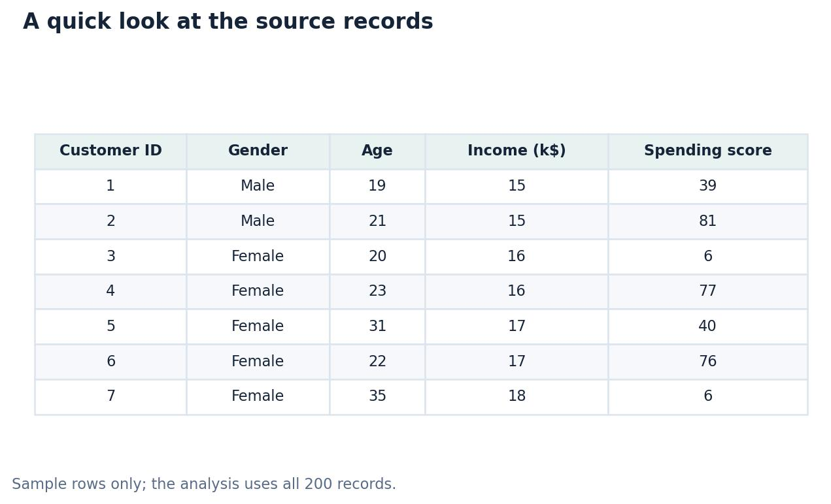

What we learned

This sample is useful for demonstrating exploratory analysis and model evaluation. It does not show that a model can increase sales, improve margins, or identify customers who would respond to an offer.
The main takeaway is to match the strength of the conclusion to the information in the data.

- Literature Survey
Background reading and context

The references below provide background on clustering, marketing, and machine learning. They informed the project’s reading, but they do not validate the results or the score bands used here.

Customer grouping and marketing context

- K-means is one established way to group observations by similarity. In this project it is used only to explore patterns in the available fields.
- RFM analysis uses transaction history that is not available in this dataset, so it is outside the scope of this analysis.
- Game theory is useful background for decision-making problems, but this project does not build or evaluate a payoff model.
No discount, price, or profit data are included here.
- A decision tree is one model we compare. Its performance depends on the data and task; the results here are modest and should not be treated as evidence of general performance.

Two ways to examine the score

We examined two related questions: whether the available fields can estimate the recorded score, and whether they can approximate score bands chosen for this project. Both are exploratory tasks using the same small dataset.

From analysis to presentation

The analysis is presented in a dashboard so the results are easy to explore. It does not generate a tested marketing strategy or claim that one customer group is more profitable than another.

Making the results easier to explore

The local Streamlit dashboard provides a simple way to explore the dataset. A presenter can:
- Filter the records and update the charts.
- Compare score groups and review individual records.
- Download the filtered records without opening the notebook.

Summary
The project demonstrates a complete exploratory workflow, from data checks and visual summaries to model comparison and an interactive dashboard.
It is a presentation project, not a production decision-support system.

- Methodology
Analysis workflow
The notebook follows a repeatable workflow: load and validate the file, explore its fields, compare models on training and held-out data, and review exploratory clusters.
  - Loading and checking the data
The dataset has 200 records and five source columns. The validation checks found no missing required values or repeated IDs. This is a useful quality check, though it does not confirm that the sample is representative or that the source is error-free.
  - Preparing the model inputs
The model pipelines prepare the input fields as part of training:
    - Gender is one-hot encoded, and numeric fields are scaled where appropriate.
    - CustomerID is excluded from the models because it is an identifier, not a customer characteristic.
  - Reviewing possible outliers
We used the interquartile range (IQR) as a screening rule and flagged two high-income records for review. A flag is not proof of an error, and it does not justify a special marketing action.
  - How the models were evaluated
For each supervised task, we kept a 20% holdout aside for a final check. Five-fold cross-validation on the training portion helped compare models. This setup is more informative than a single score, but the small sample still limits what we can conclude about future records.
    - Training portion: used for fitting and cross-validation.
    - Held-out portion: used once for a final, separate evaluation.

  - Two modeling questions
Track A: estimating the spending score

For regression, we compared a mean baseline, linear regression, and a shallow decision tree using five-fold cross-validation on the training data. We then evaluated the selected model and the baseline on the held-out records. The test error is still substantial relative to the 1–100 score range.

Track B: approximating the score bands

For classification, the target groups were derived from the recorded spending score. The chosen cutoffs are convenient for this exercise, not validated customer segments:
    - Low scores (1–39): 59 customers
    - Medium scores (40–69): 87 customers
    - High scores (70–99): 54 customers
A shallow decision tree reached 85% accuracy and a macro F1 score of 0.841 on the held-out records. These measures describe how well it reproduced the chosen labels in this split; they do not show business value or future purchase behavior.
  - Campaign impact: what is missing
We did not calculate a payoff matrix. The dataset contains no response, discount, cost, or margin information, so profitability cannot be estimated.

Score group | Illustrative idea | Important note
High | Reward & retain | Example only; not tested with campaign data.
Low / Medium | Engage & grow / Build loyalty | Ideas are based only on score bands.

  - The local dashboard
The dashboard is a local, presenter-friendly view of the same dataset. It provides:
    - An overview of customer count, average age, income, and spending score, with a segment mix and scatter plot.
    - Filters for age, annual income, gender, and score group, plus a choice to color the scatter plot by score group or gender.
    - A group-comparison view and a searchable customer list with filtered CSV export.
The dashboard is an exploration aid. It does not predict behavior for new customers or decide which marketing action to take.

Results and discussion
This section summarizes what the models did on this sample. Cross-validation and held-out results are useful for comparison, but neither proves how a model would perform on future mall customers.
  - Regression: estimating the recorded score
We compared a mean baseline, linear regression, and a shallow decision tree. The decision tree had the lowest cross-validation MAE in this run. Its holdout results should be read alongside the baseline because the sample is small.

Table 4.1 – Regression Model Evaluation Results

Model | CV MAE | CV MAE SD | Test MAE | Test RMSE | Test R²
Shallow decision tree | 17.22 | 1.76 | 13.37 | 20.50 | 0.148
Mean baseline | 21.57 | 1.99 | 18.67 | 23.56 | −0.126
Linear regression | 21.80 | 1.09 | — | — | —

On the held-out records, the selected tree had an MAE of 13.37 points and an R² of 0.148; the mean baseline MAE was 18.67 points. This is a modest result on one small split, not evidence that the model will predict future scores reliably.
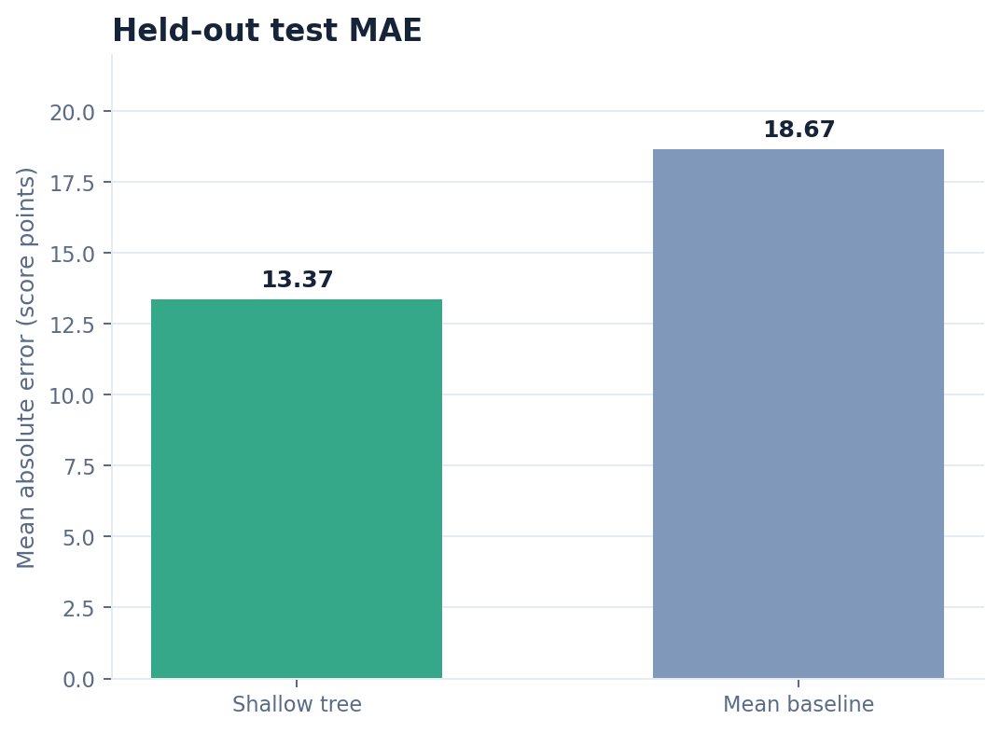
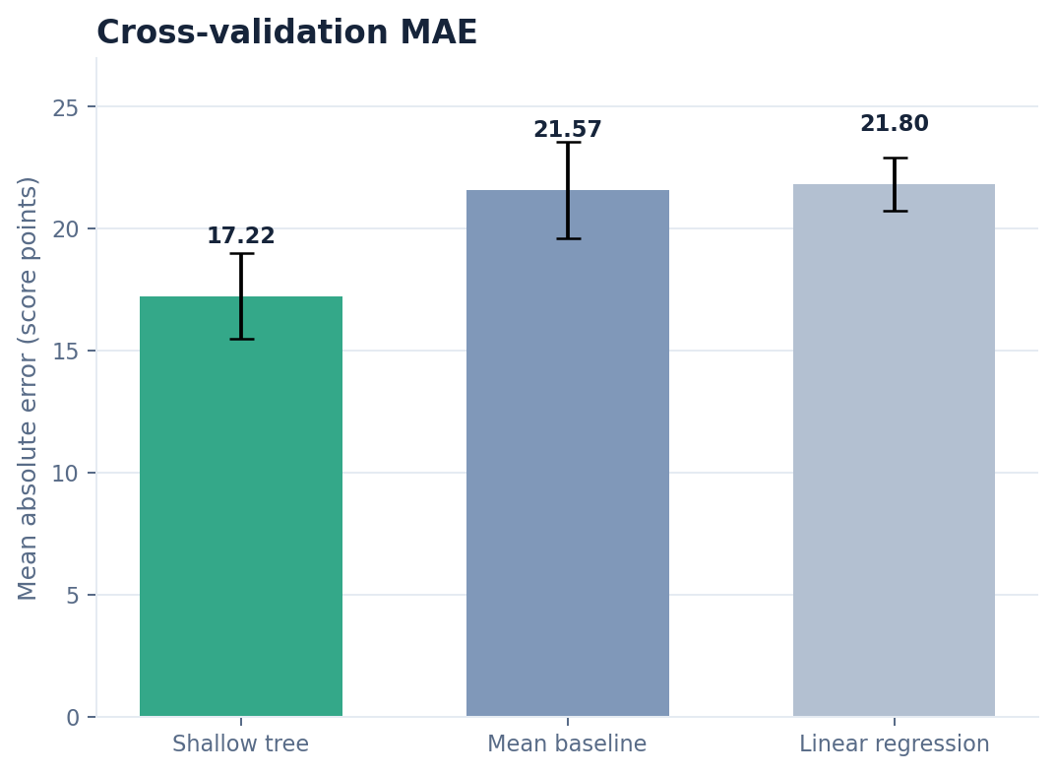
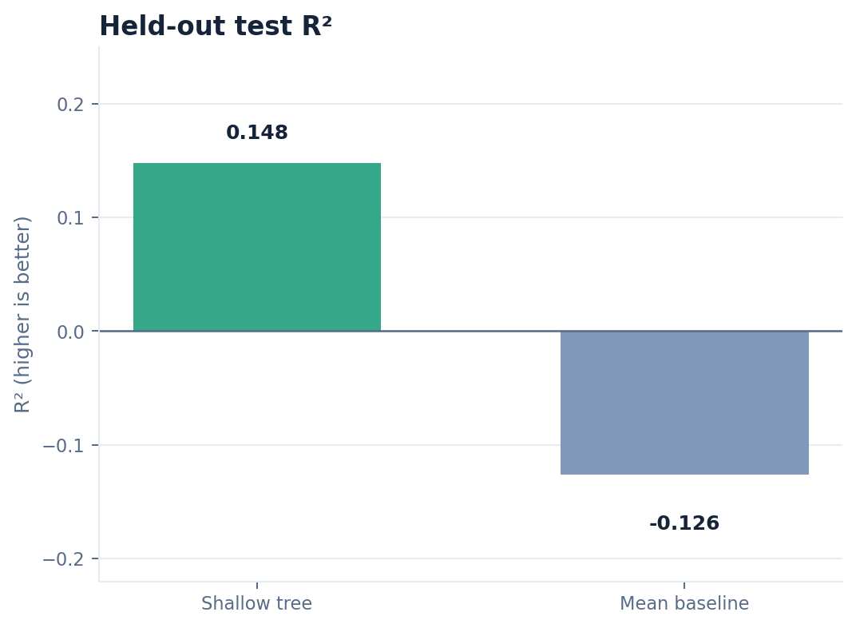

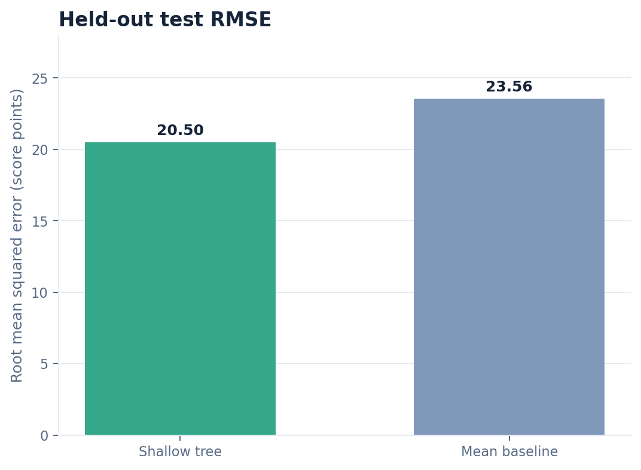
  - Spending-score group counts
For a clear summary, we grouped the recorded scores into three ranges. The Medium group is the largest in this dataset; that does not make it the largest business opportunity.

Table 4.2 – Spending Category Distribution

Score group | Score range | Customers
Low | 1–39 | 59
Medium | 40–69 | 87
High | 70–99 | 54

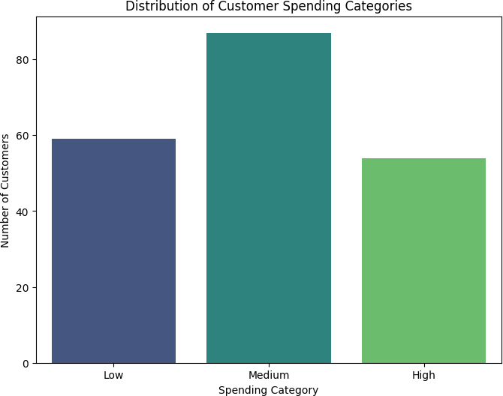

  - Classification: approximating the score bands
The shallow decision tree reached 85% accuracy on the held-out records when reproducing the score bands. The bands are derived from the score itself and should not be interpreted as natural customer types.

Table 4.3 – Classification Report

Group | Precision | Recall | F1 score | Support
High | 0.65 | 1.00 | 0.79 | 11
Low | 1.00 | 0.67 | 0.80 | 12
Medium | 1.00 | 0.88 | 0.94 | 17

The test report shows different precision and recall across the three groups. With only 40 held-out records, a small number of changed predictions could shift these figures, so treat them as an example of model evaluation rather than a reliable targeting rule.

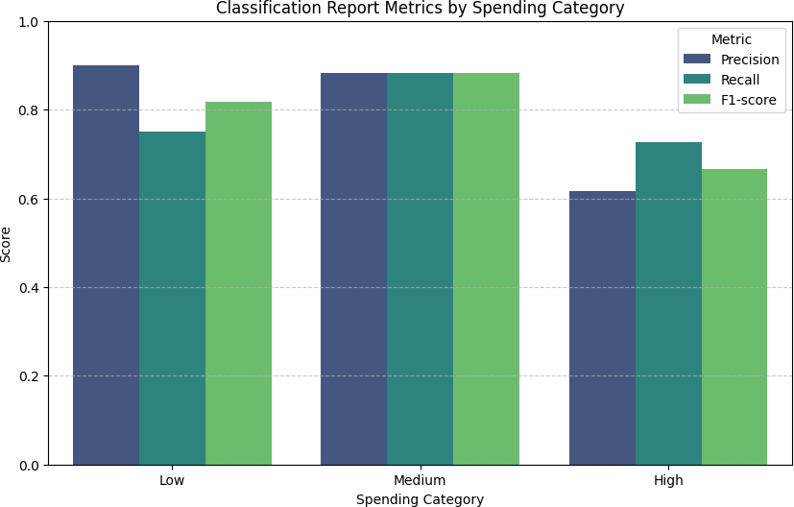

  - Campaign evaluation: data still needed

We cannot compare discount strategies with this dataset: it contains no offer exposure, response, discount cost, or sales margin. The following table lists information that would be needed for a future campaign evaluation.

Table 4.4 – Information needed to evaluate a campaign

Information needed | What it would show | Included here? | Why it matters
Offer exposure and response | Who saw and accepted an offer | No | Needed to estimate response.
Discount cost and sales margin | Financial effect of an offer | No | Needed to assess profitability.

    - An engagement idea based on a score band is only an example; this dataset does not show what these customers would do in response to an offer.
    - To estimate campaign impact, future work would need offer exposure, acceptance, costs, margins, and a suitable comparison design.

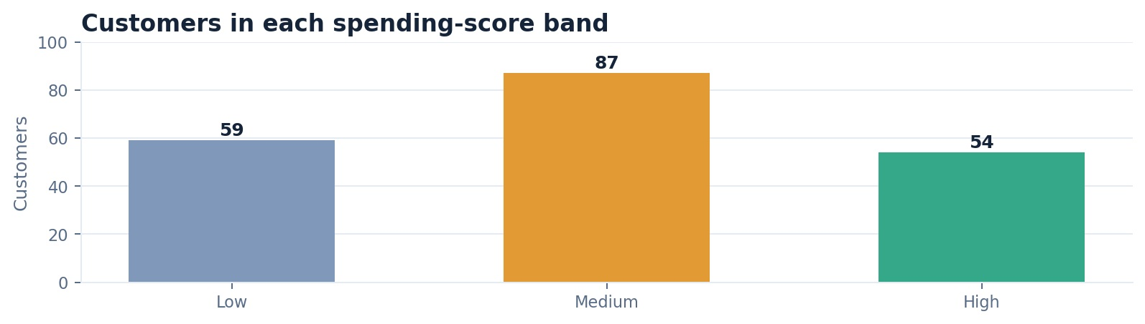
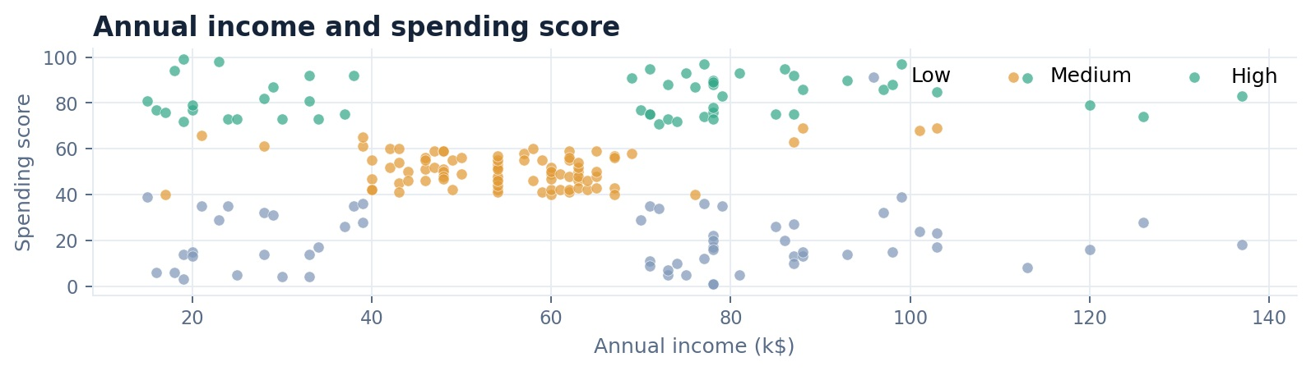
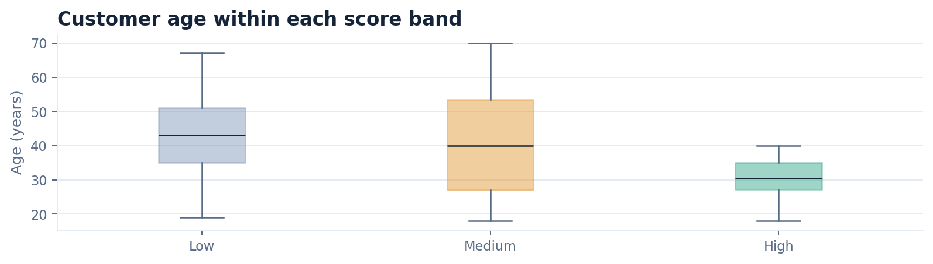

- Conclusion and limitations
This project brought together data checks, exploratory charts, model comparisons, and a local dashboard. The classification model reproduced the chosen score bands reasonably well on one held-out split, while score estimation remained an exploratory task. Neither result supports a claim about future spending or marketing impact.

What this dataset cannot tell us
The file has no transaction history, dates, campaign responses, revenue, or customer lifetime value. It is small and may not represent the mall’s wider customer base. Score bands and dashboard ideas are illustrative, and the cluster results need to be checked on more data before they inform decisions.

Possible next steps
A stronger follow-up would use a larger, representative dataset with transaction history and campaign outcomes. That would make it possible to test whether customer groups remain stable and whether any engagement idea changes measurable outcomes.

Tools and data
- Source file: Mall_Customers.csv.
- The file contains 200 rows and five source fields: CustomerID, Gender, Age, Annual Income, and Spending Score. The analysis checks the data before using it.

Tools used
Python and its data-science libraries were used for the notebook, model comparisons, and dashboard.
- Pandas: reading and summarizing the dataset. The IQR rule was used to flag possible outliers for review.
- Scikit-learn: preprocessing pipelines, train/test splitting, cross-validation, regression, classification, and clustering.
- Matplotlib and Seaborn: charts used to explore the fields and review model results.
- Streamlit: a local dashboard for exploring the customer records; it is not a live service.

These sources offer background on clustering and marketing. They are not evidence that the score bands or findings in this report are validated.

References
- MacQueen, J. (1967). Some Methods for Classification and Analysis of Multivariate Observations.
  - Semantic Scholar | Direct PDF (via SciSpace)

- Hughes, A.M. (1994). Strategic Database Marketing.
  - Google Books | Internet Archive
- Breiman, L. (2001). Random Forests.

