**Connecting UHF Beacon to Kenwood**

**Common Errors:**

* Make sure only one connection to a COM port is made at a time. i.e. UHF/OBC configurator connection to COM 11 and PuTTY connection to COM 11 at the same time will not work.
* If UHF is in transparent mode, **DO NOT CONNECT WITH UHF/OBC configurator tool.** It will keep the UHF in transparent mode forever or will extend timeout to undisclosed time.
* If Kenwood is stuck in transparent mode and holding Ctrl and pressing C three time does not work, make sure local line editing is set to “Force off” in the PuTTY configuration.

**Pre-Getting Started (to make sure that there is a connection):**

* Open UHF/OBC configurator tool from ENDUROSAT
* Click the create new connection icon in top left (plug icon)
* 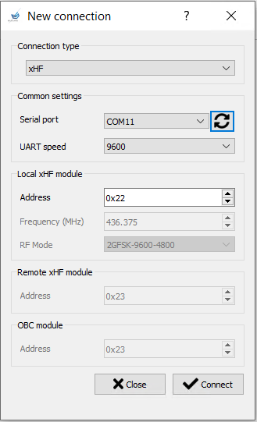Make sure connection type is xHF, everything else should be setup correctly (double check with figure 1)

Figure 1

* Click Connect
* Click Read (in figure 2), **DO NOT CHANGE ANYTHING ON THIS SCREEN AND HIT WRITE**

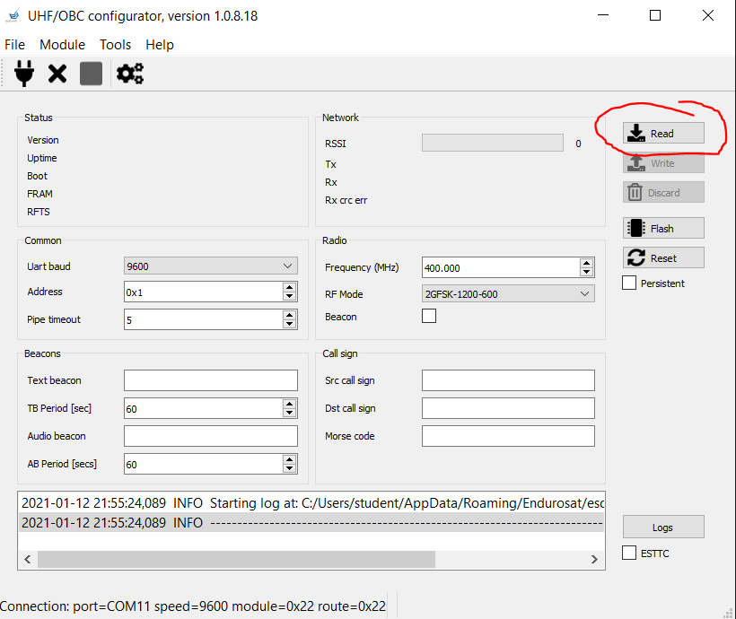

Figure 2

* If UHF is connected properly, you should see something similar to figure 3 and window at the bottom will throw no errors

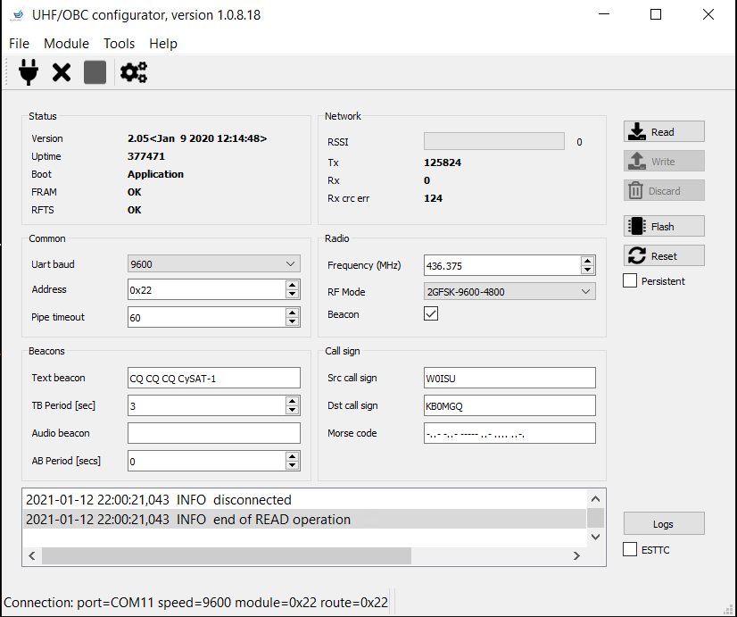Figure

* Close connection with the X in the top left to continue

**Getting Started:**

* Open PuTTY
* Click UHF UART in Saved Session and load it. (Note: if PuTTY connection does not work, refer to pre-getting started. If the xHF/OBC Configure connects, refer to common errors at the top of this document. If the error is still not resolved, refer to PuTTY presets document.)
* Open another tab of PuTTY
* Click on Kenwood in Saved Session and load it. (Note: if PuTTY connection does not work, refer to pre-getting started. If the xHF/OBC Configure connects, refer to common errors at the top of this document. If the error is still not resolved, refer to PuTTY presets document.)
* If connection successful and pre-getting started is done, a constant string of scrolling text will appear on the Kenwood’s PuTTY terminal.

**Commands for PuTTY:**

(CRC32 is not required for testing)

Enable Beacon: ES+W22000440 803240D4

Disable Beacon: ES+W22000400 E45E85D0

Enable Transparent (Pipe) Mode: ES+W22000420 D668E752

Change Beacon Text: ES+W22FB0B**YOURTEXTHERE** CRC32

Ex: ES+W22FB0BHello Earth E361E6C8