**Appendix 1 to Part 960--Filing Instructions and Information To Be**

**Included in the Licensing Application**

Prospective applicants are encouraged to contact NOAA for a non-binding preconsultation prior to filing an application or other licensing actions.

(a) Where to file. Applications and all related documents shall be filed with the Assistant Administrator, National Environmental Satellite, Data and Information Service (NESDIS), NOAA, Department of Commerce, 1335 East West Highway, Silver Spring, Maryland 20910.

(b) Form. No particular form is required but each application must be in writing, must include all of the information specified in this subpart, and must be signed by an authorized principal executive officer. In addition, applicants must submit a copy on electronic media using commonly-available commercial word processing software.

(c) Number of copies. One (1) copy of each application must be submitted in a readily reproducible form accompanied by a copy on electronic media.

(d) The following information shall be filed by the applicant in order to evaluate its suitability to hold a private remote sensing space system license. Data provided regarding the applicant's proposed remote sensing space system must be in sufficient detail to enable the Secretary to determine whether the proposal meets requirements of the Act.

**Sec. I Corporate Information**

1. The name, street address and mailing address, telephone number and citizenship(s) of (as applicable):

Iowa State University, Howe Hall 537 Bissel Rd Ames, IA, 50011, +1(515)294-6839

1. Applicant as well as any affiliates or subsidiaries;

Iowa State University

(ii) Chief executive officer of the applicant and each director; Tomas Gonzalez-Torres, Matthew Nelson

(iii) Each general corporation partner; N/A

(iv) All executive personnel or senior management of a partnership;

(v) Any directors, partners, executive personnel or senior management who hold positions with or serve as consultants for any foreign nation or person; N/A

(vi) Each domestic beneficial owner of an interest equal to or greater than 10 percent in the applicant; N/A

(vii) Each foreign owner of an interest equal to or greater than 5 percent in the applicant; N/A

(viii) Each foreign lender and amount of debt where foreign indebtedness exceeds 25 percent of an applicant's total indebtedness; N/A

(ix) A person upon who service of all documents may be made.

Primary: Tomas Gonzalez-Torres, [tgt@iastate.edu](mailto:tgt@iastate.edu),

Secondary: Matthew Nelson [mnelson@iastate.edu](mailto:mnelson@iastate.edu)

(2) A description of any significant or substantial agreements between the applicant, its affiliates and subsidiaries, with foreign nation or person, including copies if available; N/A

(3) A copy of the charter or other authorizing instrument certified by the jurisdiction in which the applicant is incorporated or organized and authorized to do business.

**Sec. II Launch Segment Information**

Provide the characteristics of the launch segment to include:

(1) Proposed launch schedule; November of 2018

(2) Proposed launch vehicle source; Cygnus Antares Rocket, Orbital ATK

(3) Proposed launch site; Wallops Facility in Virginia

(4) Anticipated operational date; December 2018, January 2019

(5) The range of orbits and altitudes (nominal apogee and perigee); 403 km, 407 km

(6) Inclination angle; 51.6 degrees

(7) Orbital period. 93 minutes

**Sec. III Space Segment**

(1) The name of the system and the number of satellites which will compose this system; The name of the system is CySat-1, and there will be 1 satellite in this system

(2) Technical space system information at the level of detail typical of a request for proposal specification (including sensor type; spatial and spectral resolution; pointing parameters, etc.);

Due to the educational nature of this satellite, CySat-1 will feature a passive (no

transmit), low-resolution payload. The architecture of the satellite resembles a

synthetic-aperture radar, but is configured as a Dicke radiometer. Due to the

relatively low gain, high beam width and long integration time – the payload will

output a measurement proportional to soil moisture for a 4,372 square kilometer

area per measurement.

Specifications for the radiometer system are as follows:

Swath area : 109.323 km x 40 km

Spatial Resolution : 4,372 sq. km

Angular Resolution: 110.267

Antenna Gain : 15-20 dB

System Gain : 50 dB

Pointing Accuracy : &lt; 5 degrees

Measurement Accuracy : &lt; 0.6 degrees

These are ideal-case numbers and implementation is anticipated to produce even

lower resolution. In general this educational experiment will be capable of

discriminating moisture content on the order of rainforest vs. dessert in the best

case.

The Attitude Determination and Control System (ADCS) is a Commercial off the Shelf system from CubeSpace. The system will have Cameras with a 150° field of view and 1 Hz update rate with a 1MP resolution (complementary metal-oxide-semiconductor) CMOS plate. Ground sample distance for our orbit altitude of approximately 250 miles is 1.82 mi/pixel.

(3) Anticipated best theoretical resolution (show calculation);

The theoretical angular resolution of the antenna is about 110.267 km.

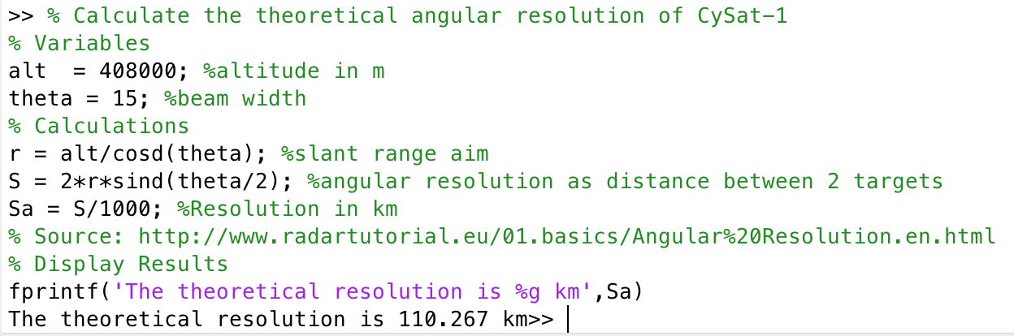

(4) Swath width of each sensor (typically at nadir); 25 mi

The swath width will be about 109.323 km given the altitude of the ISS (CySat

1’s launch point) and a beam width of 15 degrees.

(5) The various fields of view for each sensor (IFOV, in-track, cross-track);

The sensors will have an In-Track field of view.

(6) On-board storage capacity;

There will be a 4 gigabyte storage capacity on the satellite.

(7) Navigation capabilities--GPS, star tracker accuracies;

No GPS within the ADCS system, Attitude determination accuracy: <0.6°

(8) Time-delayed integration with focal plane;

The integration time will be about 5 seconds.

(9) Oversampling capability;

There will be no oversampling capability on this satellite

(10) Image motion parameters--linear motion, drift; aggregation modes;

There will be a linear motion of about 40 km over the integration time of 5 seconds. Also, any drift that occurs during imaging will happen due to the inaccuracy of the attitude control and determination system. The satellite may roll a maximum of 1 degree, drifting the image a distance of 7.122 km on the Earth’s surface.

(11) Anticipated system lifetime.

This satellite is serving as a proof of concept, and our team expects the satellite to prove that the concept is viable within 3 months. The goal is for the system to live for 1 year, but a more realistic expectation per an IEEE report on CubeSat reliability is about 3 months, perfect for our concept of design. According to this report, nano-satellite reliability falls to around 70% at 120 days after a perfect launch.

**Sec. IV Ground Segment**

(1) The system data collection and processing capabilities proposed including but not limited to: Tasking procedures; scheduling plans; data format (downlinked and distributed data); timeliness of delivery; ground segment information regarding the location of proposed operations centers and stations, and tasking, telemetry and control; data distribution and archiving plans;

The system will transmit back ASCII strings for general status updates and the raw data from the payload. Data archiving will be done in a SQL server.

1. The command (uplink and downlink) and mission data (downlink) transmission frequencies and system transmission (uplink and downlink) footprint, the downlink data rate, any plans for communications crosslinks;

Downlink data rate is 9600 bps. Transmission footprint is whatever the circle around Howe hall is that allows us to communicate with the satellite.

1. The plans for protection of uplink, downlink and any data links;

 In case of ground station failure, we can easily fix the issue. In case of antenna failure on CySat, we can possibly use the SDR as a backup antenna.

1. The methods applicant will use to ensure the integrity of its operations, including plans for: Positive control of the remote sensing space system and relevant operations centers and stations; denial of unauthorized access to data transmissions to or from the remote sensing space system; and restriction of collection and/or distribution of unenhanced data from specific areas at the request of the U.S. Government.

System Integrity: Sensitive operations will be time stamped and then ciphered with a HMAC to insure integrity. Sensitive operations will be defined as anything that transmits data (data is deleted off the system after transmission) or modifies the settings of the satellite.

**Sec. V Other Information**

A. The applicant's plans for providing access to or distributing the unenhanced data generated by the system including:

(1) A description of the plan for the sale and distribution of such data; The data will not be sold and will be accessible as it will be shared with NASA due to the CRADA contact

The data will not be sold. It is being used for educational purposes within Iowa State University’s Aerospace Engineering department.

(2) The method for making the data available to governments whose territories have been sensed; As the Data will be available for NASA and because of that it will be public domain.

(3) A description of the plans for making data requested and purchased by the Department of the Interior available to the National Satellite Land Remote Sensing Data Archive for inclusion in the basic data set; and

(4) The licensee's plans to make the data available for non-commercial scientific, educational, or other public benefit purposes, such as the study of the changing global environment.

B. If the applicant is proposing to follow a commercial data distribution and pricing policy as provided for by Sec. 960.12, the application shall include the following additional financial information: N/A as the data will not be sold as it will be public domain.

(1) The extent of the private investment in the system;

(2) The extent of any direct funding or other direct assistance which the applicant or its affiliates or subsidiaries have received or anticipate receiving from any agency of the U.S. Government for the development, fabrication, launch, or operation of the system including direct financial support, loan guarantees, or the use of U.S. Government equipment or services;

(3) Any existing or anticipated contract(s) between the applicant, affiliate, or subsidiary and U.S. Government agencies for the purchase of data, information, or services from the proposed system;

(4) Any other relationship between the applicant, affiliate, or subsidiary and the U.S. Government which has supported the development, fabrication, launch, or operation of the system; and

(5) Any plans to provide preferred or exclusive access to the unenhanced data to any particular user or class of users.

C. The applicant will submit a plan for post-mission disposition of any remote-sensing satellites owned or operated by the applicant. If the satellite disposition involves an atmospheric re-entry the applicant must provide an estimate of the total debris casualty area of the system's components and structure likely to survive re-entry.

The structure will burn up in the atmosphere all materials have a low enough melting point. The steel screws while they have a higher melting point are small enough that they will be able to burn up and therefore there should be no remnants when CySat-1 does re-enter the atmosphere.