# Overview

What if you could automatically copy the settings from a “master” QlikView object to all other objects in the same QlikView application, or another application, or a whole lot of other QlikView applications…

… You can …

This application currently supports copying the Active and Inactive foreground and background color settings (the title bar coloring of a QlikView control), the Caption (and control) Fonts, the ColorMap settings of Charts, and copying the Wallpaper image (base64 data) from one app to another.

Before operating on a project’s files, the –prj folder contents are backed up in a zip file in case anything goes awry during the operation.

# Preparation: -prj Folder Creation

In order for this to work, you must have enabled “-prj” folders for your QlikView development environment.

Skip this section if you already have established –prj folders in your environment.

If you want more information on what the –prj folder contains, see this: <https://help.qlik.com/en-US/qlikview/November2017/Subsystems/Client/Content/QlikView_Project_Files.htm>

1. Create a folder named the same way as QlikView application with -prj as suffix, in the same folder as the QlikView application (the .qvw file). For example if the application file is named MyApplication.qvw the project folder would be named MyApplication-prj.
2. Open the QlikView application that you want to export to the -prj folder.
3. Press Save (or Ctrl+S) to trigger the export of the application content to the -prj folder.
4. Open the -prj folder in a file explorer window to confirm the content has been exported. The folder should contain XML and TXT files corresponding to the objects and properties in the QlikView application.

Repeat these steps for every QlikView project you are developing.

Here is an example of two QlikView Applications and their matching –prj folders from my development system:

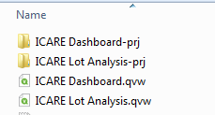

Figure 1 - -prj Folders

# Preparation: Selecting Your Master Object

The QVPrjManager app works by copying settings from one QlikView object to other objects in the –prj folder or objects in other –prj folders. In order to do this you must select one object to be the “master” object.

Open QlikView, make all necessary changes to an object that you want to copy to other objects and then save the QlikView application. For instance, you may have changed the Active and Inactive color settings, or the Caption font. Once you have selected your object, make note of the object ID, which is found on the General properties page of the object. The object ID becomes the name of the XML file in the –prj folder, for example, a Chart with an ID of “CH04” will have its settings stored in the –prj folder in “CH04.xml”.

Now you are ready!

# Operation: Running the QVPrjManager

Starting QVPrjManager… - if it doesn’t start, install Microsoft .NET runtime version 4.5.2 (or higher) from here: <https://www.microsoft.com/en-us/download/details.aspx?id=42643>

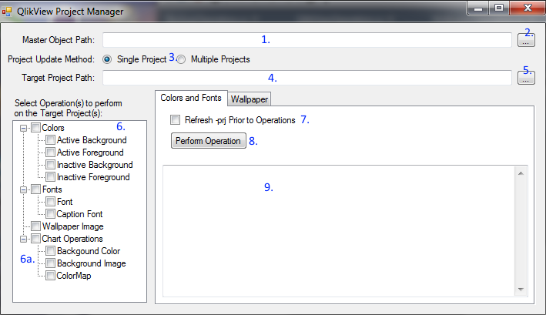

Figure 2 - QVPrjManager at Start with decorations.

1. Click the button (#2 from image) to select your master object .xml file. Your selection will be loaded into the textbox (#1).
2. For now, leave “Single Project” selected (#3).
3. Choose your Target Project Path by clicking the #5 button and selecting the “.qvw” file you want to update. The filename will be loaded into the textbox #4.
4. Choose one or more Operations (#6) by clicking the appropriate check boxes in the treeview.
   1. Chart Operations (#6a) will only be visible when the Master Object is a QlikView Chart object.
5. If you would like to force the –prj folder to be refreshed before performing operation(s) selected in #6, then check the “Refresh –prj Prior to Operations” box (#7).
6. Click the “Perform Operation” button (#8) and watch the textbox (#9) fill up with the progress as the operations are performed. When finished, you will see an “Operations Complete!” notification window.

# Example: ColorMap Copy

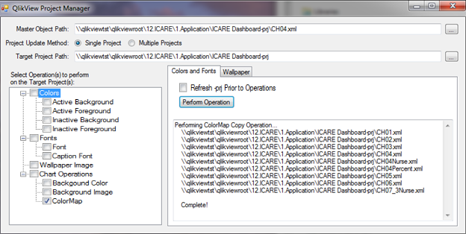

Figure 3 - ColorMap Copy

Note that only Chart and Sheet objects are affected by the ColorMap operation.

You will be asked if you would like to update the ColorMap of Sheet objects before Operation starts.

# Example: Caption Font Copy

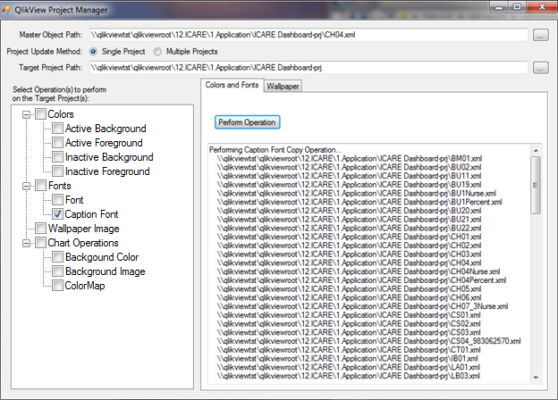

Figure 4 - Caption Font Copy

Note how all objects in the application are affected.

# Notes

1. ColorMap only operates on Chart objects.
2. Wallpaper Image only operates on a different Target Project – it makes no sense to copy the Wallpaper Image from and to the same project.
3. Wallpaper Image affects only TopLayout.xml.
4. If you want to change the Wallpaper in the master project, click the “Wallpaper” tab and use the buttons there which will update the Wallpaper in the TopLayout.xml file located in the project pointed to by your Master Object Path.
5. Remember to start QlikView, load the application QVW in order to see your changes.