Campus Facility Reservation System (IT401W). Results of the supplementary boundary-value tests for the Database and Backend Testing role. Simultaneous booking and approval testing is recorded in Database_Backend_Testing_Results (TS_005), which takes precedence and is not repeated here.

Item 7: Run the supplementary boundary-value tests (BV-01 to BV-09):
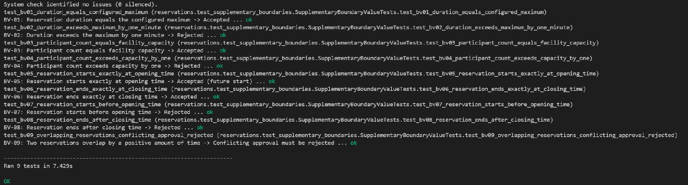
Command: python manage.py test reservations.test_supplementary_boundaries -v 2. Ran 9 tests in 7.429s: OK.

1. Test environment
Item | Details
Project | IT401W Campus Facility Reservation (Django web application)
Role | Database and Backend Testing
Test date | October 23, 2026
Branch and commit tested | Documents/jacinto commit: 65fff5
Software | Django 6.1.1, SQLite, Windows and PyCharm (as in the main results document)
Test database | A fresh in-memory SQLite database (shared-cache mode) is created for every run and deleted afterwards. The local db.sqlite3 file is not touched.
Test files | reservations/test_supplementary_boundaries.py (9 tests)
How tests were run | python manage.py test reservations.test_supplementary_boundaries -v 2

2. Summary
Scenario | Name | Test cases | Executed | Passed | Failed | Not run or pending
TS_008 | Boundary values: duration, capacity, operating hours and overlapping bookings | 9 | 9 | 9 | 0 | 0
Total |  | 9 | 9 | 9 | 0 | 0
All 9 boundary-value test cases passed. One small clean-up item was noticed (F-07). Simultaneous bookings and approvals are covered in Database_Backend_Testing_Results (TS_005).

3. Test scenarios

TS_008: Boundary values for duration, capacity, operating hours and overlapping bookings
Evidence: screenshot under Item 7 (Ran 9 tests in 7.429s: OK). A re-run of the same file on a clean copy of the repository (Python 3.12, Django 6.1.1) also passed: Ran 9 tests in 11.718s: OK.
Common set-up: facility with capacity 60, open 08:00 to 17:00; maximum booking length 4 hours; advance-booking window 30 days; event date 7 days ahead; times in Asia/Manila. Cases BV-01 to BV-08 check the model validation (full_clean) only. BV-09 also checks the approval service.
TC ID | Test Case Description | Steps / Pre-condition | Expected Result | Actual Result | Status | Automated Test
TC_113 | BV-01: Duration equal to the configured maximum is accepted | 1. Read the maximum duration (4 hours).  2. Build a pending booking 09:00 to 13:00.  3. Run full_clean() and save(). | Validation passes and the booking is saved as Pending with a length of exactly 4 hours. | Validated and saved. Length was 4 hours, status Pending. | PASSED | test_bv01_duration_equals_configured_maximum
TC_114 | BV-02: Duration one minute over the maximum is rejected | 1. Build a pending booking 09:00 to 13:01.  2. Run full_clean(). | ValidationError on end_time: "Maximum reservation duration is 4 hours." Nothing is saved. | ValidationError raised on end_time with that message. Nothing saved. | PASSED | test_bv02_duration_exceeds_maximum_by_one_minute
TC_115 | BV-03: Participant count equal to the capacity is accepted | 1. Facility capacity is 60.  2. Build a pending booking 09:00 to 11:00 with 60 participants.  3. Run full_clean() and save(). | Validation passes and the booking is saved with 60 participants. | Validated and saved with 60 participants. | PASSED | test_bv03_participant_count_equals_facility_capacity
TC_116 | BV-04: Participant count one over the capacity is rejected | 1. Build a pending booking 09:00 to 11:00 with 61 participants.  2. Run full_clean(). | ValidationError on participant_count: "Maximum facility capacity is 60." Nothing is saved. | ValidationError raised on participant_count with that message. Nothing saved. | PASSED | test_bv04_participant_count_exceeds_capacity_by_one
TC_117 | BV-05: Booking that starts exactly at opening time is accepted | 1. Opening time is 08:00.  2. Build a pending booking 08:00 to 10:00 on a future date.  3. Run full_clean() and save(). | Validation passes. The saved start time is 08:00 local and in the future. | Validated and saved. Start was 08:00 Manila time, in the future, status Pending. | PASSED | test_bv05_reservation_starts_exactly_at_opening_time
TC_118 | BV-06: Booking that ends exactly at closing time is accepted | 1. Closing time is 17:00.  2. Build a pending booking 15:00 to 17:00.  3. Run full_clean() and save(). | Validation passes. The saved end time is 17:00 local. | Validated and saved. End was 17:00 Manila time, status Pending. | PASSED | test_bv06_reservation_ends_exactly_at_closing_time
TC_119 | BV-07: Booking that starts one minute before opening is rejected | 1. Build a pending booking 07:59 to 09:59.  2. Run full_clean(). | ValidationError on start_time mentioning operating hours. Nothing is saved. | ValidationError raised on start_time with the operating-hours message. Nothing saved. | PASSED | test_bv07_reservation_starts_before_opening_time
TC_120 | BV-08: Booking that ends one minute after closing is rejected | 1. Build a pending booking 15:01 to 17:01.  2. Run full_clean(). | ValidationError mentioning operating hours. Nothing is saved. | ValidationError raised with the operating-hours message. It is reported on start_time, not end_time. Nothing saved. | PASSED | test_bv08_reservation_ends_after_closing_time
TC_121 | BV-09: Approval of a booking that overlaps an approved one by one minute is rejected | 1. Approved booking 09:00 to 10:00 exists.  2. Create a pending booking 09:59 to 10:59 for another user.  3. Set it to approved and run full_clean().  4. Approve it through update_reservation as an admin. | Both attempts raise a ValidationError: "This facility already has an approved reservation during the selected time." The booking stays Pending. | Both attempts raised the conflict error on start_time. The booking stayed Pending. | PASSED | test_bv09_overlapping_reservations_conflicting_approval_rejected

4. Findings
The following issue was noticed.
ID | Finding | Where | How it was confirmed | Severity | Required change
F-07 | Small clean-up item: the last check in BV-09 uses any(... for _ in [1]), which is a plain "in" check written in a roundabout way. | test_supplementary_boundaries.py | Found by reading the code. | Low | Replace the last BV-09 check with assertIn.

5. Not tested
Boundary values are now covered by this document. Simultaneous bookings and approvals are covered in Database_Backend_Testing_Results (TS_005). The following is still not covered:
- Browser behavior: buttons, page layout and JavaScript. This is covered by manual tests in Browser_Behavior_Test_Results.
- Simultaneous rescheduling, or more than two competing approvals.
- Concurrency against PostgreSQL. File-based SQLite is covered in Database_Backend_Testing_Results.
- Boundaries for the advance-booking window (exactly 30 days and 31 days), a booking that crosses midnight, a participant count of 0 and 1, and bookings that touch a closure exactly at its start or end.
- Adjacent bookings that share an endpoint are not part of this document. They are covered by the booking-conflicts tests in Database_Backend_Testing_Results (TC_012).
- Boundary cases through the reservation form and the admin view. The tests call the model and the service only.

6. Behaviors to confirm with the team
These tests confirm what the code does today. The team should confirm that these are the intended rules:
- A booking that ends after closing time is reported against the start time field, with the same message as a booking that starts before opening time (BV-08).

