Database and Backend Testing: Test Results

Campus Facility Reservation System (IT401W). Results of the checklist items for the Database and Backend Testing role.

Item 1: Run python manage.py check and python manage.py test:

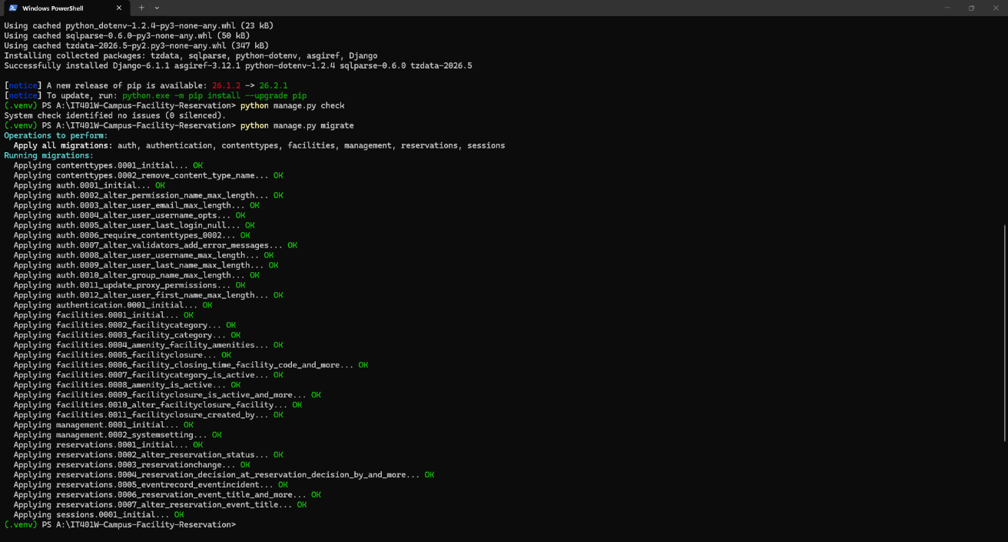
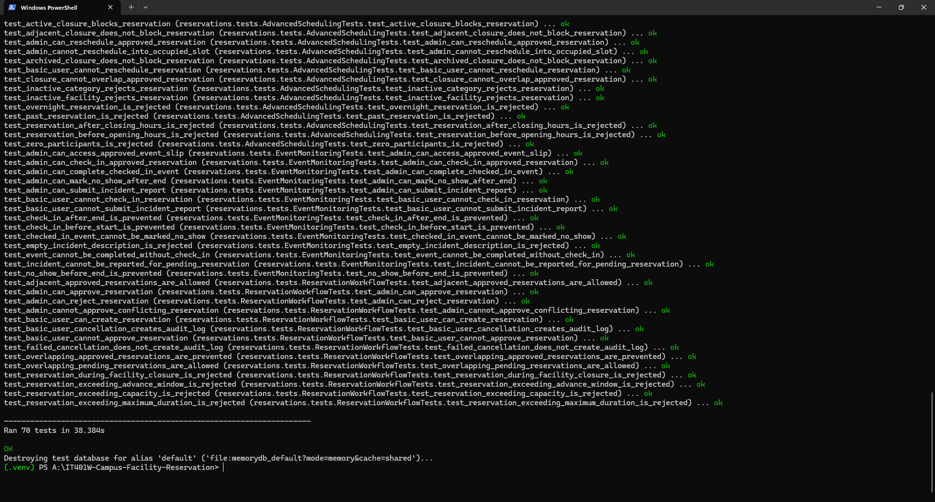

Item 2: Run and verify seed_demo on a fresh local database:
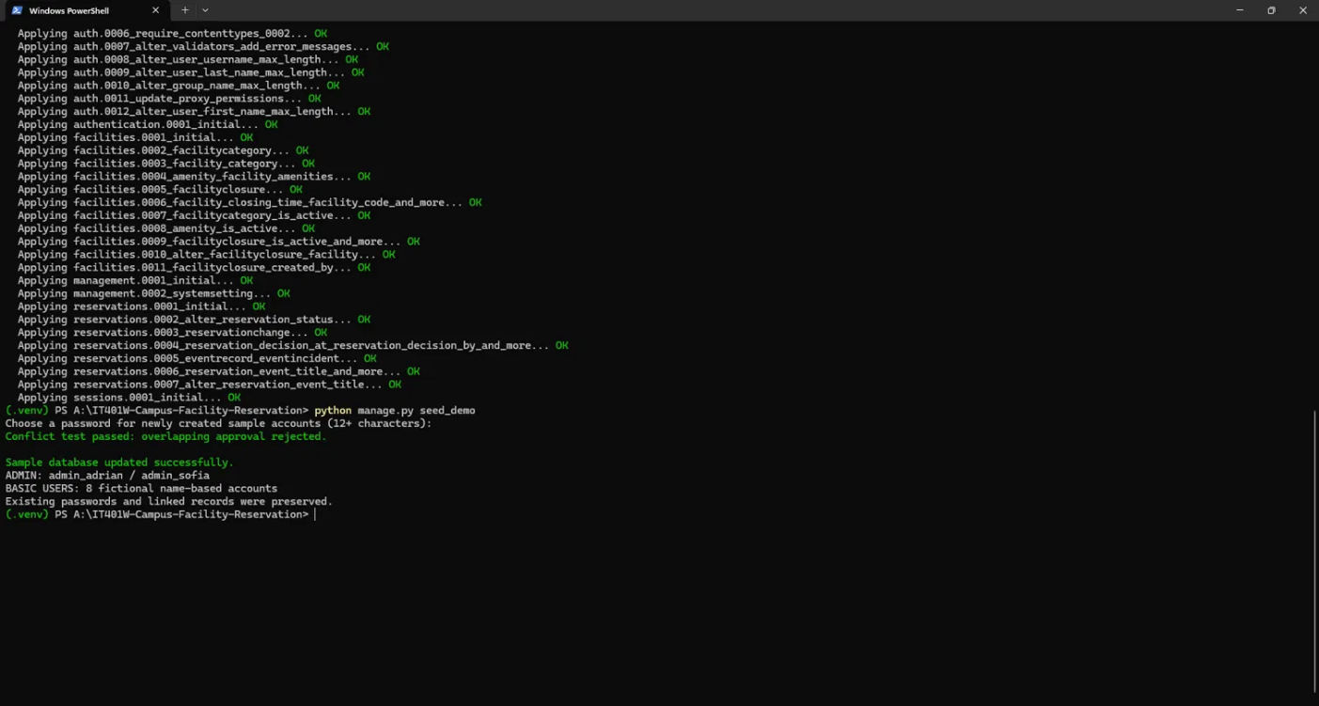

item 3: Test booking conflicts, adjacent schedules, and cancellations:
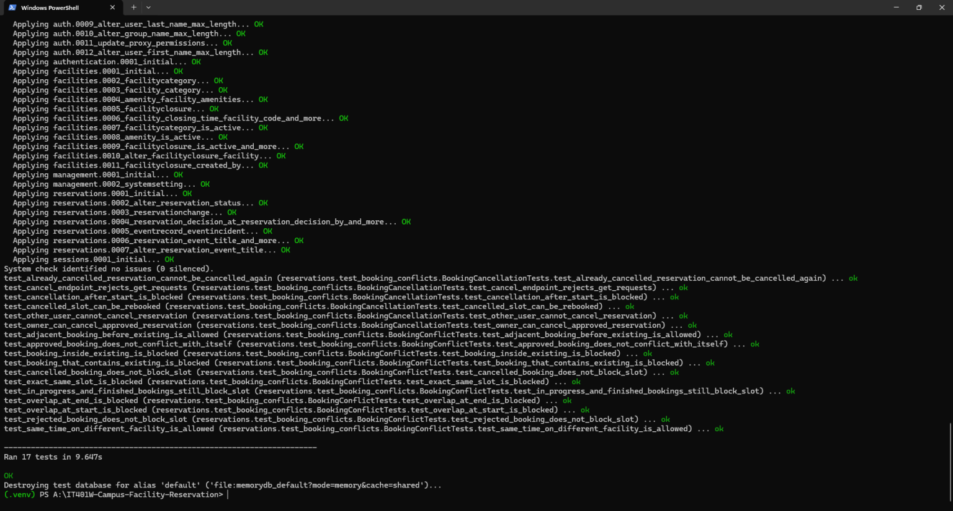

item 4: Test approvals, rejections, rescheduling, and closures:
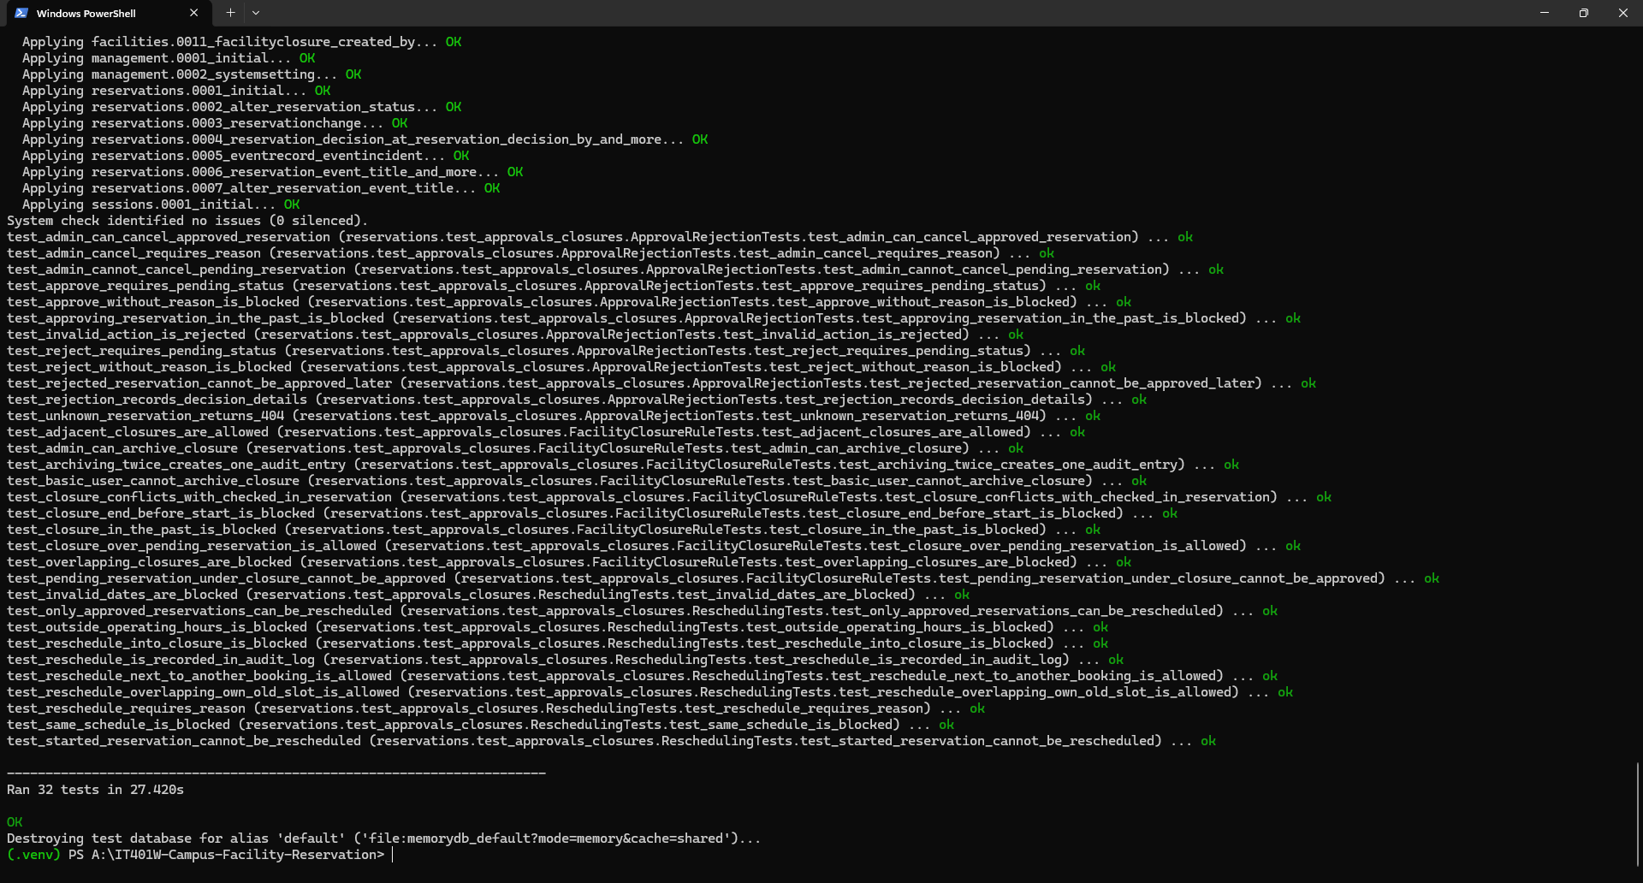

item 5: Test event check-in, completion, no-show, and audit records:
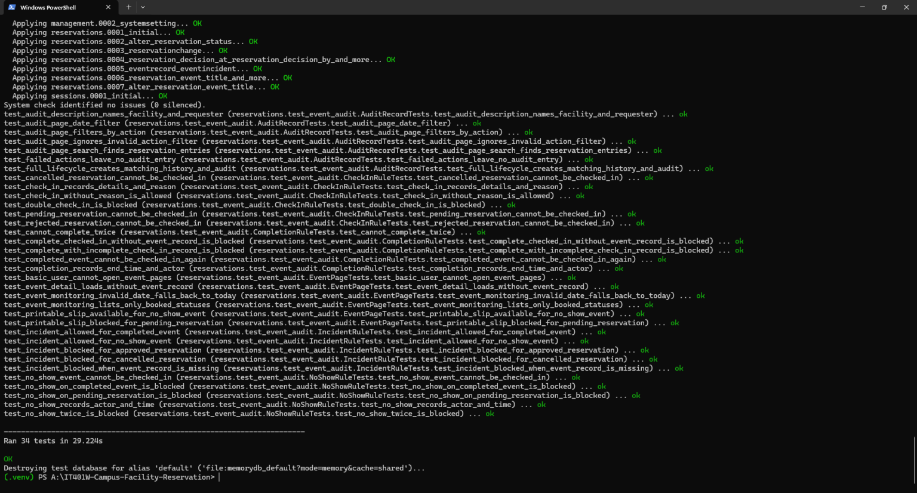

item 6: Add missing regression tests and record actual Pass/Fail results:
PR Link: https://github.com/M31ZY00/IT401W-Campus-Facility-Reservation/pull/6

153 test run

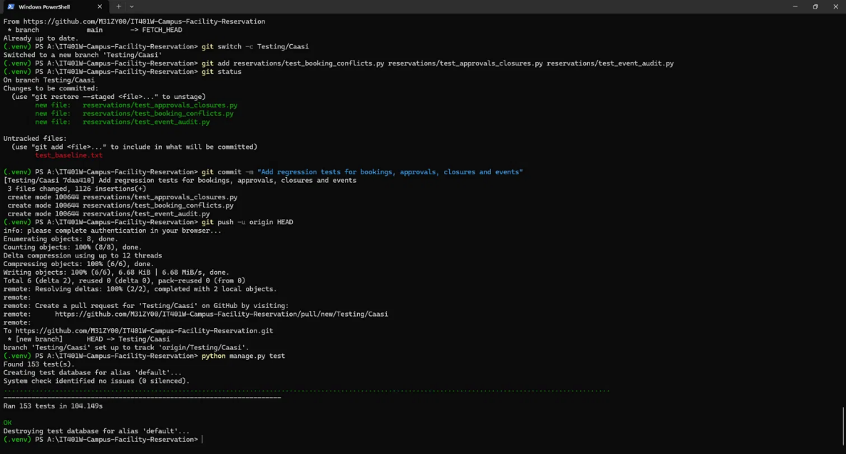

repeat seed_demo check
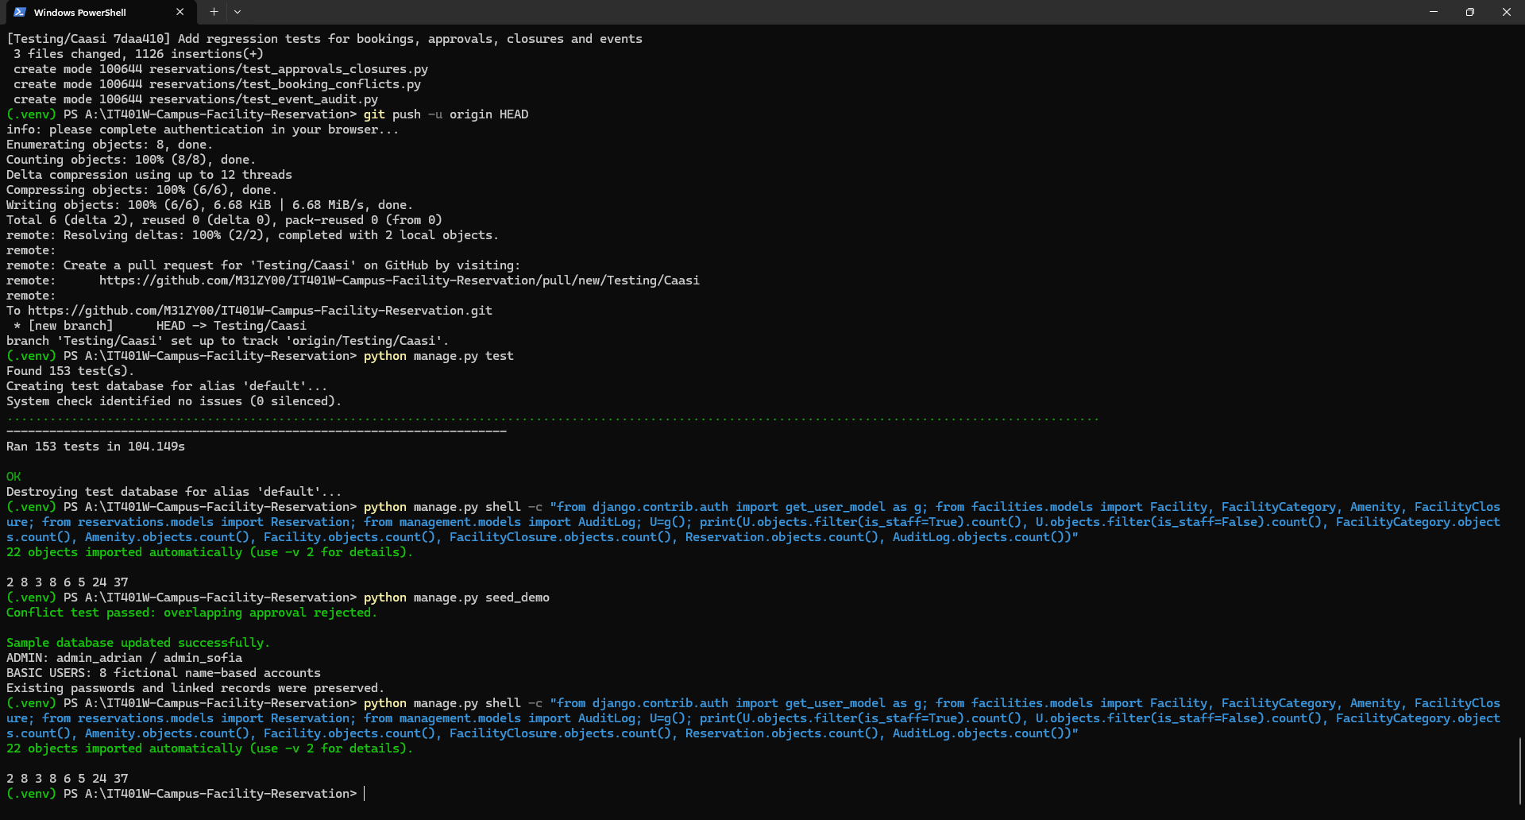

Update: simultaneous bookings and database lock testing:

Latest main pulled (fast-forward to dbc342b), then check and migrate
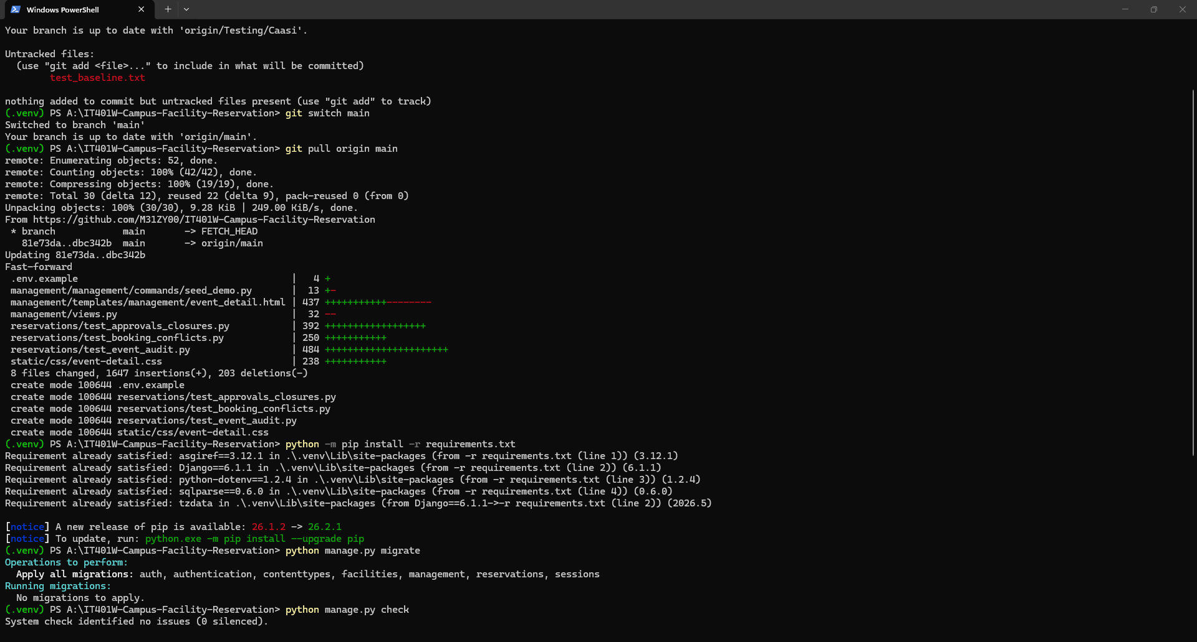

Simultaneous approvals and bookings (4 tests)
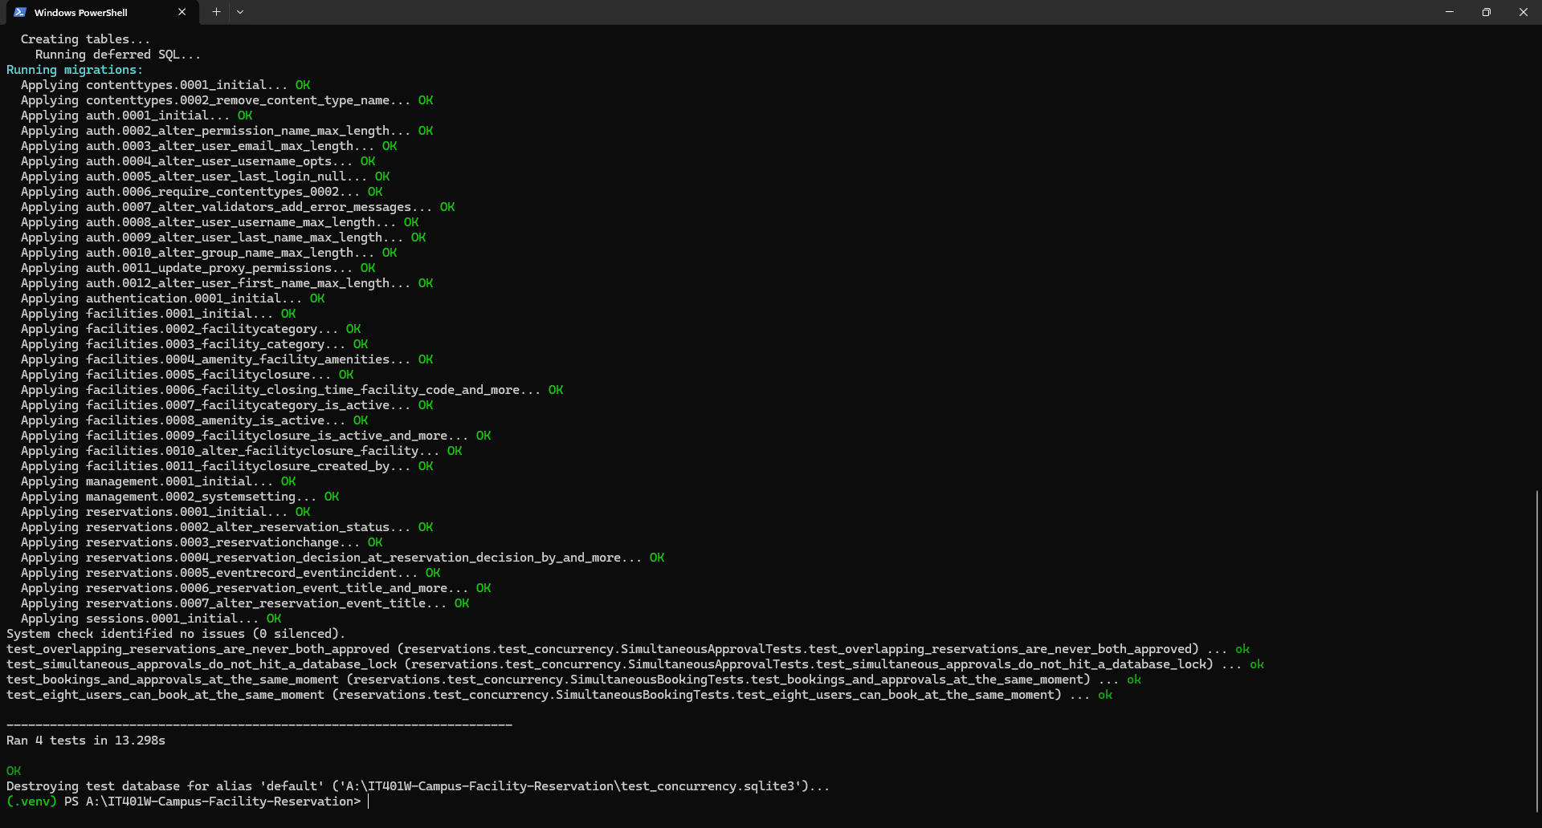

Thirty users booking at the same moment
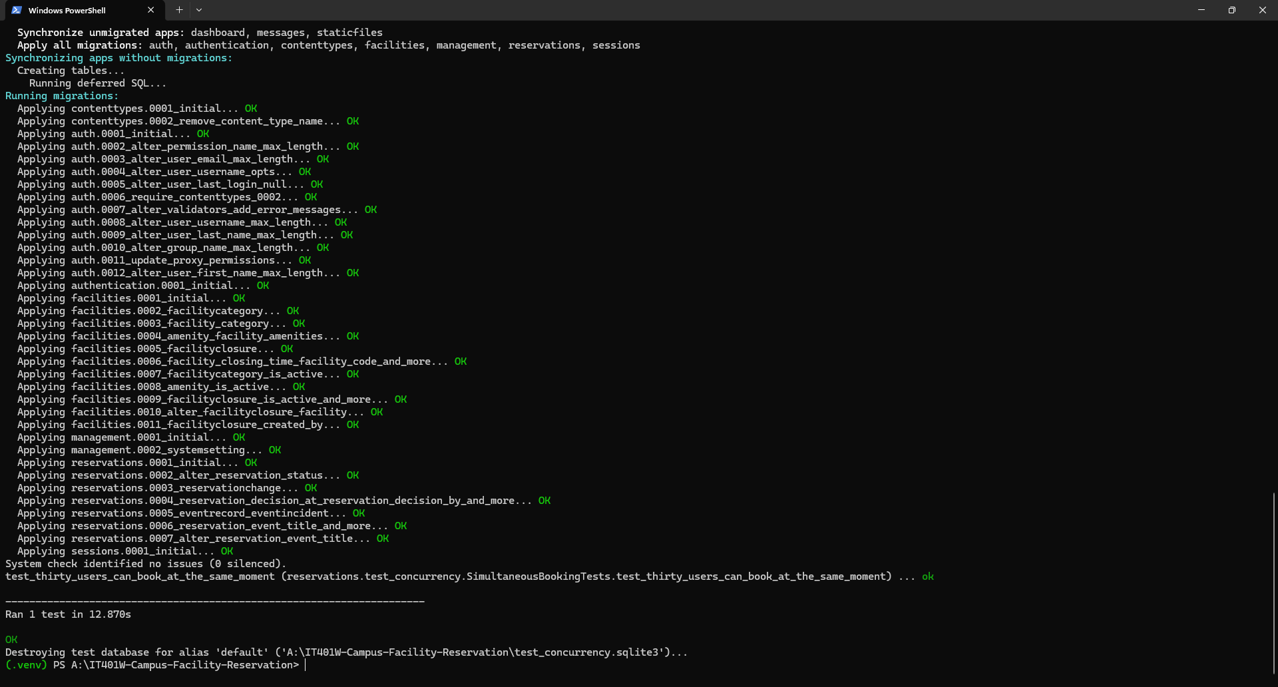

Booking and approval while the database is locked (2 tests)
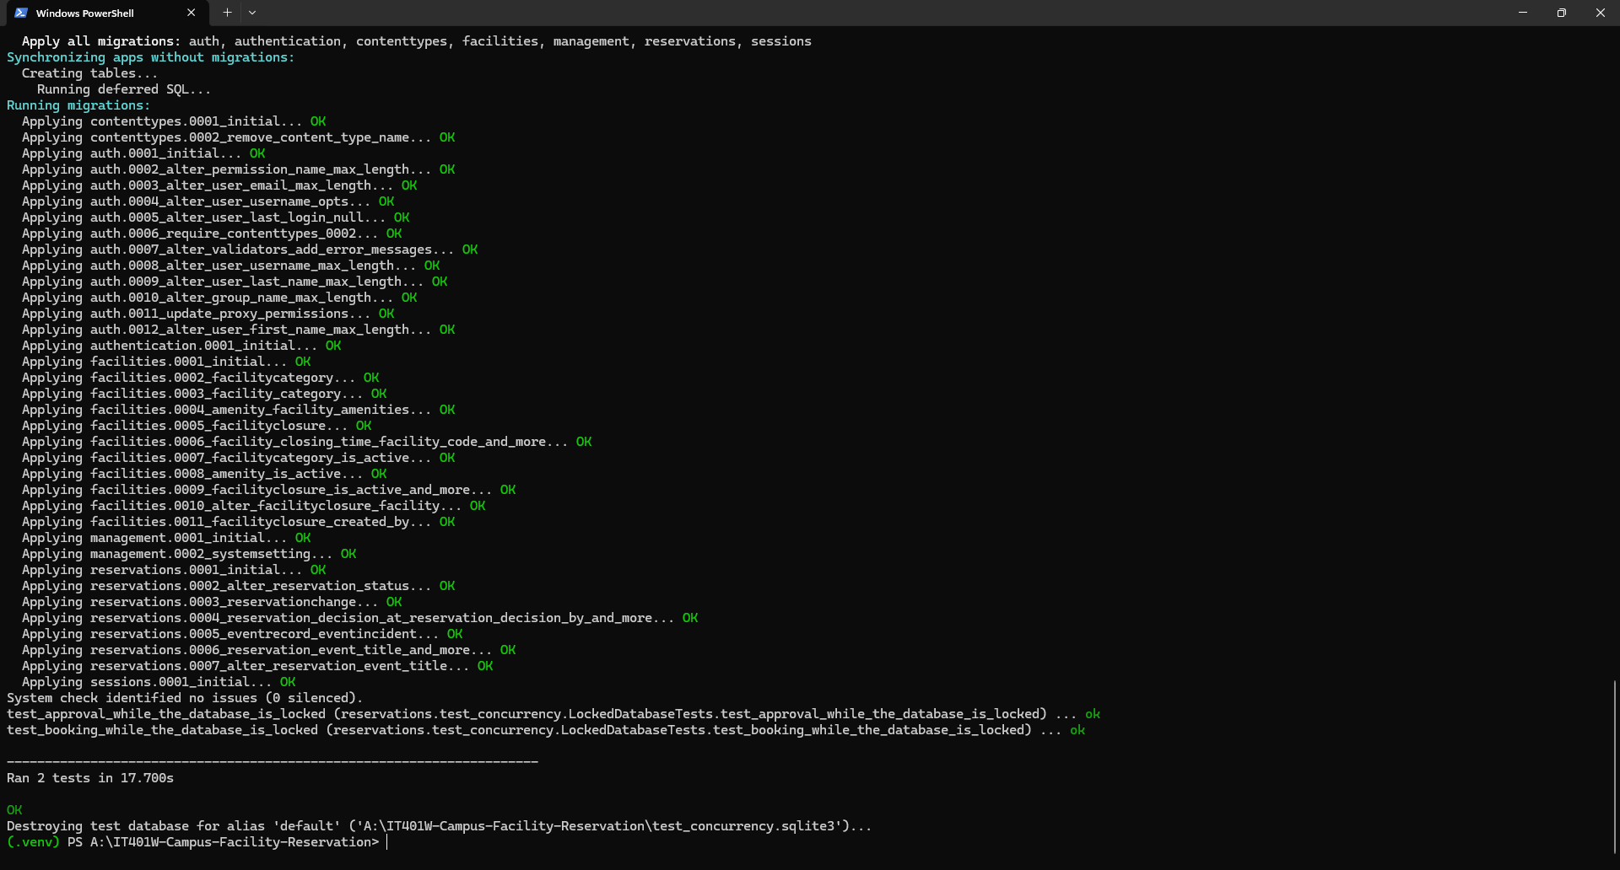

Full test run on the updated main (160 tests, 7 skipped)
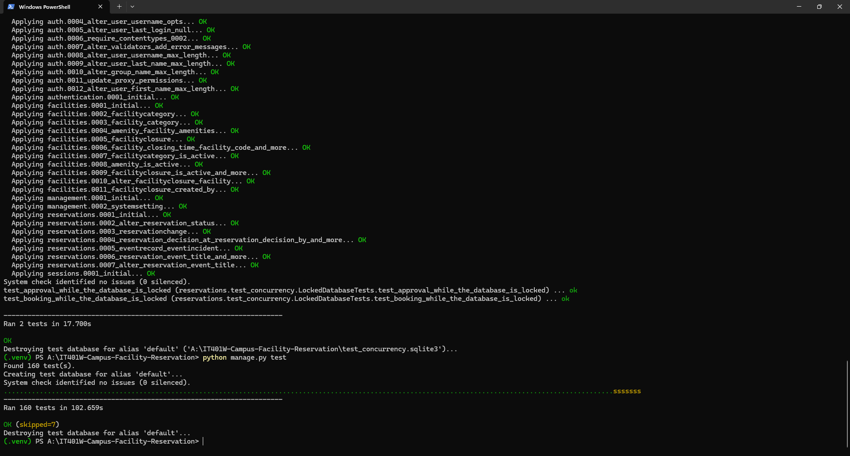

After the F-06 fix: concurrency tests (7) and the full test run (161 tests, 7 skipped)
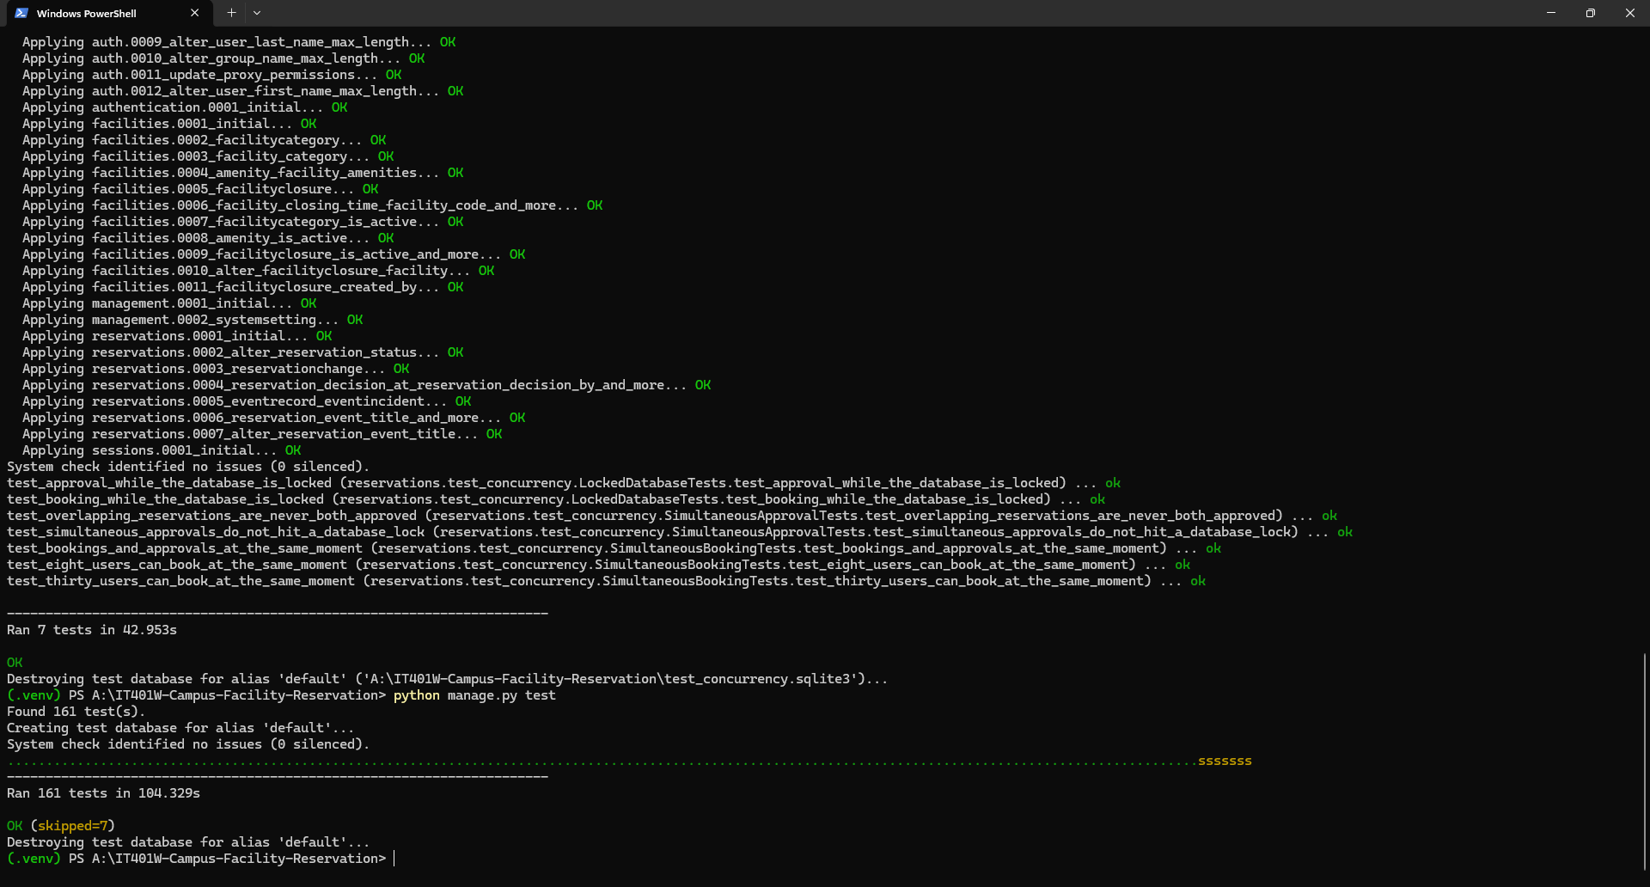

1. Test environment
Item | Details
Project | IT401W Campus Facility Reservation (Django web application)
Role | Database and Backend Testing
Test date | October 19, 2026
Branch and commit tested | Testing/Caasi, commit 7daa410 (pull request #6). Based on the latest main, which was up to date when the branch was created.
Software | Django 6.1.1, Python 3.14, SQLite, Windows PowerShell and PyCharm
Test database | A fresh in-memory database is created for every test run and deleted afterwards. The local db.sqlite3 file is not touched by the tests.
How tests were run | python manage.py test -v 2 (all tests) and python manage.py test <module> -v 2 (one file at a time)
How the concurrency tests were run | python manage.py test reservations.test_concurrency --settings=config.settings_concurrency --noinput -v 2. They use a separate settings file so that the tests run on a temporary SQLite file, and they skip themselves in a normal run. Branch Testing/Caasi-concurrency, based on main at commit dbc342b.
Branch for the F-06 fix | fix/create-reservation-database-error, based on main at commit b83d758 (which includes the merged concurrency tests).

2. Summary
Scenario | Name | Test cases | Executed | Passed | Failed | Not run or pending
TS_001 | Environment, migrations, seed_demo and baseline checks | 6 | 6 | 6 | 0 | 0
TS_002 | Booking conflicts, adjacent schedules and cancellations | 17 | 17 | 17 | 0 | 0
TS_003 | Approvals, rejections, rescheduling and closures | 32 | 32 | 32 | 0 | 0
TS_004 | Event check-in, completion, no-show and audit records | 34 | 34 | 34 | 0 | 0
TS_005 | Simultaneous bookings and approvals, and database lock behavior | 8 | 8 | 8 | 0 | 0
TS_006 | Re-run on the team's latest main | 2 | 2 | 2 | 0 | 0
Total |  | 99 | 99 | 99 | 0 | 0
All 99 test cases passed. TC_095 failed in the first run (a booking made while the database was locked crashed) and passed after the fix for F-06 (see TC_095 and F-06).

3. Test scenarios

TS_001: Environment, migrations, seed_demo and baseline checks
Evidence: screenshots under Item 1 and Item 2 of the document.
TC ID | Test Case Description | Steps / Pre-condition | Expected Result | Actual Result | Status | Automated Test
TC_001 | Django system check passes | 1. Activate the virtual environment.  2. Run python manage.py check. | No issues reported. | System check identified no issues (0 silenced). | PASSED | manage.py check
TC_002 | Database migrations apply on a fresh database | 1. Start with no existing database.  2. Run python manage.py migrate. | Every migration applies without errors. | All migrations, from contenttypes.0001 to sessions.0001, applied with OK. | PASSED | manage.py migrate
TC_003 | seed_demo runs on a fresh database | 1. Run python manage.py seed_demo on the new database.  2. Enter a demo password of at least 12 characters. | Sample data is created, the built-in conflict check passes and a success message is shown. | Conflict test passed: overlapping approval rejected. Sample database updated successfully. No errors. | PASSED | manage.py seed_demo
TC_004 | seed_demo does not duplicate data when run again | 1. Run python manage.py seed_demo a second time.  2. Compare record counts with the first run. | No password prompt, no errors and unchanged record counts. | Second run asked for no password and ended with both success lines. Counts after the first and second run were identical: 2 admins, 8 basic users, 3 categories, 8 amenities, 6 facilities, 5 closures, 24 reservations, 37 audit entries. | PASSED | manage.py seed_demo
TC_005 | Existing automated tests pass (baseline) | 1. Run python manage.py test -v 2 before adding any new tests. | All 70 existing tests pass. | Ran 70 tests in 38.384s: OK. An earlier run took 38.702s and also passed. | PASSED | python manage.py test
TC_006 | All tests pass together with the new regression tests | 1. On branch Testing/Caasi, run python manage.py test. | All 153 tests pass (70 existing plus 83 new). | Ran 153 tests in 104.149s: OK. | PASSED | python manage.py test

Baseline: the 70 existing tests (TC_005)
Test group | File | Tests | Result
Accounts and login | authentication/tests.py | 7 | Passed
Required field validation | facilities/tests.py | 8 | Passed
Admin access | management/tests.py | 3 | Passed
Closure preview and save | management/tests.py | 7 | Passed
System settings | management/tests.py | 3 | Passed
Advanced scheduling | reservations/tests.py | 14 | Passed
Event monitoring | reservations/tests.py | 14 | Passed
Reservation workflow | reservations/tests.py | 14 | Passed
Total |  | 70 | All passed

TS_002: Booking conflicts, adjacent schedules and cancellations
Evidence: screenshot under Item 3 of the document. Run: python manage.py test reservations.test_booking_conflicts -v 2 (Ran 17 tests in 9.647s: OK).
TC ID | Test Case Description | Steps / Pre-condition | Expected Result | Actual Result | Status | Automated Test
TC_007 | Exact same slot as an approved booking is blocked | 1. Approved booking exists 09:00 to 11:00.  2. Validate a new booking for 09:00 to 11:00 on the same facility. | Validation error: the facility already has an approved reservation. | Conflict error raised and the booking was refused. | PASSED | test_exact_same_slot_is_blocked
TC_008 | Booking that overlaps the start of an approved booking is blocked | 1. Approved booking 09:00 to 11:00.  2. Validate a new booking 08:00 to 10:00. | Validation error for the conflict. | Conflict error raised. | PASSED | test_overlap_at_start_is_blocked
TC_009 | Booking that overlaps the end of an approved booking is blocked | 1. Approved booking 09:00 to 11:00.  2. Validate a new booking 10:00 to 12:00. | Validation error for the conflict. | Conflict error raised. | PASSED | test_overlap_at_end_is_blocked
TC_010 | Booking that contains an approved booking is blocked | 1. Approved booking 10:00 to 11:00.  2. Validate a new booking 09:00 to 12:00. | Validation error for the conflict. | Conflict error raised. | PASSED | test_booking_that_contains_existing_is_blocked
TC_011 | Booking inside an approved booking is blocked | 1. Approved booking 09:00 to 12:00.  2. Validate a new booking 10:00 to 11:00. | Validation error for the conflict. | Conflict error raised. | PASSED | test_booking_inside_existing_is_blocked
TC_012 | Back-to-back (adjacent) booking is allowed | 1. Approved booking 11:00 to 13:00.  2. Validate a new booking 09:00 to 11:00 on the same facility. | No conflict: one booking ends exactly when the other starts. | Validation passed with no error. | PASSED | test_adjacent_booking_before_existing_is_allowed
TC_013 | Same time on a different facility is allowed | 1. Approved booking 09:00 to 11:00 in Room 1.  2. Validate a booking 09:00 to 11:00 in Room 2. | No conflict between different facilities. | Validation passed with no error. | PASSED | test_same_time_on_different_facility_is_allowed
TC_014 | Rejected booking does not block the slot | 1. Rejected booking 09:00 to 11:00.  2. Validate a new booking 09:00 to 11:00. | No conflict. | Validation passed with no error. | PASSED | test_rejected_booking_does_not_block_slot
TC_015 | Cancelled booking does not block the slot | 1. Cancelled booking 09:00 to 11:00.  2. Validate a new booking 09:00 to 11:00. | No conflict. | Validation passed with no error. | PASSED | test_cancelled_booking_does_not_block_slot
TC_016 | Checked-in, completed and no-show bookings still block the slot | 1. For each status (checked in, completed, no-show), create a booking 09:00 to 11:00.  2. Validate a new booking 10:00 to 12:00. | Validation error for each status. | Conflict error raised for all three statuses. | PASSED | test_in_progress_and_finished_bookings_still_block_slot
TC_017 | An approved booking does not conflict with itself | 1. Only one approved booking exists, 09:00 to 11:00.  2. Validate that same booking. | No conflict. | Validation passed with no error. | PASSED | test_approved_booking_does_not_conflict_with_itself
TC_018 | Owner can cancel an approved reservation | 1. Log in as the booking owner.  2. Send the cancel request for an approved booking. | Status becomes cancelled. A history record and a CANCEL audit entry are saved. | Status changed to cancelled. History record and audit entry were created. | PASSED | test_owner_can_cancel_approved_reservation
TC_019 | A cancelled slot can be booked again | 1. Owner cancels an approved booking 09:00 to 11:00.  2. Another user validates a booking for 09:00 to 11:00. | The new booking is allowed. | Validation passed with no error. | PASSED | test_cancelled_slot_can_be_rebooked
TC_020 | Cancellation after the booking has started is blocked | 1. Approved booking that started 30 minutes ago.  2. Owner sends the cancel request. | Status stays approved. No audit entry is created. | Status stayed approved. No audit entry. | PASSED | test_cancellation_after_start_is_blocked
TC_021 | Another user cannot cancel someone else's reservation | 1. Log in as a different user.  2. Send the cancel request for the owner's booking. | Page not found (404). Status unchanged. | Received 404. Status stayed approved. | PASSED | test_other_user_cannot_cancel_reservation
TC_022 | An already cancelled reservation cannot be cancelled again | 1. Cancelled booking exists.  2. Owner sends the cancel request. | No new history record and no new audit entry. | No history record or audit entry was created. | PASSED | test_already_cancelled_reservation_cannot_be_cancelled_again
TC_023 | Cancel request using GET is refused | 1. Log in as the owner.  2. Open the cancel address with a GET request. | Method not allowed (405). Status unchanged. | Received 405. Status stayed approved. | PASSED | test_cancel_endpoint_rejects_get_requests

TS_003: Approvals, rejections, rescheduling and closures
Evidence: screenshot under Item 4 of the document. Run: python manage.py test reservations.test_approvals_closures -v 2 (Ran 32 tests in 27.420s: OK).
TC ID | Test Case Description | Steps / Pre-condition | Expected Result | Actual Result | Status | Automated Test
TC_024 | Approve without a reason is blocked | 1. Pending booking.  2. Admin sends approve with an empty reason. | Not approved. Stays pending. No history or audit entry. | Booking stayed pending. Nothing recorded. | PASSED | test_approve_without_reason_is_blocked
TC_025 | Reject with a blank reason is blocked | 1. Pending booking.  2. Admin sends reject with a reason of spaces only. | Not rejected. Stays pending. No history or audit entry. | Booking stayed pending. Nothing recorded. | PASSED | test_reject_without_reason_is_blocked
TC_026 | Unknown action is refused | 1. Pending booking.  2. Admin sends an action named DELETE. | Nothing changes. | Booking stayed pending. Nothing recorded. | PASSED | test_invalid_action_is_rejected
TC_027 | An approved booking cannot be rejected | 1. Approved booking.  2. Admin sends reject with a reason. | Status stays approved. | Booking stayed approved. Nothing recorded. | PASSED | test_reject_requires_pending_status
TC_028 | An approved booking cannot be approved again | 1. Approved booking.  2. Admin sends approve with a reason. | Status stays approved. No new history. | Booking stayed approved. Nothing recorded. | PASSED | test_approve_requires_pending_status
TC_029 | A rejected booking cannot be approved later | 1. Rejected booking.  2. Admin sends approve with a reason. | Status stays rejected. | Booking stayed rejected. Nothing recorded. | PASSED | test_rejected_reservation_cannot_be_approved_later
TC_030 | Approving a booking whose time has passed is blocked | 1. Pending booking dated in the past.  2. Admin sends approve. | Not approved. Stays pending. | Booking stayed pending. Nothing recorded. | PASSED | test_approving_reservation_in_the_past_is_blocked
TC_031 | Unknown reservation number returns not found | 1. Admin sends approve for reservation 999999. | Page not found (404). | Received 404. | PASSED | test_unknown_reservation_returns_404
TC_032 | Rejection saves the decision details | 1. Pending booking.  2. Admin rejects with the reason 'Room reserved for exams'. | Status rejected. Admin, reason and time are saved. REJECT audit entry contains the reason. | Status rejected. Decision details and audit entry were saved. | PASSED | test_rejection_records_decision_details
TC_033 | Admin can cancel an approved reservation | 1. Approved booking.  2. Admin cancels with the reason 'Event called off'. | Status cancelled. History record and CANCEL audit entry saved. | Status changed to cancelled. History and audit entry created. | PASSED | test_admin_can_cancel_approved_reservation
TC_034 | Admin cancellation requires a reason | 1. Approved booking.  2. Admin sends cancel with an empty reason. | Status stays approved. Nothing recorded. | Booking stayed approved. Nothing recorded. | PASSED | test_admin_cancel_requires_reason
TC_035 | Admin cannot cancel a pending reservation | 1. Pending booking.  2. Admin sends cancel with a reason. | Status stays pending (a pending booking must be rejected instead). | Booking stayed pending. Nothing recorded. | PASSED | test_admin_cannot_cancel_pending_reservation
TC_036 | Rescheduling to the same time is blocked | 1. Approved booking 09:00 to 11:00.  2. Admin reschedules to 09:00 to 11:00. | Refused. Original times kept. No history or audit entry. | Times unchanged. Nothing recorded. | PASSED | test_same_schedule_is_blocked
TC_037 | Rescheduling requires a reason | 1. Approved booking.  2. Admin reschedules with a reason of spaces only. | Refused. Original times kept. | Times unchanged. Nothing recorded. | PASSED | test_reschedule_requires_reason
TC_038 | Only approved bookings can be rescheduled | 1. Pending booking.  2. Admin reschedules it to 13:00 to 15:00. | Refused. Original times kept. | Times unchanged. Nothing recorded. | PASSED | test_only_approved_reservations_can_be_rescheduled
TC_039 | A booking that has already started cannot be rescheduled | 1. Approved booking that started 30 minutes ago.  2. Admin reschedules it. | Refused. Original times kept. | Times unchanged. Nothing recorded. | PASSED | test_started_reservation_cannot_be_rescheduled
TC_040 | Rescheduling outside operating hours is blocked | 1. Approved booking 09:00 to 11:00 (facility opens 08:00).  2. Admin reschedules to 07:00 to 09:00. | Refused. Original times kept. | Times unchanged. Nothing recorded. | PASSED | test_outside_operating_hours_is_blocked
TC_041 | Rescheduling into a facility closure is blocked | 1. Active closure 13:00 to 15:00.  2. Admin reschedules a booking into 13:00 to 15:00. | Refused. Original times kept. | Times unchanged. Nothing recorded. | PASSED | test_reschedule_into_closure_is_blocked
TC_042 | Invalid dates are refused when rescheduling | 1. Approved booking.  2. Admin submits text instead of dates. | Refused. Original times kept. | Times unchanged. Nothing recorded. | PASSED | test_invalid_dates_are_blocked
TC_043 | Shifting a booking so it overlaps its own old slot is allowed | 1. Approved booking 09:00 to 11:00.  2. Admin reschedules to 10:00 to 12:00. | New times saved. Status stays approved. A history record keeps the old and new times. | Times changed to 10:00 to 12:00. History record saved. | PASSED | test_reschedule_overlapping_own_old_slot_is_allowed
TC_044 | Rescheduling next to another booking is allowed | 1. Another user's booking 11:00 to 13:00.  2. Admin moves a booking from 09:00 to 11:00 to 13:00 to 15:00. | Allowed: no overlap. | Start time changed to 13:00. | PASSED | test_reschedule_next_to_another_booking_is_allowed
TC_045 | Rescheduling is saved in the audit log | 1. Approved booking.  2. Admin reschedules it with a reason. | An UPDATE audit entry that mentions the reschedule is saved. | Audit entry was created. | PASSED | test_reschedule_is_recorded_in_audit_log
TC_046 | Closure that starts in the past is blocked | 1. Validate a closure from two hours ago to one hour ago. | Validation error. | Validation error raised. | PASSED | test_closure_in_the_past_is_blocked
TC_047 | Closure that ends before it starts is blocked | 1. Validate a closure from 14:00 to 13:00. | Validation error. | Validation error raised. | PASSED | test_closure_end_before_start_is_blocked
TC_048 | Overlapping closures are blocked | 1. Closure 13:00 to 15:00 exists.  2. Validate a closure 14:00 to 16:00. | Validation error. | Validation error raised. | PASSED | test_overlapping_closures_are_blocked
TC_049 | Back-to-back closures are allowed | 1. Closure 13:00 to 15:00 exists.  2. Validate a closure 15:00 to 17:00. | No error. | Validation passed. | PASSED | test_adjacent_closures_are_allowed
TC_050 | Closure over a checked-in reservation is blocked | 1. Checked-in booking 09:00 to 11:00.  2. Validate a closure 10:00 to 12:00. | Validation error. | Validation error raised. | PASSED | test_closure_conflicts_with_checked_in_reservation
TC_051 | Closure over a pending reservation is allowed | 1. Pending booking 09:00 to 11:00.  2. Validate a closure 10:00 to 12:00. | No error (only approved and checked-in bookings block a closure). | Validation passed. | PASSED | test_closure_over_pending_reservation_is_allowed
TC_052 | Pending reservation under a closure cannot be approved | 1. Pending booking 10:00 to 11:00.  2. Closure 09:00 to 12:00 is created.  3. Admin approves the booking. | Not approved. Stays pending. | Booking stayed pending. | PASSED | test_pending_reservation_under_closure_cannot_be_approved
TC_053 | Admin can archive a closure | 1. Active closure.  2. Admin sends the archive request. | Closure becomes inactive. An ARCHIVE audit entry is saved. | Closure became inactive. Audit entry created. | PASSED | test_admin_can_archive_closure
TC_054 | Archiving twice creates only one audit entry | 1. Active closure.  2. Admin sends the archive request twice. | Exactly one ARCHIVE audit entry. | One audit entry was created. | PASSED | test_archiving_twice_creates_one_audit_entry
TC_055 | Basic user cannot archive a closure | 1. Active closure.  2. Log in as a basic user and send the archive request. | Access denied (403). Closure stays active. | Received 403. Closure stayed active. | PASSED | test_basic_user_cannot_archive_closure

TS_004: Event check-in, completion, no-show and audit records
Evidence: screenshot under Item 5 of the document. Run: python manage.py test reservations.test_event_audit -v 2 (Ran 34 tests in 29.224s: OK).
TC ID | Test Case Description | Steps / Pre-condition | Expected Result | Actual Result | Status | Automated Test
TC_056 | Pending reservation cannot be checked in | 1. Pending booking in progress.  2. Admin sends check-in. | Refused. Status stays pending. No event record, history or audit entry. | Booking stayed pending. Nothing recorded. | PASSED | test_pending_reservation_cannot_be_checked_in
TC_057 | Cancelled reservation cannot be checked in | 1. Cancelled booking in progress.  2. Admin sends check-in. | Refused. Nothing recorded. | Booking stayed cancelled. Nothing recorded. | PASSED | test_cancelled_reservation_cannot_be_checked_in
TC_058 | Rejected reservation cannot be checked in | 1. Rejected booking in progress.  2. Admin sends check-in. | Refused. Nothing recorded. | Booking stayed rejected. Nothing recorded. | PASSED | test_rejected_reservation_cannot_be_checked_in
TC_059 | Checking in twice is blocked | 1. Approved booking in progress.  2. Admin sends check-in two times. | Only one history record and one audit entry. Status checked in. | One history record and one audit entry. | PASSED | test_double_check_in_is_blocked
TC_060 | Check-in saves the details and the reason | 1. Approved booking in progress.  2. Admin checks in with the reason 'Organizer arrived on time'. | Status checked in. Event record has the admin and start time. History and audit entry include the reason. | All details were saved with the reason. | PASSED | test_check_in_records_details_and_reason
TC_061 | Check-in without a reason is allowed | 1. Approved booking in progress.  2. Admin checks in with no reason. | Status checked in. Audit entry has no reason text. | Checked in. Audit entry had no reason text. | PASSED | test_check_in_without_reason_is_allowed
TC_062 | An event cannot be completed twice | 1. Checked-in event.  2. Admin sends complete two times. | One history record and one audit entry. Status completed. | Single record created. | PASSED | test_cannot_complete_twice
TC_063 | Completing without an event record is blocked | 1. Booking marked checked in but with no event record.  2. Admin sends complete. | Refused. Status stays checked in. Nothing recorded. | Status stayed checked in. Nothing recorded. | PASSED | test_complete_checked_in_without_event_record_is_blocked
TC_064 | Completing with an incomplete check-in record is blocked | 1. Checked-in booking whose event record has no start time.  2. Admin sends complete. | Refused. No end time saved. Nothing recorded. | Status stayed checked in. No end time. | PASSED | test_complete_with_incomplete_check_in_record_is_blocked
TC_065 | Completion saves the end time and who completed it | 1. Checked-in event.  2. Admin sends complete. | End time is saved, is not before the start time, and the admin is recorded. | End time and admin were saved. | PASSED | test_completion_records_end_time_and_actor
TC_066 | A completed event cannot be checked in again | 1. Completed booking.  2. Admin sends check-in. | Refused. Nothing recorded. | Status stayed completed. Nothing recorded. | PASSED | test_completed_event_cannot_be_checked_in_again
TC_067 | No-show on a completed event is blocked | 1. Completed booking whose time has ended.  2. Admin sends no-show. | Refused. Nothing recorded. | Status stayed completed. Nothing recorded. | PASSED | test_no_show_on_completed_event_is_blocked
TC_068 | No-show on a pending reservation is blocked | 1. Pending booking whose time has ended.  2. Admin sends no-show. | Refused. Nothing recorded. | Status stayed pending. Nothing recorded. | PASSED | test_no_show_on_pending_reservation_is_blocked
TC_069 | Marking no-show twice is blocked | 1. Approved booking whose time has ended.  2. Admin sends no-show two times. | One history record and one audit entry. Status no-show. | Single record created. | PASSED | test_no_show_twice_is_blocked
TC_070 | No-show saves who marked it and when | 1. Approved booking whose time has ended.  2. Admin sends no-show. | No-show time and admin are saved. No start time. History shows approved to no-show. | All details were saved. | PASSED | test_no_show_records_actor_and_time
TC_071 | A no-show event cannot be checked in | 1. No-show booking.  2. Admin sends check-in. | Refused. Nothing recorded. | Status stayed no-show. Nothing recorded. | PASSED | test_no_show_event_cannot_be_checked_in
TC_072 | Full event flow creates matching history and audit records | 1. Approved booking in progress.  2. Admin checks in, then completes. | History shows approved to checked in and checked in to completed. Audit has CHECK_IN and COMPLETE with the admin, model and reservation number. | History and audit entries matched. | PASSED | test_full_lifecycle_creates_matching_history_and_audit
TC_073 | Audit description names the facility and the requester | 1. Approved booking in progress.  2. Admin checks in. | Description contains the reservation number, facility name and requester username. | All three were present. | PASSED | test_audit_description_names_facility_and_requester
TC_074 | Failed actions leave no audit entry | 1. Try five invalid actions (for example check-in on a pending booking, no-show on a rejected booking). | No audit entries are created. | Audit log stayed empty for all five. | PASSED | test_failed_actions_leave_no_audit_entry
TC_075 | Audit page filters by action | 1. Run check-in and complete.  2. Open the audit page with no filter, then with CHECK_IN, then with COMPLETE. | 2 entries, then 1, then 1. | Counts were 2, 1 and 1. | PASSED | test_audit_page_filters_by_action
TC_076 | Audit page search finds entries by reservation number | 1. Run check-in and complete.  2. Search the audit page for the reservation number. | Both entries are found. | 2 entries found. | PASSED | test_audit_page_search_finds_reservation_entries
TC_077 | Audit page ignores an invalid action filter | 1. Run check-in and complete.  2. Open the audit page with an unknown action filter. | Page loads and shows all entries. | Page loaded with 2 entries. | PASSED | test_audit_page_ignores_invalid_action_filter
TC_078 | Audit page filters by date | 1. Run check-in and complete.  2. Filter from today, then from tomorrow. | 2 entries from today, 0 from tomorrow. | Counts were 2 and 0. | PASSED | test_audit_page_date_filter
TC_079 | Incident can be reported for a completed event | 1. Complete a checked-in event.  2. Admin reports an incident. | Incident saved with the admin as reporter. CREATE audit entry saved. | Incident and audit entry saved. | PASSED | test_incident_allowed_for_completed_event
TC_080 | Incident can be reported for a no-show event | 1. Mark an event as no-show.  2. Admin reports an incident. | Incident saved. | Incident saved. | PASSED | test_incident_allowed_for_no_show_event
TC_081 | Incident cannot be reported for an approved reservation | 1. Approved booking not yet checked in.  2. Admin reports an incident. | No incident saved. | No incident saved. | PASSED | test_incident_blocked_for_approved_reservation
TC_082 | Incident cannot be reported for a cancelled reservation | 1. Cancelled booking.  2. Admin reports an incident. | No incident saved. | No incident saved. | PASSED | test_incident_blocked_for_cancelled_reservation
TC_083 | Incident cannot be reported when the event record is missing | 1. Booking marked checked in but with no event record.  2. Admin reports an incident. | No incident saved and no event record created. | Nothing was saved. | PASSED | test_incident_blocked_when_event_record_is_missing
TC_084 | Event monitoring page lists only approved-type bookings for the chosen date | 1. Approved, pending and cancelled bookings on one day.  2. Admin opens event monitoring for that date. | Only the approved booking is listed. | Only the approved booking was listed. | PASSED | test_event_monitoring_lists_only_booked_statuses
TC_085 | Event monitoring page handles an invalid date | 1. Admin opens event monitoring with date 'not-a-date'. | Page loads (falls back to today). | Page loaded (200). | PASSED | test_event_monitoring_invalid_date_falls_back_to_today
TC_086 | Printable slip is blocked for a pending reservation | 1. Pending booking.  2. Admin opens its printable slip. | Redirected back to event monitoring. | Redirected (302) to event monitoring. | PASSED | test_printable_slip_blocked_for_pending_reservation
TC_087 | Printable slip is available for a no-show event | 1. No-show booking.  2. Admin opens its printable slip. | Slip page loads. | Page loaded (200). | PASSED | test_printable_slip_available_for_no_show_event
TC_088 | Event detail page loads when there is no event record | 1. Approved booking with no event record.  2. Admin opens its detail page. | Page loads. | Page loaded (200). | PASSED | test_event_detail_loads_without_event_record
TC_089 | Basic user cannot open the event pages | 1. Log in as a basic user.  2. Open event monitoring, event detail and printable slip. | Access denied (403) for all three. | Received 403 for all three. | PASSED | test_basic_user_cannot_open_event_pages

TS_005: Simultaneous bookings and approvals, and database lock behavior
Evidence: screenshots under the Update heading at the start of the document. Run: python manage.py test reservations.test_concurrency --settings=config.settings_concurrency --noinput -v 2 (before the F-06 fix: Ran 4 tests in 13.298s: OK. Ran 1 test in 12.870s: OK. Ran 2 tests in 17.700s: OK. After the fix: Ran 7 tests in 42.953s: OK).
TC ID | Test Case Description | Steps / Pre-condition | Expected Result | Actual Result | Status | Automated Test
TC_090 | Two admins approve overlapping bookings at the same moment: never both approved | 1. Two pending bookings on the same facility, 09:00 to 11:00 and 10:00 to 12:00.  2. Two admins click approve at the same moment.  3. Repeat on 10 different days. | At most one booking is approved each time. | At most one booking was approved in all 10 rounds. | PASSED | test_overlapping_reservations_are_never_both_approved
TC_091 | Simultaneous approvals finish without a database lock error | 1. Two pending bookings on the same facility, 09:00 to 11:00 and 10:00 to 12:00.  2. Two admins click approve at the same moment.  3. Repeat on 10 different days. | Exactly one booking approved and the other refused. No database error and no 'database conflict' message. | Exactly one approved in all 10 rounds. No database errors. | PASSED | test_simultaneous_approvals_do_not_hit_a_database_lock
TC_092 | Eight users book at the same moment | 1. Eight users submit a booking for the same day at the same moment. | All eight bookings saved. No errors. | Eight bookings saved. No errors. | PASSED | test_eight_users_can_book_at_the_same_moment
TC_093 | Bookings and approvals at the same moment | 1. Two admins approve overlapping bookings while six users submit new bookings, all at once. | One booking approved, eight bookings in total, no database errors. | One approved, eight in total, no errors. | PASSED | test_bookings_and_approvals_at_the_same_moment
TC_094 | Thirty users book at the same moment | 1. Thirty users submit a booking at once. | All thirty bookings saved. No errors. | Thirty bookings saved. No errors. | PASSED | test_thirty_users_can_book_at_the_same_moment
TC_095 | A booking made while the database is locked shows a clear message | 1. Hold the database file locked from another connection.  2. A user submits a booking. | The user sees a friendly message, as admin actions do, and nothing is saved. | Before the fix: after about 5 seconds the request crashed with a database error (OperationalError) and nothing was saved.  After the fix: the form shows the message 'The reservation could not be saved due to a database conflict. Please try again.' and nothing is saved. | PASSED | test_booking_while_the_database_is_locked (updated after the F-06 fix to expect the message)
TC_096 | An admin approval made while the database is locked shows a clear message | 1. A pending booking exists.  2. Hold the database file locked from another connection.  3. Admin approves the booking. | Friendly 'database conflict' message shown and the booking stays pending. | Friendly 'database conflict' message shown. Booking stayed pending. | PASSED | test_approval_while_the_database_is_locked
TC_099 | A database error while booking shows a clear message and saves nothing | 1. A user submits a valid booking.  2. The database fails while the reservation is being saved (simulated in the test). | The form shows the database conflict message. No reservation, history or audit entry is saved. | The form showed the message. No reservation, history or audit entry was saved. | PASSED | test_database_error_shows_message_and_saves_nothing (reservations/test_booking_conflicts.py)

TS_006: Re-run on the team's latest main
Evidence: screenshots of the full test runs under the Update heading at the start of the document. Run: python manage.py test (Ran 160 tests in 102.659s: OK, skipped=7. After the F-06 fix: Ran 161 tests in 104.329s: OK, skipped=7).
TC ID | Test Case Description | Steps / Pre-condition | Expected Result | Actual Result | Status | Automated Test
TC_097 | All tests pass on the team's latest main | 1. Use branch Testing/Caasi-concurrency (main at commit dbc342b plus the new concurrency files).  2. Run python manage.py test. | All tests pass. | Ran 160 tests in 102.659s: OK (skipped=7). The 7 skipped tests are the concurrency tests, which need the separate settings file. The other 153 tests passed. | PASSED | python manage.py test
TC_098 | All tests pass after the F-06 fix | 1. Use branch fix/create-reservation-database-error (main at commit b83d758 plus the fix).  2. Run python manage.py test. | All tests pass. | Ran 161 tests in 104.329s: OK (skipped=7). The 7 skipped tests are the concurrency tests, which were re-run separately: Ran 7 tests in 42.953s: OK. | PASSED | python manage.py test

4. Findings
The following issues were noticed during testing and reported to the team. The Resolution column shows the status of each one.
ID | Finding | Where | How it was confirmed | Severity | Resolution
F-01 | The .env.example file is missing from the repository, although the setup guide tells everyone to copy it. Settings read DJANGO_SECRET_KEY from the environment, so a fresh clone cannot run until a .env file is created by hand. | Repository root (local clone and GitHub file list) | Confirmed by inspection. The exact error without a .env file was not reproduced. | Medium | Fixed. Merged into main (team update).
F-02 | seed_demo prints 'Existing passwords and linked records were preserved' on a brand-new database, where nothing existed to preserve. | seed_demo output | Confirmed in the screenshot of the first run. | Low | Fixed. Merged into main (team update).
F-03 | management/views.py contains a view named view_audit_logs that is not used. The audit log address points to audit_log_list in settings_views.py instead, so the old function looks like leftover duplicate code. | management/views.py and management/urls.py | Found by reading the code. Not run. | Low | Fixed. Merged into main (team update).
F-04 | The file dashboard/migrations/_init_.py has a single underscore on each side, so the folder has no __init__.py. | dashboard/migrations/ | Seen in the file listing. The effect was not tested. Probably harmless if the dashboard has no database models. | Low | No change needed. The team confirmed it is harmless.
F-05 | seed_demo only creates upcoming bookings for the day after the first run, and later runs skip them, so the demo data has no upcoming bookings after that day passes. | seed_demo command | Found by reading the code. Not run on a later day. | Low | Fixed. Merged into main (team update).
F-06 | create_reservation (a user submitting a booking) has no database error handling. If the database stays locked for about 5 seconds, the user gets a crash page (OperationalError). The admin actions show a friendly database conflict message in the same situation. | reservations/views.py (create_reservation) | Reproduced by TC_095 by holding the database locked from another connection. The lock error reported by the team during simultaneous bookings was not reproduced with up to 30 bookings at once. Re-tested after the fix: TC_095, TC_098 and TC_099 pass. | Medium | Fixed on branch fix/create-reservation-database-error. Awaiting review and merge.
Resolution status for F-01 to F-05 comes from the team's update after the fixes were merged into main. The team's report of passing tests was confirmed by TC_097, but the individual fixes have not been re-checked by the tester. F-06 was fixed afterwards on a separate branch and re-tested (TC_095, TC_098 and TC_099). TS_001 to TS_004 were recorded on October 19, 2026, before these fixes. TS_005 and TS_006 were first recorded afterwards, on the updated main (commit dbc342b), and re-run after the F-06 fix.

5. Not tested
- Browser behavior: buttons, page layout and JavaScript. The tests check logic, the database and page responses only.
- Simultaneous bookings from real browsers or under heavier load. The tests used threads on one machine, up to 30 bookings at once, on a temporary SQLite file.
- Boundary values: a booking of exactly the maximum length, a headcount exactly at capacity, and bookings that start exactly at opening time or end exactly at closing time.

6. Behaviors to confirm with the team
These tests confirm what the code does today. The team should confirm that these are the intended rules:
- An admin cannot cancel a pending booking. It has to be rejected instead.
- A facility closure can be created over a pending booking, although that booking can no longer be approved afterwards.

