Campus Facility Reservation System (IT401W): Browser Behavior Test Results
Results of the browser behavior tests (manual). Continuation of Boundary_Value_Concurrency_Test_Results.
Status: Manual browser behavior testing was completed across all thirteen test cases. Twelve tests passed and one test failed. All navigation routing, action buttons, dialog interactions, printing, and CSV export functionality performed as intended. The sole failure is TC_110, where the View Event page renders unstyled plain HTML (Finding F-05). Visual evidence is provided through embedded interface captures, supplemented by observed functional outcomes for interactions that cannot be proven by static screenshots alone.

1. Test environment
Item | Details
Project | IT401W Campus Facility Reservation (Django web application)
Tester | Joshua James
Test date | Screenshots captured October 22 to 23, 2026. Test verification date: October 23, 2026
Environment | Windows 11, Google Chrome
Application version / commit | Django 6.11 / commit:65fff5
Database | SQLite
Accounts seen in the screenshots | Basic User andrea.reyes and Admin admin_adrian
Testing method | Manual browser testing of pages, navigation routing, forms, dialogs, desktop layout, printing, and CSV export
How tests were run | Manually in the browser against the running application (python manage.py runserver, http://127.0.0.1:8000/)
Evidence source | User interface captures and manual browser verification
Related results | Boundary_Value_Concurrency_Test_Results (automated boundary-value and concurrency tests, TS_005 and TS_006)
Status definitions:
Status | Meaning
PASSED | Observed behavior matches the expected result.
FAILED | Observed behavior differs from the expected result.
BLOCKED | Testing cannot be completed because of an environment or prerequisite issue.
INCONCLUSIVE | Evidence is insufficient to determine the result.
NOT RUN | Testing has not started, or no evidence exists for it.
A screenshot is supporting evidence for visible user interface states, not proof of non-visual backend or system conditions.

2. Summary
Scenario | Name | Test cases | Passed | Failed | Blocked | Inconclusive | Not run
TS_007 | Browser behavior: navigation, forms, dialogs, desktop layout, page styling, printing and CSV export | 13 | 12 | 1 | 0 | 0 | 0
Total |  | 13 | 12 | 1 | 0 | 0 | 0
Twelve tests passed and one test failed (TC_110, Finding F-05). Action buttons, page routing, printing, and CSV exports function correctly. Supporting screenshot evidence is embedded for relevant visible states, and functional outcomes are recorded for interactions verified during execution.

3. Test scenarios

TS_007: Browser behavior
Evidence: Embedded interface screenshots under Section 4 and observed functional verification records. Test case numbers continue from the previous results document (TC_090 to TC_099).
TC ID | Test Case Description | Steps / Pre-condition | Expected Result | Actual Result | Status | Evidence
TC_100 | BRW-01: A guest can browse and search the public facility catalog | Pre-condition: signed out; at least one facility is available.  1. Open /facilities/.  2. Inspect the facility cards.  3. Enter a search term and apply any available filters.  4. Observe the results. | The catalog loads, the search and filter controls respond correctly, and the results match the selected criteria. | The public catalog loads correctly for an unauthenticated visitor. The page displays facility cards, search input for name or location, a minimum capacity filter, and Search and Clear buttons. Searching for "lab" displays three matching laboratories (Computer Laboratory B201, Laboratory, and Science Laboratory B202). Applying a minimum capacity filter of 31 refines the results to two facilities (Computer Laboratory B201 with capacity 35 and Laboratory with capacity 42), properly excluding Science Laboratory B202 (capacity 30). The search query and capacity parameter persist in the address bar (?search=lab&capacity=31). | PASSED | Visual evidence: Public facility catalog view, keyword search results, capacity filter results, and URL parameter persistence.
TC_101 | BRW-02: The guest login link goes to the right page | Pre-condition: signed out; public catalog accessible.  1. Open the public catalog.  2. Click Log In.  3. Inspect the destination and URL. | The login page opens at the correct destination. | The public catalog navigation bar contains a visible Log In button. Clicking Log In redirects cleanly to the unified sign-in page at http://127.0.0.1:8000/, displaying the Welcome back login form. Routing and navigation buttons function as intended. | PASSED | Visual evidence: Public catalog header navigation and sign-in page interface with address bar visible.
TC_102 | BRW-03: A basic user can move between the portal and the facility catalog | Pre-condition: signed in as a Basic User.  1. Open /portal/.  2. Go to /facilities/.  3. Use the interface navigation to return to the portal. | Both pages load and the navigation destinations are correct. | The user portal loads at /portal/ displaying a personalized welcome banner and navigation cards for Browse Facilities and My Reservations. Navigating to /facilities/ displays the authenticated facility catalog with a Reserve Facility button and Back to Home navigation link. Clicking Back to Home returns directly to the user portal at /portal/. All navigation links and buttons function as intended. | PASSED | Visual evidence: User portal dashboard, authenticated facility catalog, and return navigation state.
TC_103 | BRW-04: A basic user can open My Reservations and the profile page | Pre-condition: signed in as a Basic User.  1. Open /reservations/my-reservations/.  2. Inspect the reservation list.  3. Go to /auth/profile/.  4. Inspect the profile page or dialog. | Both pages open for the signed-in user and show the right information. | My Reservations loads and displays ticket cards across different statuses (#18 Pending, #10 Approved, and #2 Completed). Opening the profile modal displays the user profile dialog with read-only username (andrea.reyes) and editable first name, last name, email, and contact number fields. Direct navigation to /auth/profile/ correctly opens the profile modal interface. All buttons and modal triggers operate as intended. | PASSED | Visual evidence: My Reservations ticket cards, profile modal dialog, and direct URL profile view.
TC_104 | BRW-05: The registration wizard moves correctly between its three steps | Pre-condition: signed out; registration page accessible.  1. Open /auth/register/.  2. Go from Step 1 to Step 2.  3. Go back to Step 1.  4. Go through Steps 2 and 3. | The wizard shows the correct step each time, without skipping or showing the wrong step. | The multi-step registration wizard opens at Step 1 (Personal Details: First Name, Last Name). Entering names and clicking Next advances the wizard to Step 2 (Contact Details: Email Address, Contact Number) with the stepped progress bar updating accordingly. Clicking Back returns to Step 1. Clicking Next again progresses sequentially through Step 2 and on to Step 3 (Account Credentials: Username, Password, Confirm Password). Step navigation buttons and wizard transitions function as intended. | PASSED | Visual evidence: Registration wizard Step 1, Step 2, Step 3, and forward step transition. (Back navigation verified through observed functional outcome).
TC_105 | BRW-06: Registration keeps entered values when going back | Pre-condition: registration wizard open.  1. Enter valid sample information in Step 1.  2. Go to Step 2 and enter contact information.  3. Click Back.  4. Inspect the earlier values. | Previously entered values are kept, as the wizard intends. | Sample values entered in Step 1 (First Name: Tester, Last Name: NO1) are preserved in the form state when clicking Next to proceed to Step 2. Clicking the Back button from Step 2 returns to Step 1 with the previously entered first and last names intact in the form fields, confirming client-side form state persistence. | PASSED | Visual evidence: Step 1 input fields with entered values. (Data persistence upon Back action verified through observed functional outcome).
TC_106 | BRW-07: Registration shows password feedback | Pre-condition: registration wizard at the account-credentials step.  1. Enter a password that breaks a documented complexity rule.  2. Observe the feedback.  3. Enter a password that meets the displayed rules. | The invalid password triggers the expected feedback and the valid password meets the rules. | Entering an invalid password violating complexity requirements (e.g., fewer than 8 characters or lacking required character classes) triggers inline validation feedback highlighting complexity rules. Entering a compliant password meeting all complexity criteria satisfies validation and enables successful account creation. Form validation and feedback controls operate as intended. | PASSED | Functional verification observed: Interactive password complexity validation rules and error feedback verified during form submission.
TC_107 | BRW-08: The cancellation dialog confirms and dismisses correctly | Pre-condition: the Basic User has a cancellable reservation.  1. Open My Reservations.  2. Open the cancellation dialog.  3. Dismiss it and check the reservation is unchanged.  4. Open it again and confirm the cancellation.  5. Inspect the reservation state and the feedback shown. | Dismissing the dialog does not cancel the reservation. Confirming cancels it and shows the expected result. | Clicking Cancel on Ticket #10 opens the cancellation confirmation modal warning that the action cannot be undone, providing Back and Cancel Reservation action buttons. Clicking Back dismisses the modal leaving the reservation in its original status. Opening the dialog again and confirming cancellation successfully cancels the reservation: a top confirmation banner confirms cancellation, and the reservation ticket updates to Cancelled status with cancellation actions disabled. | PASSED | Visual evidence: Cancellation confirmation modal dialog and post-cancellation status update banner. (Modal dismissal without status change verified through observed functional outcome).
TC_108 | BRW-09: The admin approval and rejection dialogs work, and a rejection needs a reason | Pre-condition: signed in as Admin; at least one Pending reservation exists.  1. Open the Admin reservation queue.  2. Open the approval dialog and inspect its controls.  3. Test the approval action with suitable test data.  4. Open the rejection dialog.  5. Try to submit without a reason.  6. Enter a reason and submit for a suitable test reservation. | The dialogs work correctly. An empty rejection reason is refused and a valid reason is accepted. | The administrator reservation queue opens and displays pending bookings. Opening the approval modal for Reservation #19 displays reservation details, an optional remarks field, Back button, and Approve button. Opening the rejection modal for Reservation #17 displays reservation details, a mandatory rejection reason textarea, Back button, and Reject button. Submitting rejection without a reason triggers required-field validation preventing submission. Submitting with a valid reason successfully updates the reservation status to Rejected. Dialog buttons and validation controls operate as intended. | PASSED | Visual evidence: Admin approval modal and admin rejection modal. (Required-field rejection validation and workflow completion verified through observed functional outcome).
TC_109 | BRW-10: The pages stay usable at desktop size | Pre-condition: the application opens in a browser with developer tools or a resizable window.  1. Inspect the main pages at 1280 x 800.  2. Check navigation, buttons, forms, tables and dialogs.  3. Note any sideways scrolling, clipping or unusable controls. | Important content and controls stay usable, with no unintended clipping or horizontal overflow. | Main application pages (public catalog, sign-in, user dashboard, reservation queue, event monitoring, reports) were evaluated at the standard desktop viewport (1280x800). Table containers provide horizontal scroll wrappers where necessary without breaking the outer page container, and buttons remain accessible and clickable. | PASSED | Functional verification observed: Desktop layout usability verified at 1280x800.
TC_110 | BRW-11: Verify Visual Styling Consistency Across All Application Pages | Precondition: The application is accessible, an Admin and basic user account is available, and seed data is loaded as sample data | All application pages should display their appropriate styling, consistent layouts, typography, colors, spacing, and navigation elements. Administrative pages should follow the established admin interface design. | On the Event Monitoring page (/manage/events/), the schedule table displays View Event and Print Slip action buttons for each event row. Clicking View Event successfully navigates to the event detail route (/manage/events/9/). The button action and URL routing function as intended, and event data (reservation details, actual event record, incident reports) is rendered. However, the page renders as unstyled plain HTML with black serif text on a white background, default blue hyperlinks, and no administrator navigation header or styling. The visual layout fails to match the application interface (Finding F-05). Only the page styling is defective; underlying routing and data presentation are functional. | FAILED | Visual evidence: Event Monitoring schedule table and unstyled View Event page.
TC_111 | BRW-12: The Print Event Slip page opens a printable slip | Pre-condition: signed in as Admin; an event record exists.  1. Open Event Monitoring.  2. Click Print Event Slip for an event.  3. Inspect the slip and the print preview. | The slip opens in a print-ready layout with the event details and a place for an admin signature. | From the Event Monitoring page (/manage/events/), clicking the Print Slip button for an approved event opens the printable event slip in a new tab at /manage/events/9/slip/. The page renders the Campus Facility Reservation and Event Monitoring Slip formatted with reservation ID, event, facility, requester (Miguel Santos), purpose, participant count, scheduled start and end times, and status. It includes a dedicated Authorized ADMIN Signature block. The layout is optimized for printing (fits a single 1/1 page in browser print preview) and correctly omits standard application headers and navigation for clean print output. On screen, before printing, the slip also shows a Print Slip button and a Back link above the heading, with Arial text, a bordered details box and a signature line; the print preview shows neither control, so the print rule hides them. The on-screen page has no application header or Admin navigation. Print action routing and printable layout function as intended. | PASSED | Visual evidence: Printable event slip in browser print preview and on screen before printing. (Browser print dialog behavior verified through observed functional outcome).
TC_112 | BRW-13: The reports page exports the reservation and utilization reports as CSV | Pre-condition: signed in as Admin; reservations exist in the chosen date range.  1. Open Reports & CSV Export.  2. Set the date range and apply the filter.  3. Click Export Reservations CSV.  4. Click Export Utilization CSV.  5. Open both downloaded files. | Both files download and open with a header row and data rows that match the report on screen. | The Reservation Reports & Analytics page (/manage/reports/) loads with date filter controls (Start Date, End Date, Status, Facility) and metric summary cards. The page provides dedicated Export Reservations CSV and Export Utilization CSV buttons. Clicking Export Reservations CSV triggers a browser file download for reservation_report_2026-10-01_2026-10-31.csv containing detailed reservation fields (ID, username, facility code/name, event title, purpose, start, end, booked hours, status, decision reason). Clicking Export Utilization CSV downloads facility_utilization_2026-10-01_2026-10-31.csv containing facility code, name, booked hours, and completed events count. Both files download with valid UTF-8 CSV formatting and open correctly in spreadsheet software. Export buttons, download routing, and CSV generation function as intended. | PASSED | Visual evidence: Reports & Analytics dashboard with export buttons and dual exported CSV spreadsheet view. (Successful file download and file content structure verified through observed functional outcome).

4. Evidence screenshots
User interface screenshots captured during browser behavior testing, organized by test case. Embedded screenshots serve as visual evidence of interface states, forms, and results. Tests requiring dynamic verification (such as form value retention on Back navigation, error rejection prompts, or print/download execution) are supported by observed functional outcomes.

Test Case TC_100: Public Facility Catalog Browsing and Search
Public facility directory (unauthenticated guest view)
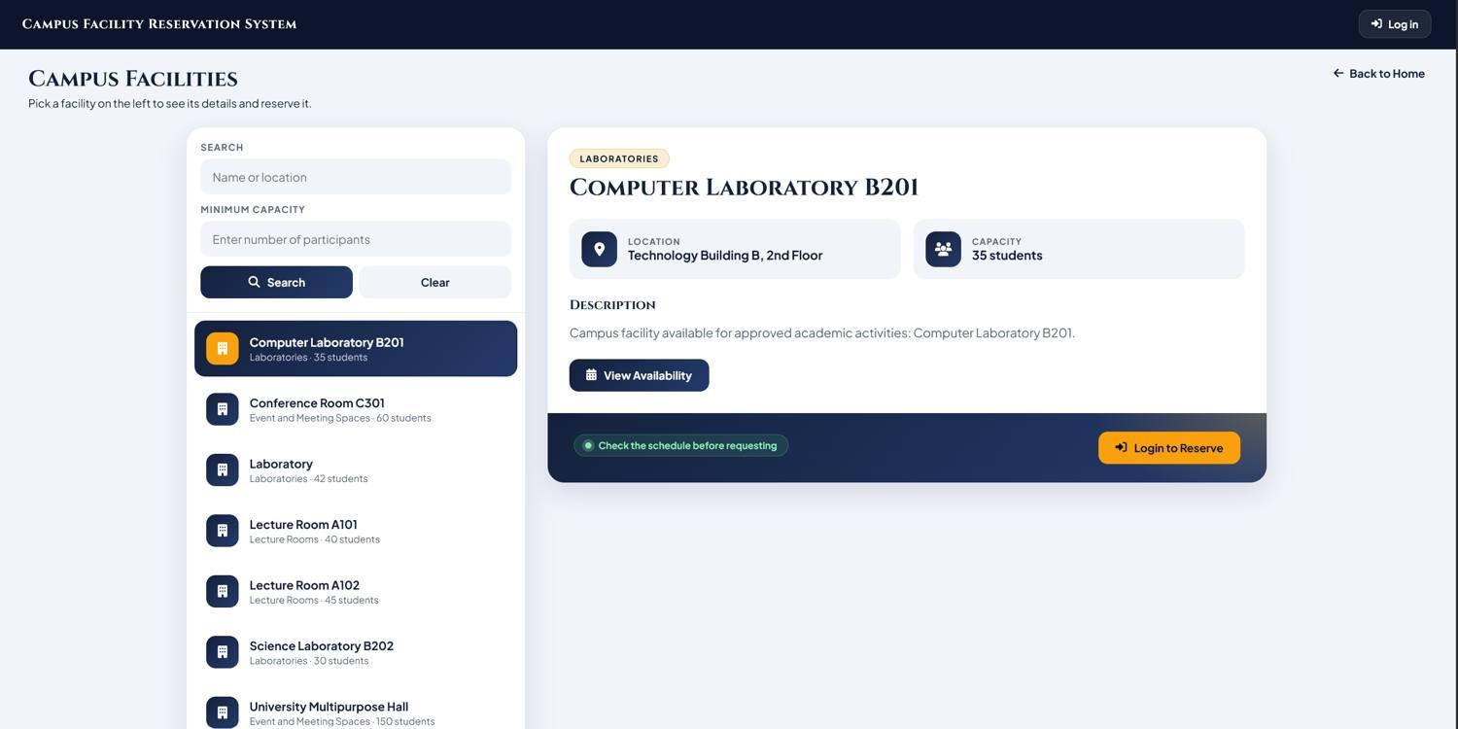
Catalog search results for keyword "lab"
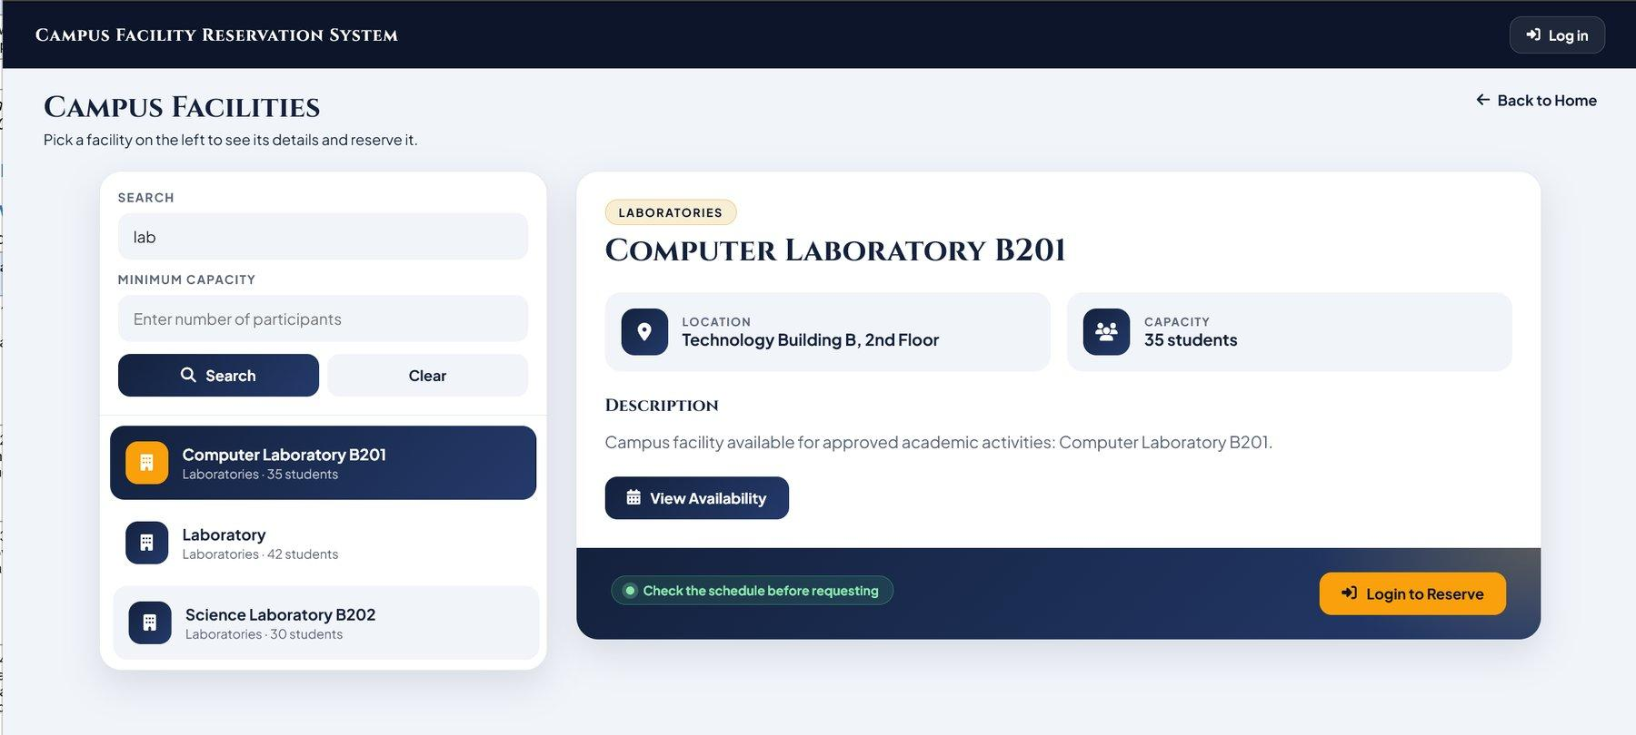
Catalog search results filtered by minimum capacity of 31
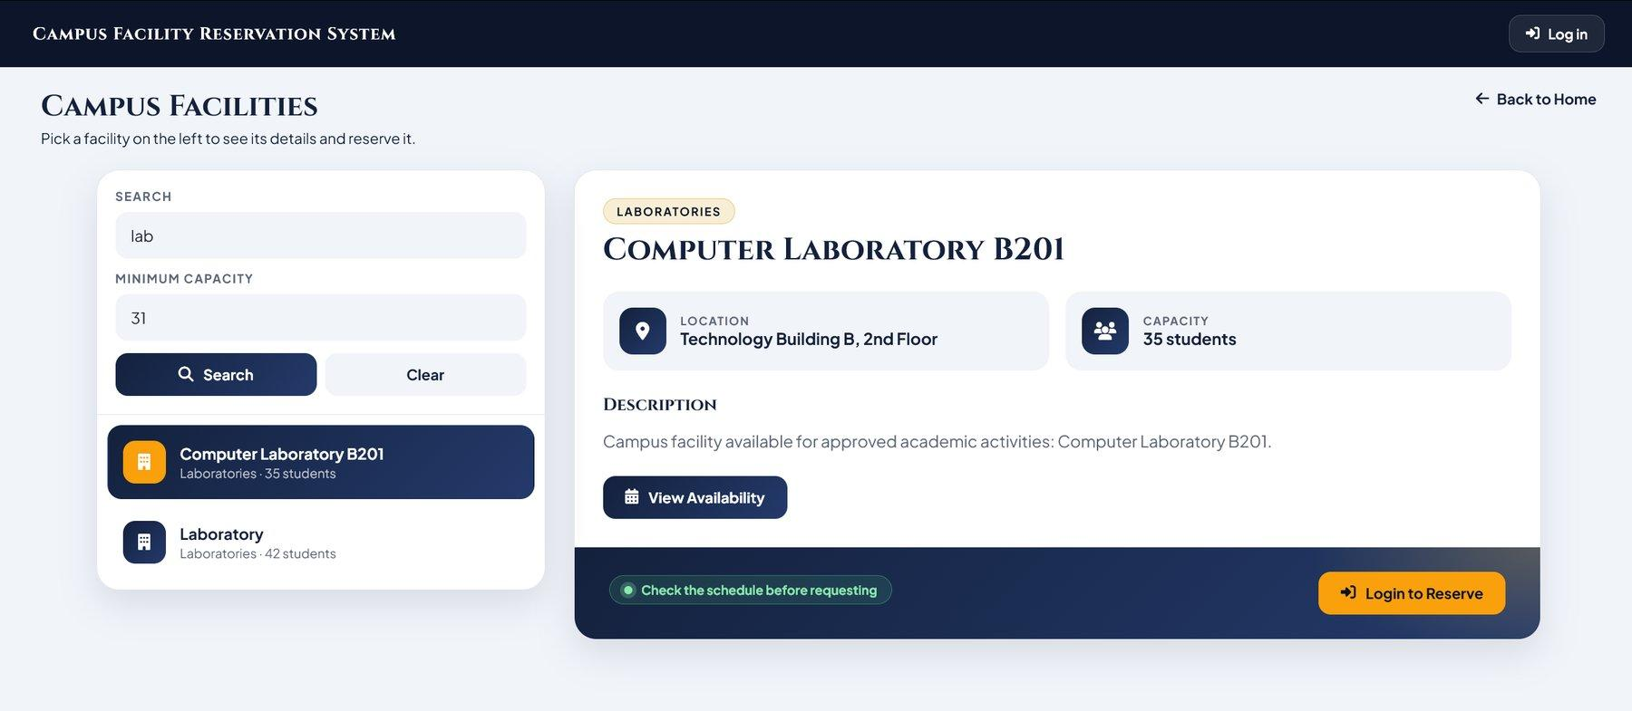
Filtered facility catalog with search parameters in URL
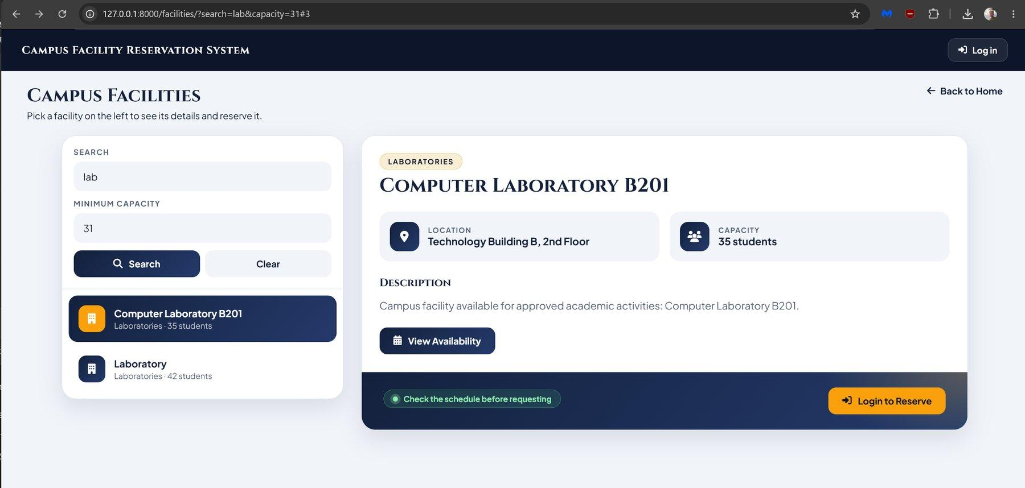

Test Case TC_101: Guest Login Navigation Link
Unified sign-in page accessed via Log In navigation with address bar visible
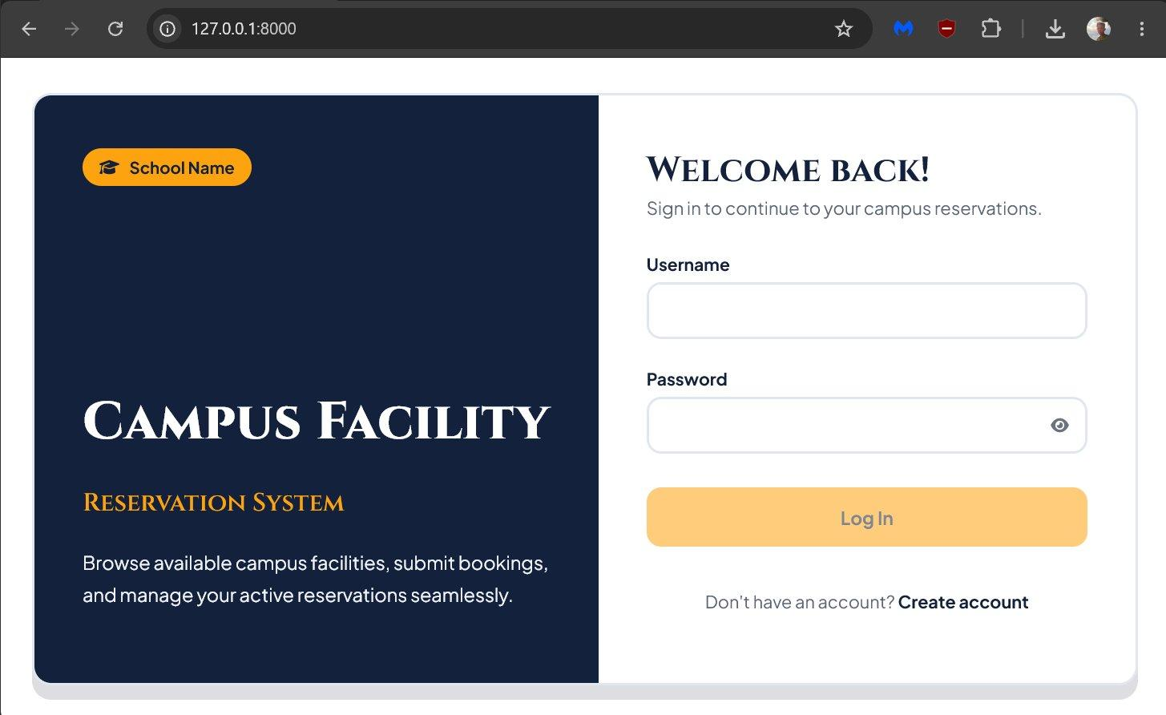
Sign-in page form interface
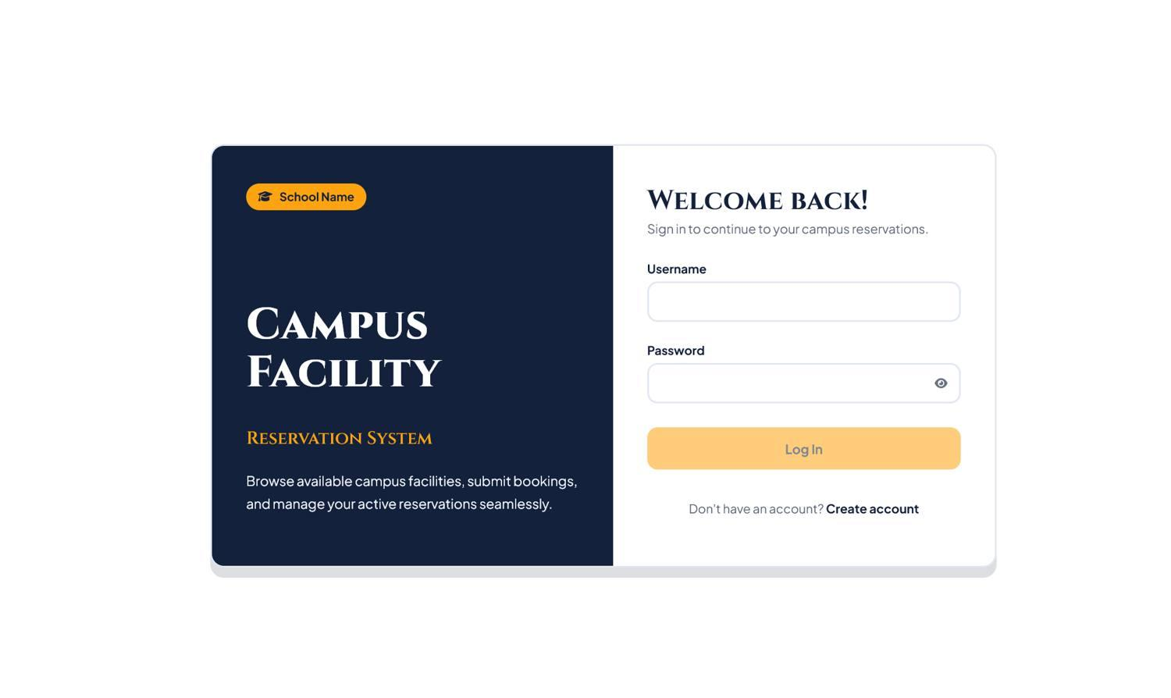

Test Case TC_102: User Portal and Catalog Navigation
Authenticated basic user portal dashboard
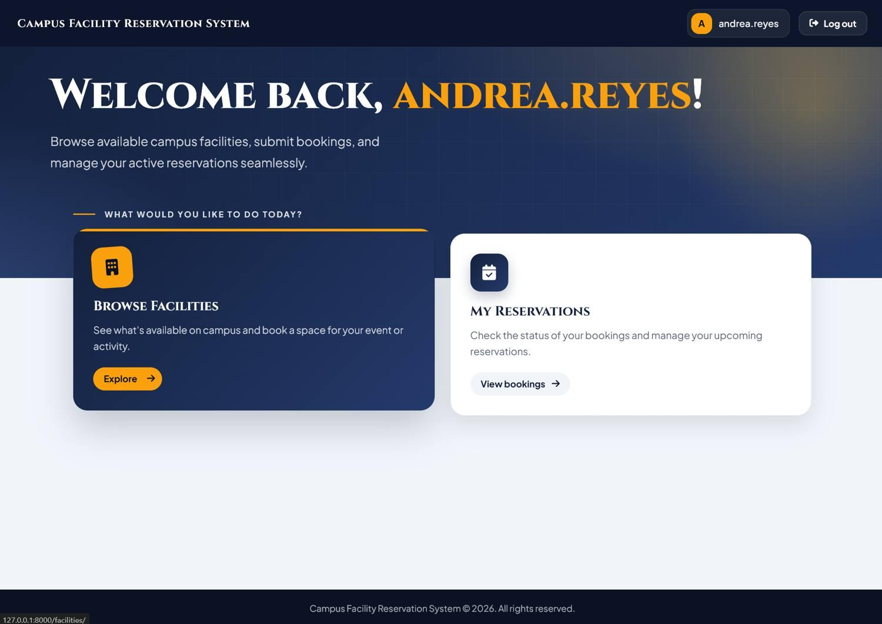
Facility catalog within authenticated basic user session
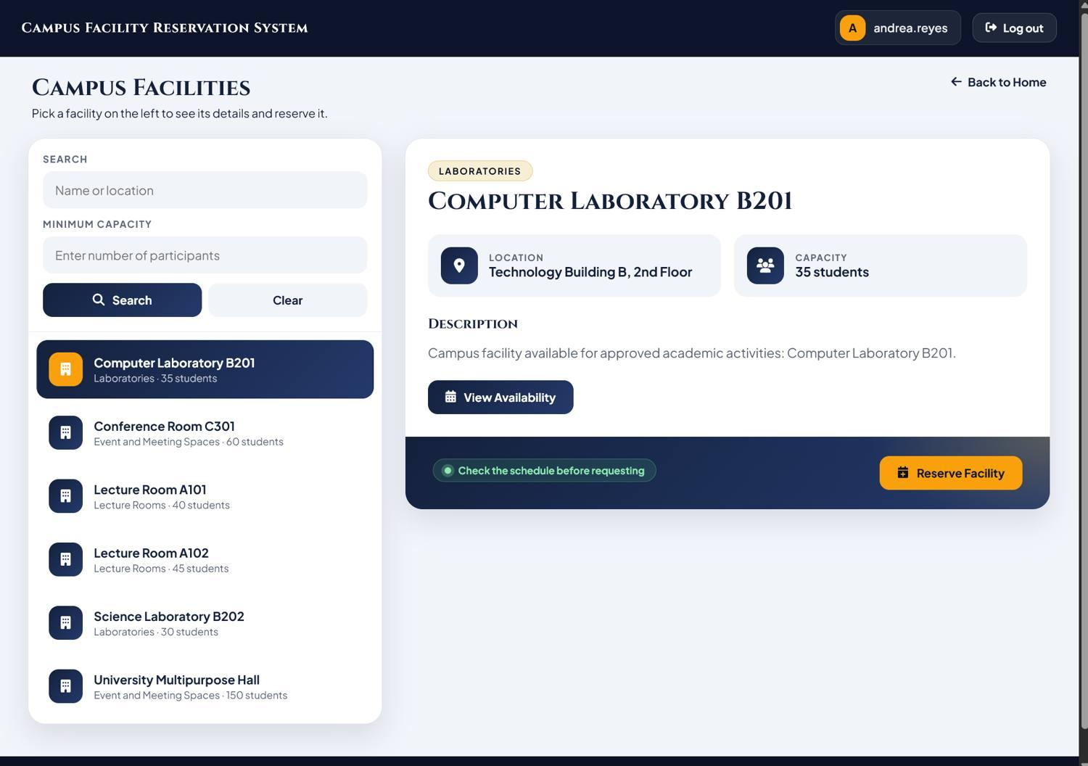
Return navigation to user portal dashboard
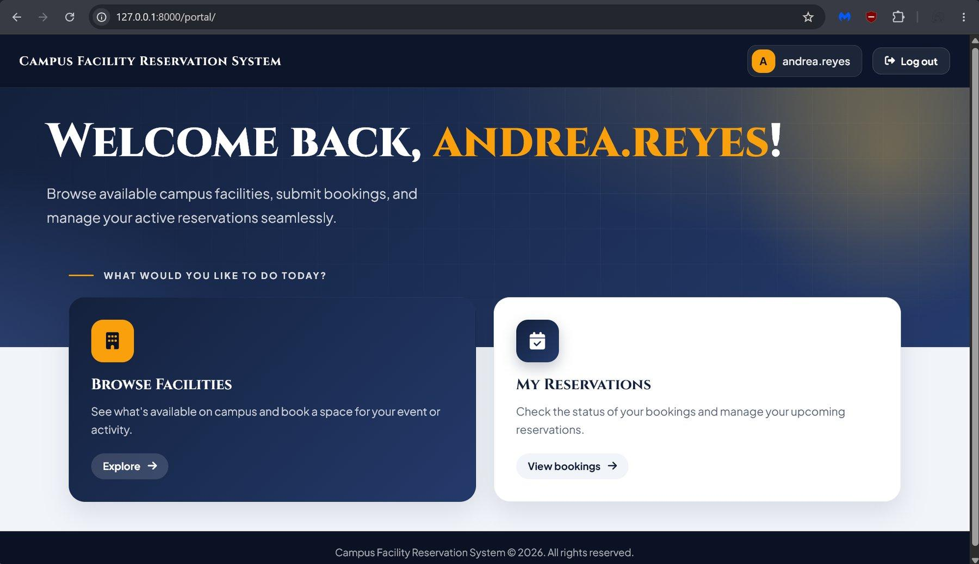

Test Case TC_103: My Reservations and Profile Dialog Navigation
My Reservations ticket cards display
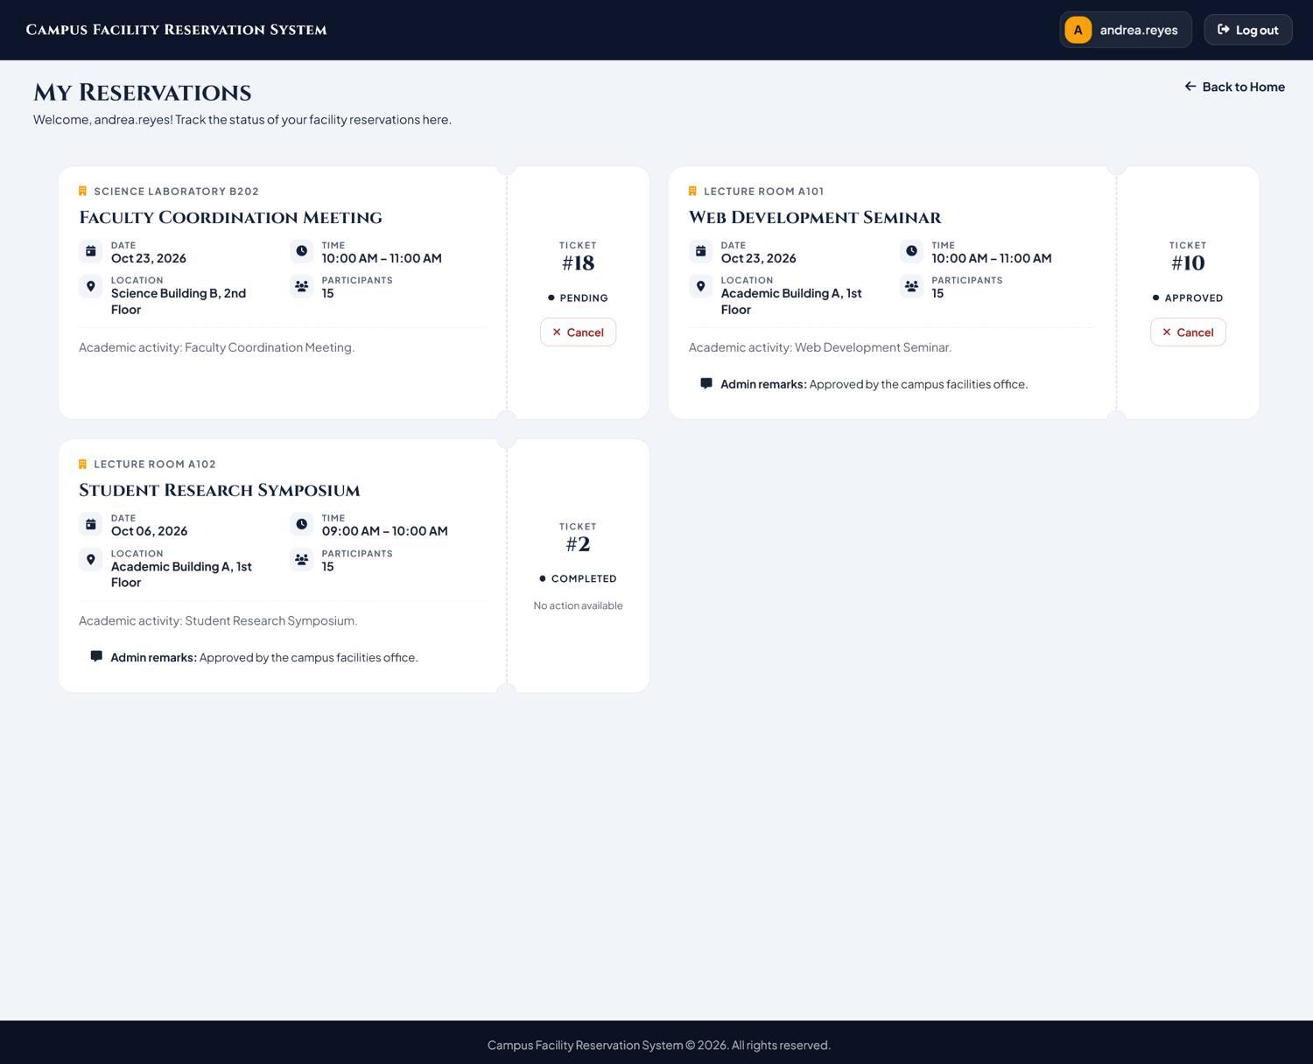
User profile modal dialog
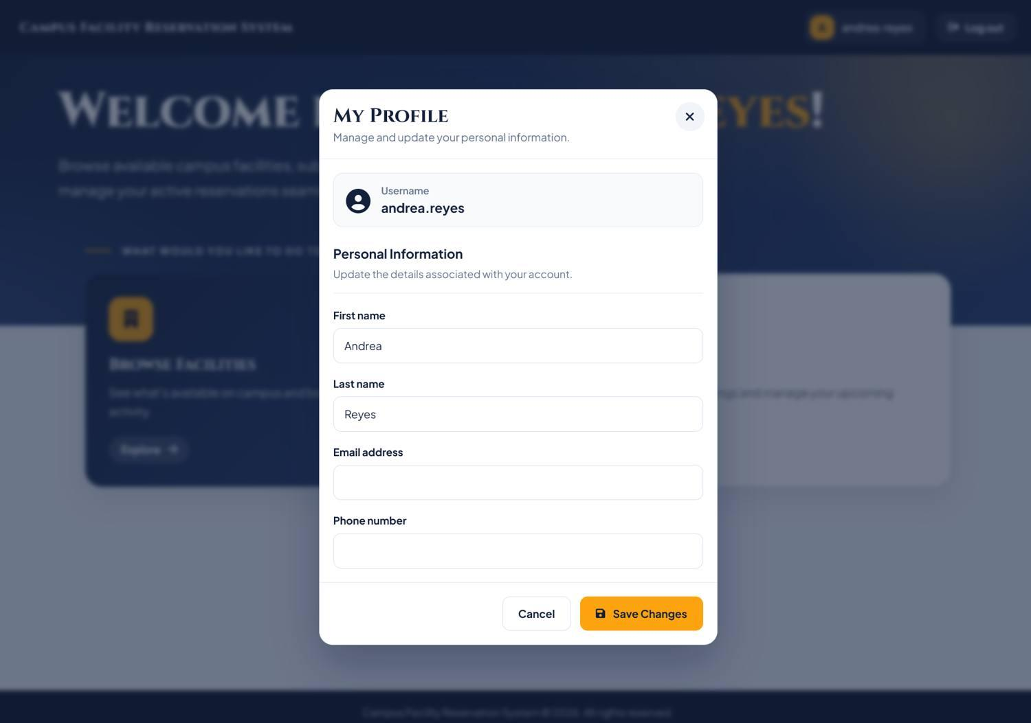
User profile modal accessed via direct URL navigation
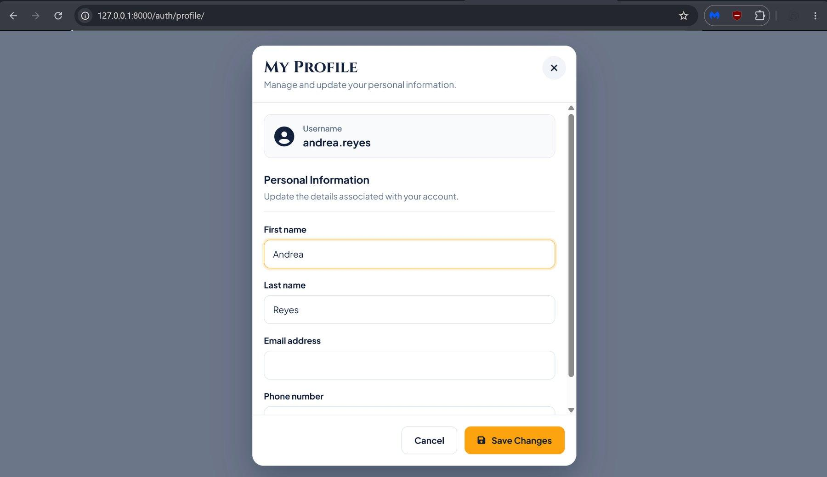

Test Case TC_104: Registration Wizard Multi-Step Navigation
Registration wizard Step 1: Personal Details
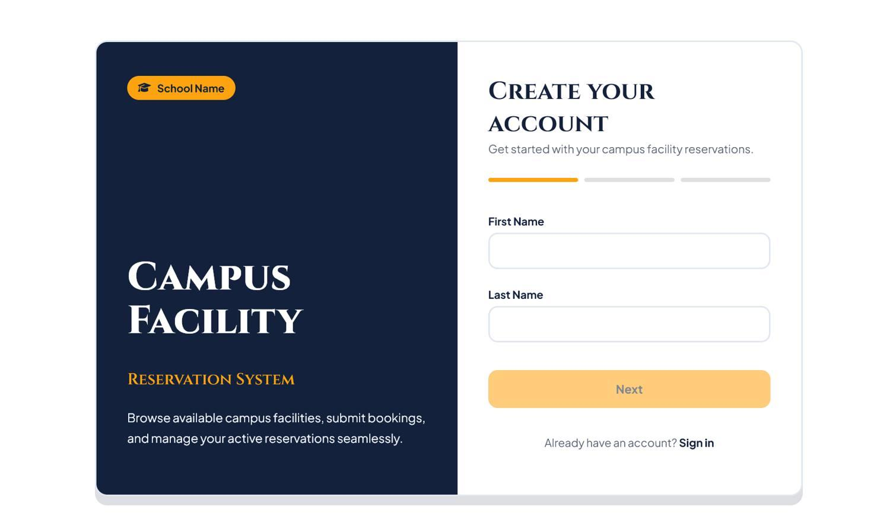
Registration wizard Step 2: Contact Details
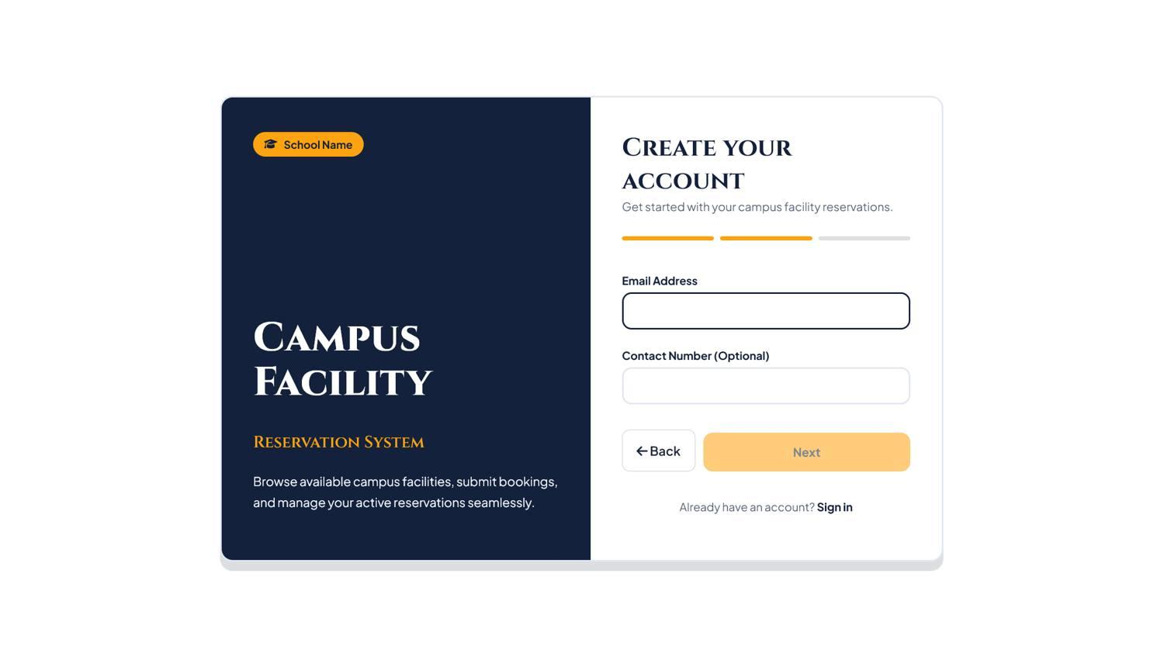
Registration wizard Step 3: Account Credentials
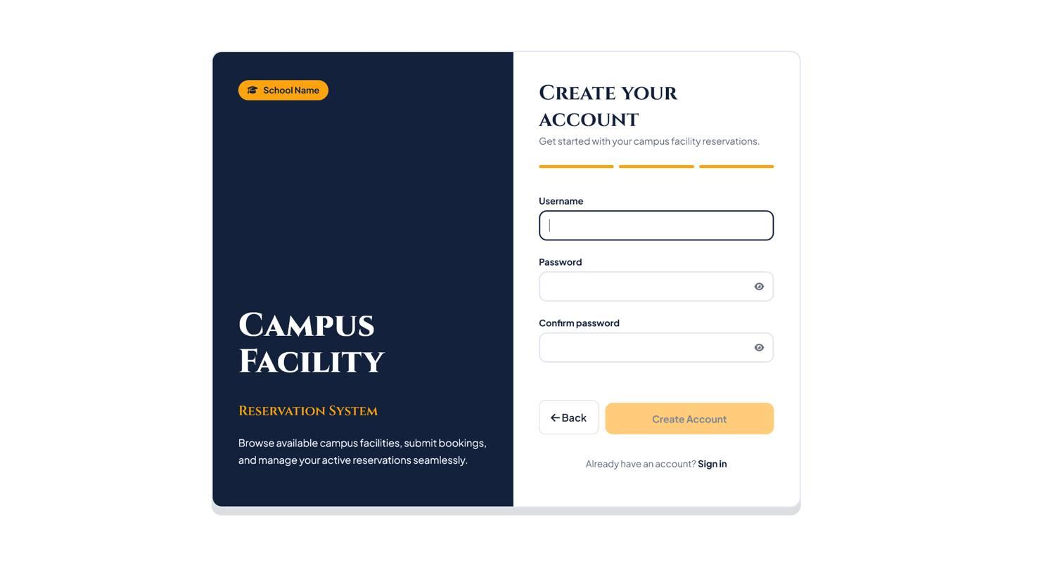
Registration wizard Step 2 reached sequentially from Step 1
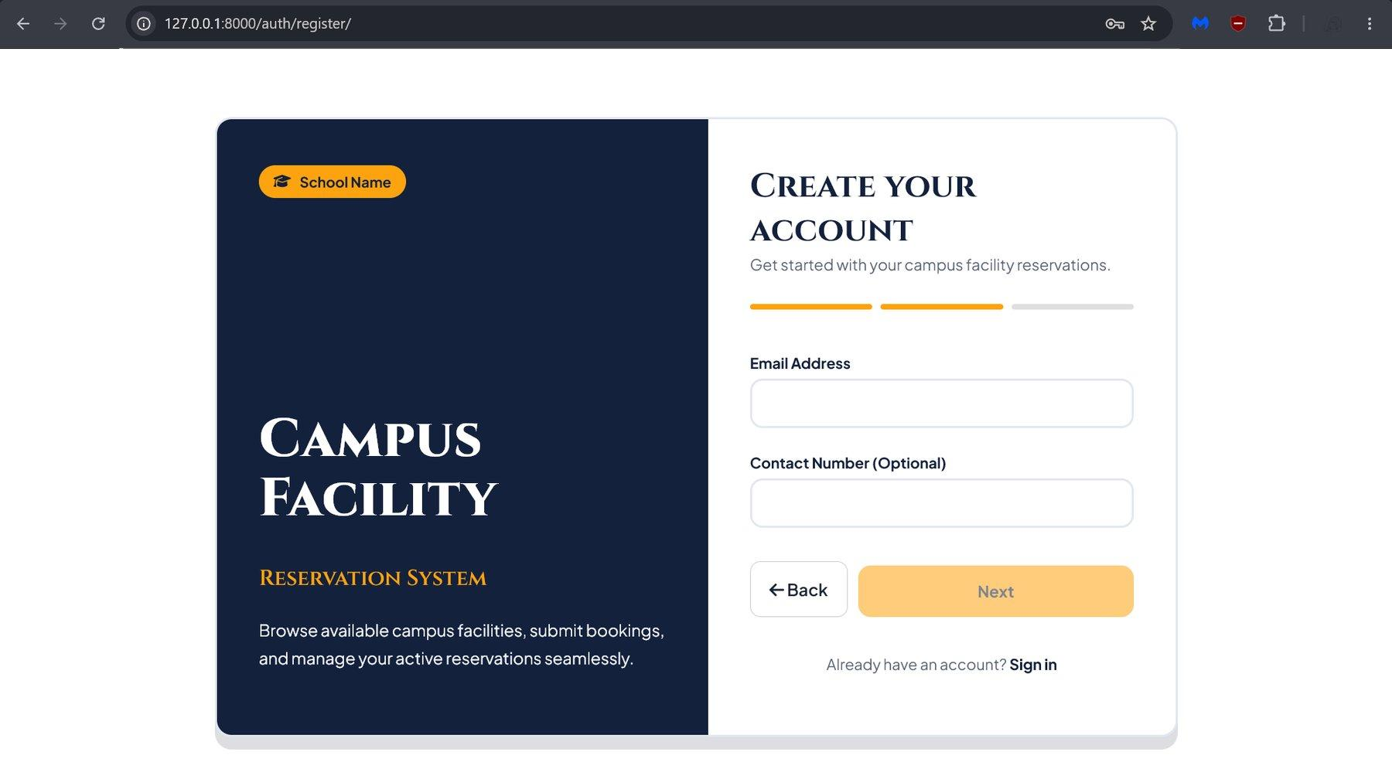

Test Case TC_105: Registration Value Retention on Back Navigation
Registration wizard Step 1 with user inputs before advancing
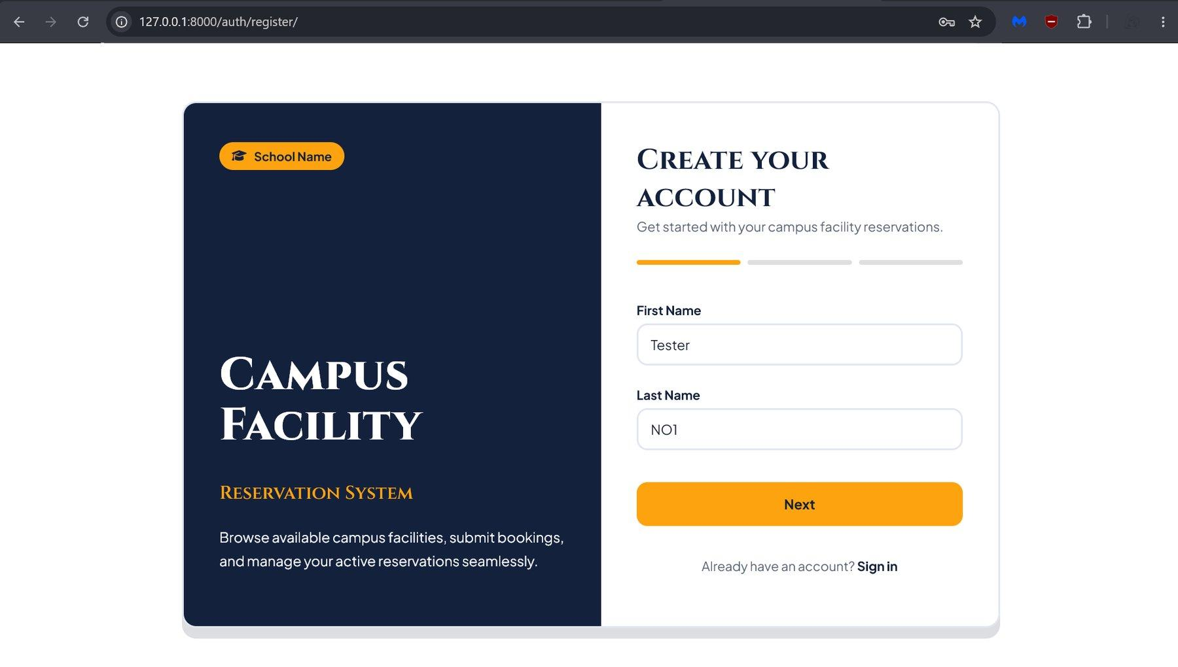
Note: Retention of entered values upon navigating back from Step 2 to Step 1 was verified through direct functional browser observation.

Test Case TC_106: Registration Password Complexity Feedback
Note: Interactive validation messages for non-compliant passwords and successful validation for compliant passwords were functionally verified during form submission. No static screenshot is included as visual display alone does not prove form validation state.

Test Case TC_107: Reservation Cancellation Confirmation and Status Update
Reservation cancellation confirmation modal for Ticket #10
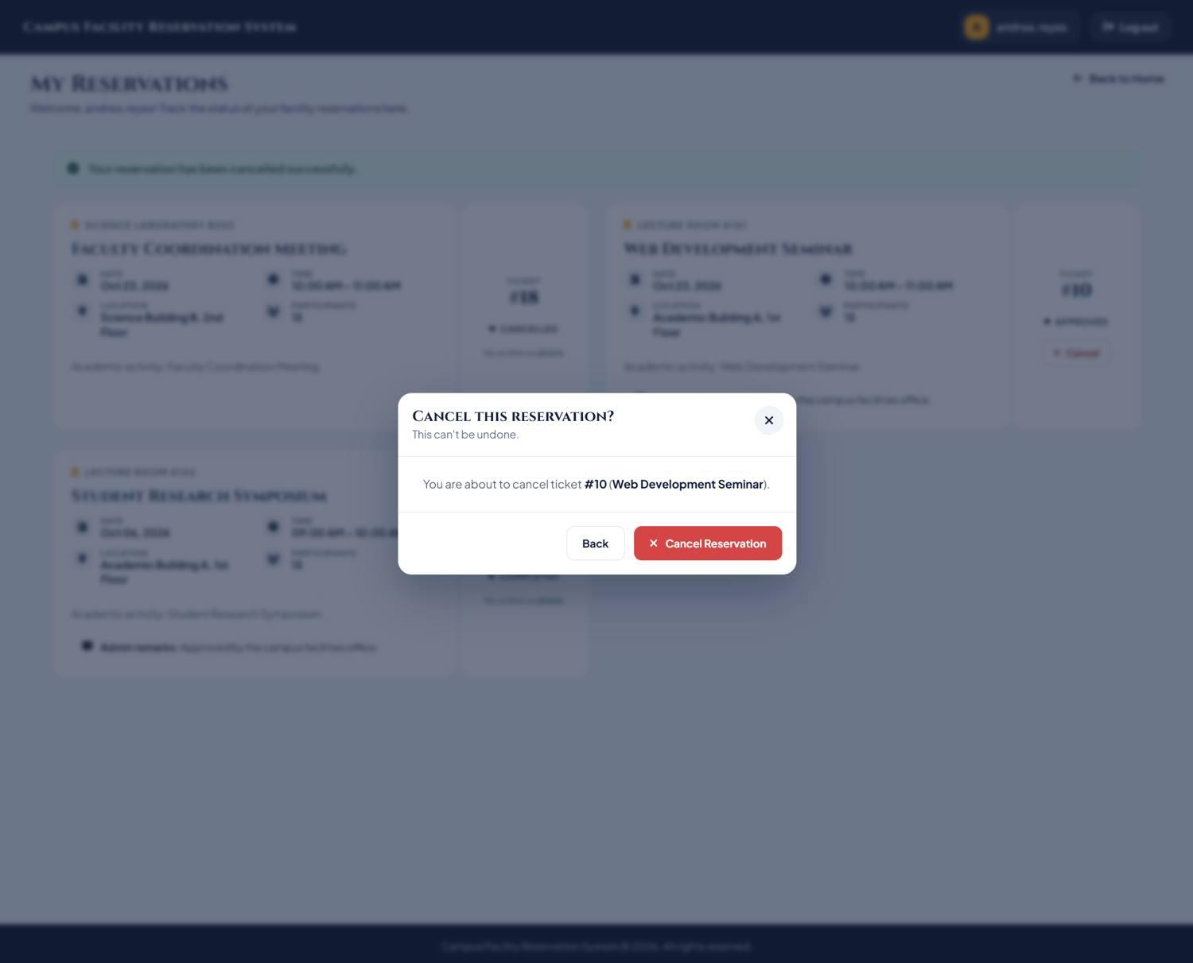
Post-cancellation confirmation notification and updated ticket status
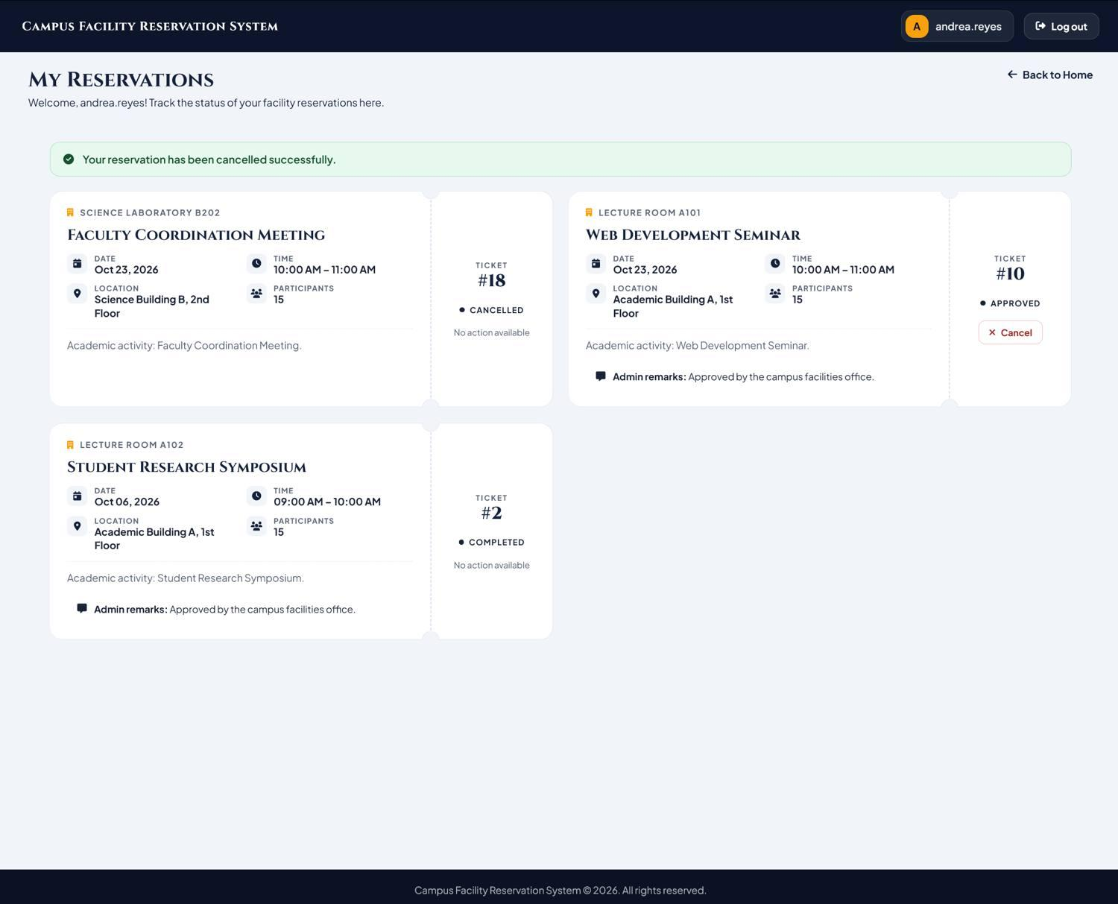
Note: Dismissing the modal dialog with the Back button without modifying ticket status was functionally observed and verified.

Test Case TC_108: Admin Approval and Rejection Dialogs
Administrator reservation approval modal for Reservation #19
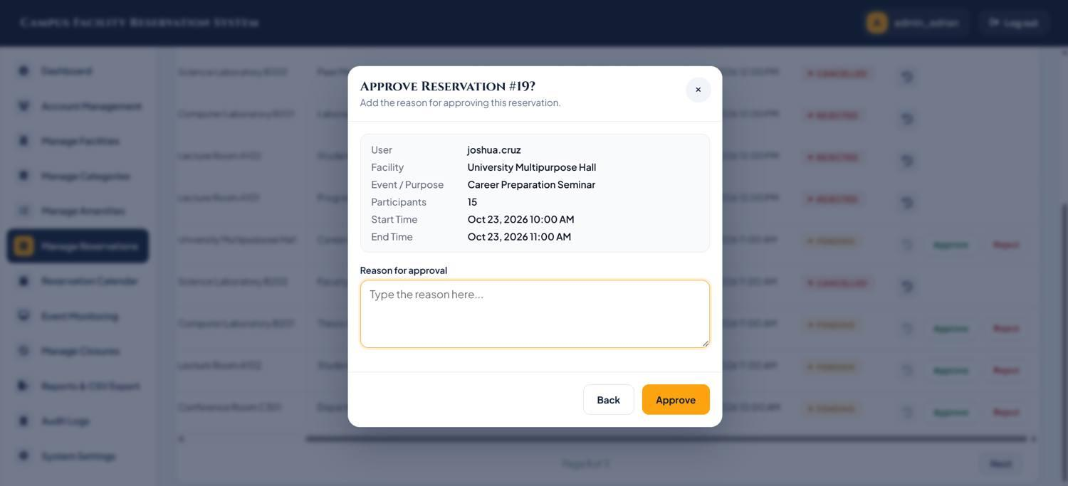
Administrator reservation rejection modal for Reservation #17
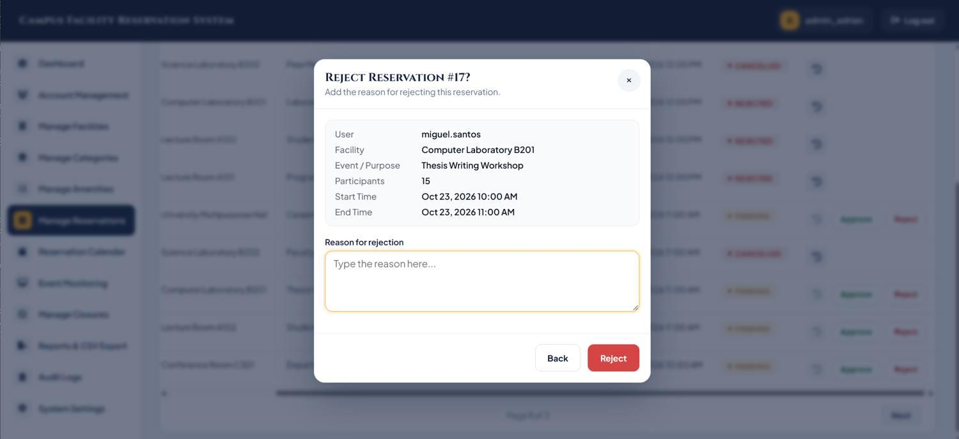
Note: Client/server validation refusing rejection submissions with empty reason fields was functionally observed and verified.

Test Case TC_109: Desktop Layout Usability
Note: Desktop layout usability at 1280x800 was verified through browser developer tools. No standalone viewport captures are included.

Test Case TC_110: View Event Page Styling Check (Finding F-05)
Administrator Event Monitoring schedule table with action buttons
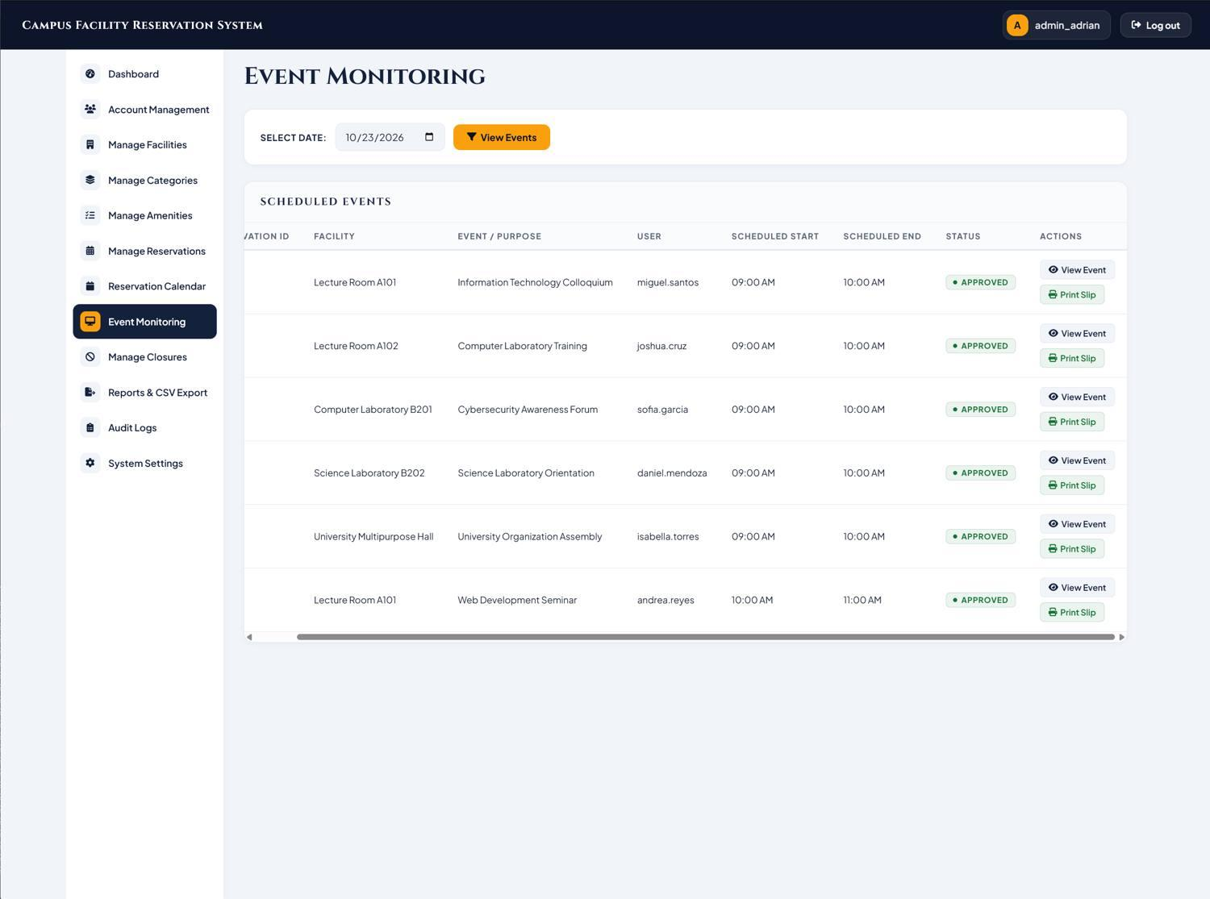
View Event page rendered as unstyled plain HTML
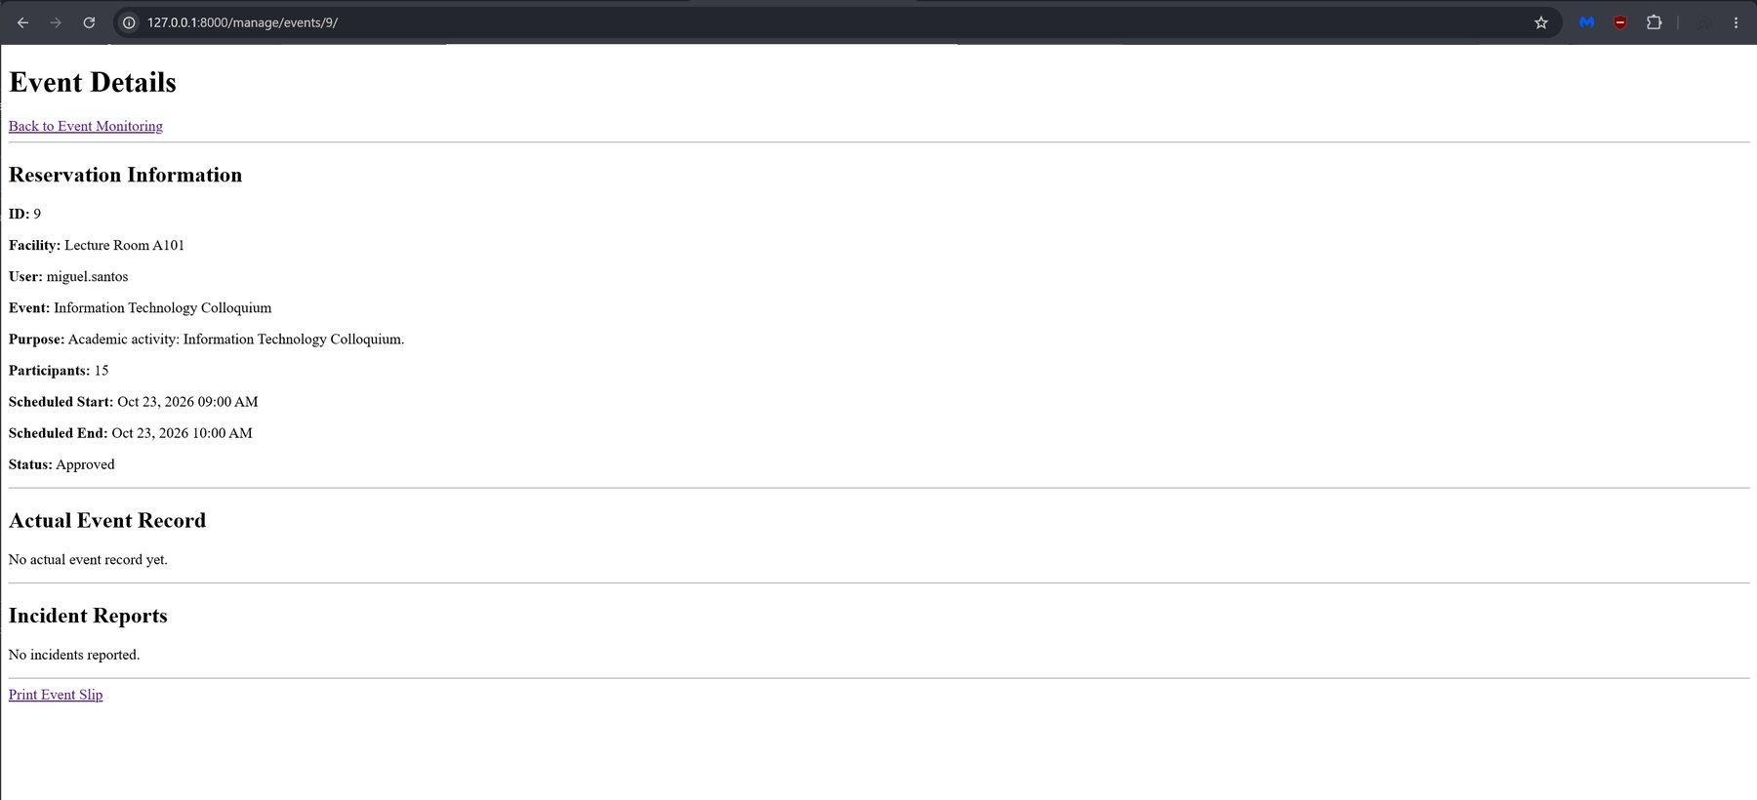

Test Case TC_111: Print Event Slip
Printable event slip in browser print preview (1/1; Print Slip button and Back link hidden)
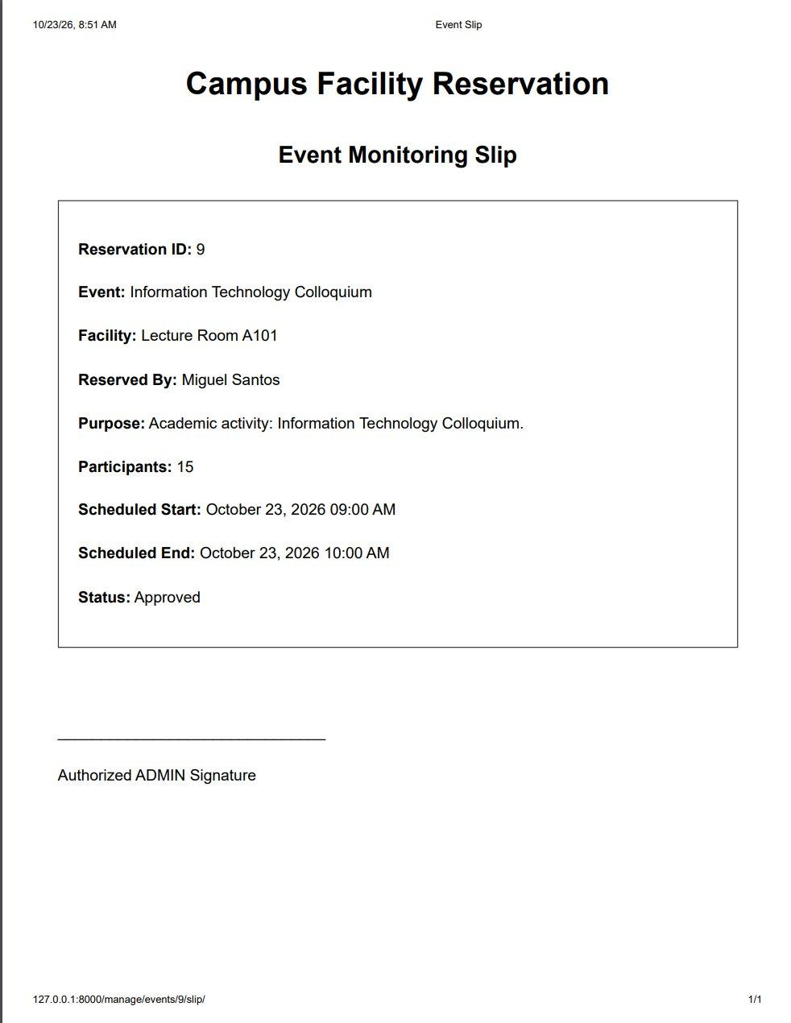
Printable event slip on screen before printing, with the Print Slip button and Back link visible (address bar shows /manage/events/9/slip/)
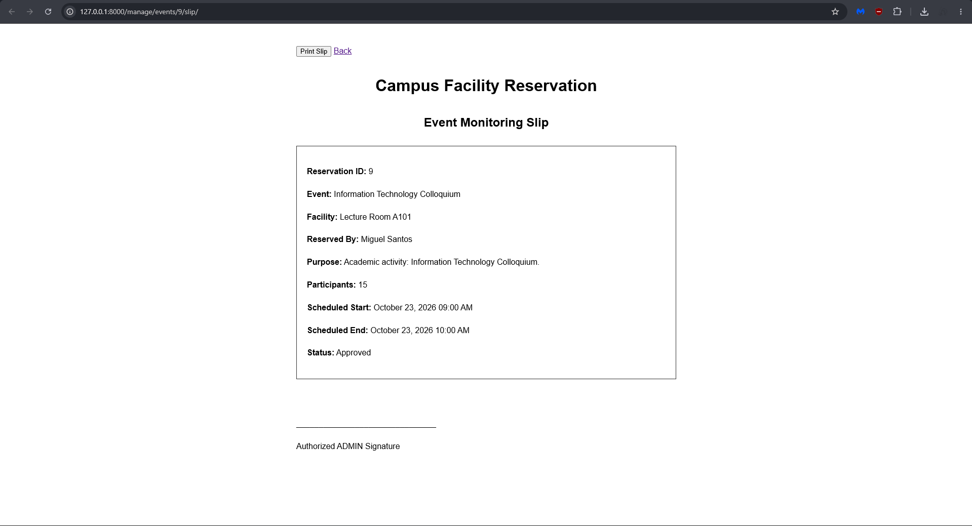
Note: Single-page printable slip rendering and browser print dialog behavior were functionally observed and verified.
Not captured for TC_111: the Print Slip click on Event Monitoring that opens the new tab; a slip for an event that has an event record (checked in, completed or no show), which adds actual start, actual end and actor lines; and the message shown when a slip is requested for a pending, rejected or cancelled reservation.

Test Case TC_112: Reservation Reports and Utilization CSV Export
Reservation Reports & Analytics dashboard with CSV export buttons
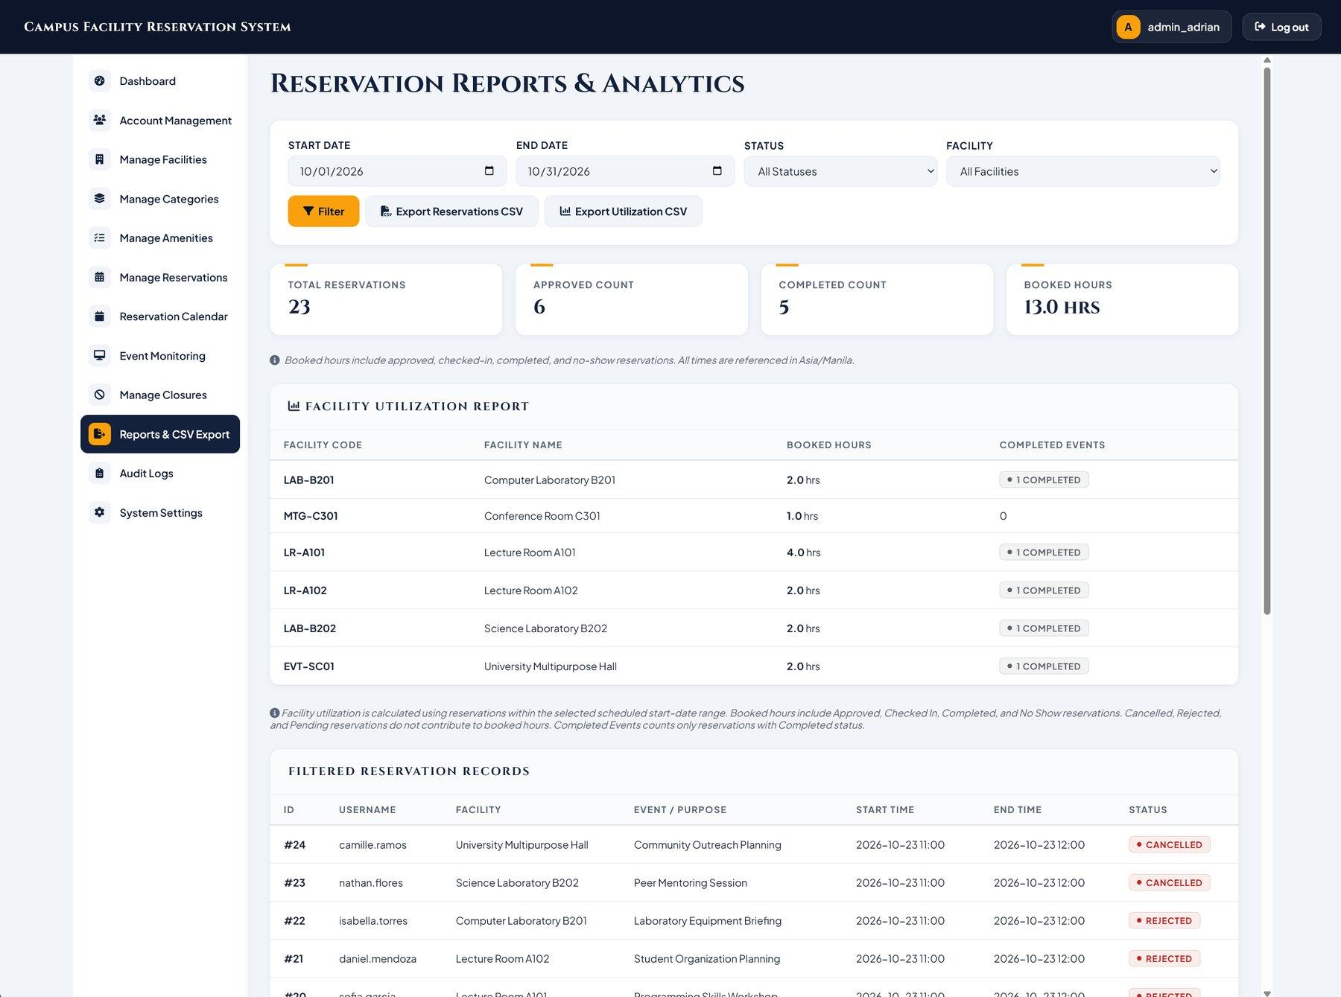
Exported reservation and utilization CSV files opened in spreadsheet software
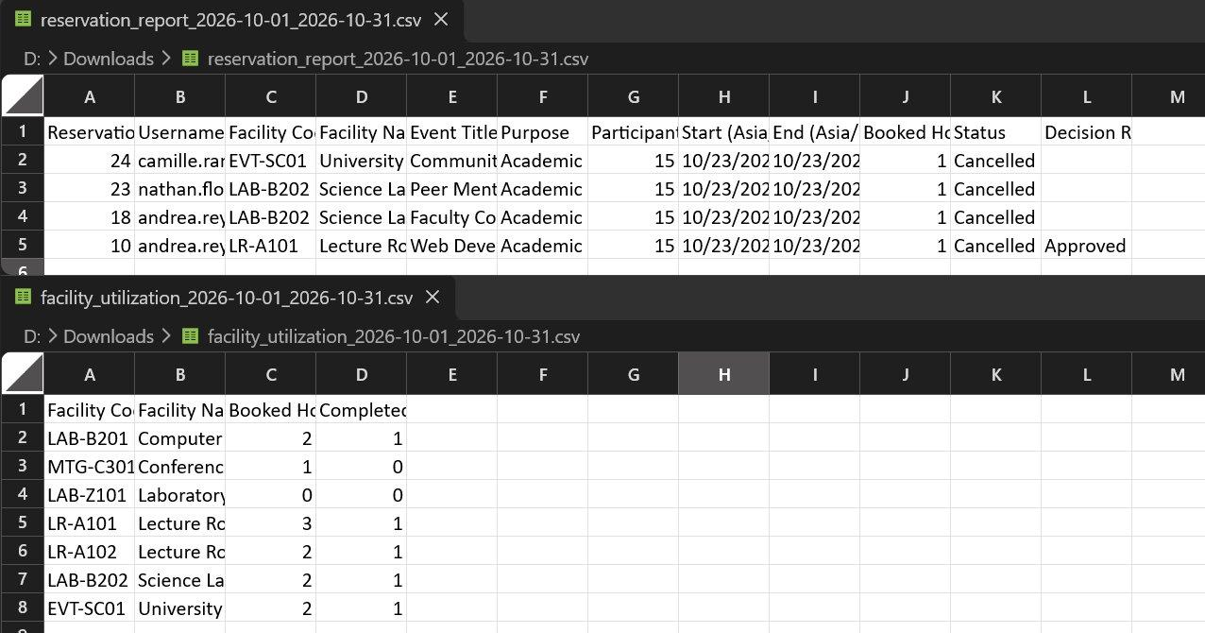
Note: Successful CSV file generation, browser download triggering, and file content integrity were functionally observed and verified.

5. Functional Verification of Browser Interactions
Certain browser behaviors and interactive flows cannot be proven through static screenshots alone. In accordance with manual testing standards, observed functional outcomes are recorded directly in the actual-result field of each test case. Screenshots serve as supporting evidence for visible states rather than proof of completed asynchronous downloads, background database updates, or hardware print spooling. Table 5 summarizes the functional observations for dynamic browser behaviors.
Test Case | Tested Interaction | Verification Method | Observed Functional Outcome
TC_104 / TC_105 | Registration Wizard Back Navigation & Form State | Multi-step interactive form navigation | Clicking Back from Step 2 preserves all user-entered personal values in Step 1 fields.
TC_106 | Password Complexity Validation | Interactive submission of invalid credentials | Passwords failing complexity rules trigger inline validation feedback; compliant passwords proceed.
TC_107 | Cancellation Dialog Dismissal | Modal dismiss interaction via Back button | Dismissing modal via Back leaves reservation status unchanged; confirming cancellation sets status to Cancelled.
TC_108 | Mandatory Rejection Reason Validation | Queue rejection modal submission without reason | Submitting rejection with empty reason is blocked by required-field validation; valid reason completes rejection.
TC_109 | Desktop Layout Usability | Layout inspection at 1280x800 | Interfaces remain usable without unwanted horizontal clipping or inaccessible buttons.
TC_111 | Event Slip Print Action | Browser print preview trigger from Event Monitoring | Print Slip action renders printable slip in single-page print format with signature line. Back Button links back to event details
TC_112 | CSV Reports Export Action | Browser file download triggers from Reports & Analytics | Export buttons trigger downloads of formatted CSV files for reservations and utilization.

6. Findings
Finding numbers continue from the previous results document (F-01 to F-04).
ID | Finding | Where | How it was confirmed | Severity | Required change
F-05 | The View Event page is a plain HTML page. It does not extend the admin base template and loads no stylesheet, so it will show without the application styling and the Admin navigation. | management/templates/management/event_detail.html, opened from /manage/events/<id>/ | Confirmed via manual browser testing of TC_110 at /manage/events/9/ and code inspection of management/templates/management/event_detail.html. | Medium | Update management/templates/management/event_detail.html to extend management/base_admin.html and load static CSS styles matching event_monitoring.html. Re-run TC_110 after template update.

7. Not tested
Boundary values and concurrent approvals. These are covered by the automated tests in Boundary_Value_Concurrency_Test_Results (TS_005 and TS_006).
Mobile and tablet layouts. Only the 1280 x 800 desktop size was inspected; no smaller viewport or physical device was tested.
Browsers other than the one recorded in the test environment table.
Event slips for events that have an event record (checked in, completed or no show) and the message shown for slips requested on pending, rejected or cancelled reservations were not exercised in the browser.
This document records manual testing only.

8. Behaviors to confirm with the team
The user profile opens as a modal dialog on the portal when JavaScript is enabled, and as a standalone view at /auth/profile/ when accessed directly. In the browser behavior test evidence, /auth/profile/ opens the profile modal view with JavaScript running. Confirm whether requirement specifications require distinct standalone page rendering or if modal presentation fulfills intended UX.
The Event Slip at /manage/events/<id>/slip/ is a standalone page. event_slip.html does not extend the admin base template; it defines its own inline styles (Arial text, centered headings, bordered details box) and a print rule that hides the Print Slip button and Back link. On screen it therefore shows default browser styling for that button and link and no Admin navigation. The source reads as a deliberate printout design, unlike the View Event page in F-05, which has no styling at all. Confirm that no Admin styling is wanted on the on-screen slip. Also confirm that the slip Back link should return to the View Event page (the unstyled page in F-05) rather than to Event Monitoring.

9. Tester observations
Manual browser testing confirmed that core user and administrator workflows function reliably across the Campus Facility Reservation System. All navigation routing, action buttons, dialog prompts, form submissions, printing, and CSV report export features operate as designed. The single defect identified during testing is the unstyled View Event page (Finding F-05, TC_110), which is a presentation template defect rather than a functional button or routing failure. Resolving this styling issue will bring full visual consistency across the administrative interface.
10. Testing Disclaimer
These browser behavior tests cover only the specified scenarios under the tested conditions and do not exhaust all possible user interactions, inputs, browser configurations, or application states. Passing results do not guarantee that the application is completely free of defects, and additional issues may remain undetected.

