Campus Facility Reservation System (IT401W). Results of the supplementary tests (boundary-value and concurrency) for the Database and Backend Testing role.

Item 7: Run the supplementary boundary-value tests (BV-01 to BV-09):
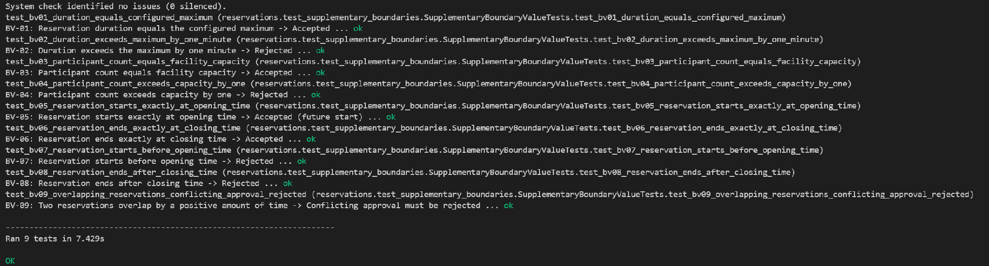
Command: python manage.py test reservations.test_supplementary_boundaries -v 2. Ran 9 tests in 7.429s: OK.

Item 8: Run the supplementary concurrent approval test:
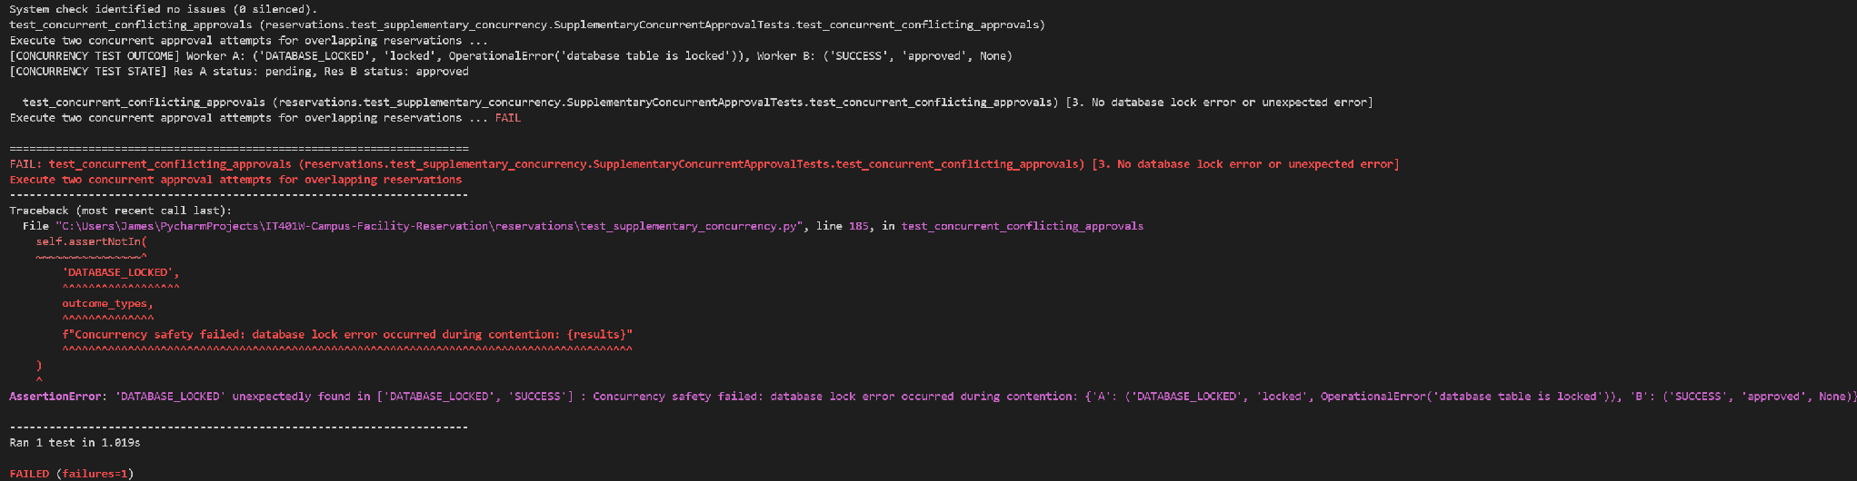
Command: python manage.py test reservations.test_supplementary_concurrency -v 2. Ran 1 test in 1.019s: FAILED (failures=1). The failure is reported on check 3 only.

1. Test environment
Item | Details
Project | IT401W Campus Facility Reservation (Django web application)
Role | Database and Backend Testing
Test date | October 23, 2026
Branch and commit tested | Documents/jacinto commit: 65fff5
Software | Django 6.1.1, SQLite, Windows and PyCharm (as in the main results document)
Test database | A fresh in-memory SQLite database (shared-cache mode) is created for every run and deleted afterwards. The local db.sqlite3 file is not touched. The concurrency test uses TransactionTestCase, so its approvals are really committed and run in two threads.
Test files | reservations/test_supplementary_boundaries.py (9 tests) and reservations/test_supplementary_concurrency.py (1 test)
How tests were run | python manage.py test reservations.test_supplementary_boundaries -v 2 and python manage.py test reservations.test_supplementary_concurrency -v 2

2. Summary
Scenario | Name | Test cases | Executed | Passed | Failed | Not run or pending
TS_005 | Boundary values: duration, capacity, operating hours and overlapping bookings | 9 | 9 | 9 | 0 | 0
TS_006 | Concurrent approval of two overlapping reservations | 1 | 1 | 0 | 1 | 0
Total |  | 10 | 10 | 9 | 1 | 0
One test failed: TC_099, the concurrent approval test. The database stayed consistent (only one reservation was approved), but the request that lost the race ended in a database lock error instead of a clean conflict message. See findings F-01 to F-03.

3. Test scenarios

TS_005: Boundary values for duration, capacity, operating hours and overlapping bookings
Evidence: screenshot under Item 7 (Ran 9 tests in 7.429s: OK). A re-run of the same file on a clean copy of the repository (Python 3.12, Django 6.1.1) also passed: Ran 9 tests in 11.718s: OK.
Common set-up: facility with capacity 60, open 08:00 to 17:00; maximum booking length 4 hours; advance-booking window 30 days; event date 7 days ahead; times in Asia/Manila. Cases BV-01 to BV-08 check the model validation (full_clean) only. BV-09 also checks the approval service.
TC ID | Test Case Description | Steps / Pre-condition | Expected Result | Actual Result | Status | Automated Test
TC_090 | BV-01: Duration equal to the configured maximum is accepted | 1. Read the maximum duration (4 hours).  2. Build a pending booking 09:00 to 13:00.  3. Run full_clean() and save(). | Validation passes and the booking is saved as Pending with a length of exactly 4 hours. | Validated and saved. Length was 4 hours, status Pending. | PASSED | test_bv01_duration_equals_configured_maximum
TC_091 | BV-02: Duration one minute over the maximum is rejected | 1. Build a pending booking 09:00 to 13:01.  2. Run full_clean(). | ValidationError on end_time: "Maximum reservation duration is 4 hours." Nothing is saved. | ValidationError raised on end_time with that message. Nothing saved. | PASSED | test_bv02_duration_exceeds_maximum_by_one_minute
TC_092 | BV-03: Participant count equal to the capacity is accepted | 1. Facility capacity is 60.  2. Build a pending booking 09:00 to 11:00 with 60 participants.  3. Run full_clean() and save(). | Validation passes and the booking is saved with 60 participants. | Validated and saved with 60 participants. | PASSED | test_bv03_participant_count_equals_facility_capacity
TC_093 | BV-04: Participant count one over the capacity is rejected | 1. Build a pending booking 09:00 to 11:00 with 61 participants.  2. Run full_clean(). | ValidationError on participant_count: "Maximum facility capacity is 60." Nothing is saved. | ValidationError raised on participant_count with that message. Nothing saved. | PASSED | test_bv04_participant_count_exceeds_capacity_by_one
TC_094 | BV-05: Booking that starts exactly at opening time is accepted | 1. Opening time is 08:00.  2. Build a pending booking 08:00 to 10:00 on a future date.  3. Run full_clean() and save(). | Validation passes. The saved start time is 08:00 local and in the future. | Validated and saved. Start was 08:00 Manila time, in the future, status Pending. | PASSED | test_bv05_reservation_starts_exactly_at_opening_time
TC_095 | BV-06: Booking that ends exactly at closing time is accepted | 1. Closing time is 17:00.  2. Build a pending booking 15:00 to 17:00.  3. Run full_clean() and save(). | Validation passes. The saved end time is 17:00 local. | Validated and saved. End was 17:00 Manila time, status Pending. | PASSED | test_bv06_reservation_ends_exactly_at_closing_time
TC_096 | BV-07: Booking that starts one minute before opening is rejected | 1. Build a pending booking 07:59 to 09:59.  2. Run full_clean(). | ValidationError on start_time mentioning operating hours. Nothing is saved. | ValidationError raised on start_time with the operating-hours message. Nothing saved. | PASSED | test_bv07_reservation_starts_before_opening_time
TC_097 | BV-08: Booking that ends one minute after closing is rejected | 1. Build a pending booking 15:01 to 17:01.  2. Run full_clean(). | ValidationError mentioning operating hours. Nothing is saved. | ValidationError raised with the operating-hours message. It is reported on start_time, not end_time. Nothing saved. | PASSED | test_bv08_reservation_ends_after_closing_time
TC_098 | BV-09: Approval of a booking that overlaps an approved one by one minute is rejected | 1. Approved booking 09:00 to 10:00 exists.  2. Create a pending booking 09:59 to 10:59 for another user.  3. Set it to approved and run full_clean().  4. Approve it through update_reservation as an admin. | Both attempts raise a ValidationError: "This facility already has an approved reservation during the selected time." The booking stays Pending. | Both attempts raised the conflict error on start_time. The booking stayed Pending. | PASSED | test_bv09_overlapping_reservations_conflicting_approval_rejected

TS_006: Concurrent approval of two overlapping reservations
Evidence: screenshot under Item 8. Run: python manage.py test reservations.test_supplementary_concurrency -v 2 (Ran 1 test in 1.019s: FAILED). Each of the five checks runs in its own subTest, so a failed check does not stop the others. Only check 3 is reported as failed. Earlier runs of the first version of the script, and 6 re-runs on a clean copy of the repository, failed the same way. The lock error hit the first thread in some runs and the second in others, so which request loses is not predictable.
Set-up: two basic users and one admin. Reservation A is 10:00 to 12:00 and reservation B is 11:00 to 13:00 on the same facility (1 hour overlap), both Pending. Two threads wait at a barrier, then each calls update_reservation(request, id, "APPROVE", reason) at the same moment.
TC ID | Test Case Description | Steps / Pre-condition | Expected Result | Actual Result | Status | Automated Test
TC_099 | Two simultaneous approvals of overlapping reservations: only one succeeds and the other fails cleanly | 1. Create the two overlapping Pending reservations.  2. Start two threads and release them together.  3. Each thread approves its own reservation as the admin.  4. Check both outcomes and the final database state. | Exactly one reservation is Approved. The other stays Pending and is refused with a validation message, with no database lock error and no unhandled exception. No partial update, and no overlapping Approved pair at the end. | Thread A: OperationalError("database table is locked"). Thread B: approved. Final state: A Pending, B Approved. Check 3 (no database lock error) failed. Checks 1, 2, 4 and 5 passed. | FAILED | test_concurrent_conflicting_approvals

Result of each required check inside TC_099:
No. | Check | Status | Evidence
1 | Exactly one of the two reservations becomes Approved | PASSED | Screenshot: Res B approved, Res A pending.
2 | The other reservation stays Pending | PASSED | Screenshot: Res A pending.
3 | The losing request raises no database lock error or unexpected error | FAILED | Thread A received OperationalError("database table is locked").
4 | The losing reservation has no ReservationChange record and no APPROVE audit entry | PASSED | No failure reported for this check in the run.
5 | No two Approved reservations overlap in the final state | PASSED | No failure reported for this check in the run.

4. Findings
One test failed, and the following issues were noticed.
ID | Finding | Where | How it was confirmed | Severity | Required change
F-01 | When two admins approve overlapping bookings at the same moment, only one is approved and the other stays Pending, so there is no double booking. But the losing request ends in a database lock error (OperationalError "database table is locked") instead of the conflict message. | reservations/services.py, update_reservation; SQLite settings in config/settings.py | Screenshot under Item 8, plus 6 re-runs that failed the same way. | Medium | Handle the lock error in update_reservation (retry once, or convert it to a ValidationError that asks the admin to retry).  Consider SQLite OPTIONS such as a longer timeout and transaction_mode IMMEDIATE, or PostgreSQL for heavy concurrent use.  Re-run the test after the change.
F-02 | The approval view already catches DatabaseError and shows "The reservation could not be updated due to a database conflict. Please try again." The test calls the service directly, so it judges the service and not what the admin sees. | management/views.py, update_reservation_status; test_supplementary_concurrency.py | Found by reading the code. The view path was not run. | Low | Team decides which behavior is intended.  Either add a test that posts to the view and expects that message, or relax check 3 to accept the handled outcome.
F-03 | The test database is in-memory SQLite in shared-cache mode, where a second writer gets an immediate "table is locked" error. The real db.sqlite3 file may behave differently, so this result may not match normal use. | Test database set-up | Database name in the test run output (memorydb, shared cache). A file-based run was not done. | Low | Also run the test against a file-based test database (set TEST NAME for the sqlite3 database) and record both results.
F-04 | Small clean-up item: the last check in BV-09 uses any(... for _ in [1]), which is a plain "in" check written in a roundabout way. | test_supplementary_boundaries.py | Found by reading the code. | Low | Replace the last BV-09 check with assertIn.

5. Not tested
These two files close two gaps listed in the main results document: boundary values are now covered, and simultaneous approval is now tested (and fails, see F-01). The following is still not covered by them:
- Browser behavior: buttons, page layout and JavaScript. This is covered by manual tests in Browser_Behavior_Test_Results.
- Simultaneous rescheduling, or more than two competing approvals.
- Concurrency against a file-based database or PostgreSQL.
- Boundaries for the advance-booking window (exactly 30 days and 31 days), a booking that crosses midnight, a participant count of 0 and 1, and bookings that touch a closure exactly at its start or end.
- Adjacent bookings that share an endpoint are not part of these two files. They are covered by the booking-conflicts tests in the main results document (TC_012).
- Boundary cases through the reservation form and the admin view. The tests call the model and the service only.

6. Behaviors to confirm with the team
These tests confirm what the code does today. The team should confirm that these are the intended rules:
- When two admins approve conflicting bookings at once, the admin who loses sees a general "database conflict, please try again" message and not the specific conflict message. A retry would then show the specific message.
- A booking that ends after closing time is reported against the start time field, with the same message as a booking that starts before opening time (BV-08).

