**Patient Registration & Authentication**

**Sequence**



|  |  |  |  |  |
| --- | --- | --- | --- | --- |
| Web Interface |  | Application Server |  | Database |
|  |  |  |  |  |

Patient

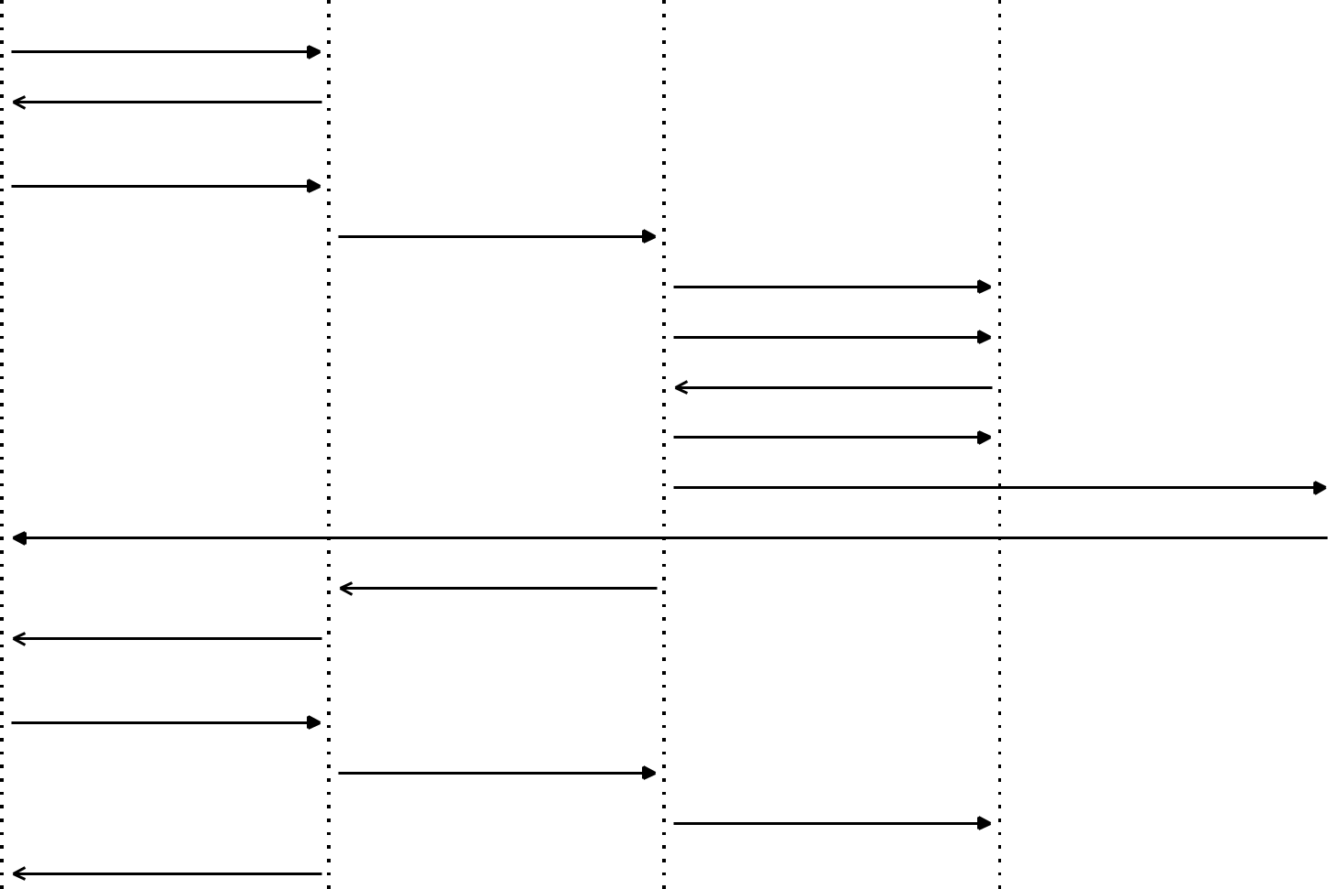

* 1. Access Registration Page

1. Display Registration Form
   * 1. Fill Registration Form

4: Submit Registration Data

5: Validate Registration Data

6: Check Email Uniqueness

7: Email Available

8: Create Patient Record

9: Generate Verification Token

10: Send Verification Email

11: Registration Success

1. Display Success Message
   1. Click Verification Link

14: Verify Token

15: Activate Account

16: Account Activated Successfully



|  |  |  |  |  |
| --- | --- | --- | --- | --- |
| Alternative Flow: Email Already |  | Alternative Flow: Validation Errors | |  |
|  |  |
| Exists |  | - Display validation messages |  |  |
|  |  |  |
| - Display error message |  | - Highlight invalid fields | |  |
| - Return to registration form |  | - Keep form data for correction | |  |
| - Highlight email field |  |  |  |  |



Email Service



**Patient Help & Support Sequence**



|  |  |  |  |  |
| --- | --- | --- | --- | --- |
| Help Portal |  | FAQ System |  | Support Database |
|  |  |  |  |  |

Patient

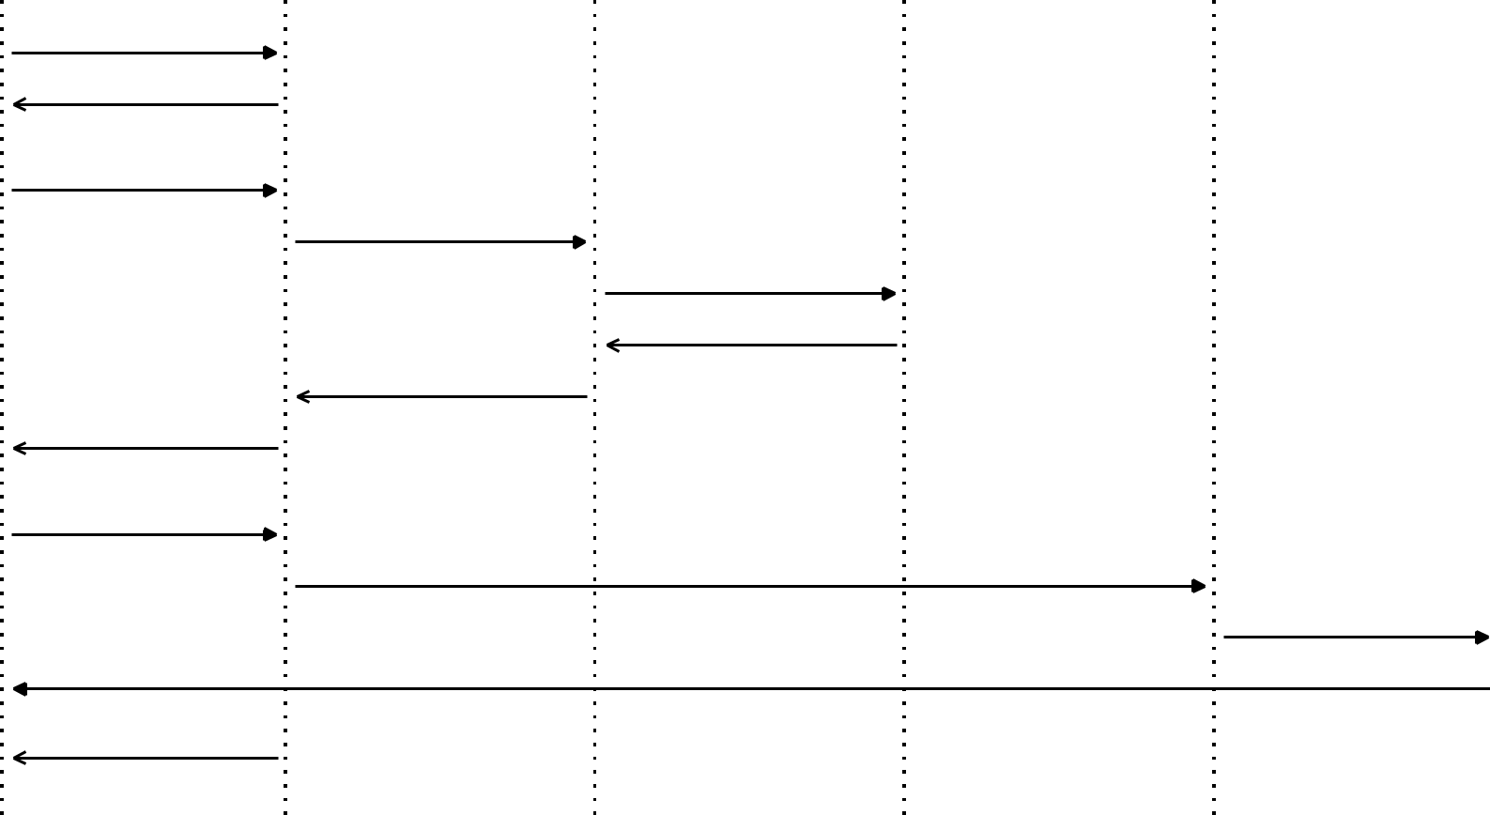

* + 1. Access Help Portal

1. Display Help Categories
   1. Enter Search Query

4: Search FAQ Database

5: Query Support Database

6: Return Search Results

7: Display FAQ Results

* 1. Show Results to Patient

1. Request Live Chat Support

10: Initialize Chat Session

12: Provide Live Support

Live Chat Service

Support Staff



11: Connect to Support Staff

13: Support Resolution



Alternative: No Results Found

* Display 'no results' message
* Suggest alternative keywords
* Offer contact options

Alternative: Chat Unavailable

* Show offline message
* Provide callback option
* Display contact information

**Appointment Booking Sequence**



|  |  |  |  |  |  |  |  |  |
| --- | --- | --- | --- | --- | --- | --- | --- | --- |
| Patient Dashboard |  | Calendar System |  | Booking System |  | Payment Gateway |  | Confirmation Service |
|  |  |  |  |  |  |  |  |  |

Patient

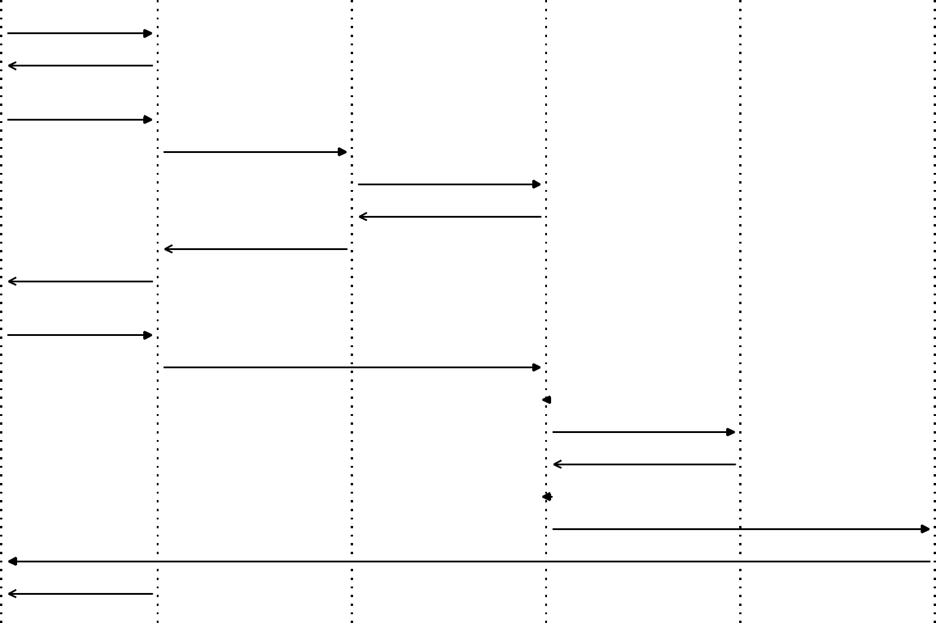

* 1. Login to Dashboard
  2. Display Dashboard

1. Click Book Appointment

4: Request Calendar View

* 1. Get Available Slots

1. Return Available Slots

7: Display Calendar

1. Show Calendar to Patient
   1. Select Date and Time

10: Submit Booking Details

11: Validate Booking

12: Process Payment

13: Payment Confirmed

14: Create Appointment

15: Generate Confirmation

16: Send Confirmation

17: Display Success Message



|  |  |  |  |
| --- | --- | --- | --- |
| Alternative: No Slots Available |  | Alternative: Payment Failed |  |
| - Display message |  | - Display payment error |  |
| - Suggest alternative dates |  | - Retry payment option | |
| - Offer waiting list option |  | - Alternative payment methods | |

**Report Access & Viewing Sequence**



|  |  |  |  |
| --- | --- | --- | --- |
| Patient Dashboard | Report Database | Security Service | DICOM Viewer |

Patient

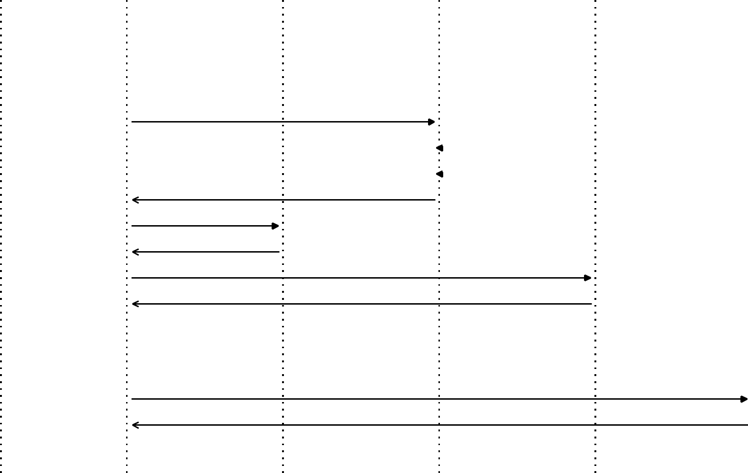

1. Access Patient Dashboard
   1. Display Reports Section
      1. Click View Report



4: Request Report Access

5: Verify Patient Identity

6: Check Access Permissions

* + 1. Access Granted
  1. Fetch Report Data

1. Return Report Data
   * + 1. Load DICOM Viewer
          1. Display MRI Images
2. Show Complete Report
   1. Request Download



14: Generate PDF Report

15: Prepare Download Link

16: Provide Download Link



|  |  |  |  |  |
| --- | --- | --- | --- | --- |
| Alternative: Access Denied |  | Alternative: No Reports Available |  |  |
| - Show access denied message |  | - Display 'no reports' message |  |  |
|  |  |  |
| - Log unauthorized attempt | | - Show pending appointments | |  |
| - Redirect to dashboard | | - Offer booking option | |  |

Download Service

