1.)Firewall window allowing to run httpd.exe

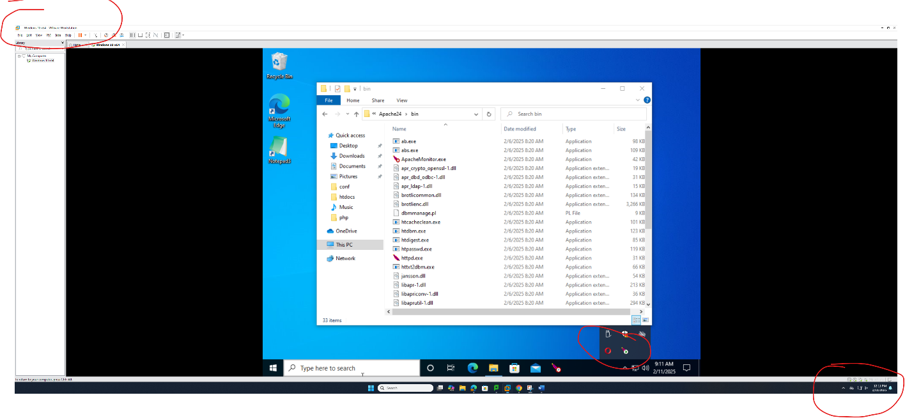3.) local host/testphp in internet browser with my name and semester info(Lab3-2)