Megan Debro

2/25/2025

It Infrastructure

1. phpMyAdmin webpageA screenshot of a computer

   AI-generated content may be incorrect.
2. localhost webpage containing Joomla sample template with my name and semester info as the title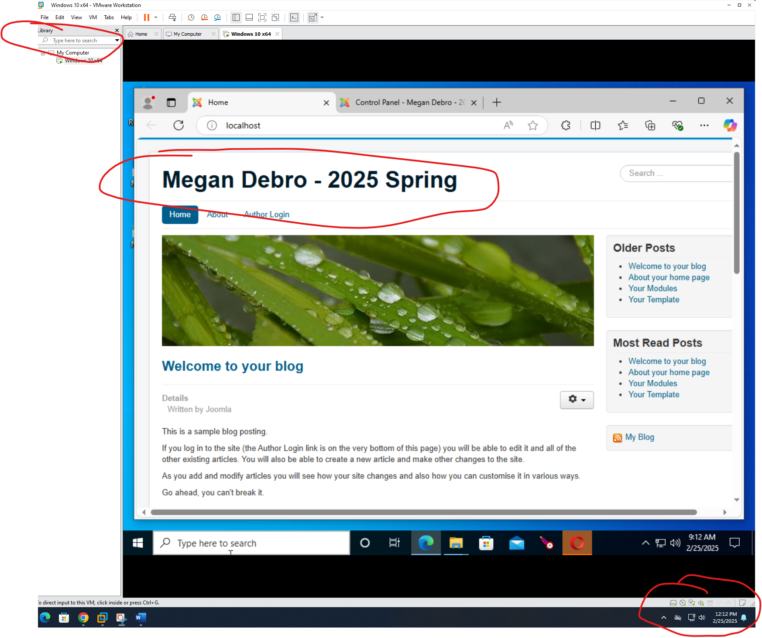
3. Joomla control panelA screenshot of a computer

   AI-generated content may be incorrect.
4. phpMyAdmin webpage containing installed Joomla database with name and semester info as the titleA screenshot of a computer

   AI-generated content may be incorrect.