Lab Report 4

Amazon Web Services Cloud 9

CSC 452-001

Andrew Almond

11/1/19

**Introduction**

From the lab, the further use of Amazon’s services through Cloud 9 greatly increase the scope of capabilities from the last lab. Cloud 9 leads to possibilities of managing the former used EC2 instances and their corresponding data as well as the now learned S3 service with its share of buckets with their attributes.

**Methods & Algorithms**

For each problem, Amazon’s Cloud 9 service was utilized to run Python programs for managing and viewing other services’ instances/buckets and their corresponding information.

Problem 1:

All of the requirements from this problem called for management of resources from the EC2 service. The first three (parts a-d) controlled the actual EC2 instance targeted by gathering information, stopping, starting, or rebooting said instance. Parts e through g had to deal with the creation or deletion of the key pair to the given instance as well as the information. The final parts did the same for the desired security group.

Problem 2:

Unlike problem 1, the focus is on using the S3 service of Amazon’s. Here, a “bucket” can be made (like in part a) to where items can be stored and retrieved (parts c and d). Like in problem 1, the information of the desired target(s) can be gathered as well (the buckets in part b, the policy in part f, and the control list in part g). Finally, the bucket can be allowed access to temporarily with a presigned URL like in part e.

**Experiments**

Problem 1:

All of the parts in this problem could be implemented and run without extra arguments besides part c. This part required specifying “ON” or “OFF” to set the state of the targeted instance.

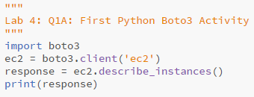

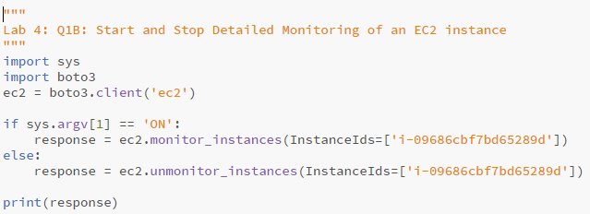

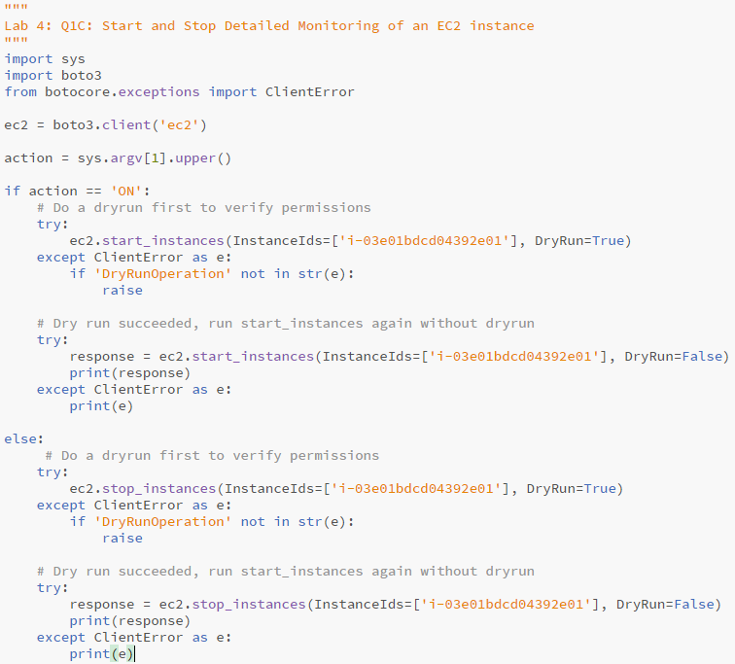

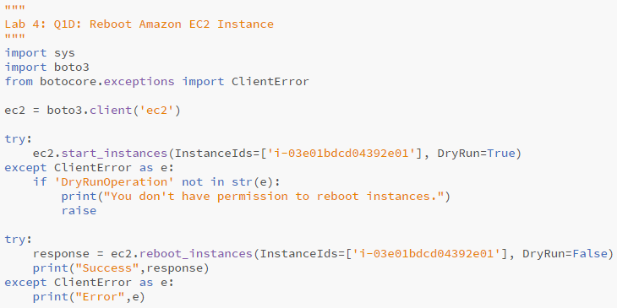

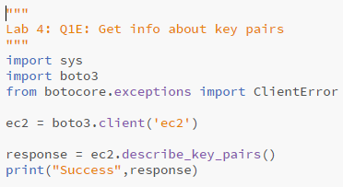

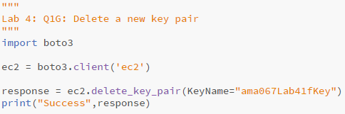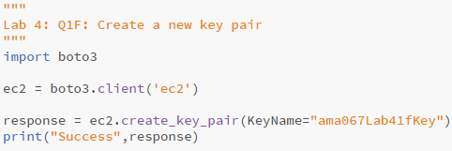

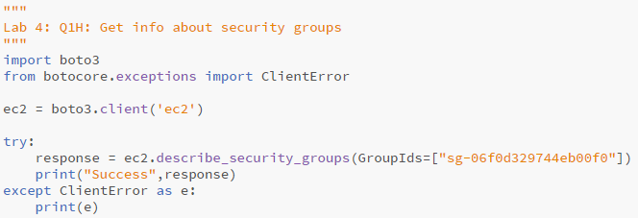

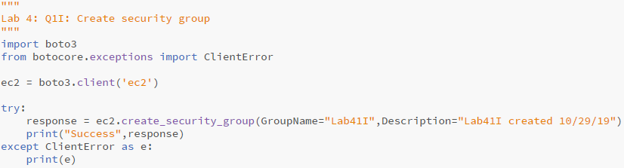

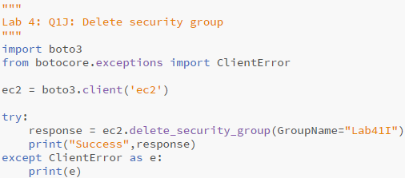

Problem 2:

Each solution for this problem didn’t require extra arguments to properly run. The target of each program was called for inside the program instead of needing to be read.

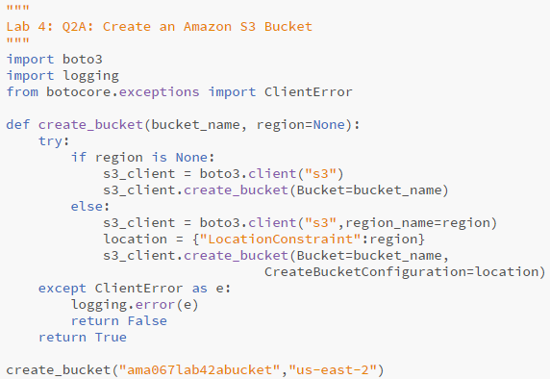

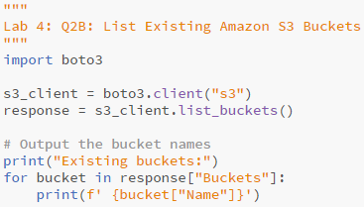

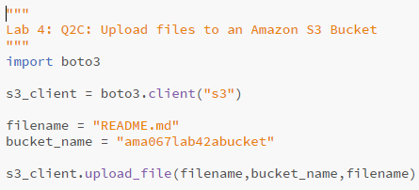

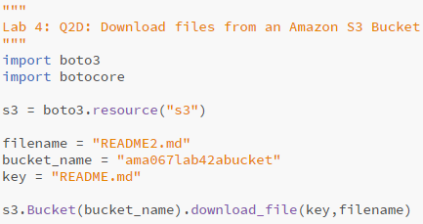

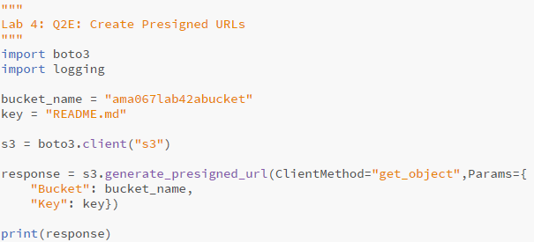

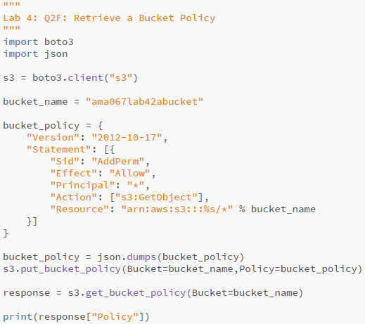

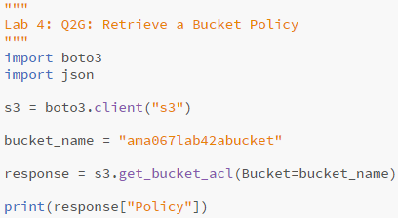

**Results**

For both problems 1 and 2, the outputs of each parts’ programs are included in the zip file and Github due to their length. Instead, below will be the Cloud 9 interface, the S3 interface showing buckets (Lab4_2A), the stored data into the bucket (Lab4_2C) and the README file downloaded from the bucket (Lab4_2D).

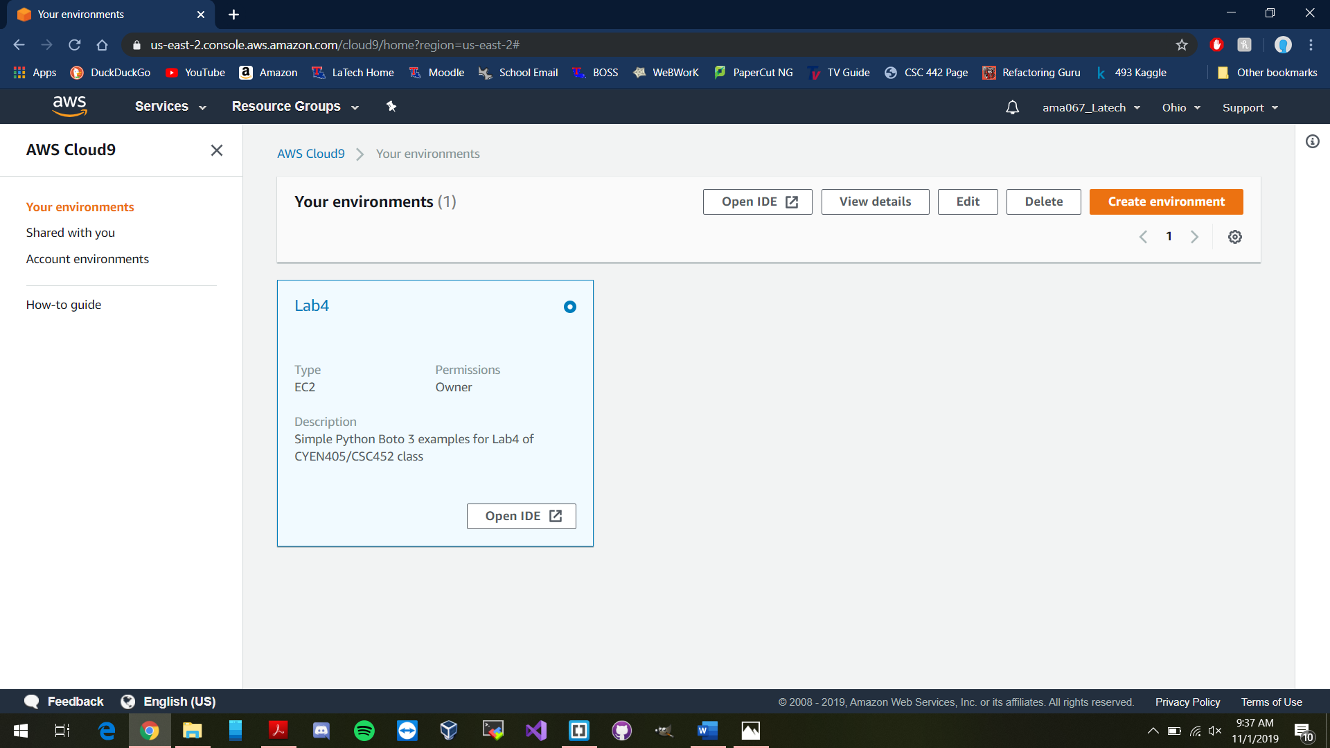

**Conclusion**

Given the outcomes of the lab, it’s clear to see the great uses of the Cloud 9 service provided by Amazon Web Services. The ability to manage and review information and instances of other services given through one interface opens the possibilities to near endless measures. Usage of this can lead to easier control over managed services without need to manually move to said services. Pairing this up with what was learned over the last lab shows again how usage of services like these given by Amazon can save time and money by offloading the work and data elsewhere.

**Github Link**

https://github.com/M3JPUV/CSC452_Labs.git