Problem 8 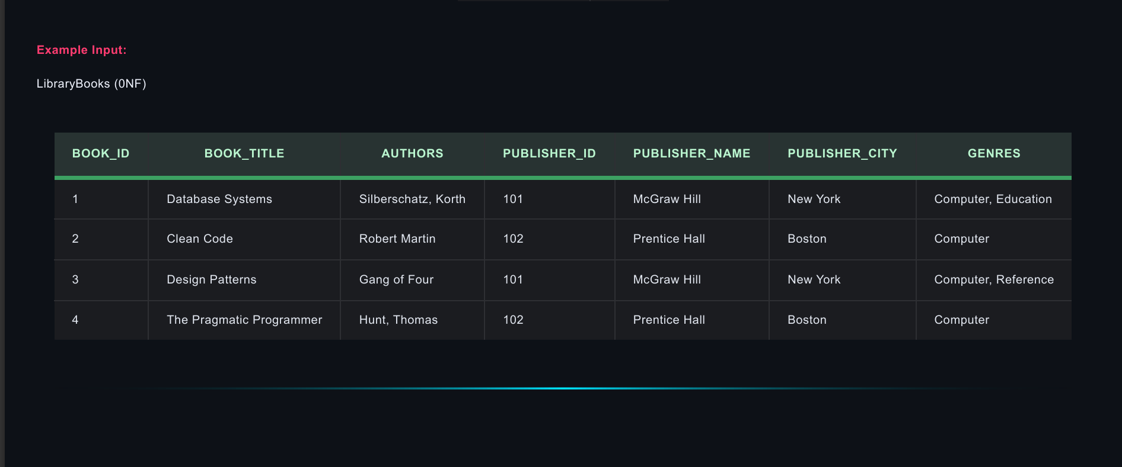
PUBLISHER_ID , PUBLISHER_NAME , PUBLISHER_CITY Repeating Groups
AUTHORS , GENRES Multivalued attributes
1NF 2NF 3NF
BOOK_ID | BOOK_TITLE | PUBLISHER_ID
1 | Database Systems | 101
2 | Clean Code | 102
3 | Design Patterns | 101
4 | The Pragmatic Programmer | 102
BOOK_ID | AUTHORS
1 | Silberschatz
1 | Korth
2 | Robert Martin
3 | Gang of Four
4 | Hunt
4 | Thomas
PUBLISHER_ID | PUBLISHER_NAME | PUBLISHER_CITY
101 | McGraw Hill | New York
102 | Prentice Hall | Boston

BOOK_ID | GENRES
1 | Computer
1 | Education
2 | Computer
3 | Computer
3 | Reference
4 | Computer

Problem 9 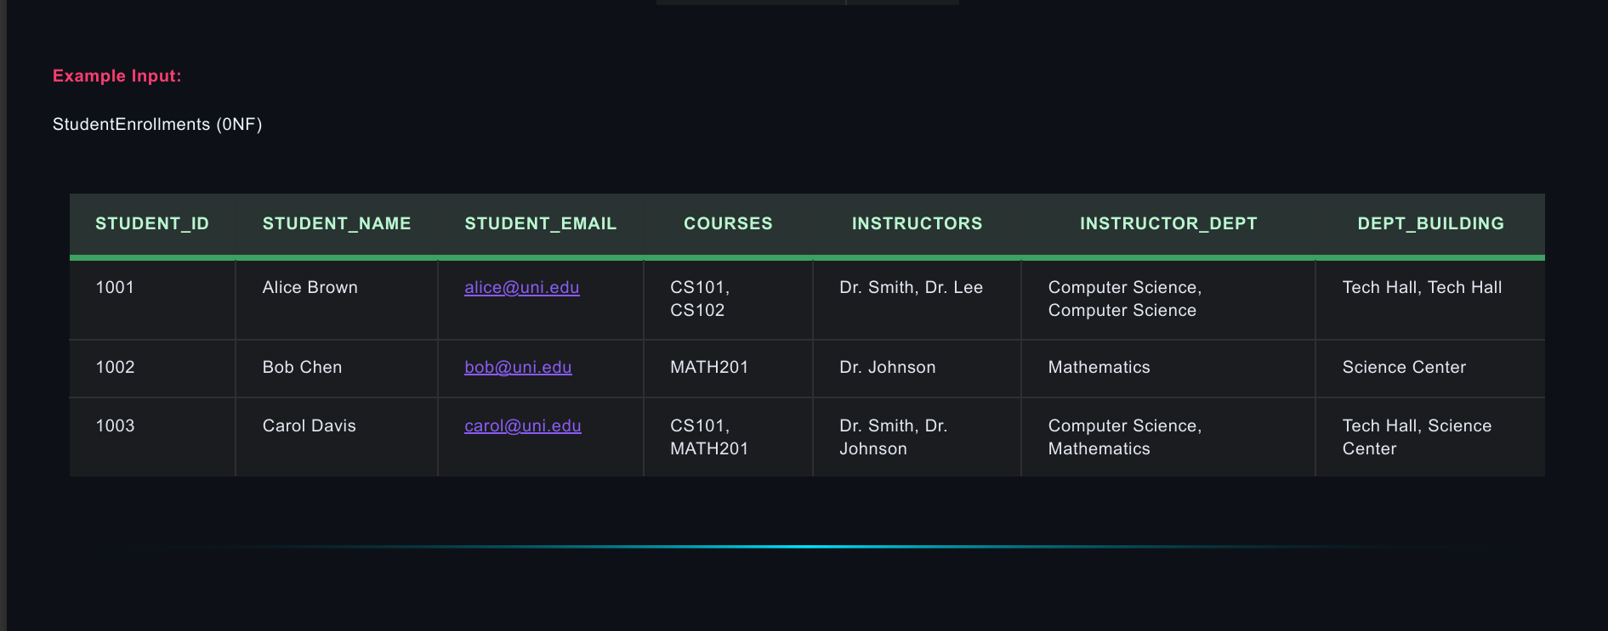
INSTRUCTORS , INSTRUCTOR_DEPT , DEPT_BUILDING Repeating Groups
COURSES Multivalued attributes
STUDENT_ID | COURSES
1001 | CS101
1001 | CS102
1002 | MATH201
1003 | CS101
1003 | MATH201
1NF 2NF
STUDENT_ID | STUDENT_NAME | STUDENT_EMAIL
1001 | Alice Brown | carol@uni.edu
1002 | Bob Chen | bob@uni.edu
1003 | Carol Davis | carol@uni.edu

COURSES | INSTRUCTORS | INSTRUCTOR_DEPT | DEPT_BUILDING
CS101 | Dr. Smith | Computer Science | Tech Hall
CS102 | Dr. Lee | Computer Science | Tech Hall
MATH201 | Dr. Johnson | Mathematics | Science Center

INSTRUCTORS INSTRUCTOR_DEPT … TFD
INSTRUCTOR_DEPT DEPT_BUILDING … TFD
STUDENT_ID | COURSES
1001 | CS101
1001 | CS102
1002 | MATH201
1003 | CS101
1003 | MATH201
3NF
STUDENT_ID | STUDENT_NAME | STUDENT_EMAIL
1001 | Alice Brown | carol@uni.edu
1002 | Bob Chen | bob@uni.edu
1003 | Carol Davis | carol@uni.edu

INSTRUCTORS | INSTRUCTOR_DEPT
Dr. Smith | Computer Science
Dr. Lee | Computer Science
Dr. Johnson | Mathematics
COURSES | INSTRUCTORS
CS101 | Dr. Smith
CS102 | Dr. Lee
MATH201 | Dr. Johnson

INSTRUCTOR_DEPT | DEPT_BUILDING
Computer Science | Tech Hall
Computer Science | Tech Hall
Mathematics | Science Center

Problem 10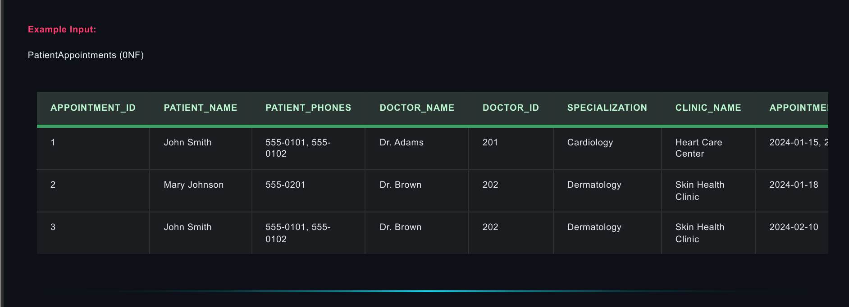PATIENT_PHONES Multivalued attributes
1NF
PATIENT_NAME | PATIENT_PHONES
John Smith | 555-0101
John Smith | 555 0102
Mary Johnson | 555-0201

APPOINTMENT  _ID | PATIENT_  NAME | DOCTOR_  NAME | DOCTOR_ID | SPECIALIZATION | CLINIC_NAME | appointment_  date
1 | John Smith | Dr. Adams | 201 | Cardiology | Heart Care Center | 2024-01-15
2 | John Smith | Dr. Brown | 202 | Dermatology | Skin Health Clinic | 2024-01-18
3 | Mary Johnson | Dr. Brown | 202 | Dermatology | Skin Health Clinic | 2024-02-10

DOCTOR_ID DOCTOR_NAME, SPECIALIZATION, CLINIC_NAME … PFD
2NF 3NF
PATIENT_NAME | PATIENT_PHONES
John Smith | 555-0101
John Smith | 555 0102
Mary Johnson | 555-0201

DOCTOR_ID | DOCTOR_  NAME | SPECIALIZATION | CLINIC_NAME
201 | Dr. Adams | Cardiology | Heart Care Center
202 | Dr. Brown | Dermatology | Skin Health Clinic

APPOINTMENT_ID | PATIENT_NAME | DOCTOR_ID | APPOINTMENT_DATE
1 | John Smith | 201 | 2024-01-15
2 | John Smith | 202 | 2024-01-18
3 | Mary Johnson | 202 | 2024-02-10

