MAWE LIMITED
COMPANY PROFILE
The Structural Foundation of Modern East African Construction
Head Office: | Juja, Kiambu | P.O. Box 1111-00000, Nairobi
Contact: | Tel: 07123456789 | Email: mawe@mawe.com

Table of Contents
1. Introduction & Executive Summary
2. Mission, Vision & Core Values
3. Executive Leadership & Management Team
4. Environmental Sustainability & Quarrying Ethics
5. Technical Specifications & Quality Assurance
6. Our Core Products Portfolio
7. Processing Infrastructure & Fleet Logistics
8. Major Clients & Strategic Projects
9. Statutory Compliance & Annexes

1. Introduction & Executive Summary
Mawe Limited is a premier, fully integrated construction materials manufacturing and supply enterprise based in Juja, Kiambu County, with robust operational reach extending across Nairobi and the greater East African region. Founded on principles of unwavering structural integrity, operational excellence, and sustainable resource extraction, Mawe Limited serves as the backbone for infrastructural development, commercial real estate, civil engineering, and residential housing projects.
By owning and responsibly operating extensive raw material reserves—including high-grade sand quarries, aggregate crushing plants, and strategic partnerships with premier cement manufacturers—Mawe Limited guarantees consistent supply chain reliability, superior material grading, and competitive wholesale pricing. Our commitment to rigorous quality control ensures that every cubic meter of sand, every ton of ballast, and every bag of cement delivered to a job site meets or exceeds Kenya Bureau of Standards (KEBS) and international engineering benchmarks.
“At Mawe Limited, we do not merely supply construction materials; we provide the foundational bedrock upon which durable communities, towering commercial edifices, and enduring infrastructure are built.”

2. Mission, Vision & Core Values
Our Vision
To be East Africa’s most trusted, innovative, and environmentally responsible provider of premium construction aggregates and building materials.
Our Mission
To empower the construction and real estate sector with uncompromised material quality, reliable logistics, and sustainable resource management, ensuring every project stands on a foundation of absolute strength.
Core Values
• Uncompromising Quality: Rigorous laboratory testing and screening guarantee superior material strength and performance.
• Reliability & Punctuality: Dedicated transport fleet ensuring on-time job site delivery without project delays.
• Environmental Stewardship: Active land rehabilitation, closed-loop water recycling, and responsible quarrying practices.
• Client Partnership: Transparent pricing, flexible supply volumes, and dedicated technical advisory for contractors and developers.
3. Executive Leadership & Management Team
Mawe Limited is steered by a multidisciplinary team of seasoned professionals with decades of combined expertise in civil engineering, geological surveying, industrial manufacturing, corporate finance, and supply chain logistics.
Eng. David Maina - Managing Director (MD)
Eng. David holds a Master of Science in Civil Engineering and a Bachelor of Science in Construction Management. With over 22 years of experience directing large-scale infrastructural projects across East Africa, David provides the strategic vision guiding Mawe Limited's quarry expansion and operational scaling.
Grace Wanjiku, CPA - Head of Finance & Corporate Strategy
Grace is a Certified Public Accountant (K) with an MBA in Finance. She oversees the company's financial health, capital allocation for heavy machinery acquisition, and sustainable cost-management models that allow Mawe Limited to maintain highly competitive market pricing without compromising quality.
James Omondi - Head of Quarry Operations & Production
James brings extensive hands-on expertise in open-cast mining, rock crushing technology, and aggregate grading. He manages day-to-day operations at our Juja processing plant, ensuring optimal mechanical efficiency, stringent workplace safety standards, and strict adherence to environmental regulations.
Sarah Chebet - Quality Assurance & Technical Services Director
Sarah specializes in materials science and geotechnical engineering. She leads our on-site testing laboratories, conducting sieve analysis, moisture content testing, and compressive strength evaluations to certify every outgoing batch of sand, ballast, and cement.

4. Environmental Sustainability & Quarrying Ethics
At Mawe Limited, industrial extraction and environmental conservation go hand in hand. We recognize that construction materials originate from the earth, and our operational philosophy is anchored in a closed-loop, regenerative model designed to protect Kiambu’s ecosystem.
• Responsible Quarrying: Our extraction pits are engineered to prevent soil erosion and protect local groundwater tables. We utilize precision controlled extraction methods to minimize noise and dust pollution.
• Land Rehabilitation & Reforestation: Depleted quarry sectors do not remain scarred. Mawe Limited executes a progressive land restoration program, backfilling with organic overburden and planting indigenous trees and vegetation to restore local biodiversity.
• Water Conservation & Recycling: Aggregate washing and dust suppression systems operate on closed-loop sedimentation basins that recycle 85% of process water, minimizing abstraction from local water sources.
5. Technical Specifications & Quality Assurance
Structural failure in construction often traces back to substandard material grading, improper aggregate sizing, or contaminated sand. Mawe Limited operates a zero-tolerance quality assurance protocol.
• Sieve Analysis & Grading: All aggregates undergo automated mechanical screening to guarantee strict compliance with BS 882 and KS EAS standards.
• Cleanliness & Silt Content: Our river sand and plaster sand are rigorously washed to maintain silt content well below the critical 3% threshold, preventing cracking in plastering and masonry works.
• Cement Hydration Standards: We partner exclusively with certified East African cement mills, supplying fresh, factory-sealed Ordinary Portland Cement (OPC) and Portland Pozzolana Cement (PPC) with optimal setting times and high early strength.

6. Our Core Products Portfolio
Mawe Limited provides a comprehensive suite of high-grade construction materials tailored for residential developments, mega-infrastructure projects, road construction, and concrete precast manufacturing.
1. Construction Sand (River Sand & Plaster Sand)
Our sand is harvested from sustainably managed sources and thoroughly washed to remove organic impurities and excess silt. We supply coarse river sand ideal for heavy structural concrete casting and fine plaster sand that guarantees exceptionally smooth wall finishes and strong mortar bonds.
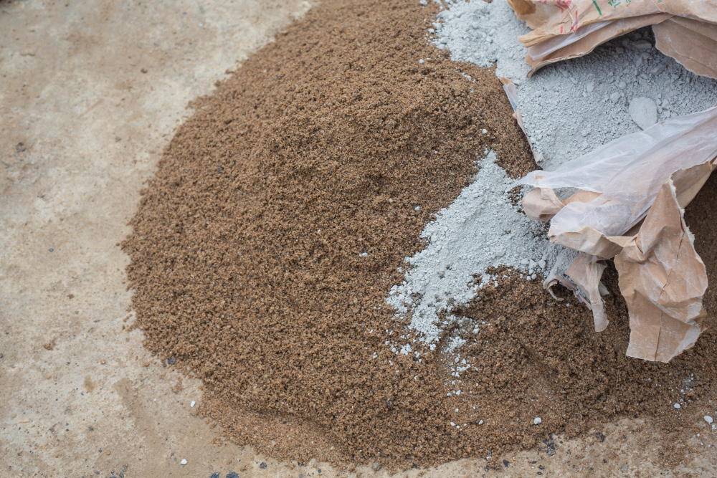
Figure 1: Premium graded construction sand and high-purity bagged cement ready for site dispatch.

2. Crushed Ballast & Aggregate (3/8", 1/2", 3/4", and 1")
Crushed from premium blue-hard phonolite rock at our Juja crushing plant, Mawe Limited ballast offers exceptional compressive strength and angular interlocking properties. Available in multiple gradations (3/8" for precast slabs, 1/2" and 3/4" for standard reinforced concrete columns and beams, and 1" for heavy foundations and road sub-bases).
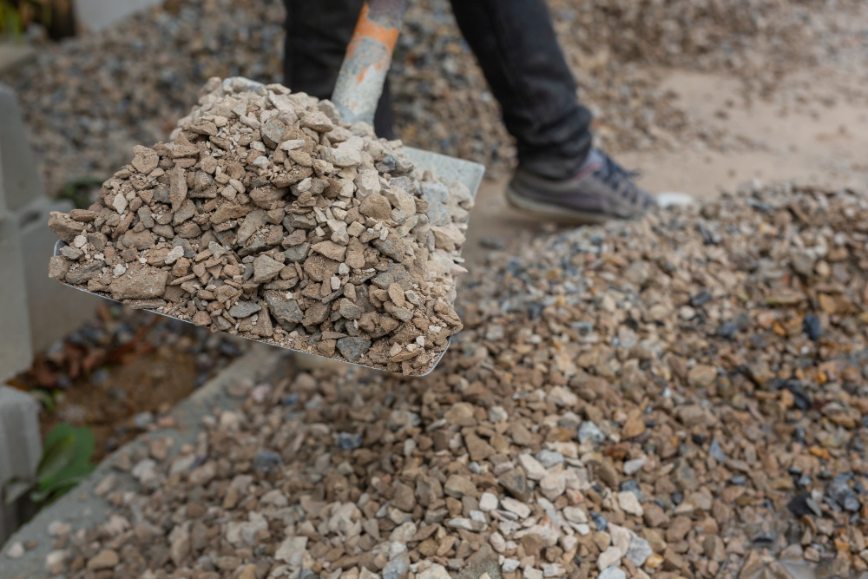
Figure 2: High-strength angular crushed ballast (blue metal) being loaded for heavy civil construction.

3. Certified Cement & Specialized Binders
As an authorized bulk distributor and aggregator, Mawe Limited supplies top-tier Portland Pozzolana Cement (PPC) and Ordinary Portland Cement (OPC). Our cement is stored in climate-controlled moisture-barrier warehouses, ensuring zero pre-hydration lumps and maximum binding strength upon mixing.
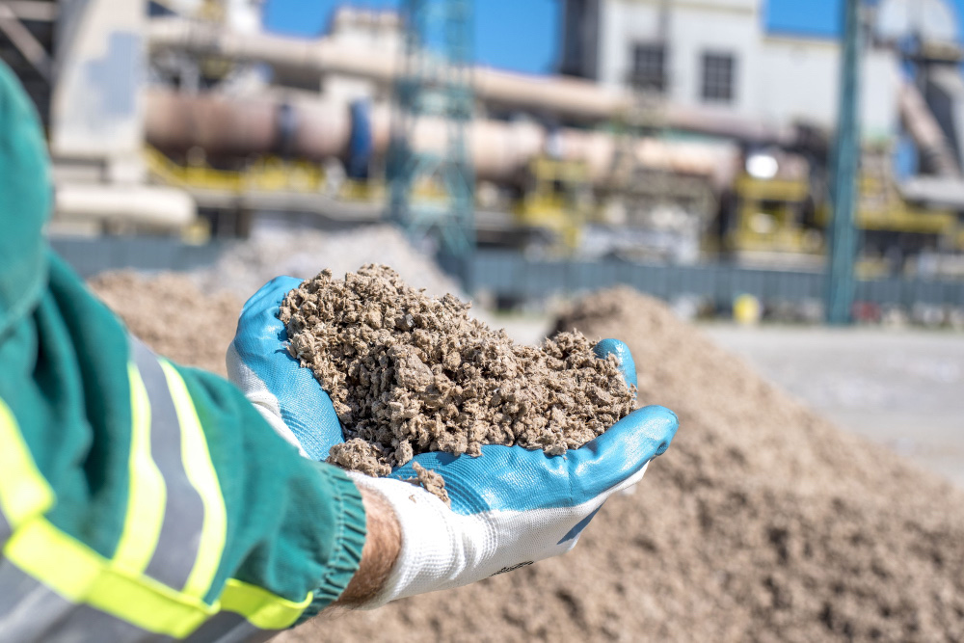
Figure 3: Quality inspection of raw material mix and binder consistency at our Juja production facility.

7. Processing Infrastructure & Fleet Logistics
Mawe Limited operates state-of-the-art crushing, screening, and washing machinery capable of processing over 1,500 tons of raw aggregates daily. Our automated jaw and cone crushers ensure precise particle size distribution.
Furthermore, our dedicated logistics fleet—comprising heavy-duty tippers, dump trucks, and bulk transport tankers—guarantees seamless delivery directly to construction sites across Nairobi, Kiambu, Machakos, and Murang'a. Real-time GPS tracking and dedicated dispatch managers ensure zero downtime for client projects.
8. Major Clients & Strategic Projects
Mawe Limited is the preferred material supplier for leading real estate developers, civil engineering contractors, government road expansion projects, and commercial hardware networks across Kenya. Our proven track record of reliable bulk supply, transparent trade terms, and consistent material quality has earned us long-standing partnerships with industry leaders.
9. Statutory Compliance & Corporate Annexes
Mawe Limited operates in full compliance with the laws of the Republic of Kenya. Our corporate governance and regulatory compliance framework includes:
✓ Certificate of Incorporation (Companies Act)
✓ Kenya Revenue Authority (KRA) Tax Compliance Certificate
✓ National Environment Management Authority (NEMA) Environmental Impact Assessment (EIA) License
✓ Mining and Quarrying Operating Permits (Kiambu County Government)
✓ KEBS Product Standardization Marks and Quality Assurance Certifications

MAWE LIMITED — BUILD WITH CONFIDENCE
Head Office: Juja, Kiambu | P.O. Box 1111-00000, Nairobi
Tel: 07123456789 | Email: mawe@mawe.com

