VSCode / Git / GitHub errors & helps

## Git: gpg: skipped <email>: No Secret Key

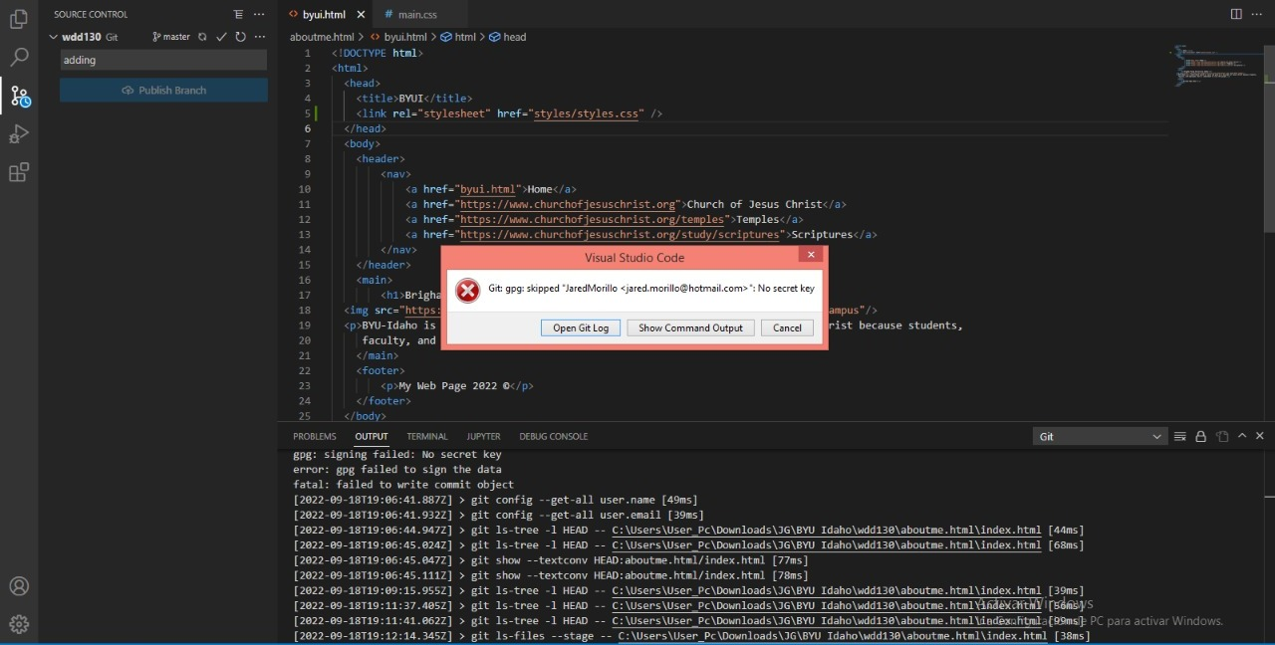

This has to do with how Git is configured with GPG signing process. This is an issue on Windows computers, as the GPG implementation is weird.

There are a few potential ways to fix this issue.

I would recommend turning off the signing with GPG.

Here are the steps to disable this option

Go to VSCode preferences - Settings

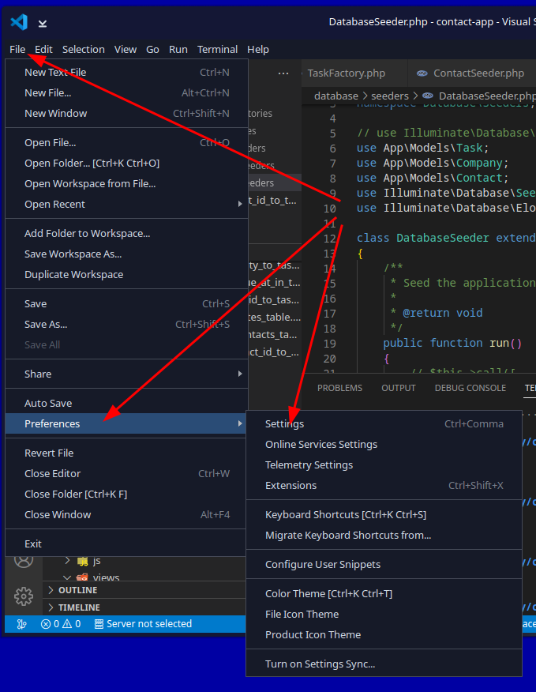

Type this into the search bar to find the setting

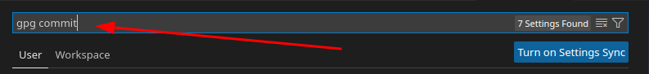

Make sure this option is not checked. This is the option that tells VSCode to use PGP while pushing to GitHub.

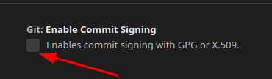

## Permission Error trying to Push to GitHub

You don’t have permissions to push to <GitHub Account> on GitHub. Would you like to create a fork and push it instead?

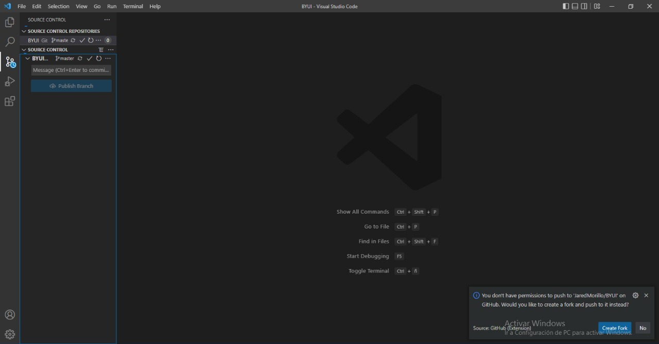

This error is because VSCode was previously configured for another user account on GitHub. There are two solutions.

Go to GitHub and log into the old account and click on the user profile picture in the top right of the web page. Select Settings

On the left navigation menu, select Password and Authentication

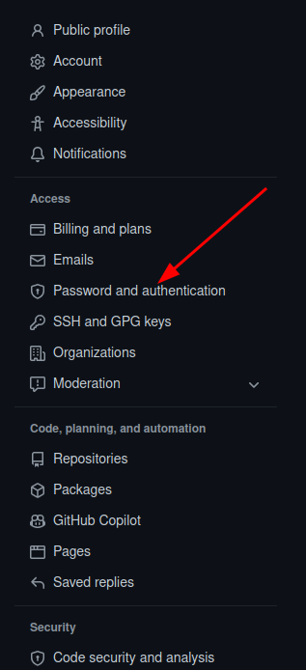

Then click on the Authorized Oauth Apps tab

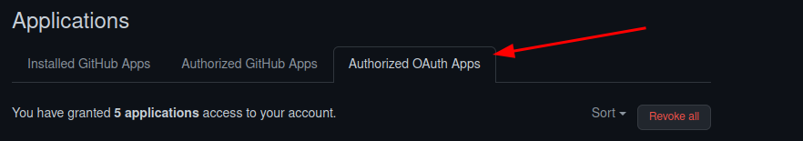

Click on the 3 dots to the left of GitHub for VSCode



Click the Revoke option



This will force VSCode to re-authenticate with GitHub.

If this is not a possibility and you must have two GitHub accounts with VSCode You have to go through an elaborate setup with a few extensions and you use the Profile icon in the bar in VSCode to switch to the various profiles. This is problematic at times.

This from StackOverflow has all the steps needed to setup multiple accounts. There are 3 possibilities.

<https://stackoverflow.com/questions/62625513/i-have-2-github-accounts-how-can-i-use-both-when-i-am-working-in-vs-code>

There are other authentication methods, but they are much more complex to setup and require installation of additional software.

## GitHub Pages does not initialize

There is an issue where the GitHub pages do not initialize the first time. This means you must re-initialize a push to GitHub and then recreate the pages setup.

1. Goto the pages setup page and change the branch to NONE

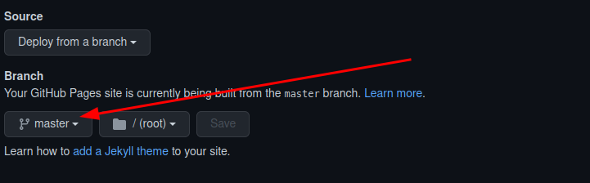

Click save

2. Go to VSCode and push to GitHub

You can do an empty push by typing the following commands in the command prompt

git commit --allow-empty -m "Trigger rebuild"

git push

3. Go back to GitHub Pages and recreate the pages setup.

Click on the Actions menu option



Watch the top entry until the icon to the left turns blue with a check mark. That means it is complete. The red circle with an X means that it failed.



You will notice that the process will take longer than 1 minute. This is due to some change GitHub has made on the server due to new features that are being added. Even publishing the push/sync from VSCode takes as long as 90 seconds (1 min 30 sec).

**If the user gets a failed again, check the spelling of the folders and file names. This process seems to fail if the user has spaces in the folder and filenames and sometime if there are underscores in these names.**

## Make sure to configure your ‘user.name’ and ‘user.email’ in git

If the user gets this error, they missed that step in the configuration of Git. It is found in the installation steps of Git for Windows.

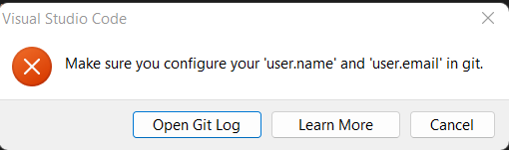

Open the terminal or command prompt. This can be the one inside VSCode

Type each of these commands

git config –global user.name ‘github user name’

git config –global user.email ‘email address used on github’

Try to push to GitHub

If you still have issues, then contact someone for help

## VSCode push/sync to GitHub seems to hang and not do anything

There are a few reasons as to why this will occur. There are a couple of things to try.

1. Open a terminal/command window and try to push to GitHub using the command line

git push

You may get an error that says something like this (It will look different on the various OS’s):

There is no tracking information for the current branch.

Please specify which branch you want to merge with.

See git-pull(1) for details

git push <remote> <branch>

If you wish to set tracking information for this branch you can do so with:

git push --set-upstream origin master

If you get that error at the command line type in the command

git push –set-upstream origin master

Then do a git push command

You may be prompted to authenticate with GitHub again.

Once the push/sync is complete, you will need to restart VSCode and the GitHub controls within VSCode should work again.

2. The other reasons why this process will hang are too numerous and hard to give instructions on how to overcome in this document. This will require more research with debug logs to see if there is a reason for the hang.

## Windows Error message: App or process blocked: git.exe

User is trying to run git commands at the command prompt and Windows is displaying the following Windows System error

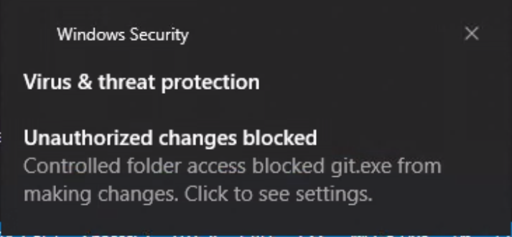

The instructions to fix this is specific to the version of Windows that is being run. Here are the basic steps:https://support.microsoft.com/en-us/windows/allow-an-app-to-access-controlled-folders-b5b6627a-b008-2ca2-7931-7e51e912b034

## Use controlled folder access

Controlled folder access in Windows Security reviews the apps that can make changes to files in protected folders and blocks unauthorized or unsafe apps from accessing or changing files in those folders.

1. Select **Start** > **Settings** > **Update & Security** > **Windows Security** > **Virus & threat protection**.
2. Under **Virus & threat protection settings**, select **Manage settings**.
3. Under **Controlled folder access**, select **Manage Controlled folder access**.
4. Switch the **Controlled folder access** setting to **On** or **Off**.

There is an option to allow just one program to run in this Controlled Folder Access and you can select git.exe from the recently blocked programs.

If you look at the Windows Notifications, you may see an error like this.

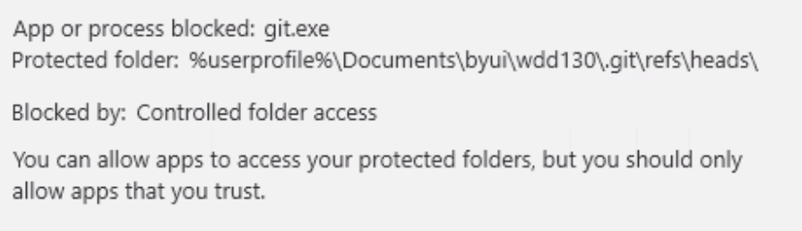This is the same steps as above for the same error. Microsoft has a few different ways to present this message. It will also be logged in the System Logs.

# **Useful suggestions**

## User is prompted to configure formatter

If the user installs the Prettier extension, which is not needed, the first time they go to format the code, they will be prompted to select a formatter for that type of file type (HTML or CSS). VSCode as a code formatter built into the editor that works well with HTML, CSS, JavaScript, and PHP.

(Need to get screenshot of these prompts)

## Users with multiple coding projects/classes

It is recommended that if you are doing multiple coding projects at a time and each has its own folder/directory structure, you install an extension called Project Manager

Go to extensions

Search for Project Manager

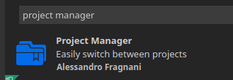

Click Install Once installed open one project folder only

Click on the Project Manager icon in the icons on the left or right of the editor



You should see a blue button that states: Project **Manager: Save Project -** Click that button and you will be prompted for a name at the top center of the screen. The default name is the folder name.

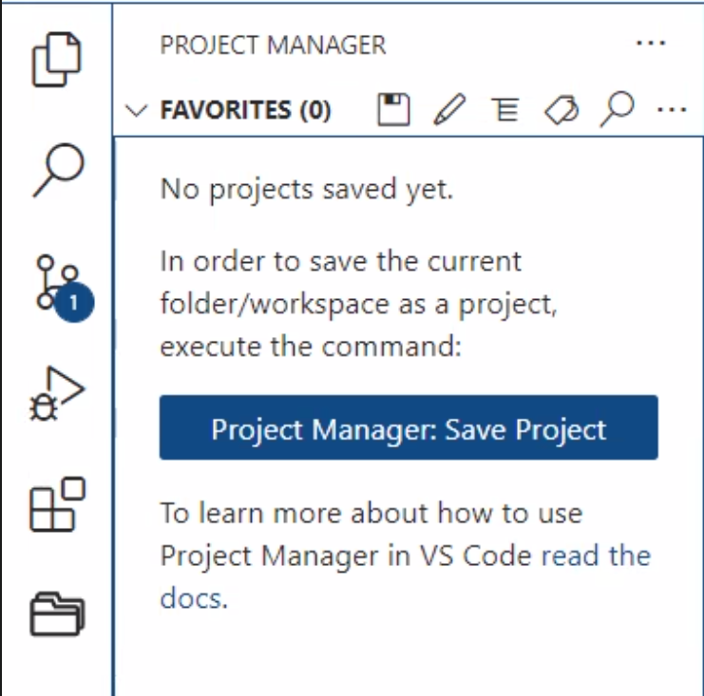

That will then add that project name to the Project Manager list of projects.

Open the second project folder in its own workspace.

Click the Save icon in the Project Manager folder icon area.

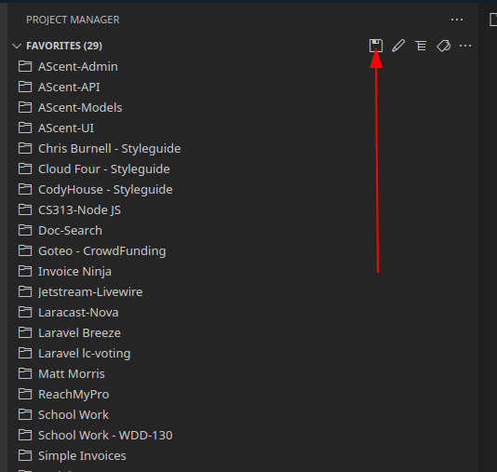

Give your project a name and hit enter. This will add it to the list.

If you click the edit icon, it will open the JSON file that lists your projects. The format is quite easy to follow. The rule is that each project must be enclosed with { } and must have a comma between the project section.

* **Name** is the name of the project
* **Rootpath** is the path to the project.
* **Paths** is not used at this time
* **Tags** is a way to categorize the type of project for sorting. This list is up to the person
* **Enabled** is if the project will display or not in the list of projects. This is a way to only show projects you are currently working on.

{

"name": "WDD-130",

"rootPath": "/var/www/html/school/wdd130",

"paths": [],

"tags": ["School", "WDD-130"],

"enabled": true

},

## 8 Pushing to Github using fewer steps

When you are on the Git tab in VSCode, the button to Commit and Sync may state **Commit** only.

If you click on the down arrow to the right of the button and select Commit & Sync

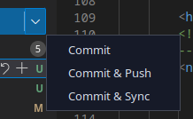

If this is the first time you are doing that you should see the following messages. On the first dialog, click the **Always** button

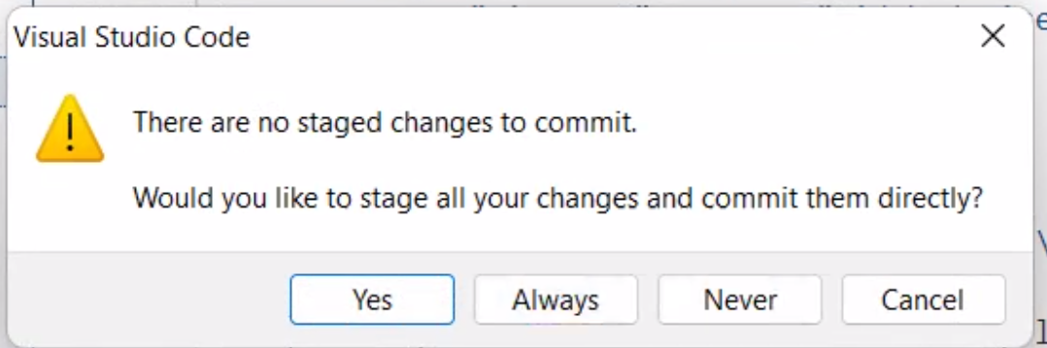

On this next dialog, click the **OK,** **Don’t Show Again** button

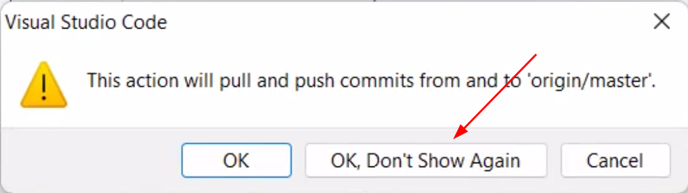

Sometimes these will prompt on the second time you click on the Commit & Sync ooption.

Your button should, but does not always, change to be this button.

