40483710: Individual Initial Design Specification Guidance

Scenario Overview
Mortality rates heavily increased following COVID-19, and global health progress continues to slow due to economic disparities, infectious diseases, and under-resourced systems. We aim to contribute to health and well-being by developing a fitness management system. Our goal is to both streamline fitness facilities and retain statistics for analysis. An organisation that utilises this service is TRIBE, an independent personal training gym located in Belfast, which utilises a booking application that allows members to sign up for fitness classes.

Real-World Challenge
This system facilitates healthy living for individuals engaged in fitness, specifically by providing organisational management for training. The daily responsibilities presented by everyday life can quickly excuse the self-imposed task of going to the gym or going for a walk. Personal training holds individuals accountable and succinctly measures progress, inspiring confidence and continued participation. Reporting is critical in this context, as it returns time to the clients. Personal trainers shoulder the responsibility of measuring progress using operational tools. These facilities, provided through data collection, will directly influence the well-being of individuals seeking health reform.

SDG Alignment
Our solution best aligns with United Nations Sustainable Development Goal 3. Generally, Goal 3 “ensures healthy lives and promotes well-being for all ages.” Heart disease, cancer, and respiratory diseases can all be greatly influenced by long-term fitness engagement. Our application facilitates the availability of preventative treatment for the groups suffering from these illnesses. By supplying a robust and diverse application to manage services, we encourage members to drive forward and combat threats to their health prematurely.

Proposed System and Key Users
Our system will manage class reservations for a fitness centre. Basic functionalities include booking classes, tracking member progress, and attendance. Member registration records initial health details. Members make reservations with their desired course, location, and time. Members can make multiple bookings, and bookings can have multiple members. Health details for each member can be accessed at any time. Classes can also be created, updated, or viewed for reference. Emerging personal fitness studios are one of the primary external stakeholders that would benefit from our system at a managerial level. Customers utilising our service are significantly influenced by our design and serve as the main key internal beneficiary.

Data Sources and Evidence Base
TRIBE fitness training centre maintains an app that serves as an invaluable resource for those engaged in fitness. It boasts many features included in our design: a schedule with the dates, times, locations, and class types for class sessions, a reservations page allowing customers to view and update their schedules, and a page where customers can record measurements over time. Centres contain attributes about their assigned coaches, location, and name, while members retain all personally identifiable information. Coaches retain personal details, centre assignment, and contact information. Classes will be sorted by type, date, time, member associations, and foreign location information. Reservations will manage the relationship between members and classes, containing foreign keys from required tables. A coach assignment table will handle the many-to-many relationship between coaches and centres. For reporting purposes, we hope to simplify progress lookups for the clientele. Gathering which members are attending, how many members are attending, and which classes they are attending will also be of interest.

Initial Data Model (ERD)
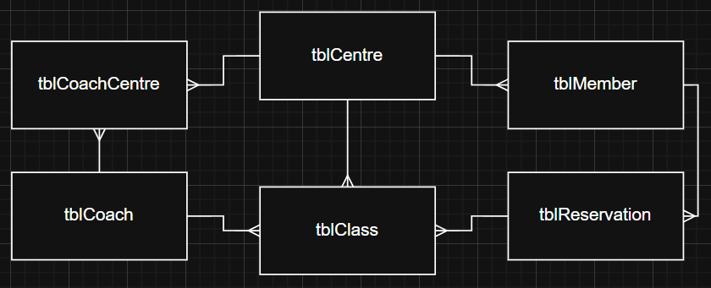

Key CRUD Functionality
Only tables pertaining to the specification may be established as entities in the database: tblCentre, tblCoach, tblCoachCentre, tblMember, tblClass, and tblReservation. Records may be created, read, updated, and deleted as needed. Business Questions: Largely pertain to organisation and clientele performance over specific periods.
- How many members are attending a specific class time on a specific date?
- Which classes are experiencing a low turnout?
- Which classes are experiencing a high turnout and may indicate a necessary increase in size?
- Which members have attended the least number of classes this month?
- Who was the most active member this year?
- Which members have experienced the greatest muscle increase over 6 months?

Data Integrity and Security Considerations
Members must be assigned unique member IDs for identification. The forename and surname of each member is required, along with their contact. Though an email is required, a telephone number is not. A member’s measurements must be appropriate and validated by a fixed range. A fitness centre must be assigned a name and address. Centres must record an email address and telephone number. Coaches may be assigned to multiple centres; their contact and personal info is recorded along with their specialisation. Coaches are then assigned to centres using the coach assignment table linking the two entities. Classes require a name, type, date, time, and unique identifier. Dates and times must be made available for future classes; previous classes will be removed. Class types will be restricted to a list of allowed values: SGPT, Hyrox, HIIT, and Boxing. Reservations must record all information regarding the class, centre, and members that will be attending. Members will retain a list of their reservations, but this can be null. All string variables will be validated for appropriate length.

