40479966 Database Design Specification
For this project, I have chosen to focus my database on a library system, allowing users to register accounts, take out books online, view what books they have taken out, possible books they could take out and produces reports showing statistics on what kind of books they and other users take out. This system is intended to make the process of viewing what books significantly easier for the regular person and encourage them to learn more and educate themselves.
This system addresses the real issue of book and overall information accessibility for the general public. Unlike in the past, libraries have become a more niche source of information compared to the internet, and people prefer to look things up online rather than go to a nearby library. While this convivence is appreciated, it has resulted in a degradation of care for public libraries. Information online is very often not fact checked or well researched, and a lot of disinformation can occur due to this. Trying to discover things online can also be very overwhelming and result in the person being overloaded with information and giving up on the learning. This system aims to make libraries much more accessible in order to shift focus on getting information from much more well researched sources. Data must be collected so people can browser the books that best match what they are looking for, and for statistical proof of which books and information people are more interested in learning about so more resources can be dedicated to those areas.
This system is aiming to tackle the fourth united nations sustainable development goal - ensuring inclusive and equitable quality education and promote lifelong learning opportunities for all. The system will not only provide a more robust way of people finding what they want to learn, it will reduce overall friction for the general population when trying to use the library service, making it more appealing. This system will inform what sort of workshops and additional materials should be created in order to support learning based on reports produced of what types of books have proven most popular. The system will also provide an easy way for students to borrow textbooks and other expensive information sources required for their education that they may not be able to afford to buy.
The database system will include 6 primary tables – User, Book, Author, Library, Wishlist, Borrowed. Users can register as a user, which includes inputting personal information such as name, date of birth, payment details and more. Users can then browse possible books that could take out and add them to their associated Wishlist entity or reserve a book and go to the library in the real world to take the book out. During this process the book will be added to the user’s associated Borrowed entity. Each copy of a book is given a record in the Book table with its name, author, date of publishing, date last taken out, if it is currently borrowed etc. The Author table will store author names, personal details, associated publishers and more. The Library table will store a different library location in each record, which will include their name, location and other relevant information.
A major example of a similar database for this specification was the ‘ArchiveGrid’ website. While this specific resource is mainly focused on cataloguing research papers rather than books, it’s structure was still majorly useful in this specification’s creation. The data source allows you to select a specific information source location, sorted by US state, and then lets you view the list of available research papers on display. Contact information is also supplied for each location, and each paper has the author listed. Papers can also be searched by author, allowing a user to view their full body of work. These examples have been taken into account and implemented in some form into this specification’s structure.
https://researchworks.oclc.org/archivegrid/?q=contributor%3A10381&ft=1
Database ERD
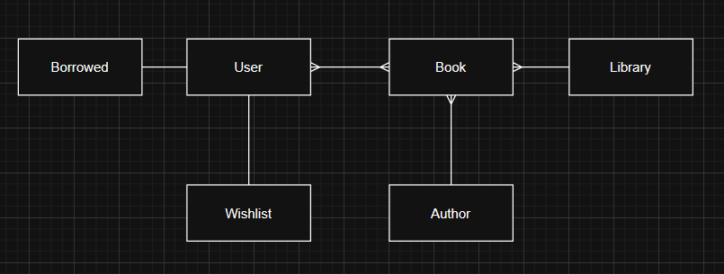
The system will support multiple crud operations, including
- Being able to create new records in user, borrowed and wishlist tables through a user interface in the web app
- Being able to read information from each table in the form of tabular reports and charts that are user friendly and answer relevant business questions
- Being able to update information in the user, borrowed and wishlist tables if required through a user interface in the web app
- Being able to delete user, borrowed and wishlist records through a user interface in the web app, and that delete being able to make cascading changes (e.g. deleting a user record will also delete associated borrowed and wishlist records)
Possible business questions that could be answered through reports are
- Which authors are taken out the most, which can show if more copies of those books need to be bought
- Which authors book’s does each user borrow the most, which can provide valuable insight to what a specific user might be interested in and can be parameterised by adding a search bar to search for a user’s or author’s specific name
- User ages and how that affects their reading habits
- Amount of books borrowed in each month, which can show when libraries are busier at which times of the year
- Which genres of books are taken out the most, to gauge user interest
Each table would require certain data integrity and security considerations to be made in order for them to be used, as if this wasn’t taken into account there could be major issues with the database, such as inaccurate data or user data being stolen. Without constraints, the database could be filled with invalid, meaningless data that cannot be effectively used by any organization. Constraints give insurance that data entered into a database will fit the correct format and be meaningful and reverent. Possible constraints can include
- NOT NULL to ensure a field in a record is filled, in case it is necessary information or required for a relationship, for example with usernames or postcodes
- UNQIUE to ensure each field in each record is different to any other to prevent any duplication, for example with primary keys
- default so you can have a regular value that a field is automatically set to if it is not filled in, for example with a rating system.

