Database Design Specification

Development Scenario + Real World Challenges
The NHS has been under very heavy pressure in recent times following the aftermath of COVID-19 from which it has never truly recovered. Hospitals and health centres are struggling from a lack of funding and resources, and patients are not receiving the care they need due to many health centres being under-staffed. The goal of this development is to create a functional database system and website for many health centres across NI to improve community access to necessary healthcare and streamline the appointment process, minimising stress on the limited staff. This seeks to minimise miscommunications with the scheduling process by improving communication between staff and patients with the creation of accessible patient records and appointment timetables. Community reach should be monitored through reports and recording analytical data, ensuring that the database is scalable for possible future expansions.

SDG Alignment
This development was made to align with the United Nations’ Third Sustainable Development Goal - to “ensure healthy lives and promote well-being for all at all ages”. We aim to target this goal by improving the accessibility of community healthcare by providing many health centres with a simpler way of keeping patient records and scheduling appointments. By making improvements to the convenience of local healthcare, we hope that this will encourage more people to be able to take action with their health and get checkups more frequently to reduce many preventable conditions and threats to both physical and mental wellbeing from going untreated.

Proposed System and Key Users
The proposed system will be facilitating the appointment scheduling process for a health centre, with additional functions such as a basic patient history record and managing doctors’ schedules to prevent overlap. Staff are able to add patient records with basic information and log prescriptions, as well as view all scheduled upcoming appointments. The patients should be able to view their own appointments and request for their own private medical history – expanding community reach to healthcare is a crucial aim for the system, so the patients are a key user of the database as well as the staff. Other possible key users are any private health companies who may be able to benefit from a similar system themselves or from the current system as an overseer.

Initial Data Model (ERD)

Entities
- CENTRE
- JOB
- DOCTOR
- CENTREDOCTOR
- PATIENT
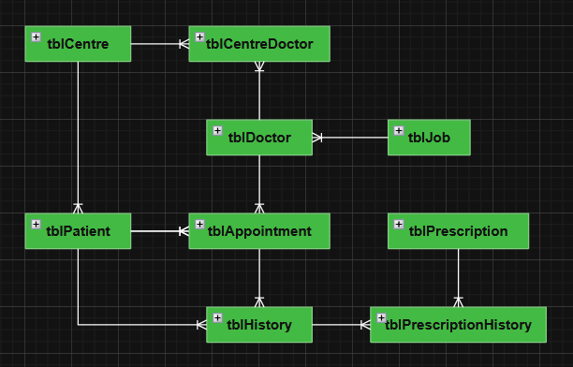
- APPOINTMENT
- HISTORY
- PRESCRIPTION
- PRESCRIPTIONHISTORY

Entity Relationship Diagram
Most entities have a one-to-many relationship to one another, except for the relationship between centres and doctors which is many-to-many. In order to create this cardinality, an extra table is needed - tblCentreDoctor - which has been created as shown.

Data Integrity and Security Considerations
To maintain data integrity, each entity instance will require its own unique ID that will allow it to be identified across the database system and allow the entity instance to be referenced in other entities. The patient’s name and contact information will be required. The patient’s current address will also need to be recorded to ensure that they have access to their local health centre for ease of access. A patient’s history should be able to be set to null for new patients.
Doctors’ contact information and particular medical specialisation is also required. Additionally, a doctor needs to be assigned to a particular place of work, therefore an extra table linking both the centres and doctors is necessary for the unique many-to-many relationship. Appointments will need to be formatted correctly and only accept future dates/times.
With the amount of highly sensitive and private information being handled by the database, security must be top priority for the safety of the patients and staff. Security risks such as SQL injections (especially in regard to parameterised reporting) should be kept in mind and measures should be taken for the prevention of such.

CRUD Functionality
Only key entities mentioned in the ERD should be created as tables in the database: tblCentre, tblJob, tblDoctor, tblCentreDoctor, tblPatient, tblAppointment, tblHistory, tblPrescription, tblPrescriptionHistory. Records of any table may be created, read, updated, and potentially deleted, and the table should be built in preparation for such.

Create
It should be possible to create all aforementioned entities as tables in the database. For tables reliant on foreign keys, their creation must be done after the table from where the foreign key is from - such as tblJob being created before tblDoctor due to the presence of the field “doctorJob” which is a foreign key. Finally, all validation rules should be able to be implemented correctly, such as the functionality of primary keys and input masks.

Read
Data retrieval should be continuously monitored and access restricted where possible due to the sensitive nature of the data being handled – such as incredibly personal information about the patient’s medical history and their addresses. This risk of exposure should always be kept in mind and handled with the care and caution it requires.

Update
The database will always be prone to change, and the scalability and flexibility of which is something very important to consider during development. All implemented parameters and constraints should be easily updated whilst still being able to carry out their necessary restrictions.

Delete
Foreign key restraints should be applied for the health centres, doctors, and patients. If a record from any of these tables gets removed, then any previous doctor appointments will be null or flag an error. The potential for any entity to be deleted should be kept in mind during development and be accounted for.

