Individual Initial Design Specification
- Scenario Overview
This proposed system is intended for road safety monitoring by the Police Service of Northern Ireland (PSNI). This is a data-driven, web-based CRUD application that will store road traffic collision information and allow structured reporting of dangerous driving times and locations. The intention of this application is not to provide a replacement for existing national systems but to demonstrate a realistic organizational database that road safety analysts can use to store and analyse collision information. The application is particularly concerned with temporal and geographic patterns of road traffic collisions.
- Real-World Challenge
The issue of road traffic collisions is an important safety issue for the public. The issue leads to fatalities, injury, and long-term health effects. The study indicates that the risk of collision is not evenly distributed over time or space. Some hours of the day, some days of the week, and some specific road locations have higher rates of accidents. It is not easy to determine the patterns of accidents without data analysis. Some roads may be identified as dangerous but not prioritized for safety. The system helps an organization to analyse trends to make informed decisions. For example, police patrols can be sent to specific hours of the day or specific roads to curb accidents
- SDG Alignment
This project aligns with United Nations Sustainable Development Goal 3: Good Health and Well-Being. Target 3.6 aims to reduce global deaths and injuries from road traffic accidents. By enabling structured analysis of when and where collisions occur, this system supports monitoring, prevention, and evidence-based policymaking. The database provides measurable indicators such as collision frequency, severity distribution, and high-risk geographic clusters, directly contributing to public health improvement
- Proposed System and Key Users
The application will be developed with HTML, CSS, JavaScript, and SQL with a MySQL database. The application will allow users to store data and generate reports. The data will be simple to input, and the reports will be easy to generate. There will be two users or the application. The first is the Road Safety Analyst. This user will be able to input data, edit data, and delete data from the system. The data will include collision data. The user will also be able to generate reports from the data. The second user is the Policy and Planning Officer. This user will be able to view reports generated from the system. The reports will help the officer determine the best times and places to enforce road safety campaigns

- Data Sources and Evidence Base
The inspiration for this design comes from publicly accessible data sets related to road safety in the UK, especially data structures that resemble the format of STATS19 collision reporting system. Some of the inspirations for this system are:
- The system keeps track of the exact date and time of collisions, which allows for analysis of collisions based on the hour of the day.
- The system keeps track of locations in a separate data structure, allowing multiple collisions to be related to a single location
- The system also uses standard severity levels(Fatal, Serious, Minor).
- Initial Conceptual Data Model
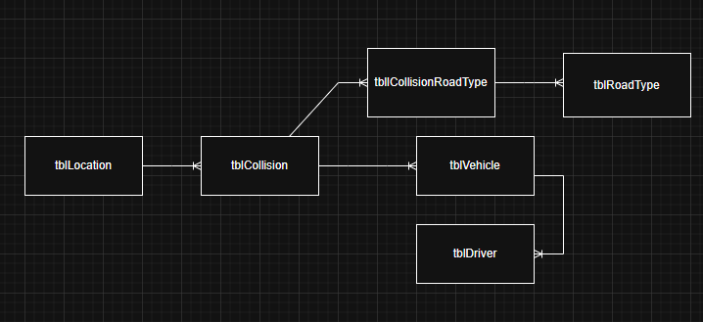
- Initial Reporting Ideas
The application will include several analytical reports designed to answer practical road safety questions. One report will identify the most dangerous hours of the day by grouping collisions using the HOUR function on the collisionDateTime field. Another will identify locations with the highest number of serious or fatal collisions by grouping records by location and ordering them by collision count. A further report will compare weekend and weekday collision totals using DAYOFWEEK classification. The system will also generate a “Top 5 high-risk areas” report for the previous 12 months using date filtering and ranking queries
- Data Integrity and Security Considerations
To ensure data reliability, both database and interface controls will be implemented. Database constraints will enforce required fields such as collisionDateTime and locationId, while severity will be limited to predefined categories. Foreign key constraints and indexing on datetime and location fields will maintain relational integrity and improve query performance.

