Design specification: 40487649
Scenario Overview
In modern times education is as important and needed as ever. T
Real-world Challenge
This system facilitates further education for adults who wish to further their learning and gain new skills. This system would support the educational institution by simplifying management of classes and teachers, increasing time available for management staff to improve facilities and run extra education activities.
SDG Alignment
Our solution aligns with the United Nations Sustainable Development Goal 4. Generally, Goal 4 aims to ‘ensure inclusive and equitable quality education and promote lifelong learning opportunities for all’. Our system would allow users to easily manage their timetables improving the ease of access of education.
Proposed System and Key Users
Our system would manage class schedules, staff assignments as well as class locations for an educational institution. Basic functionalities include creating classes, allocating locations for the classes, viewing class timetables for a member and allocating teachers.
Data Sources and Evidence Base
Queen’s University Belfast is a large university with roughly 25,000 students. As such we decided what better system to model our solution after. Due to Queen’s not publishing its internal data our system will use fabricated data as test data. Queen’s system contains many common elements with our proposed systems i.e. students, lecturers
Initial Data Model
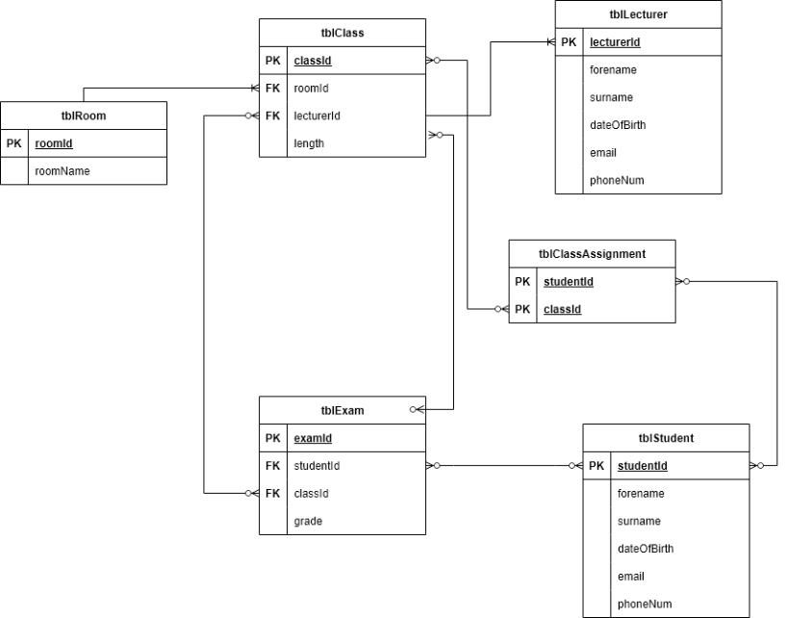
Key CRUD Functionality
Only tables established in the specification may be used as entities in the database:
Records may be created via the web interface for additional classes, lecturers, and class assignments.
Data Integrity and Security Considerations
Each student and lecturer must be assigned a unique id to identify it. The forename and surname of each student and teacher is required. The assigned email address for staff is required. Lecturers may be assigned to multiple classes. A class may only be assigned one location. Classes require a subject, an id, a location and a teacher ID.

