1. Install PyDev from Eclipse Marketplace. Open Eclipse, go to menu: Help -> Eclipse Marketplace..., search PyDev, and install it following the instructions.
2. First we need the environment to develop Python project on Windows.

Open Eclipse PyDev Preferences, setup the Python Interpreter.

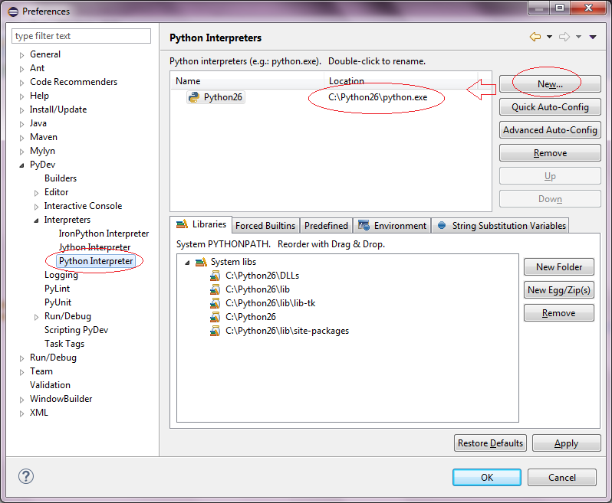

Go to PyDev Editor, check the option Auto-format editor contents before saving.

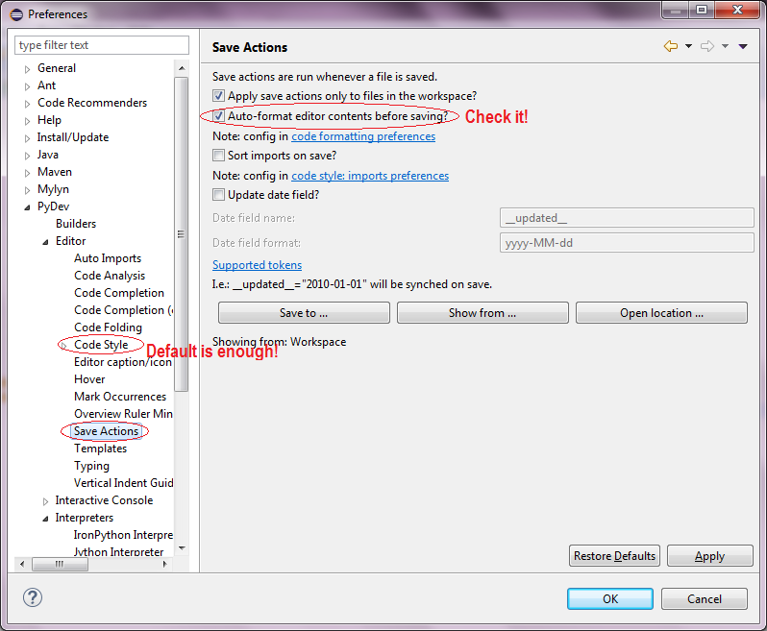

1. In most case, the default Code Style shipped with PyDev is enough. But pay attention to following common pitfalls:

Must use **4 spaces to indent** Python source code.

1. Go to Eclipse Preferences General -> Workspace, set Text file encoding to **UTF-8** and New text file line delimiter to **Unix**.